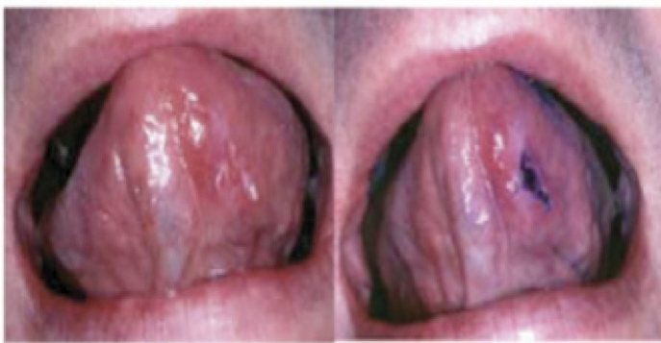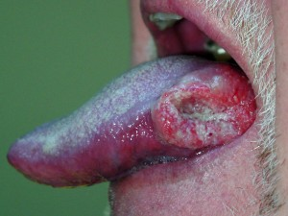

* Must provide proper dental examination
* Include a thorough oral cancer screening
* Educate patient about risk factors of oral cancer
* Identify any abnormalities in the mouth refer to specialist

New York City College of Technology

Department of Dental Hygiene

* Al-Aufi, C. (2012, Feb 17). Hive health media. Retrieved from http://www.hivehealthmedia.com/women-hpv-vaccine-not/
* Centers for disease control and prevention. (2012, February 15). Retrieved from http://www.cdc.gov/std/HPV/STDFact-HPV.htm
* Glenn r. foreman . (n.d.). Retrieved from http://www.drforeman.com/orarisk-testing
* Global Pharma Sector news. (2011, Feb 24.) retrieved from Http:www.globalpharmasectornews.com/2011/02/oral-sex-relates-to-cancer-risk/
* Medicinenet.com . (n.d.). Retrieved from http://www.medicinenet.com/oral_cancer/page3.htm
* Oral cancer foundation. (2011, 10 04). Retrieved from http://www.oralcancerfoundation.org/hpv/index.htm
* Sex symbols royalty free stock photo. (n.d.). Retrieved from http://www.123rf.com/photo_8525396_sex-symbols.html
* Zulkifli Ismail, D. (2012, janurary 15). thestar online. Retrieved from http://thestar.com.my/health/story.asp?file=/2012/1/15/health/10251289&sec=health
* Human Papilloma Virus is a sexually transmitted viral infection
* 40 types of HPV are transmitted through sexual contact and infects genital areas of both male and female
* HPV 16 and HPV 18 are the 2 major strains that cause the vast majority of cervical cancer
* HPV 16 is the most common strain of HPV found in oral squamous cell carcinoma

**Role of Healthcare**

**Provider**

## What is HPV?

Lashana Jones

Hiliary Pena

Susan Wu

NYCCT WELLNESS FAIR

MAY 10th, 2012

* HPV 16 and HPV 18 are measured as the most harmful strains of HPV.
* When E6 and E7 genes are combined in HPV 16 & 18, they create strong binding capabilities.
* This interaction allows HPV 16 and HPV 18 to replicate very rapidly and in great number.
* This leads to uncontrolled reproduction of the viral cells.
* This progression eventually leads to cancer.

Squamous cell carcinoma under the tongue

**Connection between HPV and Oral Cancer**

**Signs and Symptoms**

**of HPV**

* Patches inside your mouth or on your lips that are white and red. White patches are most common. Which sometimes become malignant.
* A sore on your lip or in your mouth that won't heal
* Bleeding in your mouth
* Lose teeth
* Difficulty or pain when swallowing
* A lump in your neck

Disclaimer: These symptoms do not necessarily mean you have oral cancer.

**Symptoms of Oral Cancer Can Include**

* Genital contact, both vaginal and anal
* Oral sex
* Can be transmitted through same sex partners
* In a rare occasion, a pregnant woman with genital HPV can pass HPV to her baby during delivery.

**Transmission of**

**HPV**

tra

* Usually appear as a small bump or a group of bumps in the genital area.
* They can be small or large, raised or flat, or shaped like a cauliflower.
* Can develop RRP which is condition where warts grow in the throat and block the airway