Pillows
How to create a pillow cake
By: Shaneeka Wood
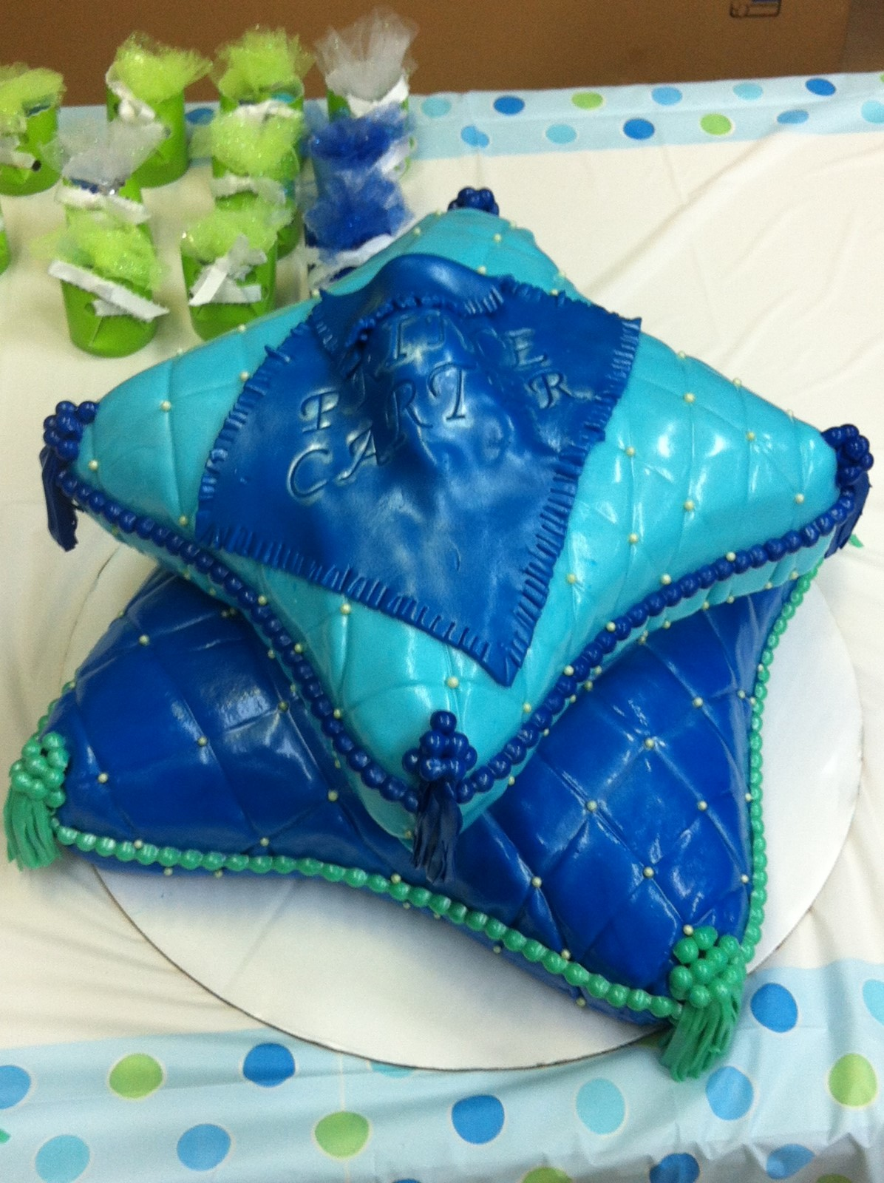
Computers in Education
Dr. L. Trinidad
New York City College of Technology

