Creating Powerpoint Videos

Getting Started
Assemble your information in the order you want in a Powerpoint file. Be sure to have titles included with your images for a clear presentation.
Have the video pans of the photographs in your project folder and we’ll add these soon.
Add an audio clip to your project folder.

Creating Transitions Between Slides
Select the first slide and the Transitions Tab from the top menu bar.
Choose the transition type you want from the menu bar (Fade is always a good option). Once you’ve made your choice, at the right side of the menu bar choose the Duration of transition.

To Add, Format, and Record Video to the Powerpoint
To add a .gif just insert an image to a slide, as usual done when inserting a picture
- To see the .gif in action switch to the Slideshow tab and Preview

To insert a video into Powerpoint like such as the pan shots you have from photographs for the assignment, go to the Insert Tab and select Video:
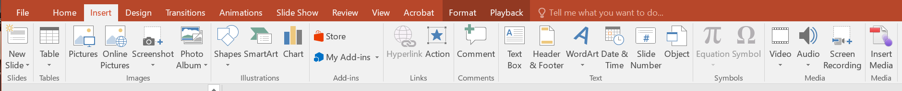
Choose Add video from my PC, and select Insert the video file you have. (To transfer the video from you’re a great tool is Dropbox you can add the file to the Dropbox app on your phone, and then retrieve the video from Dropbox account on your regular computer).
Once it’s inserted you can choose the Format video tools. One good option for the Format is to put a border around the video.
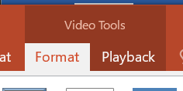

Playback option. Select Play to preview the video. You may want to use the Fade In or Fade Out option. For Start you can keep On Click. Keep the other options unchecked.

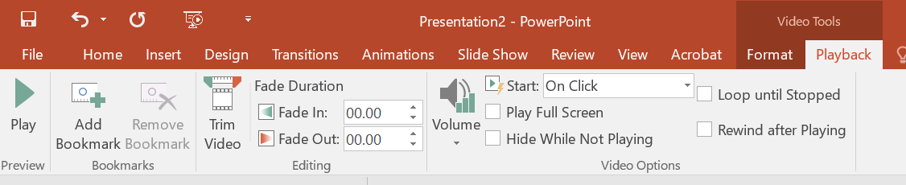

Adding Audio
https://support.office.com/en-us/article/video-add-and-record-audio-eeac1757-5f20-4379-95f2-0d0cd151d5b8
You can add audio or record your own narration:
To add your audio, Select Insert > Audio > Audio on My PC
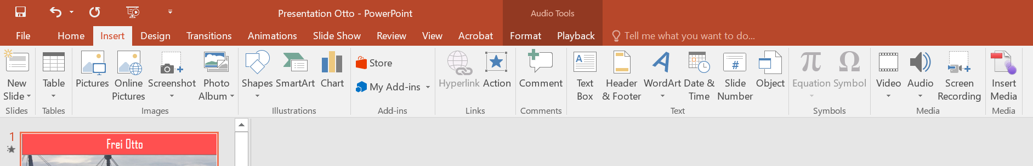

- The Audio icon and controls will appear on your slide
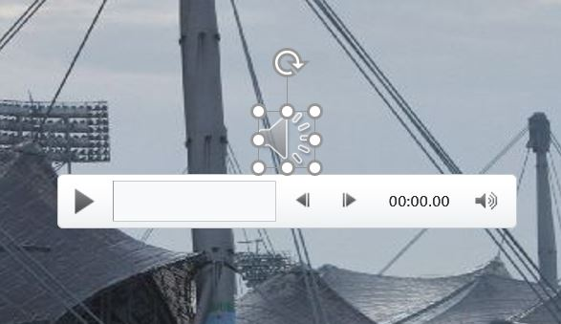

- To select options for how it plays on your slide, select the Audio icon.

- then select Playback on the top menu bar.
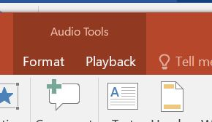

Trim – will cut the length
Fade in or out will change how the audio begins or ends
To choose when it begins to play during slide – you can choose Clicked sequence, When clicked or Automatically—or if you want it to play throughout the slide show, select Play in Background.

Setting Timings for Each Slide
You will want to decide the time spend on each image depending on how much information you want to show form each slide. You may want to have more time for long quotes for example.
You can set the times in the Slide Show menu tab. Rehearse timings can help you see the presentation before you record – or you can redo your recording – accessed through the Record Slide Show. Note: When you record, you will need to click on the video screen to get the video to play. (Once the Slide Show is recorded it will play automatically though).
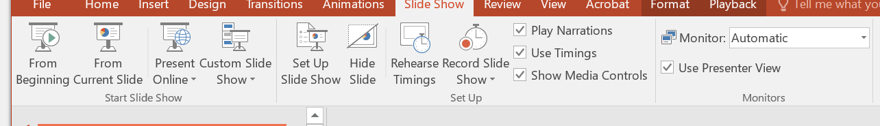

Final Step: Create Video
Go to File > Export > Create Video to produce an MP4 video file.

