What is GIS Analysis [Adapted from the ESRI Guide to GIS Analysis, Andy Mitchell]

GIS analysis is a process for looking at geographic patterns in your data and at relationships between features. The actual methods you use can be very simple – sometimes, just by making a map you’re doing analysis – or more complex, involving models that mimic the real world by combining many data layers.
The chapters in this book follow the process you go through when performing an analysis.
- Frame the question
You start an analysis by figuring out what information you need. This is often in the form of a question. Where were most of the burglaries last month? How much forest in each district? Which parcels are within 500 feet of this bakery? Being as specific as possible about the question you’re trying to answer will help you decide how to approach the analysis, which method to use, and how to present the results.
Other factors that influence the analysis are how it will be used and who will use it. You might simply be exploring the data on your own to get a better understanding of how a place developed or how things behave; or you may need to present results to policy makers or the public for discussion, for scientific review, or in a courtroom setting. In the latter cases, your methods need to be more rigorous, and the results more focused.

- Understand your data
The type of data and features you’re working with help determine the specific method you use. Conversely, if you need to use a specific method to get the level of information you require, you might need to obtain additional data. You have to know what you’ve got (the type of features and attributes, discussed later in this chapter), and what you need to get or create. Creating new data may simply mean calculating new values in the data table or obtaining new layers.

- Choose a method
There are almost always two or three ways of getting the information you need. Often, one method is quicker and gives you approximate information. Others may require more detailed data and more processing time and effort, but provide more precise results. You decide which method to use based on your original question and how the results of the analysis will be used. For example, if you’re doing a quick study of assaults in a city to look for patterns, you might just map the individual crimes and look at the maps. If the information will be used as evidence in a trial, though, you might want a more precise measure of the locations and numbers of assaults for a given time.

- Process the data
Once you’ve selected a method, you perform the necessary steps in GIS. You will want to choose parameters that might be required during the analysis (see handouts and section on Mapping Basics – Representing Data Fundamentals below).

- Look at the results
The results of the analysis can be displayed as a map, values in a table, or a chart – in effect, new information. You need to decide what information to include on your map, and how to group the values to best present the information. You must also decide whether charts – used alongside the map-- would help others easily see the information you’re presenting.
Looking at the results can also help you decide whether the information is useful or valid, or whether you should rerun the analysis using different parameters or even a different method. GIS make it relatively easy to make these changes and create new output. You can compare the results from different analyses and see which method presents the information most accurately.

Mapping Basics –Representing Data Fundamentals

- Point mapping – Shows items like individual locations, phenomena
Figure 1
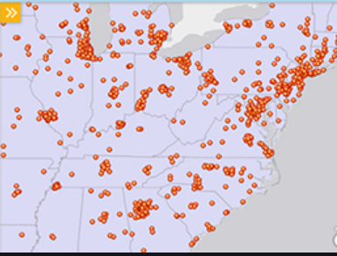
This map shows individual locations with same size
points.

Figure 2
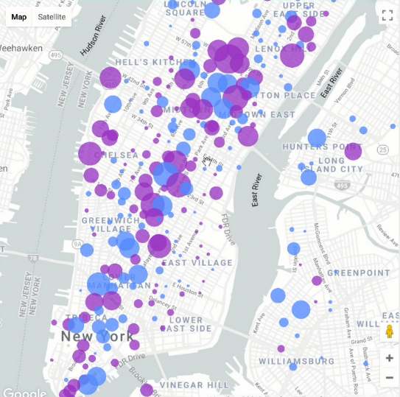
This map expands the radius of points to show intensity

- Color-coding polygons – Shows location of things like land use attached to a specific polygon bounded area, like a lot or block.

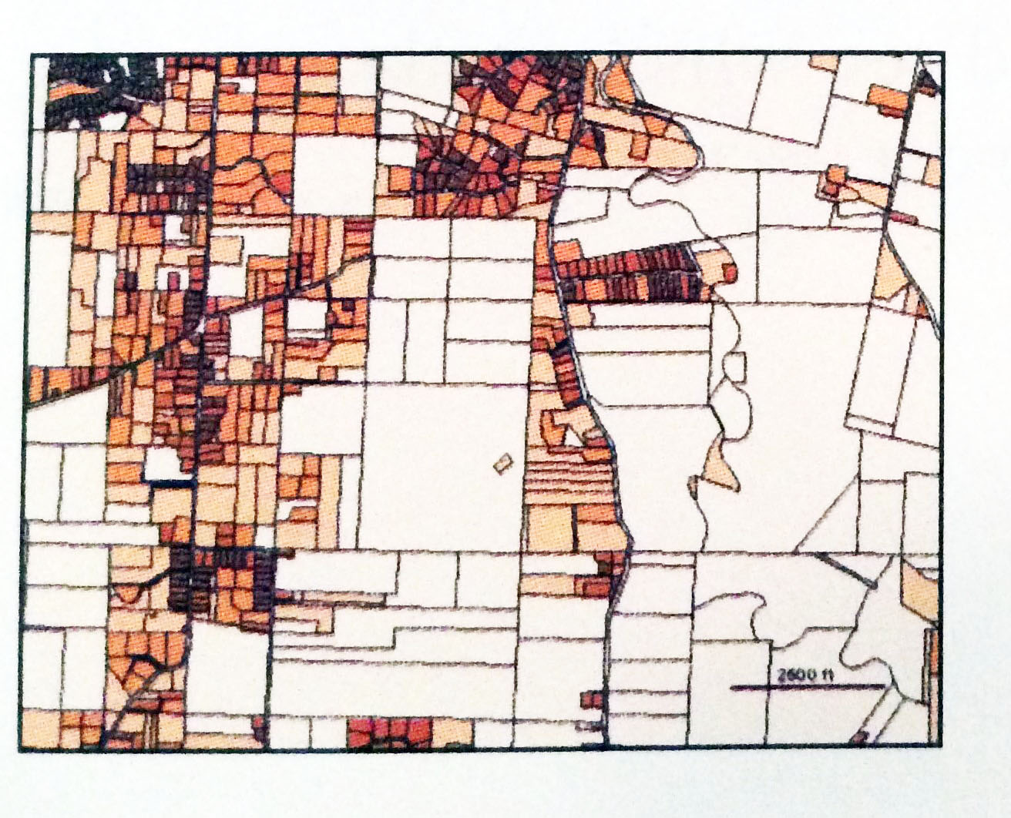
Figure 3
Parcels color-coded by land use

Figure 4
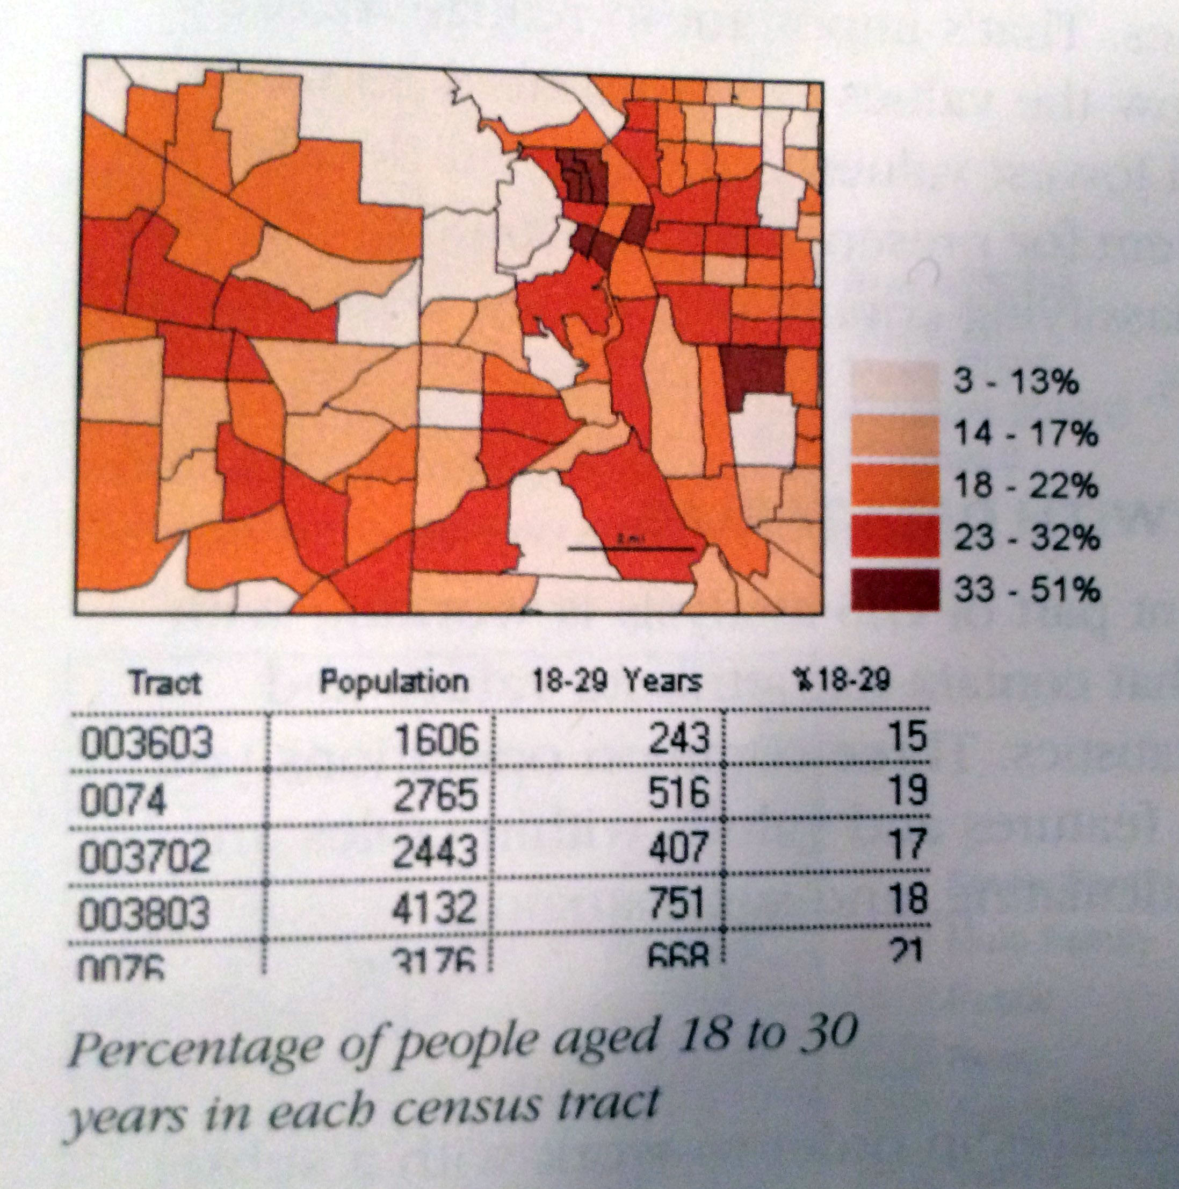
Color-coded parcels showing percentage of people aged 18 to 30 years in each census tract

***Note: It is important to show percent rather than direct population numbers in order to be able to compare data in the map

If you’d like to dive deeper into understanding these topics, see the ArCGIS Book shown below for a guidebook on using ArcGIS to represent a variety of ideas.
