SITE REPORT History of the Theatre, ID. Fall 2022

Theatre Research Project, Act I

[Student Name and Section # here]
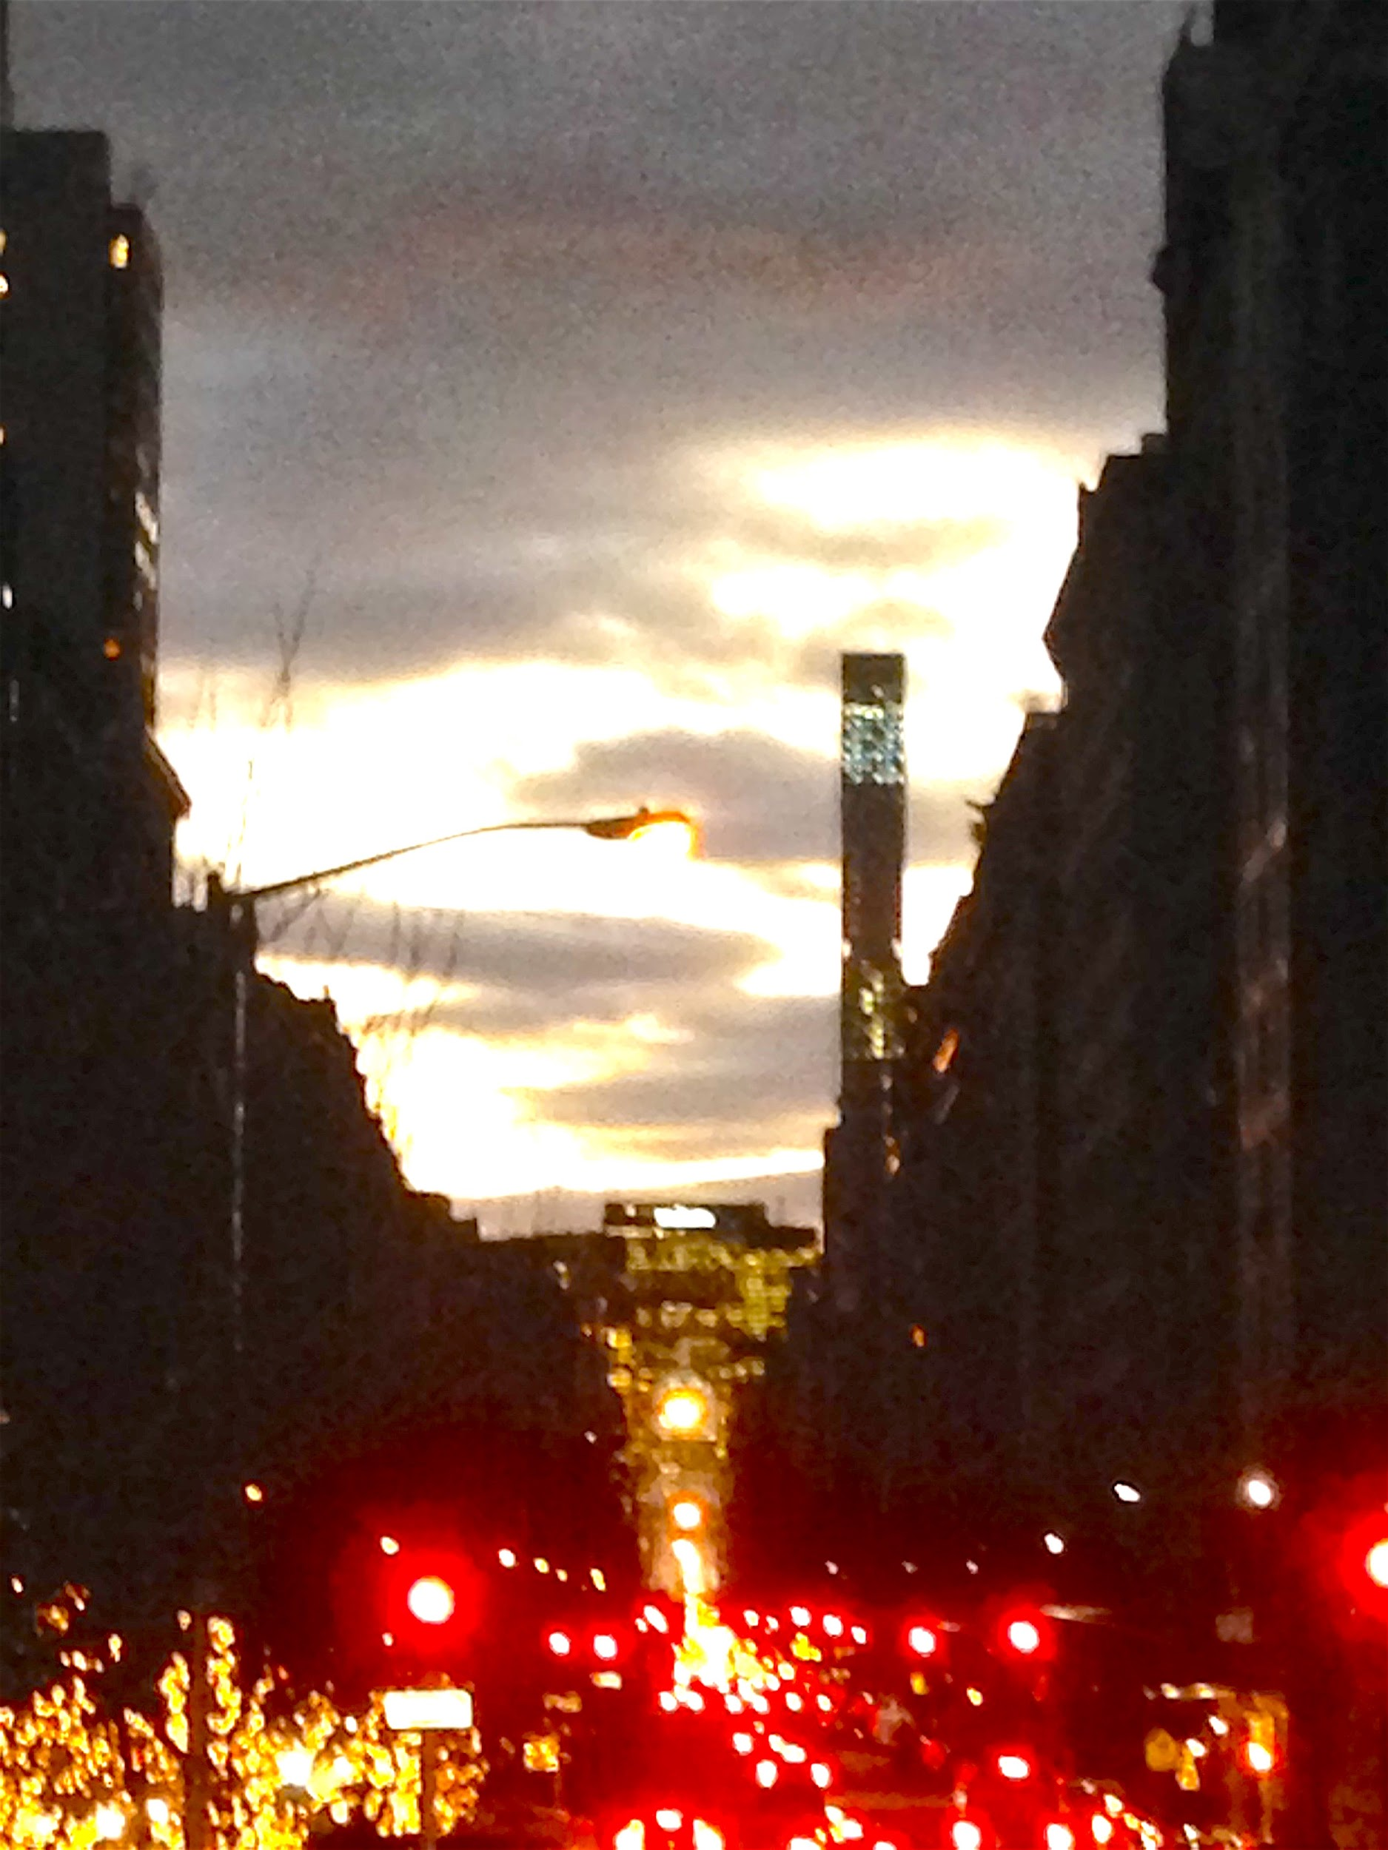

[Street view photograph]
[Caption] Short phrase describing the image
[Attribution] Photographer, database, date
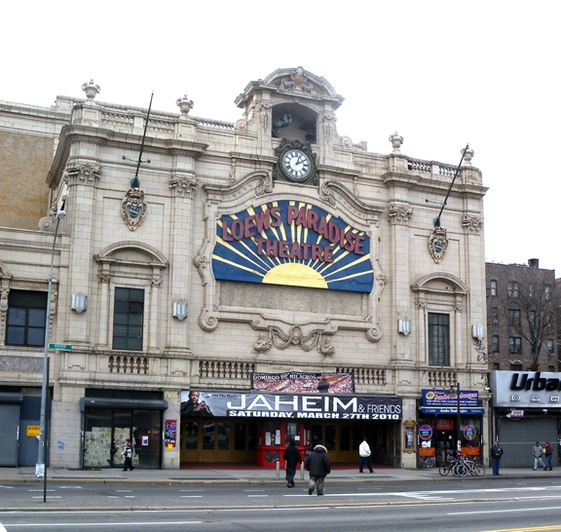

[Theatre façade]

[Title] Name of theater
[Attribution] Photographer, database, date

SITE OBSERVATIONS
Answer questions A and B individually. Use the GIS online tools OASISNYC, Zola, Google Maps, Social Explorer, etc., to gather information.

A. Plan View (birds-eye view): Hand-sketch a map of your neighborhood
- Mark key institutions, landmarks, shopping areas, gathering points, and transportation corridors for the community.
- Indicate name for neighborhood, natural and man-made boundaries, and adjacent communities.
- Describe your method of data collection.
Examples for inspiration:
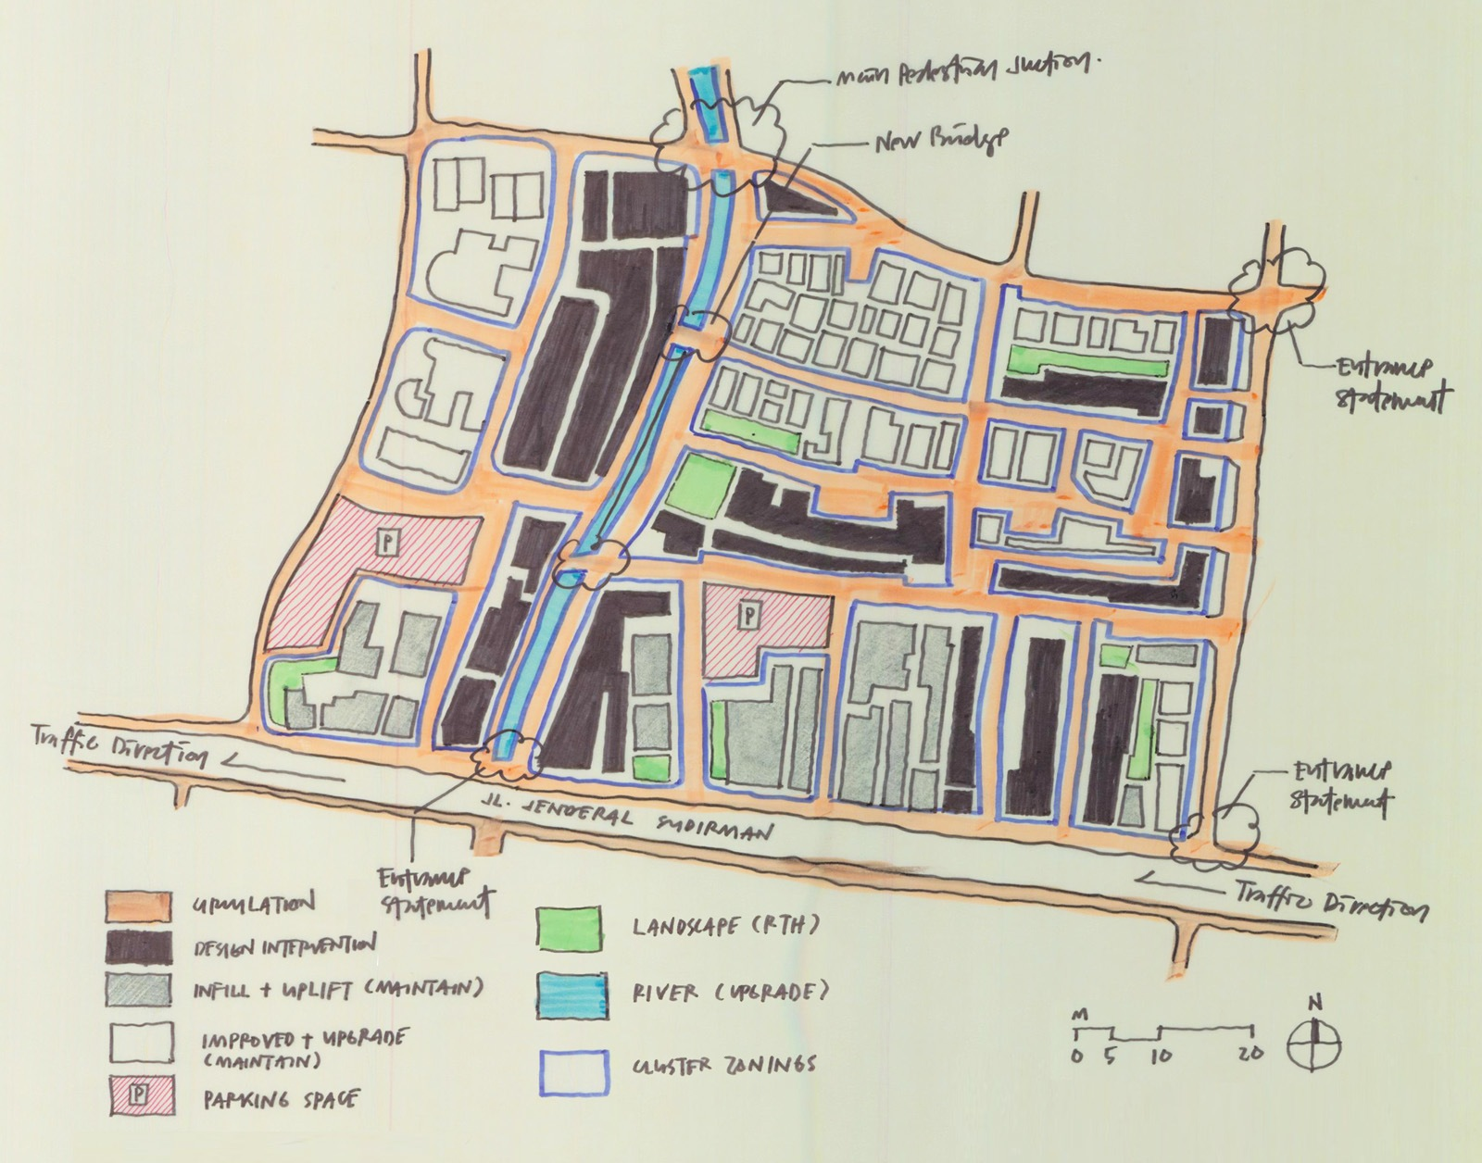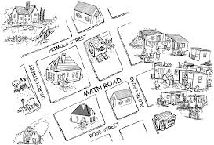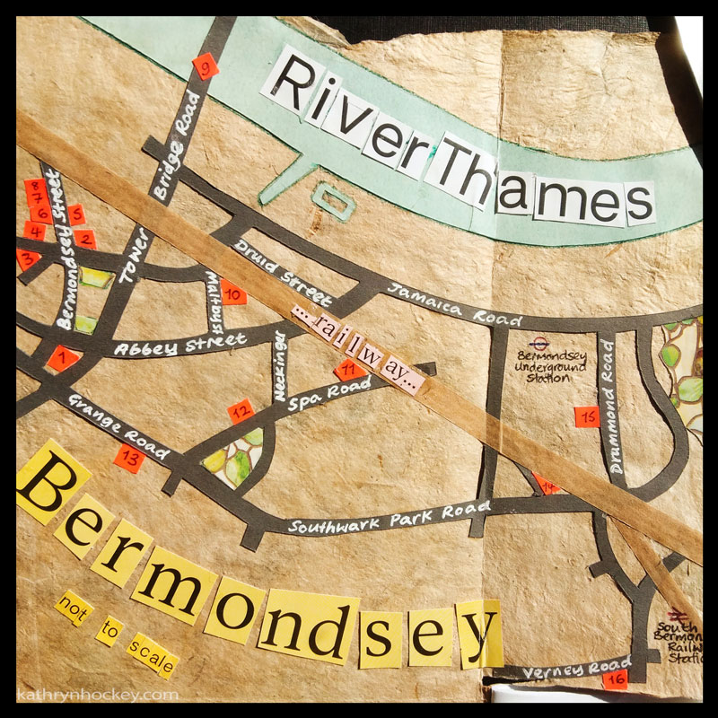

B. User’s perspective: written responses
- What do you notice about the scale and shape of buildings? Describe general patterns, textures, colors, and building materials. How are the buildings arranged in relation to one another and to the street?

- Describe urban infrastructures that facilitate human movement: sidewalks, streets, transportation hubs, signage, car garages, stairs, paths, bike lanes, bike stands, open courtyards, etc. Describe also public spaces like squares, parks, and other areas where people can assemble.

- Does the place include residential, commercial, and industrial buildings? Which of the three building types is most prominent? Do any of the buildings recall a different time – either past or future? Why?

- Describe the types of stores, restaurants, and cafes. What do these facilities tell you about the kinds of people that use the space?

- What kinds of people occupy the space and how do they interact with the environment? Is this place crowded? Walkable? Easy to navigate? Does the area seem very busy or desolate and private? How do people move through the space (use adverbs)?

ANALYSIS/DISCOVERIES
Looking over all of your observational notes, draw some general conclusions about this place and the people who live and work there. Think about how the area compares to other areas of the city. What makes this area unique? What is the genius locus, or spirit, of this place? How do designed structures (buildings, streets, parks, sidewalks, monuments, signs, transportation hubs, etc.) instruct people to use the space, or guide the ways they move through the space? See if you can write your response without using the word “vibe”.

QUESTIONS for FURTHER RESEARCH

In the next stages of the research project you will pursue answers to questions about how the theatre, human residents and visitors, and local urban infrastructures and buildings combine to create a theatrical community. Write two research questions that will help you learn more about how the theater serves the community in which it is located now and how it did when it was first built. Your questions should follow directly from the analysis section and be complex and specific enough to serve as the basis of a research project. In other words, do not ask questions that can be answered in a single sentence.
- Question to help understand the theatrical community of the present:

- Question to help understand the theatrical community of the past:

