My closet Journey
  - By: Shayina Dubuisson

My Eighteenth Birthday
On my eighteenth birthday, I had school, I wanted to dress nice, but I did not want to over dress because I was still in high school and there was a dress code. In my high school, the students had to be very be careful of what they wear because if you wear a crop top and it is too high the faculty would make you wear a gym t-shirt and when it was summer time and girls decided to wear shorts, they would give them gym shorts.
I definitely broke their dress code and I wore a sweater cropped top, high rise bleach ombre jeans, a pair of Jordan’s, an expensive watch that my aunt brought me for Christmas, I had on my “S” initial ring that I always wear, a gold chain, and I wore clip-ins hair extensions. My birthday is in January, so when I came into school nobody stopped me because I had on a heavy coat. I received many compliments for my outfit that day because I never wore a crop top to school and people were amazed at my outfit. They also knew that it was my birthday because I was carrying balloons that said happy birthday.
Everyone was obsessed with my Jordan’s because those pair of sneakers were very popular and they were hard to get. It was hard for me to get them as well; I had to stand on a line just to get those sneakers. I did not do much on that day since it was a school day, but I enjoyed the day with my friends after school and they made the day special for me.

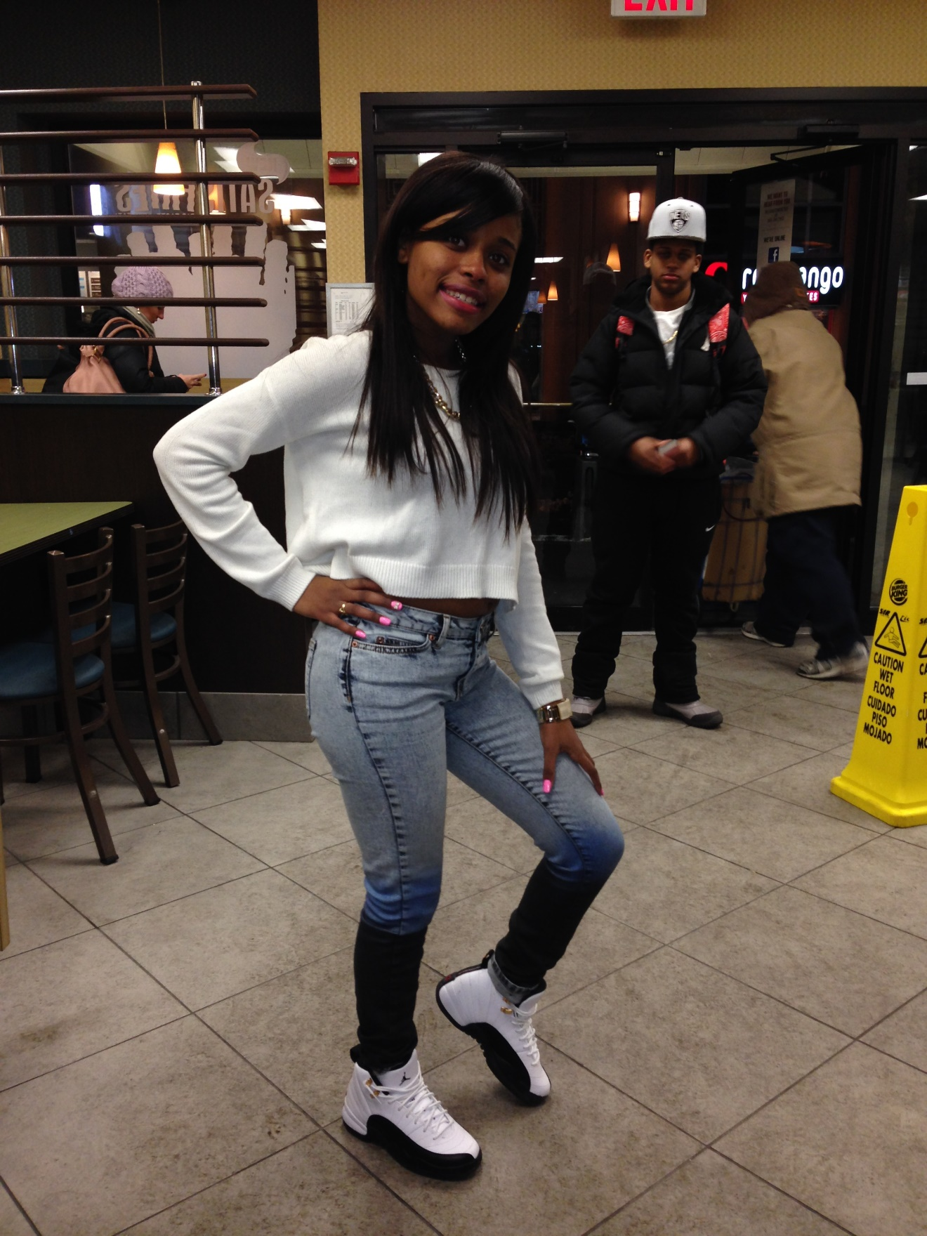
Eighteenth Birthday [Personal photograph taken in Fulton Street, NY, NY]. (2014, January 23). Sweater crop top, bleached jeans, and sneakers
My Prom
The theme for my prom was Great Gatsby, many people dressed according to the theme and wore a gown that was similar to The Great Gatsby, but I did not. At the time, I was very indecisive about going to prom for many reasons, but I just decided to go because I only get one high school prom. When my mom and I went to buy my dress, I already had my mind set on color that I wanted. I really wanted my dress to be nude because I felt like I would go with my skin tone and it would look flattering on me. When my mom and I got to the store, I tried on two dresses and they both were nude. One had one strap and rhinestones going across and down dress, it had ruffles, and it had a split at the end. The other dress was like a Cinderella because it was a strapless dress, it had a lot tulle at the end, so it was very full, and it had a corset, which had rhinestones on it.
I decided to go with the first one and on the day of my prom, I wore matching nude shoes with it that had little rhinestones, a diamond necklace with the matching bracelet and earring, I also wore my hair in curls, and I had hombre blonde hair clip-ins. My mom did my makeup and she did a nice subtle bronze Smokey eye on, she added blush, and lip-gloss. I looked and felt extremely beautiful that day. My mom took many pictures and when my limo came all my neighbors were staring at me as if I was celebrity and they showered me with compliments. I had an amazing night; I just wish I could have gone to the after party when the prom was over.

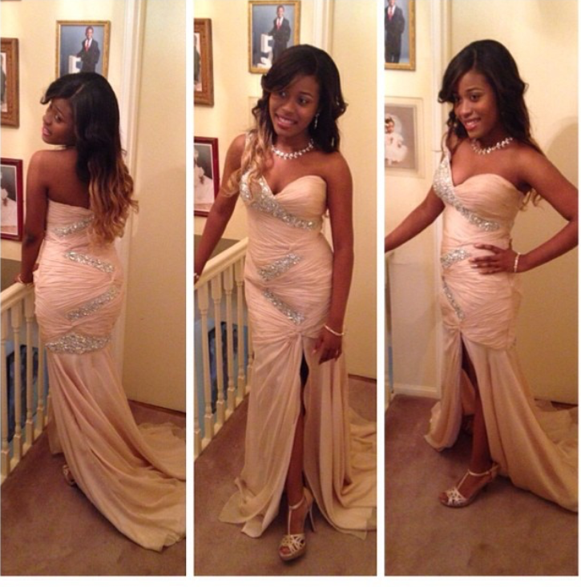
Prom [Personal photograph taken in Brookly,NY]. (2010, June 1). Nude rhinestone dress

My Twentieth Birthday
For my twentieth birthday, I wanted to look sexier, but I also wanted to look conservative. I wore a black long sleeve steep V-neck bodysuit, which showed a little bit of cleavage, with black tailored fitted pants that I brought from ASOS, for accessories, I wore gold rings, bangles, and choker necklace. Since my outfit was all black, I wanted to add color to it so I wore red pointed Steve Madden heels. I also painted my nails red to match my shoes and I had a black and white floral design on both of my ring fingers. My makeup was slightly dramatic, I wore black eyeliner on my waterline and I did a small dramatic wing, I used my Lancôme powder duo foundation in the shade 500 suede, for my lips I used MAC’s dark red lipstick which is called rebel, I also used Anastasia Beverly hills dip brow do to my eyebrows. I wanted my makeup to last all night so I used the urban decay setting spray so it can stay in place.
I wanted my hair to look natural but long, so one of my friends who is a hairstylist helped me to get a weave and sew it in. The hair was 22inches long and I parted my hair down the middle so I can look more mature and sophisticated. That night I went out with a few friends to a Caribbean restaurant called Suede in Brooklyn to have dinner. All my friends were so surprised that I decided to show some cleavage because at the time I did not like to wear sexy clothing all the time. I wanted to change my style up because the following year I was going to turn twenty-one years old and I wanted to show that I was reaching adulthood. One of my friends who was 21 years old was able to get me a drink as treat for my birthday. After the dinner, I went to lounge to dance and hear some music. I had a lot of fun with my friends and liked the outfit that I decide to wear that night.
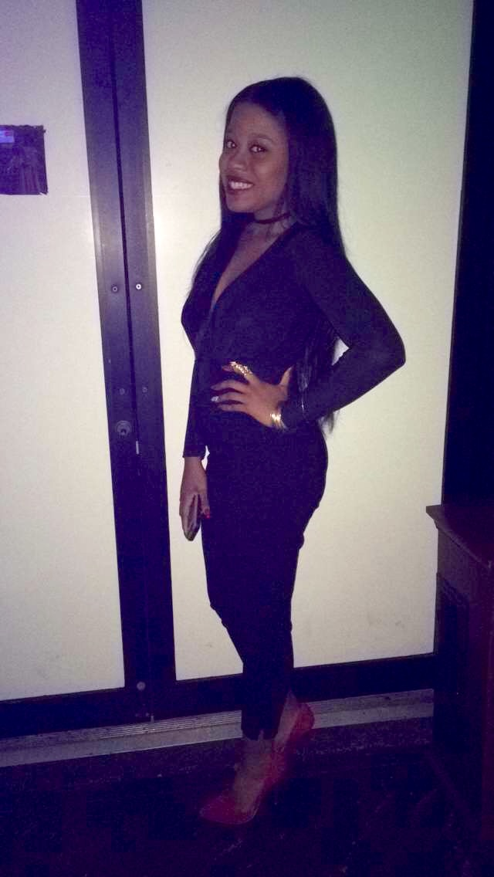
Twentieth Birthday [Personal photograph taken in Brooklyn]. (2016, January 26).
Black v- neck bodysuit, tailored pants, and Steve Madden pumps

My Twenty- First Birthday
For my twenty-first I was excited that I reached the legal age to drink and to go to clubs. My inspiration behind my outfit was Marie Antoinette. I wanted it to be an urban version of her, so I decided to get a blush pink jumpsuit with a ruffle bardot at the top, with clear heels, and a white choker with a clear rhinestone hanging in the middle. My nails were nude, and I had rhinestones on some of my nails. I went to Sephora that day to get my makeup done and I told the makeup artist that I wanted a soft glam look. I showed her a picture of my outfit and she did a soft pink Smokey eye, for my eyebrows, she used Anastasia Beverly hills brow wiz in the shade chocolate, she contoured my face using the Kat von D palette, and for my lips, she used a dusty pink lipstick. I wanted to wear a weave for my birthday so I dyed the hair hombre honey blonde, so the blonde could compliment the pink outfit that I was wore and so it could also follow the inspiration behind the look I was going for which was, Marie Antoinette.
I went to a Japanese restaurant called Fushimi in Williamsburg, Brooklyn. The food and drinks there was amazing. Everyone was giving me many compliments on my hair because they loved how the honey blonde went with my skin tone and it went with the outfit that I decided to wear. After dinner, I went to a club called Hudson Terrace where I had a lot and got sick and vomited everywhere. I still had fun and enjoyed myself, but I wish my night did not ended shortly. That night I learned not to mix seafood with alcohol to avoid getting sick.
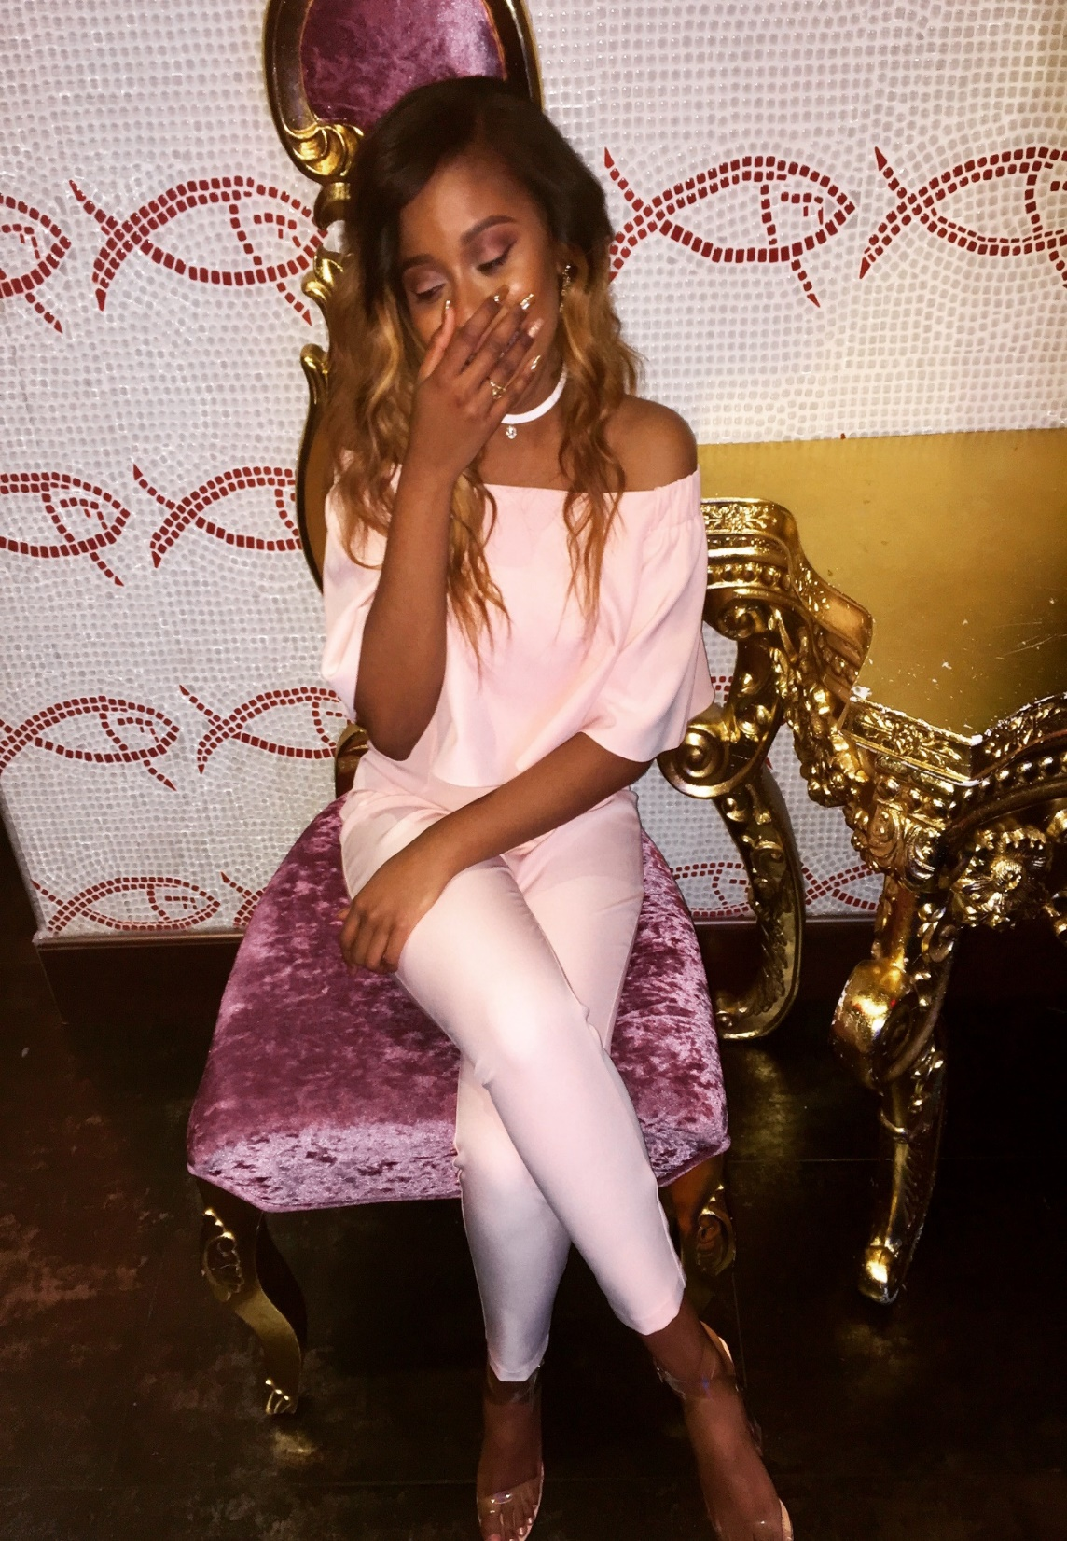
Twenty-first birthday [Personal photograph taken in Brooklyn]. (2017, January 27).
Blush pink jumpsuit, white rhinestone choker, and clear-strapped shoes

Halloween 2017
On October 31, 2017, I went to a Halloween party and it was at a club called Stage 48. Everyone had to wear a costume to get in, I did not want to buy a brand-new costume to wear for this event especially because I was on a budget, so I decided to improvise and just create a costume with stuff that I already have. I used to be a cheerleader in high school, so I wore my high school cheerleading uniform with a pair of black and white Jordan sneakers. For my makeup I did it regular and added a little bit of eyeshadow on my eyelids, and I also did a wing with my eyeliner, and I also did a special effect makeup on my face and used liquid latex to create a scar and I used bright and dark red eyeshadow so it can look like a bloody scar on my face. I also wore a wig and did a halo braid in it so I can look like an actual school cheerleader. I also wore a small black heart shaped chained cross body bag to hold my belongings.
I never went to an adult Halloween party before so I was a skeptical about how it will be like. When I went inside, I saw everyone in different types of costumes. There were people dressed up like Poison Ivy, Kel from Good Burger the movie, Batman, Beyonce, Cardi B, Janet Jackson, T-pain the rapper etc. Many people planned their costumes in advance that is why they were so unique and interesting. My friend was dressed up as a maid and she didn’t plan out her costume either. She wore the same maid costume that she wore our sophomore year on Halloween in high school. It was funny because we were both on a budget and did not put any thought into our costumes. Overall, I enjoyed myself at the Halloween party and I met new people at the party with interesting personalities.

Citycitegroup.com [Photograph]. (2017, October 29). Brooklyn,NY. cheer leading costume
My Twenty-Second Birthday
I was very excited for my twenty second birthday, January 23, 2018, because I was going to Atlantic City in New Jersey and that was the first time that I was going away with friends to have fun. Atlantic City is a place for gambling, clubbing, and having fun so I wanted to look extravagant and mature. The night of my birthday I went to a club called Envy Night club and I wore a champagne sequin dress and clear strappy heels. I made the color for my eyeshadow match the color of my dress which made my eyes look more bright, I used eyeliner to make a dramatic wing and place fake eyelashes over my eyelashes, I wore a full coverage foundation by Kat von D to cover up my acne scars, I also used the Anastasia Beverly hills glow kit to highlight my face can look my vibrant, and I used a natural pink lipstick for my lips from MAC called Taupe. For my hair, I had a 24- inch weave and I dyed it blonde and left the roots dark.
I had a fun night at club Envy. Although it was difficult for me to dance because my dress was so tight, my friends and I danced all night and we were making the security guards laugh with our dance moves. After the club we went back to our hotel, my friends surprised me with a cake, and I was so happy that I almost cried. They never surprised me before with anything, so I was so happy that they did that for me.

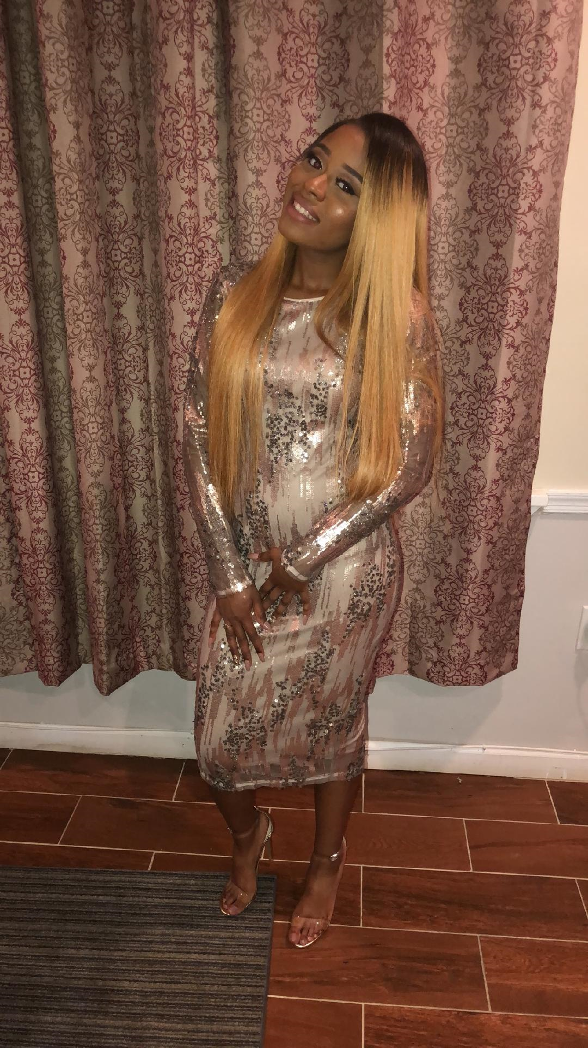
Twenty- Second Birthday [Personal photograph taken in Atlantic City, NJ]. (2018, January 23).
Sequins dress and strapped high heels.

My Twenty-third Birthday
On my twenty- third birthday, I did not want to go out because I wanted to stay home so I can relax and drink champagne. My friends convinced me to go out because they did not want me to stay home and do nothing. We ended up going to a lounge in Queens, New York called Pegasus. The look that I was going for was a sexy athleisure wear outfit. I see athleisure wear outfits all the time on social media, and fashion Influencers would wear a tracksuit with a crop top and strappy heels. I wanted my outfit to look similar to theirs so I wore a neon yellow tracksuit, the pants were baggy and the jacket was cropped, I also wore a patent leather black bralette, 6-inch black booties, and a rhinestone choker with hoop earrings. I decide to straighten my natural hair and do loose curls. My makeup was dramatic; I did a neutral Smokey eye. The products that I used to create the makeup look was the: Maybelline super stay foundation in the sage warm bronze, Colourpop’s concealer, Anastasia Beverly Hills dip brow in the shade chocolate to do my eyebrows, NYX matte eyeliner gel to draw a wing eyeliner on my eyes, and I used E.L.F’s matte lipstick in the shade praline.
My night out with my friends was amazing we danced and had fun. I told myself that would be the last time I wore 6-inch heels without bringing flats because by the end of the night my feet were in pain. My friend had to help me walk to his car. Overall, my night was good and I enjoyed my twenty- third birthday with my friends.

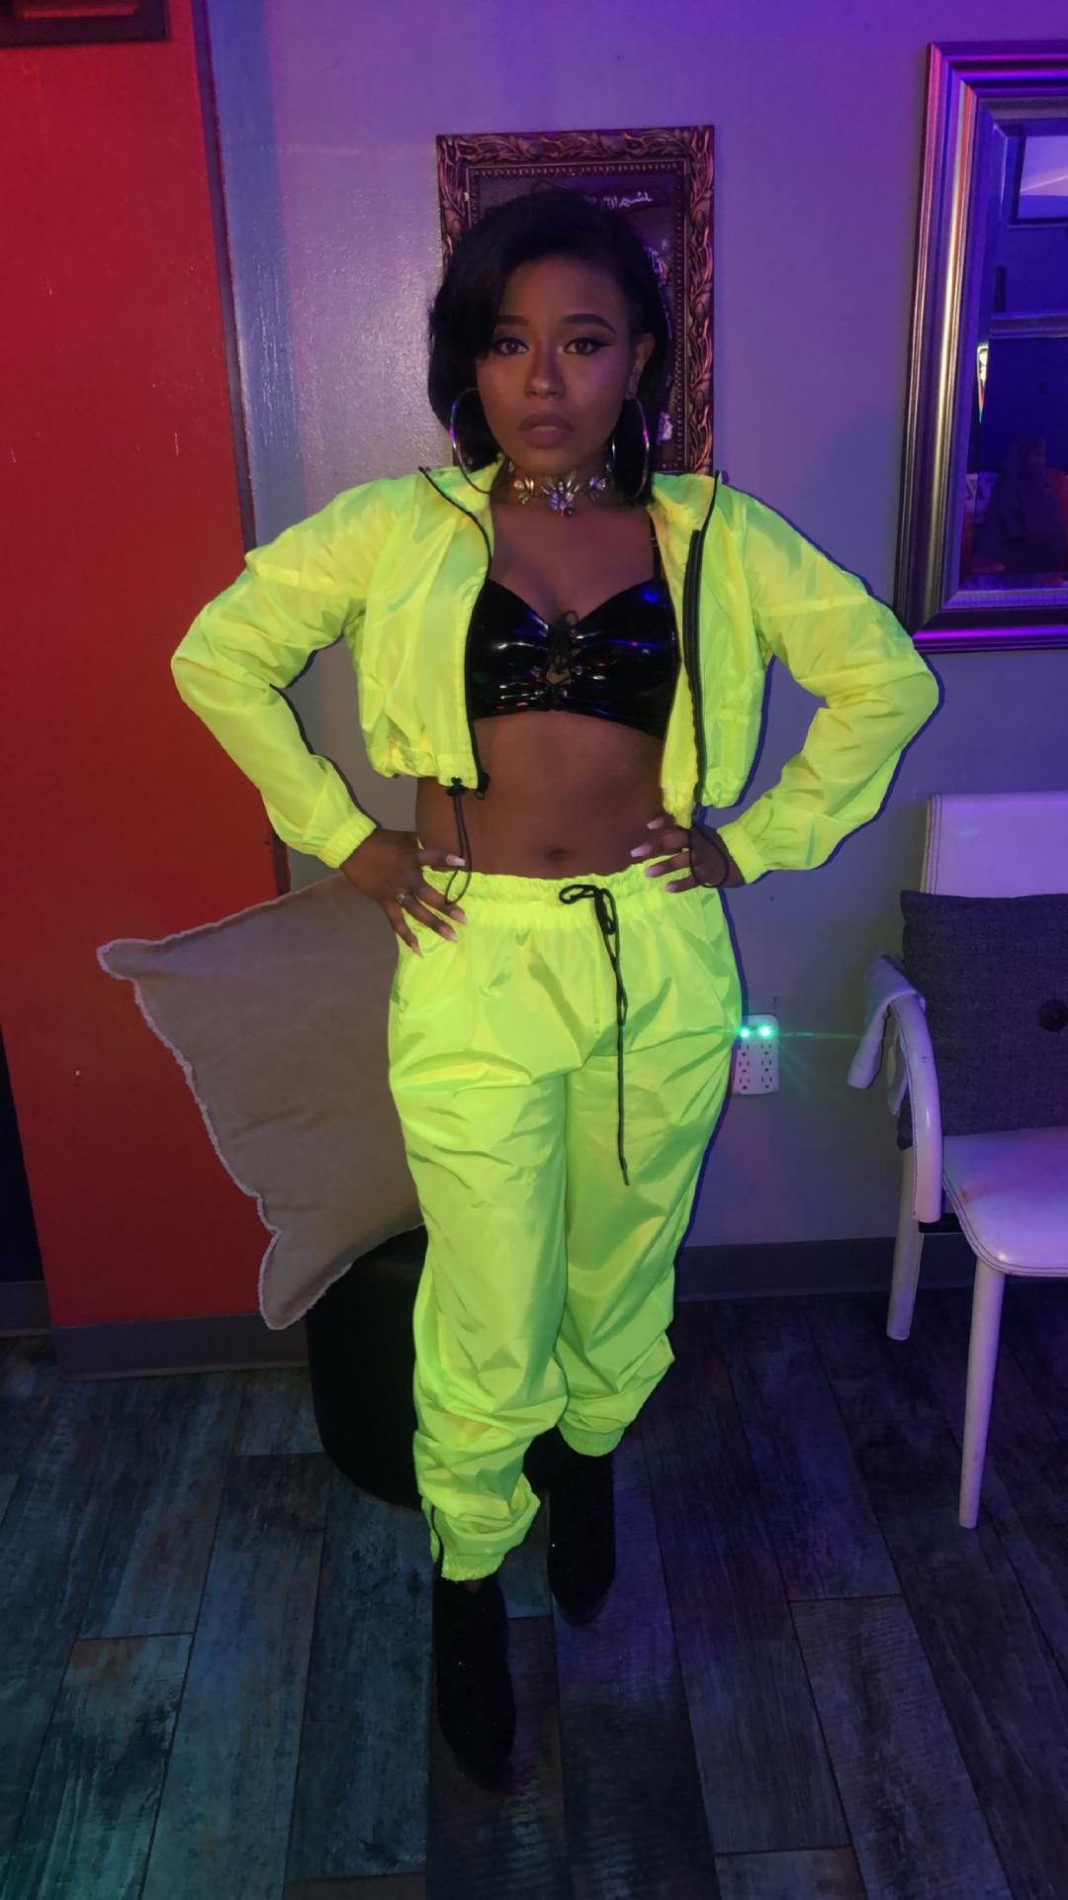
Twenty-third birthday [Personal photograph taken in Queens, NY]. (2019, January 23).
Neon yellow tracksuit, patent leather crop top and black 6-inch booties.
My Uncle’s Wedding
For my Uncle’s wedding, I wanted to wear a floral dress because the wedding was in the summer time located in Fort Lauderdale, Florida where it is always hot. I wanted my dress to suit the atmosphere of Florida’s environment and since I was a guest I did not want to over dress, I wanted to be very classy and conservative. The colors of my dress were very pretty, the purples and blues stood out nicely against the black, white, and gray colors that was on my dress. I wore black and grey peep toed shoes to match my dress. I did not really want to wear a lot of jewelry because I really liked the floral print that was on my dress so I wore a gold bracelet and stud earrings. My hair was very long, I put hair clip-ins in my hair to add more length and for more volume and I curled it with the curling wand. My makeup was very light and subtle. I wore my Lancôme duo powder foundation for an airbrush finish and added pink lip-gloss to my lips to give it a nice shine. My nails were light pink and long.
My uncle’s wedding was nice his wife looked so beautiful and the reception was so much fun. The colors for the wedding was orange and turquoise blue, which I did not like. I felt like the colors did not go well together, but I liked the orange flowers that choose for the corsage. It complimented the groomsmen all black suit because the orange gave the suit color. My family and I was very happy that my uncle found love because he was single for a very long time. He finally found his soulmate and now she is a part of our family and she is the nicest person I have ever met. Her name is Monica and I’m glad to call her an aunt now.

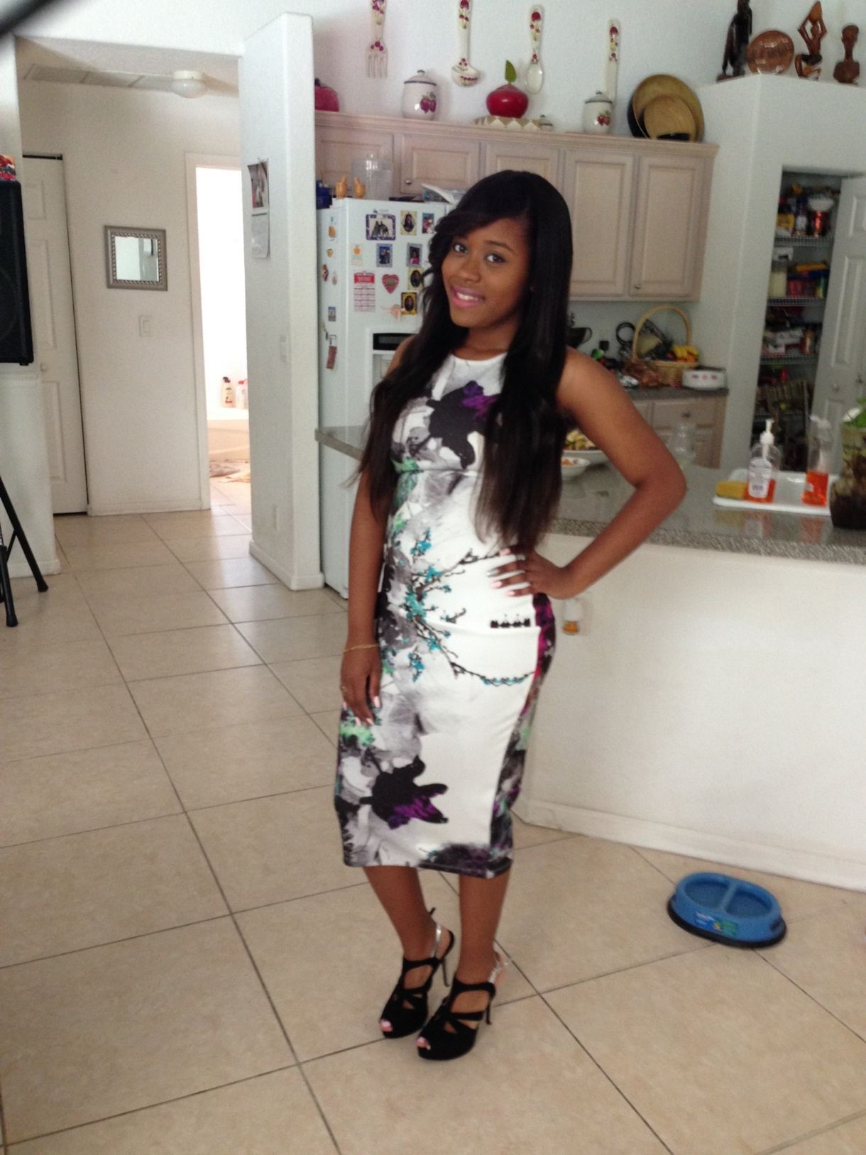
Uncle's wedding [Personal photograph taken in Port Saint Lucie, FL]. (2015, March 21).
floral print dress and peep toed shoes.

A Party at Coney Island
My friends and I went a party in Coney Island the amusement park and the most popular dj’s in New York was going to be there. We were very excited to dance and enjoy ourselves because it was summer and we had a long break before we went back to school, so we wanted to have as much as we can. We got to the party late, so we only had two hours of fun after the party we went to boardwalk, and we started taking pictures where they had nice graffiti wall paintings and beautiful art pieces. I wore a white tank crop top, with distressed bleached high waisted shorts, with an Aztec print kimono, and Steve Madden sandals. I wore my hair curly because I wanted to do a wet and curly look since it was hot outside; I wanted my wet hair to cool me off. I didn’t want wear too much jewelry because I hate when I go to a party I lose a piece jewelry, so I kept it simple, and I wore a pair of hoop earrings that I brought from Rainbow.
I had a good time walking the boardwalk with my friends and I enjoyed watching the beach scenery because it was very calm and soothing. After we walked the boardwalk, we said goodbye to each other and went home.

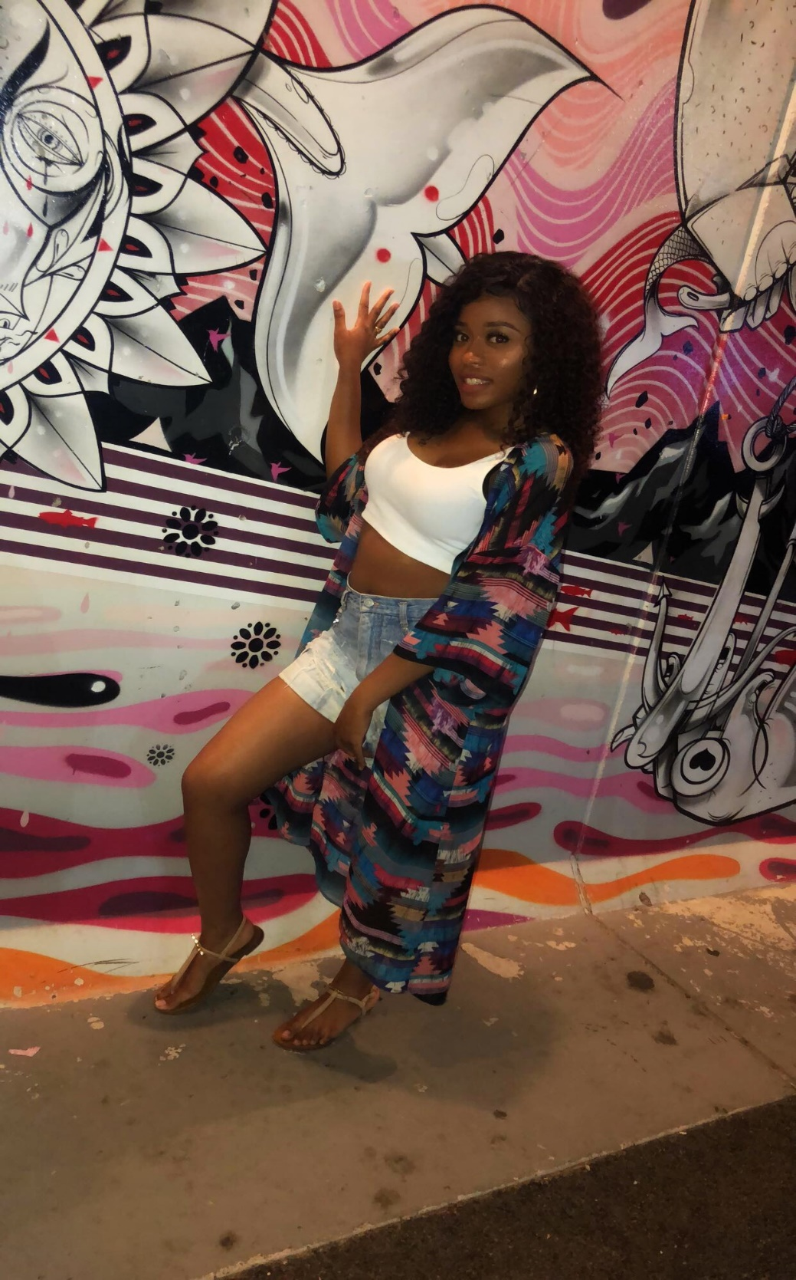
A Party at Coney Island [Personal photograph taken in Brooklyn]. (2018, July 6).
White crop top, distressed bleached shorts, Steve Madden sandals and hoop earrings

Photoshoot Day
I used to be a Youtuber my sophomore year of college I was really into “do it yourself” videos and I had gotten better at doing my makeup. I brought a sky blue bomber jacket from Forever21 for $35.00 and I wanted to add rhinestones on it so it could look like an expensive jacket. I placed the rhinestones on my jacket one by one and then when I was done I let dry for about an hour. When I was done, I took pictures of it and I wanted to take professional pictures in addition to the video, on how I style the bomber. For the photoshoot I wore the bomber that I customized, light blue distressed jeans, a white shirt, a choker, and my Melody Eshani Reebok sneakers. I did my hair in a curly Mohawk. I wanted my jewelry to look shiny so I wore rhinestone studs and a rhinestone-studded ring.
That was my first photoshoot and the photographer had to help me with poses, which was embarrassing. I did not know how to be a model and just be comfortable posing in front of someone I barely know. The photographer was very nice about helping me and all the pictures came out amazing. My subscribers on YouTube loved the way I showed them how to add rhinestones to a jacket. They also like the pictures that I took; it gave them ideas on how to style an embellished jacket.

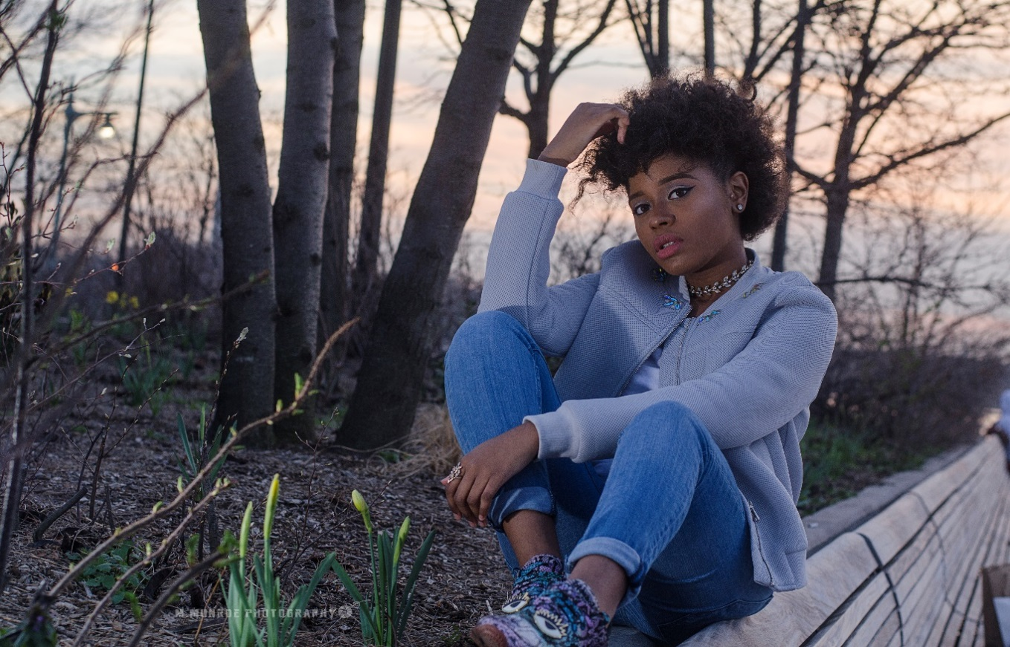
Photo shoot Day [Personal photograph taken in Brooklyn]. (2017, April 17).
Light blue bomber, white shirt, light blue jeans and Reebok sneakers

REFERENCES
A Party at Coney Island [Personal photograph taken in Brooklyn]. (2018, July 6).
White crop top, distressed bleached shorts, Steve Madden sandals and hoop earrings

Citycitegroup.com [Photograph]. (2017, October 29). Brooklyn, NY. Cheerleading costume
Eighteenth Birthday [Personal photograph taken in Fulton Street, NY, NY]. (2014, January 23). Sweater crop top, bleached jeans, and sneakers
Twentieth Birthday [Personal photograph taken in Brooklyn]. (2016, January 26).
Black v- neck bodysuit, tailored pants, and Steve Madden pumps

Twenty-first birthday [Personal photograph taken in Brooklyn]. (2017, January 27).
Blush pink jumpsuit, white rhinestone choker, and clear-strapped shoes

Twenty- Second Birthday [Personal photograph taken in Atlantic City, NJ]. (2018, January 23)
Sequins dress and strapped high heels.

Twenty-third birthday [Personal photograph taken in Queens, NY]. (2019, January 23).
Neon yellow tracksuit, patent leather crop top and black 6-inch booties.

Uncle's wedding [Personal photograph taken in Port Saint Lucie, FL]. (2015, March 21).
Floral print dress and peep toed shoes.

Photo shoot Day [Personal photograph taken in Brookly,NY]. (2017, April 17).
Light blue bomber, white shirt, light blue jeans and Reebok sneakers
Prom [Personal photograph taken in Brooklyn]. (2010, June 1). Nude rhinestone dress

