MECH3550 Final Project

1. Create the Assembly shown below.

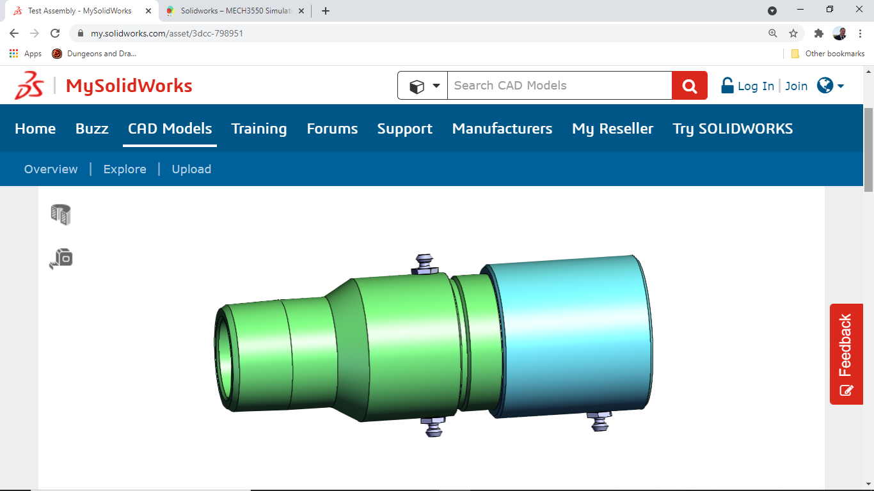

1. Use the following link to find the 3D object with dimensions to use:

<https://my.solidworks.com/asset/3dcc-798951>

1. You can build it using the tape measure tool to get the dimensions of each part, or you can click on “View on 3DCC” and get access to the part/assembly files used to create this model. You can also try using the following link to access the part/assembly files: <https://www.dropbox.com/sh/tfu1ilgjivh8uiz/AAAolZcjBdkDEQ65-zzfZzCLa?dl=0>
2. Apply a Flow of 1500 psi starting at the larger opening.
3. Use SimulationXpress to do a Stress Analysis and FloXpress to do a Flow Analysis. Also, complete a Sustainability Analysis & Cost Analysis as well.

Extra Credit:

1. Improve the Design in one of the Categories mentioned above.