Course No: MECH 3550 Name:
Section No:

Department of Mechanical Engineering Technology
Lab No.
Title:

FACULTY ONLY
Returned for corrections.........................................................
Corrections due.................................................................... Corrections handed in............................................................

Comments

Grade...................... Approved by.............................
STUDENTS ONLY
Date experiment completed:
Date due
Date handed in

Squad No...................
List
Members .....................................................................
.....................................................................
.....................................................................
.....................................................................
.....................................................................
REPORT FOLDER
NEW YORK CITY
COLLEGE OF TECHNOLOGY
OF THE CITY UNIVERSITY OF NEW YORK

Purpose:
Begin to familiarize yourself with MATLAB and Solidworks. Create a small Matlab File and Solidworks Model. Try to understand what is necessary for basic simulation modeling, system dynamics, discrete-event simulation, data collection, and analysis.
Hypothesis:
I will learn more about the basics of Matlab and Solidworks by completing this Lab Assignment
Procedure:
In order to create a Basic Matlab system, I reviewed the OER course by using the link provided under the Matlab tab on the course website. I accessed Matlab by using the Apporto Remote Desktop Access, and I created an example similar to what was shown to us during lecture.
In order to create a Basic Solidworks model, I reviewed some of the videos shown on youtube that instructed me on the basics of Solidworks modeling. I accessed Solidworks using the Apporto Remote Desktop Access. I then created a basic Solidworks model which is shown below.

Data / Observations:
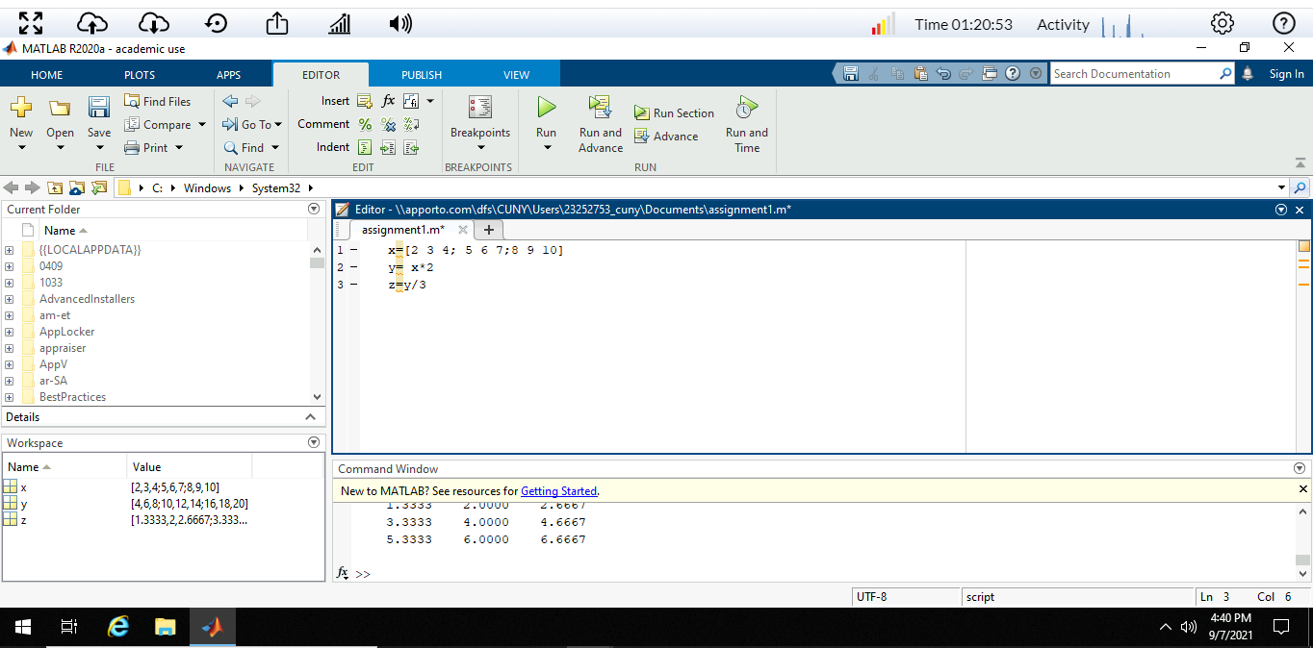
Fig1. Basic Matlab System Input and Output
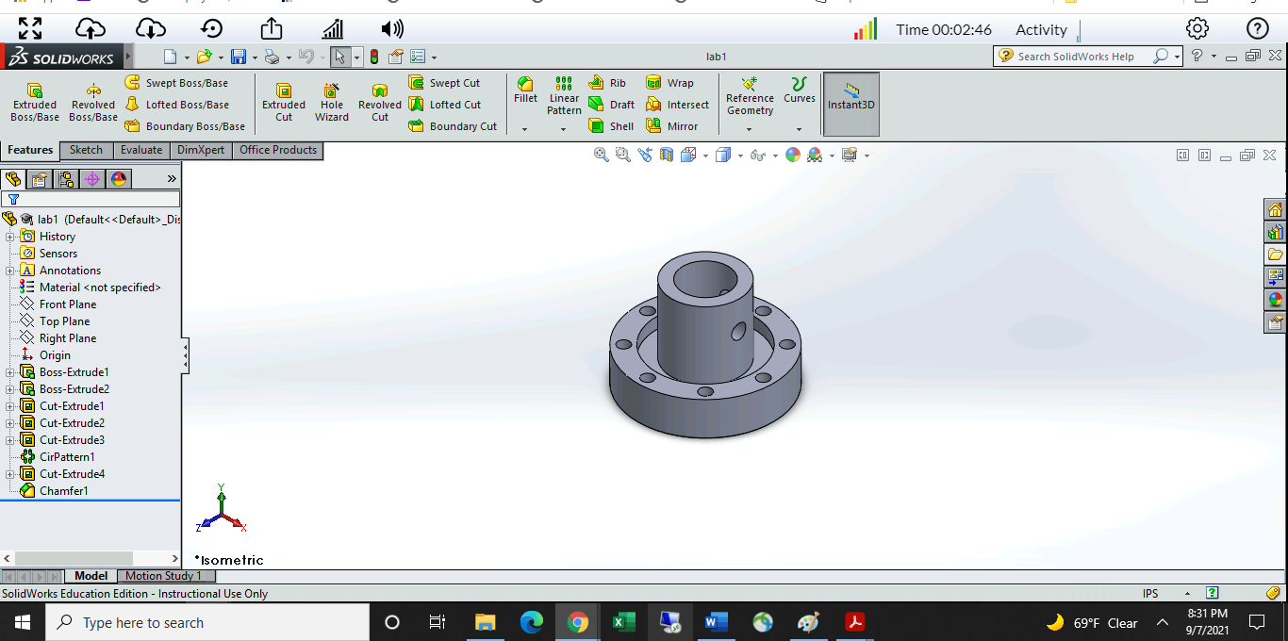
Fig2. Basic Solidworks Model
Calculations:
There were no calculations necessary for this assignment.

Analysis of Results:
My hypothesis was correct. In other words, I was able to learn more about the basics of Matlab and Solidworks by completing this Lab Assignment

Sources of Error:
I had some trouble with accessing Solidworks and Matlab, but eventually I was able to get access using the Apporto Remote Desktop Access.
Conclusion:
This introductory assignment help me familiarize/refamiliarize myself with the software that we’ll be learning in this course. I was able to complete the assignment of being able to create a basic model in both Matlab and Solidworks. I had a little trouble and spent a little more time on this assignment than I wanted to, but I got a lot out of it. I’m looking forward to the learning more about how to use both Matlab and Solidworks!

