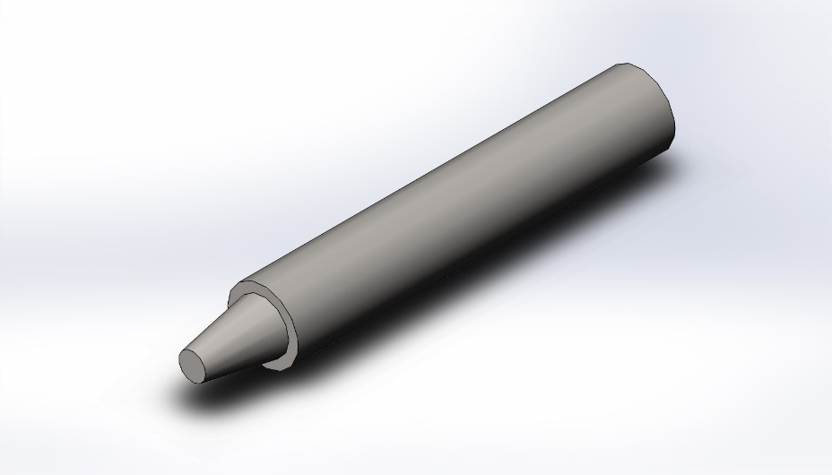 | Simulation of shaft  Date: Tuesday, October 31, 2017  Designer: Solidworks  Study name: SimulationXpress Study  Analysis type: Static  Table of Contents  Description 1  Assumptions 2  Model Information 2  Material Properties 3  Loads and Fixtures 3  Mesh information 4  Study Results 6  Conclusion 9

Description
Stress
https://www.solidworks.com/product/solidworks-simulation

Assumptions

Model Information

Model name: shaft
Current Configuration: Default
Solid Bodies
Document Name and Reference | Treated As | Volumetric Properties | Document Path/Date Modified
Boss-Extrude1 | Solid Body | Mass:0.239454 kg  Volume:3.06992e-005 m^3  Density:7800 kg/m^3  Weight:2.34665 N | E:\Documents\MECH3550\EDU_Simulation_Model_Files_2015\Inital Files\EDU_Simulation_Initial_Model_Files_2014\spider\shaft.SLDPRT  Oct 31 17:18:44 2017

Material Properties
Model Reference | Properties | Components
 | Name: Plain Carbon Steel  Model type: Linear Elastic Isotropic  Default failure criterion: Unknown  Yield strength: 2.20594e+008 N/m^2  Tensile strength: 3.99826e+008 N/m^2 | SolidBody 1(Boss-Extrude1)(shaft)

Loads and Fixtures
Fixture name | Fixture Image | Fixture Details
Fixed-1 |  | Entities: 1 face(s)  Type: Fixed Geometry

Load name | Load Image | Load Details
Force-1 |  | Entities: 1 face(s)  Type: Apply normal force  Value: 0.001 N

Mesh information
Mesh type | Solid Mesh
Mesher Used: | Standard mesh
Automatic Transition: | Off
Include Mesh Auto Loops: | Off
Jacobian points | 4 Points
Element Size | 0.123318 in
Tolerance | 0.00616589 in
Mesh Quality | High

Mesh information - Details
Total Nodes | 10012
Total Elements | 6392
Maximum Aspect Ratio | 3.1094
% of elements with Aspect Ratio < 3 | 100
% of elements with Aspect Ratio > 10 | 0
% of distorted elements(Jacobian) | 0
Time to complete mesh(hh;mm;ss): | 00:00:01
Computer name: | V530SOZLEK

Study Results

Name | Type | Min | Max
Stress | VON: von Mises Stress | 2.17053e-007 N/m^2  Node: 3645 | 1.47441 N/m^2  Node: 997
shaft-SimulationXpress Study-Stress-Stress

Name | Type | Min | Max
Displacement | URES: Resultant Displacement | 0 mm  Node: 63 | 4.72346e-011 mm  Node: 9682
shaft-SimulationXpress Study-Displacement-Displacement

Name | Type
Deformation | Deformed shape
shaft-SimulationXpress Study-Displacement-Deformation

Name | Type | Min | Max
Factor of Safety | Max von Mises Stress | 1.49615e+008  Node: 997 | 1.01631e+015  Node: 3645
shaft-SimulationXpress Study-Factor of Safety-Factor of Safety

Conclusion

