Sunny Lee
City Tech
SBS 3201
T Shirt Submission

Learning yourself within takes time, development of confidence and knowing exactly who you are. In society appearance represents more than you know. Ones knowing it all starts with dress. Growing up in the Bronx wasn’t such a pretty place but it was a major influence of how I developed my own sense of identity. Knowing myself, developing character, viewing a sense of knowledge by viewing situations helped me understand who I was and where I wanted to be in this life. Who am I in gender dress and society? The first step is establishing myself, growing as a person, acquiring confidence, and using clothing to convey my uniqueness and personality is choosing what to wear. Even though I identify as a woman, I always tried to display my femininity through dress, but I also felt very confident when I expressed myself in a masculine manner while still being true to who I am.
My shirt represents the origins of clothing and its motivations. The flowers stand in for my modest family of five, and Soho is where I first fell in love with dressing and caring for my appearance. In my opinion, love is the only thing that matters. My birth and upbringing in the Bronx hold particular significance for me, as it was the site of numerous struggles, traumas, and acts of bravery. A narrowed waist symbolizes my accentuated hips, a change in my physique that I struggled to accept but ultimately came to love and value. The white shirt was changed to a tie died It was great to use natural berries for Pink because it reminded me of my roots which is to have the ability to create something out of nothing. Pink was a joyful color to wear and made me feel most beautiful growing up, So I decided to revise the color of my shirt to add modesty. At the same time, it was a safe color to wear to preserve my innocence and to highlight my sexuality and skin tone.
Over all “Social structures typically arise within any society to integrate kinship, economic, religious and political activities.”(Higgins & Eitcher ,N.D) It indicates that one's social status is shaped by one's family, religion, and economic standing. You become one by recognizing and appreciating who you really are. Navigating through society requires an understanding of oneself, one's background, and the people one surrounds oneself with. Understanding the origins of someone's values and ideas, together with accepting and appreciating them for them, aids in understanding.

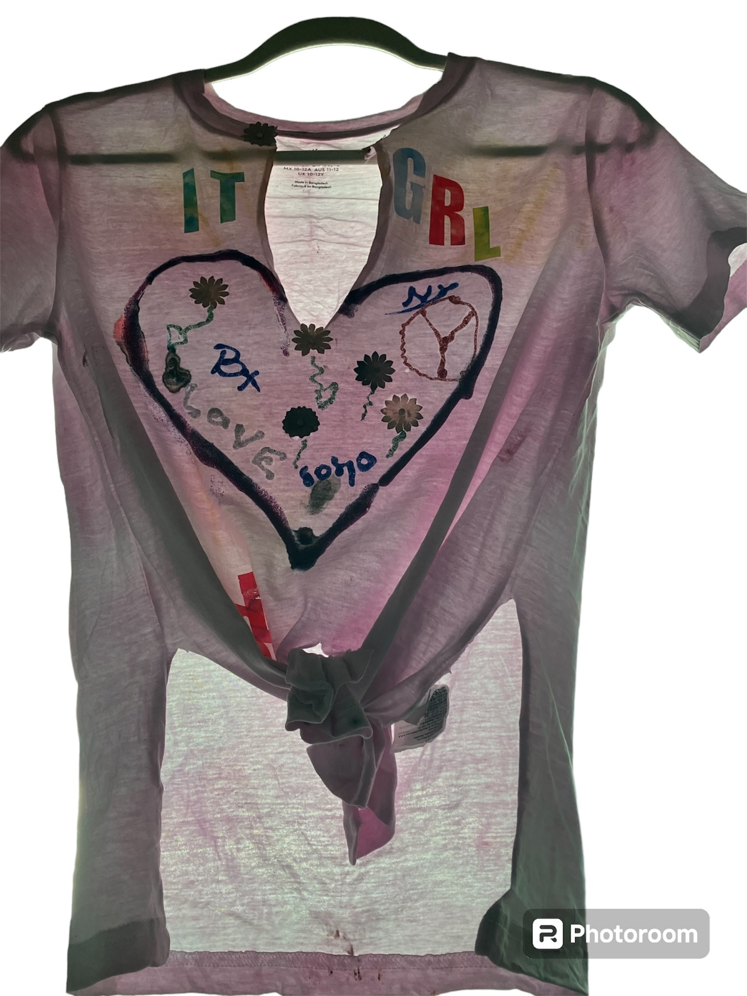
Font of T shirt

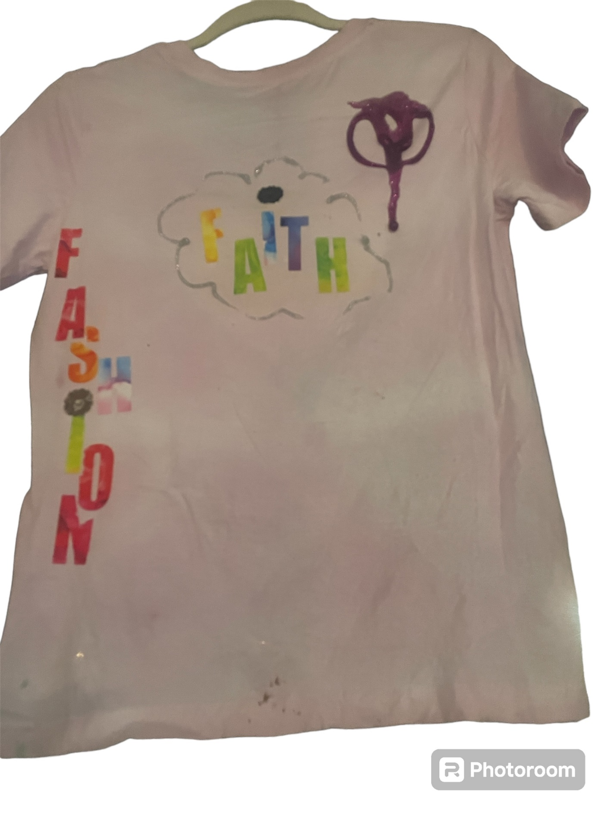
Back of Shirt

