Binyu. Sun (Sunny)
3/28/2016
CDMG1111 E450
Professor Koening
The Evolution of PlayStation Logo
PlayStation has a rich history and a special place in many people’s hearts. Ever since the 90s PlayStation has revolutionized the gaming industry. They have now become one of the largest and most successful brands worldwide in the gaming industry and consumer electronics. It was first known to people by the flat colorful logo of a red P overlapping on an S that is contains yellow, green and blue. The logo was very inventive at the time when it was first introduced to the audience, and even now, still leaves a mark on people's memory. PlayStation has evolved a ton since it first went on market and the logo evolved with them.
PlayStation video game division of Sony Computer Entertainment from Japan. PlayStation has many names under its title. The most famous ones are the original PlayStation following with the PlayStation 2, PlayStation 3, last but not least, the next gen system PlayStation 4. The PlayStation logo along other logos like Nintendo and Microsoft Xbox icon was the logo everyone can recognize easily when it comes to gaming. The logo changed with every one of them. While in the logo itself it always kept the essence of its original design. The typography changed with the system every time they upgrade.
The first PlayStation system was shown to others on the December of 1994, and it's been twenty-one years. The play stations logo was designed by famous Japanese designer Manabu Sakamoto who also designed a few other logos for Sony, includes the Sony computers VIAO logo. It was first used as the vector graphic with the polygon shapes of the 4 colors in its design. (Figure 1)The font it was used for this PlayStation log was called “Zrnic”. The PlayStation logo did not just get on the system as the only logo concept at the time, needless to say they went through two dozens different designs before they decided to use one that the one they are using now. (Figure 2)
The PlayStation 2, was released in 2000. The PlayStation 2 is the best-selling home console to date, having reached over 155 million units sold as of December 28, 2012. The PlayStation 2 logo features a more rectilinear Shape design that gives us a visual of “PS2”. This is also very similar to the PSP design on the handheld portable gaming device in the PlayStation family. Although no specific designer for the logo was credited for the logo, it is most likely the the creator for the PlayStation system it self Ken Kutaragi “The father of PlayStation”. The font they used for the logo was called “BTSE PS2” (Figure 3)
PlayStation 3 logo has a more curvilinear shape that makes up the characters of PS3, however PlayStation 3 has changed through multiple phases, it has changed 3 time since it first launched. The logo was first shown to gamer as the PlayStation 3 “Spider-Man 3” Font (Figure 4) in 2006, due to the visibility of the text PlayStation 3 being too long and looks tiny they changed it to a shorter Spider Man-3 font PS3. "On a practical level, when you have PlayStation 3 spelt out, the aspect ratio was such that if you wanted it on a billboard it became tiny," Hirai said. "It didn't work in terms of visibility." On 2009 they finally changed it back again to a gentler shape, more reminiscent of Sony's earlier logos for the PS2 and PSP (though slightly more rounded). (Figure5)
PlayStation 4 was launched on November 15, 2013 in North America, and November 29, 2013 in Europe, South America and Australia, and February 22, 2014 in Japan. PlayStation 4 takes elements from the PS3 logo and combines it with the nostalgia of its original PlayStation 1 logo. This new logo would feature a simple black and white color scheme for the logo. PlayStation 4 font is the same as the last logo PlayStation 3 used, and the name of the font is “PhatBoy Slim”. PlayStation 4 is currently the ongoing gaming console under Sony Computer Entertainment right now.
PlayStation is the best selling gaming console there is thus far. It shouldn’t be a surprise if PlayStation continually making history. The PlayStation logo is a major part of the modern days cultural phenomenon. It has been seen and memorized by so many people, also so many people that lived in the 90s can relate to it. Lets never forget what kind of impact PlayStation had made in the cyber world as well as the real world.
Figure 1
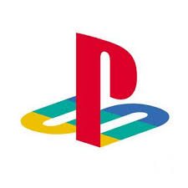
Figure 2
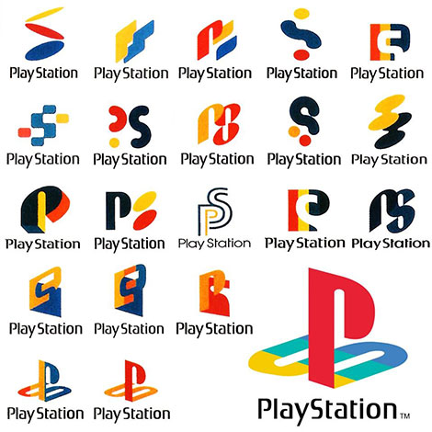
Figure 3
Figure 4
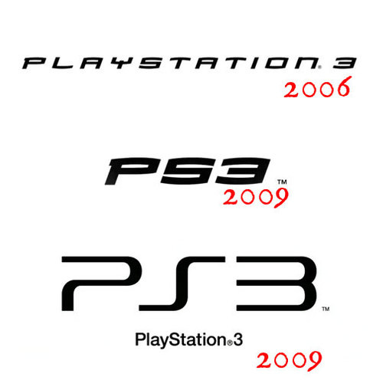
Figure 5
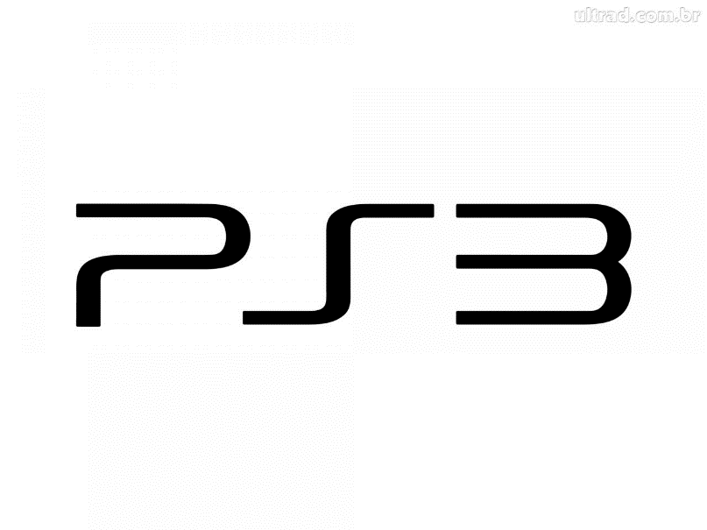
Work Cited
"Brand Identity: The Gaming Edition." Brand Identity: The Gaming Edition. N.p., n.d. Web. 05 Apr. 2016.
"PlayStation." Wikipedia. Wikimedia Foundation, n.d. Web. 05 Apr. 2016.
"PlayStation Logo - Design and History of PlayStation Logo." Logo Design Blog RSS. N.p., n.d. Web. 05 Apr. 2016.
"PlayStation 2" Wikipedia. Wikimedia Foundation, n.d. Web. 05 Apr. 2016.
"PlayStation 3." Wikipedia. Wikimedia Foundation, n.d. Web. 05 Apr. 2016.
"PlayStation 4." Wikipedia. Wikimedia Foundation, n.d. Web. 05 Apr. 2016.
"Sony Completely Rebrands The PlayStation 3." Kotaku. N.p., n.d. Web. 05 Apr. 2016.
"Why Sony Ditched The Spider-Man PS3 Font." Kotaku. N.p., n.d. Web. 05 Apr. 2016.

“The PlayStation ®Story” PlayStation.N.P.,N.D.Web. 23 Feb. 2016.

