NEW YORK CITY COLLEGE OF TECHNOLOGY

TCET TELECOMMUNICATION ENGINEER DEPARTMENT

TCET 2220: TRANSMISSION SYSTEM

PROFESSOR: VIVIANA VLADUTESCU
SMITH CHART

FINAL PROJECT BY SALAM SECK

Project 1
Guidelines: Please type all the solutions! For the Smith Chart use Tools/ Typewriter to inset symbols or text. Email and UPLOAD your project 1 on your ePortfolio. In addition to this poject you also need to upload Project 2 and the reflections on the seminars/workshops/field trips, and email them to me.
- A 0.334λ long Z₀=50 Ω T-line is terminated in a load Z_{L}=100-j100 Ω. Calculate and use the Smith Chart to find:
a)Γ_{L};

z_{L} = $\frac{ZL}{Z0 }$ = $\frac{100-J100}{50 }$ = 2 – j2 $Ω$

Γ_{L} = 0.62; we determined it from the graph by projecting along the RADIALLY SCALED PARAMETERS.

b)VSWR;

From the same projection also we did find that the VSWR is equal to 4.25 (VSWR = 4.25).

c)Z_{in} seen by the source.

Z_{in} = (0.55 + j0.89) = 27.5 + j44.5$Ω$

- Suppose a Z₀=50 Ω T-line is is terminated in a 100 Ω load. Determine the aquired impedance of a quarter-wave matching section of T-line.

Find Z₁: Z₁ = $\sqrt{Z0 ZL}$ = $\sqrt{50 x 100}$ = 70.71Ω

- Suppose a 50 Ω coaxial cable made with a Teflon dielectric, that must operate at 800MHz T-line is terminated in a Z_{L}=10-j15 Ω. Use the Smith Chart to
- Create a matching network by adding a reactive element at a suitable location along the T-line:

Z_{L} = 10 – j15Ω
F = 800MHz
Z₀ = R₀ = 50Ω

z_{L} = $\frac{ZL}{Z0}$ = $\frac{10-j15}{50}$ = 0.2 – j0.3Ω

- determine the length of the coaxial line between the load and the capacitor:
y_{new} = 1 - j1.95
d= 0.314λ – 0.201λ= 0.113λ
l= 0.5λ – 0.314λ = 0.186λ + 0.186λ = 0.372λ
- determine the value of the series capacitor added to provide an impedance match:
1.95j = X_{c}
1.95j = $\frac{j}{wc}$
1.95j = $\frac{j}{2πfc}$
1.95 = $\frac{1}{2πfc}$
C = $\frac{1}{1.95 (2π\left(800MHz\right))}$
C = 1.02pf
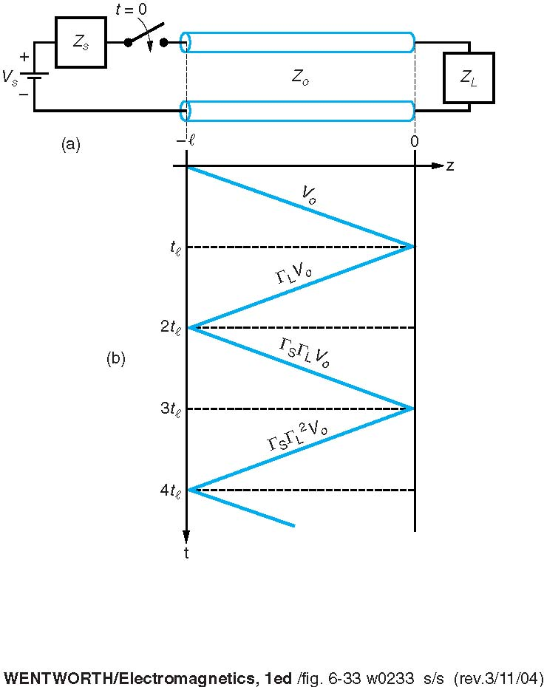
- You would like to match a 170Ω load to a 50 Ω T-Line.
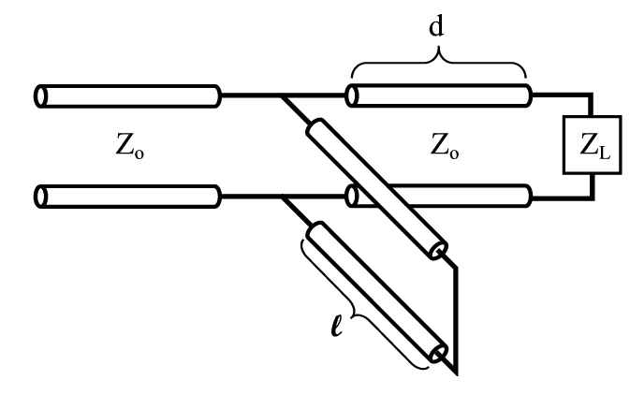

(a) Determine the characteristic impedance required for a quarter-wave transformer.
R¹₀ = $\sqrt{50 x 170 }$ = 92.19Ω
Zs = 92.19 [$\frac{170+j92.19\tan{(\frac{π}{2})}}{92.19+j170\tan{(\frac{π}{2})}}$]
Zs = 42.66Ω
- Consider a 6 cm long 75 Ω transmission line terminated in a 125 Ω load and having a matched source impedance (Z_{s} = 25 Ω). Propagation velocity on the T-Line is 0.1c. The source is a 0.4 ns square pulse of amplitude 4V.
V⁺₁ = $\frac{V0 Z0}{Zs+Z0}$ = $\frac{\left(4 \right)(125)}{25+125}$ = 3.33V
V_{L} = $\frac{\left(V +1\right)\left(1+ ΓL\right)}{1-(Γs ΓL)}$ = $\frac{\left(3.33\right)(1+0.62)}{1-0}$ = 5.39V
V⁻₁= (V⁺₁) ($ΓL)$ = (3.33) (0.62) = 2.06V
VOLTAGE STEADY STATE IS:
V⁺₁ + V⁻₁ = 3.33V + 2.06V = 5.39V

