NEW YORK CITY COLLEGE OF TECHNOLOGY

TCET TELECOMMUNICATION ENGINEER DEPARTMENT

TCET 2220: TRANSMISSION SYSTEM

PROFESSOR: VIVIANA VLADUTESCU
SMITH CHART

FINAL PROJECT BY SALAM SECK

Project 1
Guidelines: Please type all the solutions! For the Smith Chart use Tools/ Typewriter to inset symbols or text. Email and UPLOAD your project 1 on your ePortfolio. In addition to this poject you also need to upload Project 2 and the reflections on the seminars/workshops/field trips, and email them to me.
- A 0.334λ long Z₀=50 Ω T-line is terminated in a load Z_{L}=100-j100 Ω. Calculate and use the Smith Chart to find:
a)Γ_{L};

z_{L} = $\frac{ZL}{Z0 }$ = $\frac{100-J100}{50 }$ = 2 – j2 $Ω$ the value is shown in P1 on the Smith chart, and the operating circle in then constructed.
The initial coordinate on the ‘’ Wavelengths toward generator’’ scale is about 0.291λ. We must rotate clockwise by 0.35λ, so this would call for a final coordinate of 0.291λ + 0.35λ = 0.641λ. However, this value exceeds 0.5λ, so we subtract 0.5λ to obtain a coordinate of 0.641λ – 0.5λ = 0.141λ. The corresponding point is P2 on the Smith chart. The value of the impedance is read as: z_{in} =0.55 + j1.18

The VSWR is read from the intersection of the operating circle with the right half of the real line and is approximately: S = 4.4

The magnitude of the reflection coefficient is determined as:
𝝘_{L} = $\frac{S-1}{S+1}= \frac{4.4-1}{4.4+1}=0.63$
The angle of the reflection coefficient at the load is about -30⁰. Thus, the reflection coefficient at the load is about: 𝝘’_{L} = 0.63˪-30⁰ = [($\frac{\left(-30\right)(π)}{180}$) = -0.523]
𝝘’_{L} = 0.63˪-0.523; where the latter angle is -0.523rad.

b)VSWR;

The VSWR is read from the intersection of the operating circle with the right half of the real line and is approximately: S = 4.4

c)Z_{in} seen by the source.

The corresponding actual impedance is:
Z_{in} = (50) (0.55 + j1.18) = 27.5 + j59$Ω$

- Suppose a Z₀=50 Ω T-line is is terminated in a 100 Ω load. Determine the aquired impedance of a quarter-wave matching section of T-line.

Find Z₁: Z₁ = $\sqrt{Z0 x ZL}$ = $\sqrt{50 x 100}$ = 70.71Ω

- Suppose a 50 Ω coaxial cable made with a Teflon dielectric, that must operate at 800MHz T-line is terminated in a Z_{L}=10 - j15 Ω. Use the Smith Chart to
- Create a matching network by adding a reactive element at a suitable location along the T-line:

Z_{L} = 10 – j15Ω
F = 800MHz
Z₀ = R₀ = 50Ω

z_{L} = $\frac{ZL}{Z0}$ = $\frac{10-j15}{50}$ = 0.2 – j0.3Ω

- determine the length of the coaxial line between the load and the capacitor:
At point P3, the normalized addmitance is about y_{new} = 1 - j1.58
The required value of admittance for the stub P4 is y_{new} = + j1.58

d = 0.5λ – 0.291λ= 0.209λ + 0.141λ = 0.35 λ
l = 0.178λ – 0.141λ = 0.036λ
- determine the value of the series capacitor added to provide an impedance match:
1.58j = X_{c}
1.58j = $\frac{j}{wc}$
1.58j = $\frac{j}{2πfc}$
1.58 = $\frac{1}{2πfc}$
C = $\frac{1}{1.58 (2π\left(800MHz\right))}$
C = 1.26pf
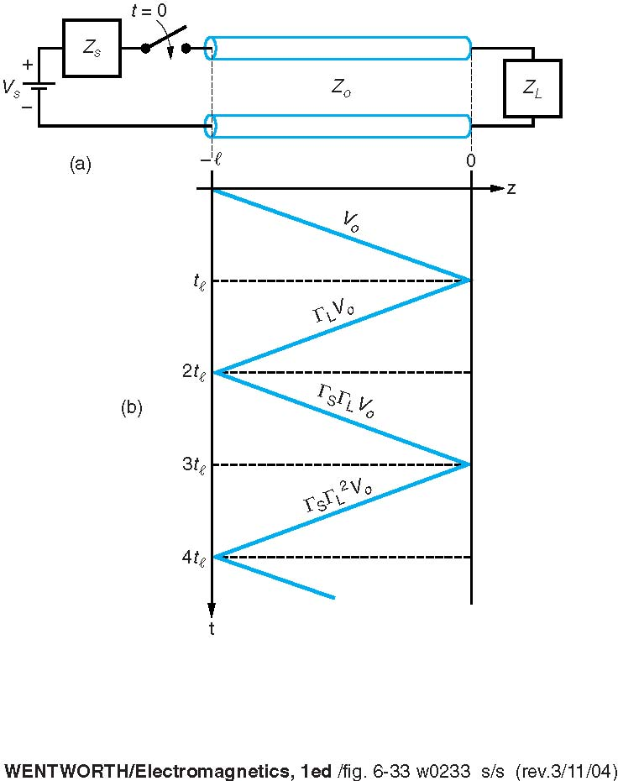
- You would like to match a 170Ω load to a 50 Ω T-Line.
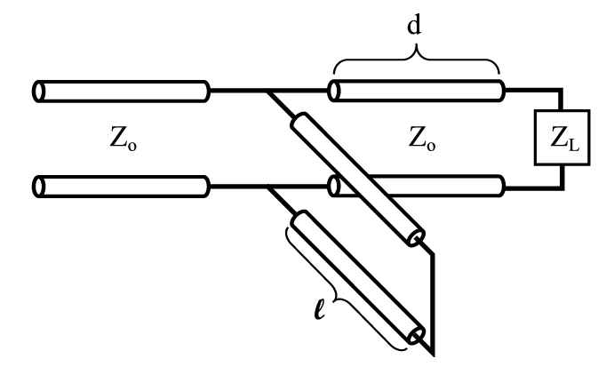

(a) Determine the characteristic impedance required for a quarter-wave transformer.

R¹₀ = $\sqrt{50 x 170 }$ = 92.19Ω
Zs = 92.19 [$\frac{170+j92.19\tan{(\frac{π}{2})}}{92.19+j170\tan{(\frac{π}{2})}}$]
Zs = 42.66Ω
- Consider a 6 cm long 75 Ω transmission line terminated in a 125 Ω load and having a matched source impedance (Z_{s} = 25 Ω). Propagation velocity on the T-Line is 0.1c. The source is a 0.4 ns square pulse of amplitude 4V.
V⁺₁ = $\frac{V0 Z0}{Zs+Z0}$ = $\frac{\left(4 \right)(125)}{25+125}$ = 3.33V
V_{L} = $\frac{\left(V +1\right)\left(1+ ΓL\right)}{1-(Γs ΓL)}$ = $\frac{\left(3.33\right)(1+0.62)}{1-0}$ = 5.39V
V⁻₁= (V⁺₁) ($ΓL)$ = (3.33) (0.62) = 2.06V
VOLTAGE STEADY STATE IS:
V⁺₁ + V⁻₁ = 3.33V + 2.06V = 5.39V

