INTRODUCTION TO LOAD-PULL SYSTEMS
AND THEIR APPLICATIONS

TCET2220: TRNASMISSION SYSREM

NAME: SALAM SECK
PROFESSOR: V. VLADUTESCU

The main goal of a load pull is to measure the response of a device as a function of load impedance. If we considering our DUT as a two-port device, Γ_{L} is nothing more than a2/b2, or the ratio between the reflected and forward traveling waves. Load-pull is an informal term which can be applied to process a systematical variation of impedance presented to a device under test (DUT), most often a transistor, to set an estimate value in a network. When the load-pull itself implies impedance variation at the load port, impedance can also be varied at any of the ports of the DUT, most often at the source. If we used it in conjunction with a signal source and signal analyzer (spectrum analyzer, power meter, vector receiver), we will see that load pull can be used to measure parameters such as output power, gain, efficiency as a function of load impedance presented to the DUT.
As we can notice, Load-pull can be used when superposition breaks down, which occurs, for example, under large-signal operating conditions associated with substantial harmonic generation or other manifestations of nonlinearity. The etymology of load-pull derives from classical oscillator characterization whereupon variation of the load impedance pulls the oscillation center frequency away from nominal. Load pull is the most common method globally used for RF and microwave power amplifier design. Source-pull is also used for noise characterization but requires multiple impedances to be presented at the source to enable simultaneous solution of an over-determined system that yields the four noise parameters. This device helps provides the measurement in term of a reflection coefficient at the load-port of transistor devices. The source and load boxes contain motor driven capacitors that move along transmission lines to present any point on the Smith chart to the Device. Computer control of the motors and data collection, and computer processing of the collected data has made this process much more useful years ago. Impedance transformation networks between the DUT and the tuner enhance the reflection coefficient tuning range, and reduce the generated VSWR. In measurement applications, the load pulling of a device is initially carried out to identify the Smith chart region and then to select an appropriate impedance transformer for the DUT, as well as a line stretcher between the device and the impedance transformer. By selecting the impedance transformer and the line stretcher, we see that the system has two degrees of freedom, namely the passive tuner and the active load-pull source. However, the passive tuner is first tuned appropriately to create a mismatch between the circulator and the impedance transformer and the load-pull measurements are then performed using the load-pull source. The mismatch created by the passive tuner reduces the power demand from the load-pull source and, therefore, helps in the optimal operation of the hybrid load-pull system. Thus, passive tuners with good resolution in magnitude and phase variation are extremely important to reduce passive load-pull from the load-pull source. Therefore, we can concluded that a hybrid load-pull system with an appropriate impedance transformer and a high-resolution passive tuner is very useful for high-power DUT load-pull measurement. As it minimizes the passive load-pull demand from the load-pull source, it also reduces the VSWR and the voltage peak in the measurement system. Whereas, the active closed loop methodology uses and phase shifted, amplified version of b2 as the reflected signal a2. To accomplish this, a coupler or circulator is used to direct the signal (b2) from the DUT through a variable amplification stage, with control of both magnitude and phase, and then re-injecting the signal as a2 back into the device. The figure.1 below shows the basic block diagram for a typical closed-loop fundamental tuning system.

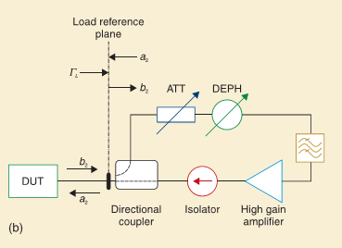
Fig.1 The active closed-loop load-pull technique.
There are several advantages to this technique over traditional mechanical load- pull tuners including speed, and ease of integration especially in on-wafer measurement systems. Since the system relies on electrical tuning with no moving mechanical parts, tuning can be fast and the amplifier within the closed-loop configuration can be used to increase a2 to measure the unity of the DUT’s reference plane. On the negative side, oscillations can occur in an active closed-loop load-pull system due to leakage from passive components. Filtering also can be used to reduce the chance of occurrences, but this can only make the system to approach a narrow band. For the hybrid load-pull system shows in figure. 2, it offers us to have the advantages of passive and active load-pull approaches when we have the potential to minimize the disadvantages of both. Hybrid load pull refers to a combination of active and passive tuning within the same system.
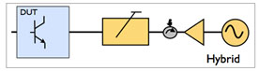
Fig.2. Hybrid load-pull
Traditional passive mechanical tuners can be used to reflect high power at the fundamental frequency allowing a much smaller active injection signal, using much smaller amplifiers to determine the system losses. Since the power levels of harmonic frequencies are often well below the power of the fundamental signal, lower power amplifiers can be used with active tuning to accomplish active harmonic load pull. Both cases require only low power levels for active tuning. One thing to remember is that, such systems can typically have the same problems of controlling the band impedance with potential stability issues. In contrast to the pre-matched and enhanced loop load-pull techniques, the impedance transforming network based load-pull setups do not experience bad lowering in the tuning range and the measurement accuracy caused by the adapters and the insertion loss of the fixture. This is achieved due to the reduced Smith chart region in which the reflection coefficients need to be synthesized. In principle, the quarter wave (λ/4) transformer technique is a special type of pre-matched load-pull system, where the enhancement in the reflection coefficient tuning range is obtained through the incorporation of a λ/4 impedance transformer between the DUT and the tuner. The quarter wave moves the matched impedance environment from 50 Ω to some other smaller value as shown in the figure 3. It can be observed that the maximum achievable reflection coefficient before impedance transformation is smaller with the matched condition at point ‘a’ in the Smith chart.Whereas, the incorporation of a λ/4 transformer transforms the matched condition to point ‘c’ in the Smith chart, which results in an enhanced tuning range, albeit with reduced Smith chart coverage. It should be noted that the 50 Ω line provides the match between the quarter wave transformer and the load-pull tuner.
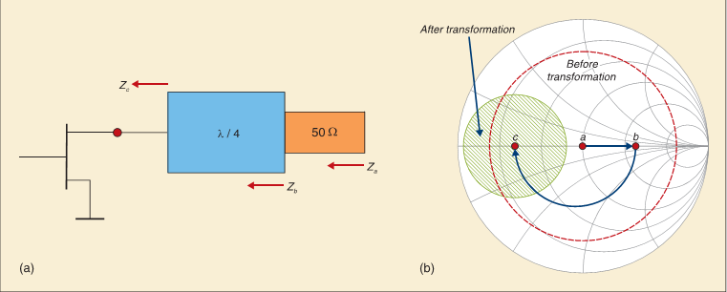
Fig.3. Pictorial representation of the quarter wave transformation technique (© IEEE 2011, IEEE Microwave Mag., used with permission, [5]).
The transformer of the measurement system’s impedance toward smaller value results in a reduced of the impedance mismatched between the load-pull system and the DUT, which reduces the VSWR and, hence, any potential damage to the DUT for the measurement of the system. The λ/4 transformer technique serves the dual purpose of VSWR reduction and tuning range enhancement. In addition, the reduced impedance mismatch which existed between the tuner and the DUT reduced the passive load-pull requirement in the case of active load-pull setups. We can take a note that the improvement in the tuning range and the reduction in the VSWR, which come at the cost of reducing the Smith chart necessities of replacing the λ/4 transformer. This results into additional hardware and calibration, which eventually increases size, cost and measurement time. Furthermore, the narrow band of a λ/4 transformer limits the usefulness of such systems in fundamental load-pull characterizations and measurements of high-power DUTs. Limitations of the quarter wave impedance transforming network, whose bandwidth are 5 to 10 percent of the carrier frequency presents harmonic load-pull applications, can overcome through the incorporation of a broadband impedance transformer, such as the ‘’Klopfenstein’’ with bandwidth covering from nearly 100 MHz to 12 GHz, between the DUT and the tuner. The broadband impedance transformer does reduce Smith chart coverage with increasing impedance transformation ratios, as we can see in the figure 4, but this also results into increased accuracy in the load-pull measurements due to the reduction of the impedance mismatch between the DUT and the tuner. Further, the broadband impedance transformer incorporation in the load-pull setup not only enhances the maximum achievable reflection coefficient, but also reduces the VSWR in both the active as well as passive load-pull systems. The reduced Smith chart coverage sometimes requires very careful selection of impedance transformers, because if the chosen impedance transformer precludes the Smith chart region where the optimal reflection coefficient for a specified DUT lies, then the very purpose of this entire process of impedance transformer incorporation gets negated. This is especially important for high impedance transformer ratios, because the smaller the impedance, the higher is the measurement sensitivity. It helps to the identification of the Smith chart region and, hence, in the selection of the impedance transformer ratio. The impedance transformer networks between the DUT and the tuner enhance the refection coefficient tuning range, as can be seen in figure 3, above and figure 4, below and reduce the generated VSWR and required passive load-pull in the load-pull systems.
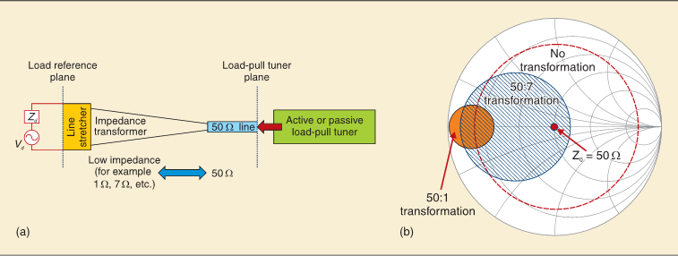
Fig.4. Conceptual representation of broadband impedance transformer based load-pull setup (© IEEE 2010, IEEE Microwave Mag., used with permission, [5]).
This section describes and quantifies the impact of Klopfenstein taper incorporation in an open-loop active load-pull setup, using a generic model that is depicted in figure 4, below. It is important to note that, although the analysis is based on an open-loop active load-pull system, it is also valid for other load-pull approaches in the load pull model. The DUT is represented by an equivalent voltage source, V_{d,} and a series impedances, Z_{d} , that is connected to the larger geometry and, hence, the smaller impedance of the impedance transformer. The circulator is connected to the smaller geometry having 50 Ω impedance. The line stretcher between the impedance transformer and the DUT adjusts the phase of the reflection coefficients in order to achieve the appropriate matching condition to minimize the required load-pull power. The parameter Γ_{d} represents the reflection coefficient at the DUT plane, Γ the transformer ratio of the impedance transformer, Γ_{lp} the synthesized reflection coefficient at the load-pull plane, and Γ_{Syst} the system reflection coefficient arising due to mismatch between the circulator and the smaller geometry of the impedance transformer. Active load pull relies on external sources to inject a signal into the output of the DUT, thereby creating a2. Because when a2 is no longer limited to a fraction of the original reflected signal, as is the case with the traditional passive mechanical tuner, the external amplifiers may be used to increase a2 nearly indefinitely so that Γ_{L} can achieve unity (Γ_{L}>1 is theoretically possible but has no practical consideration). The operating methodology of the envelope load-pull concept system is similar to the active closed-loop active load-pull technique. The major difference between the two techniques is the manner in which the traveling wave is modified before being fed back for the synthesis of the desired reflection coefficient at the DUT reference plane. The envelope load-pull utilizes external control variables for X and Y to modify the phase and amplitude of the reflected traveling wave, a₂, as shown in figure.4. Thus, we see that in envelope load-loop system, the modification in the forward traveling wave and then its feedback to the device takes place at the baseband or at an intermediate frequency, which shields the system from any oscillation at the carrier RF frequency. Figure.4. shows a generic block diagram of the ELP (envelope load-pull) system which consist of a quadrature demodulator that down-converts the incident traveling wave into baseband signals, a control unit that modifies the baseband signal components generated by the quadrature demodulator through external control variables X and Y, a quadrature modulator that up-converts the modified baseband signal components, and a local oscillator ( LO) that provides the desired signal to the quadrature demodulator and modulator.
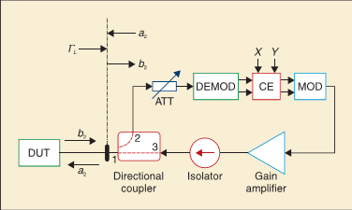
Fig. 4. A generic setup architecture of the active envelope load-pull technique.

We can conclude that, the article which was presented about the load-pull concept and its usefulness in modern wireless power amplifier design. Load pull analysis is used to construct a set of contours (typically on a Smith Chart), which determine the maximum power output achievable with a given load impedance. These contours are very useful in assessing the actual impedance a device should see when it is used in an amplifier. It subsequently reviewed the most common load-pull techniques along with their advantages and limitations. The article discussed two of the latest developments in load-pull configurations which have either brought or have the potential to bring a paradigm shift in PA design techniques.

References:
- Load-pull Techniques with Applications to Power Amplifier Design By Fadhel M. Ghannouchi, Mohammad S. Hashmi.
- Load-pull Techniques with Applications to Power Amplifier Design – Fadhel M. Ghannouchi, Mohammad S. Hashmi – Google Books.
- Load- pull system pros and cons / Tek Talk.
- Maury Microwave/ MW & RF device characterization Solutions/ Active & Hybrid Load-Pull.
- Microwave journal Frequency Matters/ Load pull system pros and cons.
- Mohammad S. Hashmi and Fadhel M. Ghannouchi/ IEEE Instrumentation & Measurement Magazine/ 1094-6969/13/$25.00©2013IEEE/ February 2013
- http://en.wikipedia.org/wiki/Load_pull.
- www.microwaves101.com/encyclopedia/loadpull.cfm
- cp.literature.agilent.com/litweb/pdf/5990-7639EN.pdf‎
- http://www.rfglobalnet.com/doc/Demo-Maury-Microwaves-Mixed-Signal-Active-Loa-0001.

