Graphic Designer

Being very interested in starting a YouTube channel , I realized that I couldn’t just have a channel with no type of designs on it at all. I started searching the web to find someone who’s artwork caught my eye as I would scroll through. Since there are alot of social media apps such as Facebook , Twitter and Instagram. It helped me find this talented person who goes by the name of “PRINCE”. He has been doing freelance graphic designing for over 6+ years and mainly only works with photoshop. I found him on twitter and he was making graphic designs for big people in the youtube industry and all of his artwork caught my eye. I remember seeing this one logo that he had made for someone and knew that he would be the perfect person to make a branding for me ( logo , banner and etc).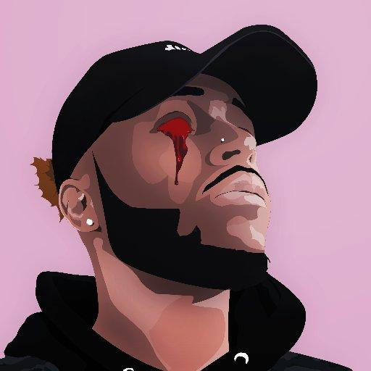

This was something that I have never seen anyone ever do before so it was pretty much interesting when I saw him make this. That picture that he made was done in Illustrator. He is honestly the reason why I wanted to become a graphic designer. The work that he made for people is for a YouTuber who is big for gaming named Ali-A. This YouTuber has over 15 Million Subscribers which is a huge number for a lot of people to watch someone play games. When I contacted the designer he was a very amazing person to talk to and his prices were not bad. For a branding he would charge $80 when he had just started off making a name for himself. Once you purchased from him , he would ask all questions that would help him with his design to help make the best thing for you. He would want to know certain things like color , things that the channel contains and things that I had liked. Once he would send you his work and you did not like how it came out he would make arrangements to the work until his customer was completely satisfied.

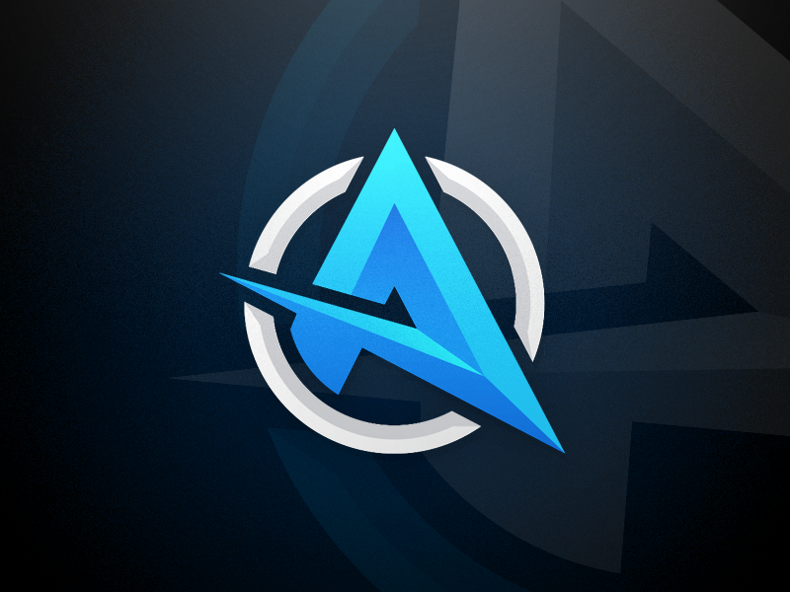

Ali=A Logo 2013

Since his work started doing very well his prices had went up and he took his work to a different website which would help him get acknowledged more by other people to see his work and his prices. He works on a site called [fiverr.com](https://www.fiverr.com/) and the way they work is that you could post a gig for people to purchase there needs. When he first started off he started at $5 for just a profile picture , then $30 for a logo. The time for him to get the work done was 1 day since he had no clients like that and he could just do the work on the spot. He still works on making branding for people and can also make custom work if you ask him too. At first when he started he would have little bit of clients such as 1-4 every week. After 6 months he started growing very big that everyone who was in the YouTube and Twitch world decided that he was the person to go to. He made his base price from $5 go to $20 , he also ended up changing how long it would take him to finish work and now he has it that delivery could take up to about 14 days and sometimes earlier if he can finish all the work that he is given.

Becoming such a big person on the site Fiverr , he has gotten over 1,000 reviews from other users and they have all given him a 5 star rating making sure that he is responding to the users and also making sure the work is coming out how they want it to. If you want him to finish your work in a day's worth , it will cost double the price. In overall , this is one of my favorite designers and one of the first people that I ever followed up with on they’re designs. I continuously still talk to him about this day and he tells me how business is going for him and the site. He said it could get frustrating when he has to many orders in queue because he can have 5 due the same day and 10 due the next 2 days. He does plan on growing out and doing bigger things but right now this is something that he feels is good enough for him until he feel like he's ready to work a big project.

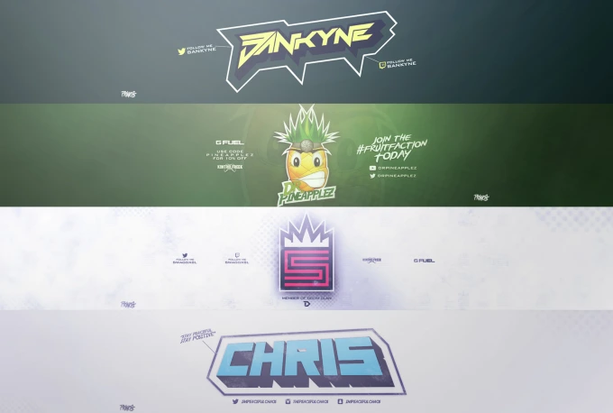

**Banners for YouTube he had done. (The 1st one is mine)**

Resources :

<https://www.fiverr.com/prlllnce>

<https://twitter.com/prlllnce>