Samantha Pezzolanti
ENG 2720 Final Project Write Up
December 8th, 2015

Twitter is a highly fluid platform where content is constantly produced and shared. Users familiar with the platform are accustomed to its affordances and constraints and the nature in which content must be posted. Platforms such as Twitter are unique in their approach to social media as it limits your word count and image attachment per post, this forces users to be creative and direct in posting their content. While many users post for enjoyment those who post for business, academics or to gain a following know wording your content is crucial to it gaining notoriety. Having content recognized and engaged with on Twitter is a science in and of itself, requiring skill and strategy from the user. Strategies to posting successful content on Twitter are abundant but in the execution and deliverance of the analytics experiment, I cultivated a unique set of strategies and guidelines to follow in order to seek out their viability in increasing user engagement, views and following. The four main components centered around, utilizing hashtags for optimizing involvement in trending topics, cross posting content to connect with users on multiple platforms and finally using the services of a third party app to increase analytics. Separate each component had its unique contribution to the project, as a whole however the components laid groundwork for determining if a small-scale individual user can achieve the results suggested.

The relevance of this Twitter analytics experiment lies in proving and or disproving popular claims that advertise an increase in engagement when applied. By formulating a cohesive and hands on experiment the results will stand to show whether each strategy holds true or lacks validity. Executing an experiment in analytics required a diverse understanding of the algorithms used to calculate engagement. Twitter basis its engagement of a tweet on three main values, how many time the tweet was viewed by users, how many users liked or retweeted the content and how many users open the links or other media in the tweet. Producing content that is more likely to be engaged with also took understanding of why users choose to interact with particular content, which in turn related to, word choice, phrasing, bias or relateability. On the other end of the spectrum it was important to factor in sheer like or the right place right time probability. Outside of probability that cannot be controlled though, the psychology of what appeals to a person is fairly well defined.

According to Patel and Puri’s Understanding Customer Psychology there are several ways to appeal to an individuals psychic. Creating content that appeals to, logic, emotion or ethics is key. When creating content there must be a hook to one or more of those aspects, free from the authors personal bias. This concept served the analytics experiment well when tweeting about hot topic issues, for instance Planned Parenthood. The topic itself is highly noticed and discussed without the use of media baiting and it is easy to get lost in a topic that spars so many personal bias and opinions. When composing tweets about the topic, though I did have my own personal opinions on the subject, I refrained from adding them to my content. Instead I opted for the ability to support the organization via facts and not my own thoughts and feelings. In turn this approach garnished the second highest viewing statistics of the entire experiment. Though it was easy to fire back at the ignorance and ill wishes I provided information for those who may not know or be ignoring the fact that the organization provides more than one service. In turn this approach garnished me 317 views and 17 individual visits to my profile page and other content. Instances like this one coupled with the hashtag strategy that you also see here in this tweet amounted to a very successful posting of content that far exceeded all the results ones before it. In addition to wording, phrasing and placement of hashtags is key.
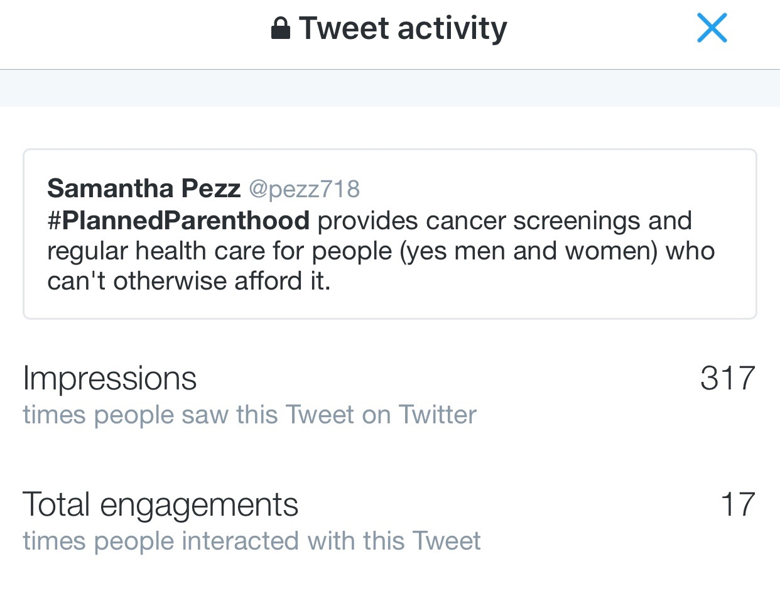
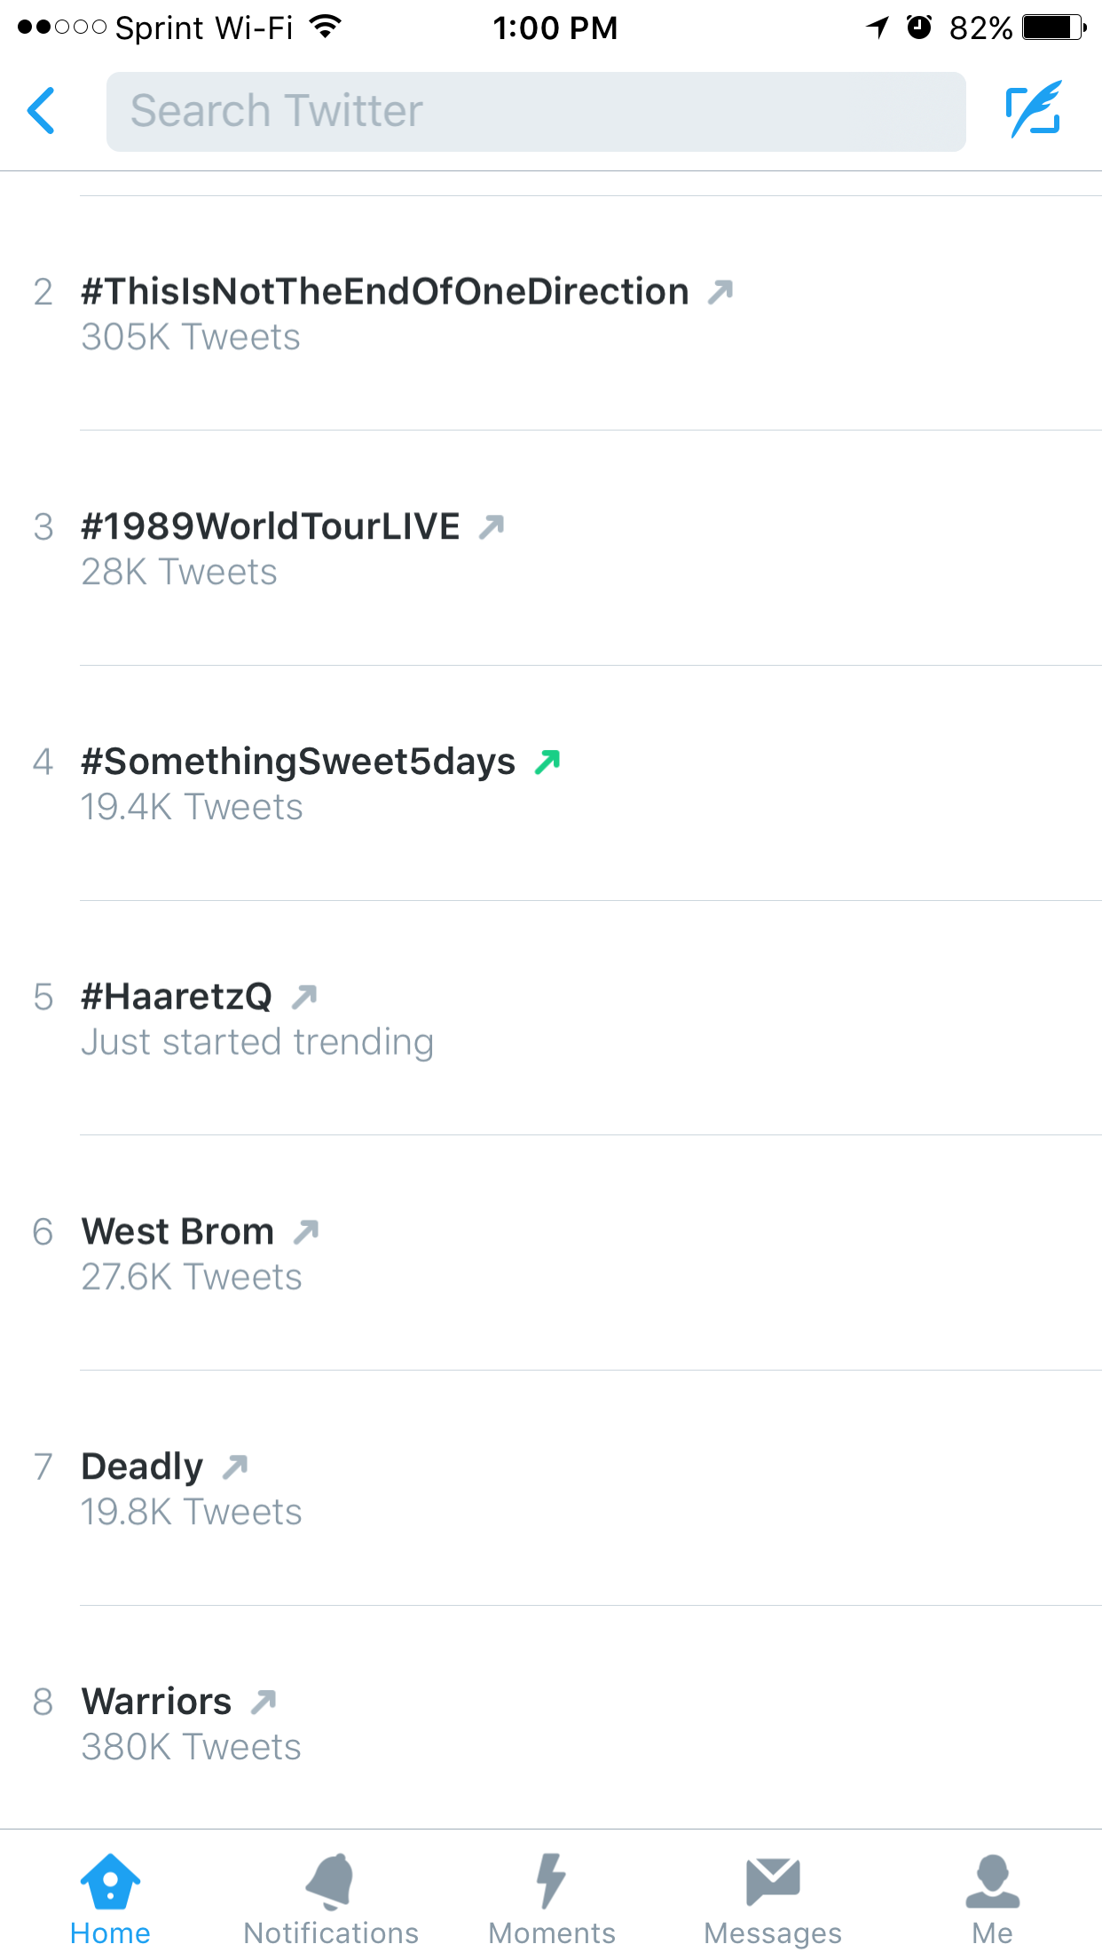
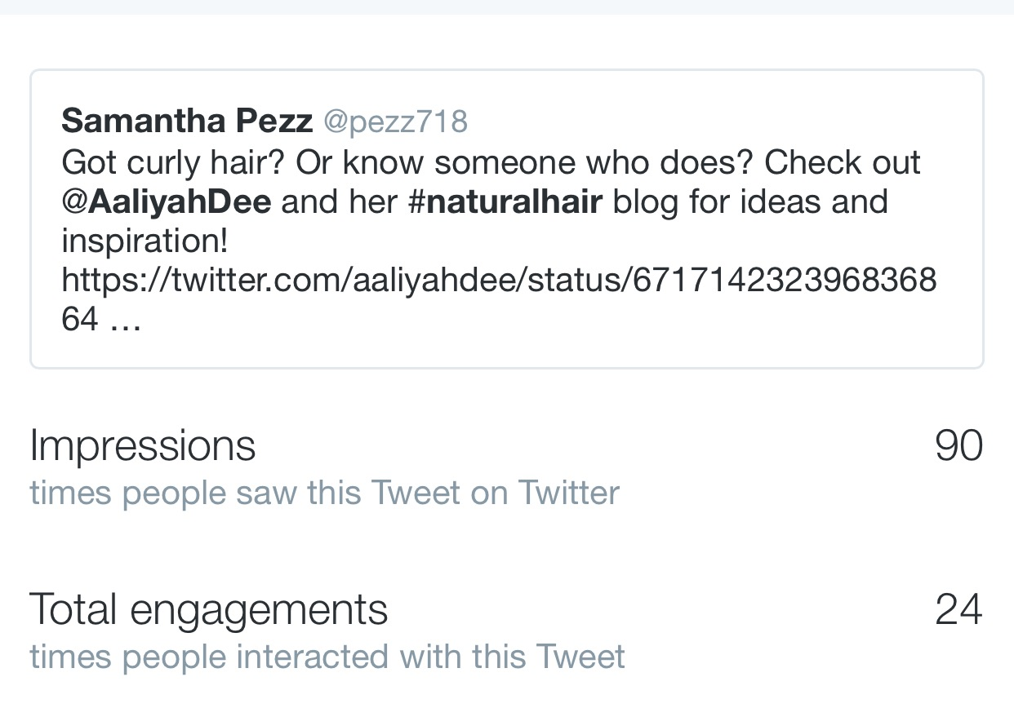
Hashtags are gateways to sub communities and their use can substantially increase a users presence online. Forbes as well as Hootsuite suggests using hashtags sparingly yet effectively. In using them several things are suggested, one stay current become part of an already existing conversation on a trending hashtag and two don’t over use them at the end of a post citing useless gibberish because it is less likely to get any attention because it looks messy. The data from the analytics experiment suggest that this strategy alone was the most effective as I saw the highest traffic to my page and overall content during the first and second weeks. As I began to familiarize myself with hashtagging and what was trending I discovered the trending page was a road map to deciding which conversation to be apart of. On the explore page you’re greeted with 10-15 trending topics, beside each is a red, green or grey arrow. The color indicates it’s strength or popularity, green being on the rise, red the decline and green is steady or little change. It was here that I observed what was trending and what was being said; I then considered which if any were relevant to my life, my studies or my goals that I could or better yet should become apart of. To date the Planned Parenthood hashtag was the one I felt the most drawn towards exploring. Outside of that one I explore the hashtags surrounding, black Friday, Charlie Sheen, Heart Health and various other quirky ones. Though it was the first strategy it was the bedrock for the rest of the experiment and knowing how to optimize the use of hashtags would assist with success in the weeks to come. The second week focused on sharing content by media accounts as well as other individual users. Similar to the first week this meant reading through and observing content for, validity, reliability of the information and ranking in the trending topics. I shared content with and without commentary, meaning I either retweeted or quoted a tweet. When I did comment I followed a similar format to the hashtag principal, make the comments relevant, thought and bias free. I chimed in on multiple shared stories ranging from local political news like the raise in toll hikes or something low stakes like an experience with a doctor’s office. I also shared content from a peers twitter page as well, she too was attempting to build a brand online and by posting her content on my page I opened her content to new audiences. When analyzing my data for week two I noticed something very interesting, aside from one shared post about the Charlie Sheen news, sharing my peers content got better analytics than any other media shared content. Not only did her content get more views, shares and interaction I was also able to enter into a community otherwise closed off to me. In turn my statistics for this week were just as successful as the first week. Thus far proving Forbes (1) 11th strategy correct, hashtags and content engagement will noticeably increase your engagement numbers. After organizing my data from weeks one and two I was optimistic the second half of the project would see equal success, moving into cross posting content from other platforms.

It is important to note that when cross posting from other sites certain plug ins or capabilities had to be enabled. For the confines of my project I was cross posting from my Open Lab site, my personal blog and my Instagram account. The open lab city (creative commons, city tech) was the only site that enabled hands off reposting, meaning I did not have to actively post it myself. As for Instagram and my wordpress blog I had to actively go in and post the updates from each platform. Open Lab saw the highest rate of cross posting as it appeared as soon as I made the slightest change to any of the open lab pages. Though the updates were semi frequent the results were dismal and I saw little traffic increase to my Twitter as well as my word press site. Several factors impacted this; foremost the fact that Open Lab is exclusive to City Tech and second is not a highly used or recognized platform. My wordpress Blog saw the highest rates of engagement and through posting my word press blogs on my twitter while using the hashtag wordpress my blog saw a 31% increase in traffic and my twitter was added to 7 wordpress and blogger lists. Lists on twitter is a way to group user content by genre, in this case if someone wanted to see posts about or from wordpress they would reference that list. Lastly it was hard to gage where traffic on my instagram came from but as far as twitter the analytics and engagement for posts from instagram were minimal and did little to bump my following or engagement. With the results of the third week dismal and showing little promise I concluded that cross posting content without a large and solid following on one or more of the platforms would be ineffective.

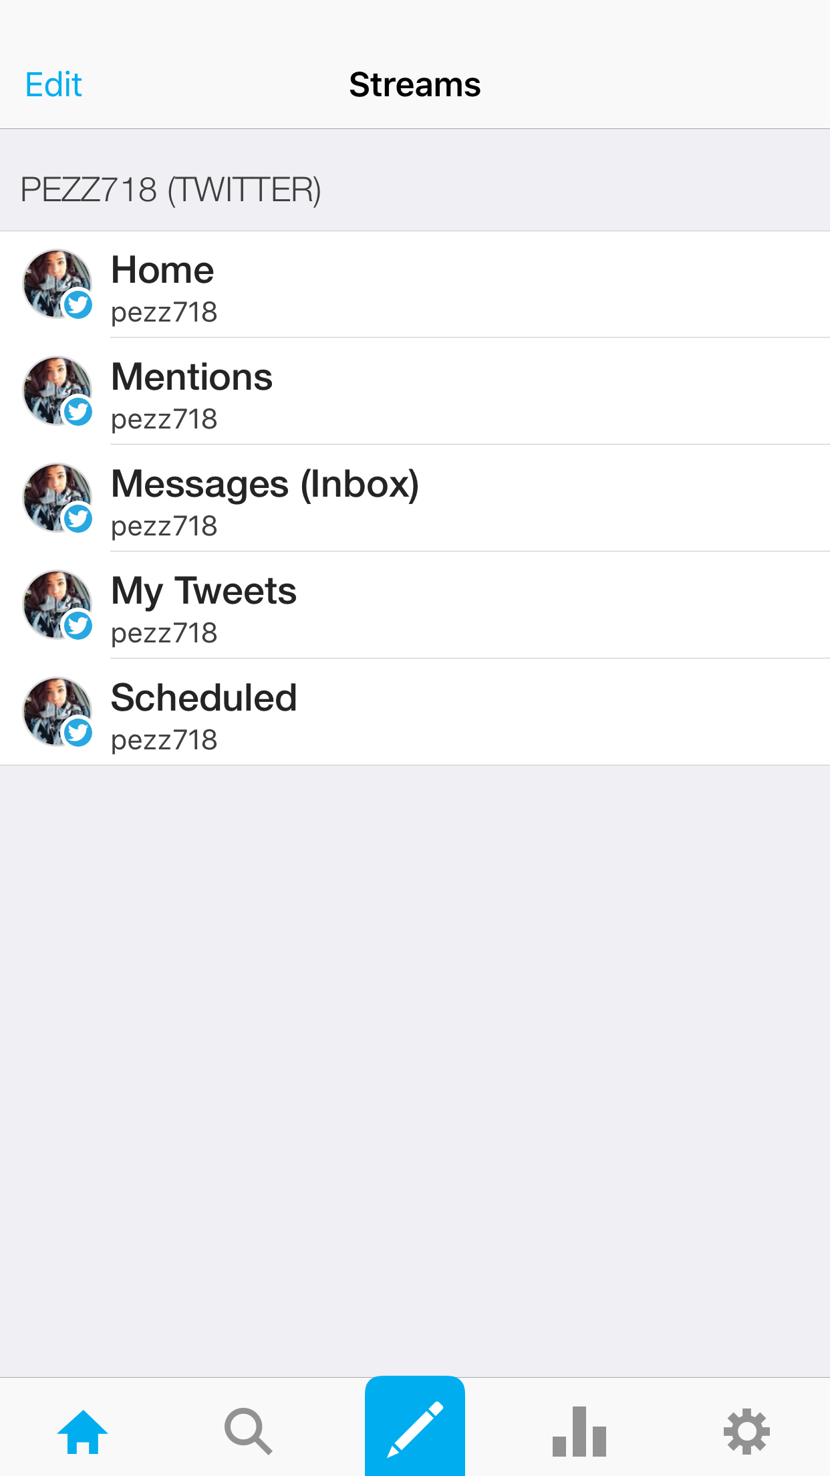
Cross posting on multiple small accounts was unable to increase analytics on its own, so in combination with cross posting the assistance of third party App Hootsuite was employed. Hootsuite offers the ability to schedule your Tweets to be posted and filter ones timeline by content or user, making appealing to a target audience or responding to a community more achievable. Tech For Luddites published an article that compared the affordances of several third party apps, one of them being Hootsuite, praising its organization capabilities and ease of use. While conducting the Twitter analytics experiment this claim was quickly disproven. Hootsuite made logging in or creating an account aggravating and complicated as someone who admins multiple twitter accounts, having to select, log in, re log in and then confirm the account multiple ways. Once logged into the desired Twitter handle the home screen was dismal and uninviting and it took multiple tries and several tutorials on how to schedule my posts.

Once the posts were scheduled I found that if I logged out of or swapped handles during the course of the day that the tweets got jumbled or didn’t appear at all, complicating my results in the final week. Therefore the fourth and final week of the experiment were a failure, or inconclusive as only a handful of tweets went up where desired and when desired. Ultimately disproving or adding doubt to the strategy provided by Bernadeen Works who claimed Hootsuite could maximize ones social media efforts and presence. Works initial claim stated that Hootsuite did the multi tasking for a user, taking away the stress of having to actively remember to post and stay current on ones account. Works claims appear to be more viable for an account run by a small business or user with an already large and established following. The platform also requires getting used to or some form of training as it doesn’t come with a built in tutorial, none of which is mentioned in Works article about the app. Collectively sharing content, which was an extension of cross posting, proved ineffective for an individual user with a personal account. Holistically however, the final numbers reflect an increase across all strategies.

The end results displayed an uptick in each category of analytics, following, views and engagement. At the start of the experiment my personal account had 21 followers and 12 views per tweet with no engagement. The graph below shows the increase over the three weeks as well as the numbers at the end of the fourth week. By the end of the experiment I had 32 followers, 17 engagements per tweet and 112 views per tweet.

Though the experiment overall reflected an increase in each category the results fall short of being a success for two reasons. One being the second half of the project, namely strategies three and four were completely unsuccessful and two the numbers by which following increased shows a lack in ability to gain a steady following even though views increased. The first half of the experiment, strategies on and two, held the most universal validity, meaning that they could most likely be applied to any user for any reason. Whether that is a business, a corporation or just an everyday user hashtags and trend engagement were a highly effective strategy.

Consistently the application of hashtags were a success, proving the claims by multiple sources true reiterating the idea that hashtags in lameness terms equals views. In my results of week one I averaged a higher amount of views per tweet than at the start of the experiment. Previously I averaged 12 views per week; at the end of the first week I was averaging about 72. The boost in numbers came from three tweets in particular, two about Planned Parenthood and the big winner about Charlie Sheen and the revelation he had contracted AIDS/HIV. This tweet may have been the most successful because of three factors, timing, sharing and hashtagging. The tweet was shared at the height or break of the story, meaning thousands upon thousands of users reacted opening a large forum of discussion. The next being the use of his name and the fact that it was so rapidly being mentioned and third because my post was attached to one of a major news source. With 419 views this is the top contender of successful content in this experiment. After gathering the results of the first week I found it useful to observe or comb through other social media accounts of individuals who either proved or disproved the theories that I was applying. There are dozens of bloggers, vloggers, Tweeters and Instagramers who have tens of thousands of followers for various reasons. Some for cosmetics or hair tutorials, some for comedy skits, others for real life issues and relating to fans, many different genres that unite tons of users. For this I looked for an account that united a large base of followers for a variety of reasons.
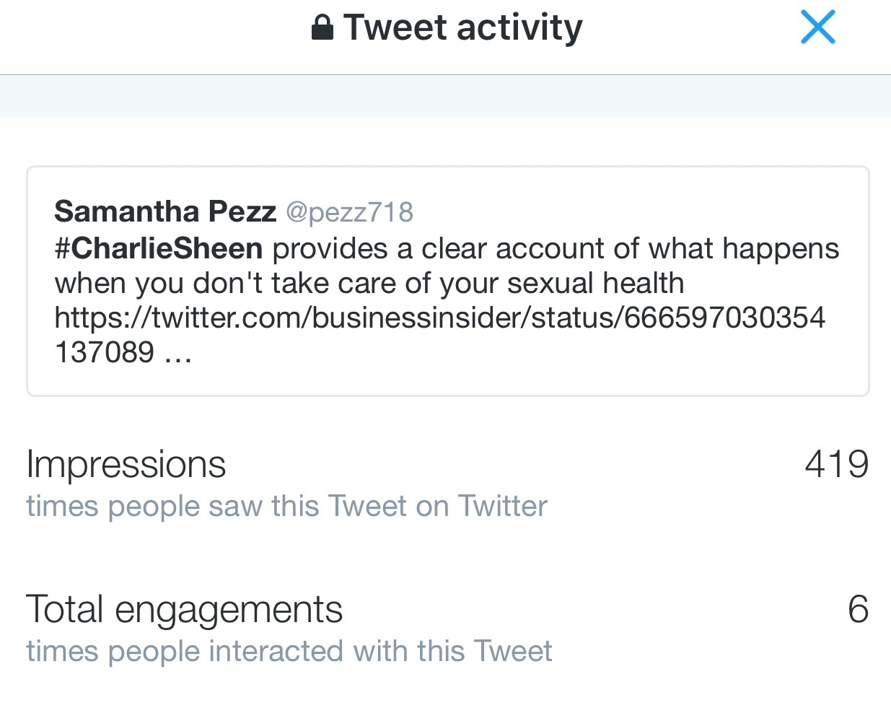
The user, or social media celebrity I looked at, as well as personally follow, was AggyAbby who’s real name is Abigail Silva. Haling from jersey Silva has 12.5k followers and several different ways to interact with her followers. What makes Silva’s following unique is that she doesn’t stick to one genre of content, meaning her posts range from comedy to event hosting and even to personal struggles and triumphs, and because of this her followers are diverse, following her for a variety of reasons. In 2013 she posted a video about infidelity in relationships and the post went viral, she gained hundreds of followers over night. Abigail’s success goes against everything the popular strategies claim you need to do in order to get that big a following, her one post cast her into the spotlight with no effort on her part.

Silva’s triumph of social media is interesting because while it combines some of the strategies lists in Forbes (2) the time frame in which she rose to notoriety was out of the statistical norm. Typically it is suggested that culminating a strong social media presence takes copious man-hours, effort and a stretch of time to achieve. However Silva snowballed all of these efforts into over night success without so much as trying. Silva continues to have a strong social media presence and has extended her presence to live events where she is able to interact with her followers, further proof that her social media success is viable proof that a user does not always have to map out a lengthy strategy to garnish social media presence.

The case study of Silva’s account further supports the claim that the strategies as a whole are unsuccessful. While some of the applied strategies increased numbers holistically they did not make a dent in my online presence. My official conclusion on the experiment is first based on the constraints of time in which it was preformed, it is possible with a larger amount of time to apply and track these strategies that they would garnish very different results. That being said applying strategies to my personal twitter account did not increase my following by a notable amount, at the end of the four weeks I had only gained 11 followers. If I were to re-conduct this experiment I would do so under very different parameters and apply different approaches to first building up my account. I believe it would be helpful if, like my Instagram account, there were a theme that immediately greeted users when they landed on my page even though my bio clearly lists my specifications my intent with the twitter page is unclear. This may also have been a contributing factor in the lack of success in the experiment, even though the content was viable and relevant the authors page was generic and lacked authenticity. While my own personal goals for this experiment were not met there is still significance in the findings.

The significance of the results lie in the trial and error I endured which can serve as a basis for any other user who may want to re-conduct or formulate their own strategy for increasing their presence on any media platform. Not only will it give a potential user the basis of what not to do it also provides a few “givens” such as, hashtags are your friend and their use coupled with trending topics will in fact get you noticed. More importantly it stands to reason that just getting noticed is not enough, you must establish yourself, your goals and your brand before seeking recognition. The most important take away is to create the entire product before calling attention to it, just having a sample is not enough. Finally that online presence building is a lengthy process and cannot possibly be accounted for in a period of four weeks.

Resources and Works Cited

Armstrong, Russel. "Marketing Pros and Cons of Twitter." Linkedin. LinkedIn, 1 Feb. 2015. Web. 17 Nov. 2015. <https://www.linkedin.com/pulse/twitter-marketing-pros-cons-russell-armstrong>.

Olanoff, Drew. "Twitter Debuts Moments." TechCrunch. 6 Oct. 2015. Web. 17 Nov. 2015. <http://techcrunch.com/2015/10/06/project-glacier/#.cxicwgi:TMDC>.

Cave, Andrew. "Will Twitter Be Dead in Three Years." Forbes. Forbes Magazine, 2015. Web. 17 Nov. 2015. <http://www.forbes.com/sites/andrewcave/2015/01/31/will-twitter-still-be-around-for-super-bowl-lii-in-2018/>.

Cohen, James, and Thomas Kenny. "CHAPTERS 2 AND 7." Producing New and Digital Media Your Guide to Savvy Use of the Web. Independence: Taylor and Francis, 2015. Print.

Kricfalusi, Elizabeth. "Twitter vs. TweetDeck vs. Hootsuite: Which Is the Best Twitter Client?" Tech for Luddites. Tech or Luddites, 3 Apr. 2015. Web. 17 Nov. 2015. <http://techforluddites.com/twitter-vs-tweetdeck-vs-hootsuite-which-is-the-best-twitter-client/>.

Prattler, Adam. "How to Use Twitter Hashtags to Get Noticed." Social Media Today. 22 Oct. 2013. Web. 17 Nov. 2015. http://www.socialmediatoday.com/content/how-use-twitter-hashtags-get-noticed

Patel, Neil, and Retia Puri. "The Complete Guide to Understand Customer Psychology – Chapter 3." Quick Sprout. Quick Sprout, 2014. Web. 6 Dec. 2015. <https://www.quicksprout.com/the-complete-guide-to-understand-customer-psychology-chapter-3/>.

Rampton, John. "25 Ways to Grow Your Social Media Presence." Forbes. Forbes Magazine, 29 Sept. 2014. Web. 12 Nov. 2015.

Works, Bernadeen. "HootSuite: Maximize Your Social Media Efforts." Business Insider. Business Insider, Inc, 26 Dec. 2012. Web. 17 Nov. 2015. <http://www.businessinsider.com/hootsuite-maximize-your-social-media-efforts-2012-12>.

