Bathing Products:
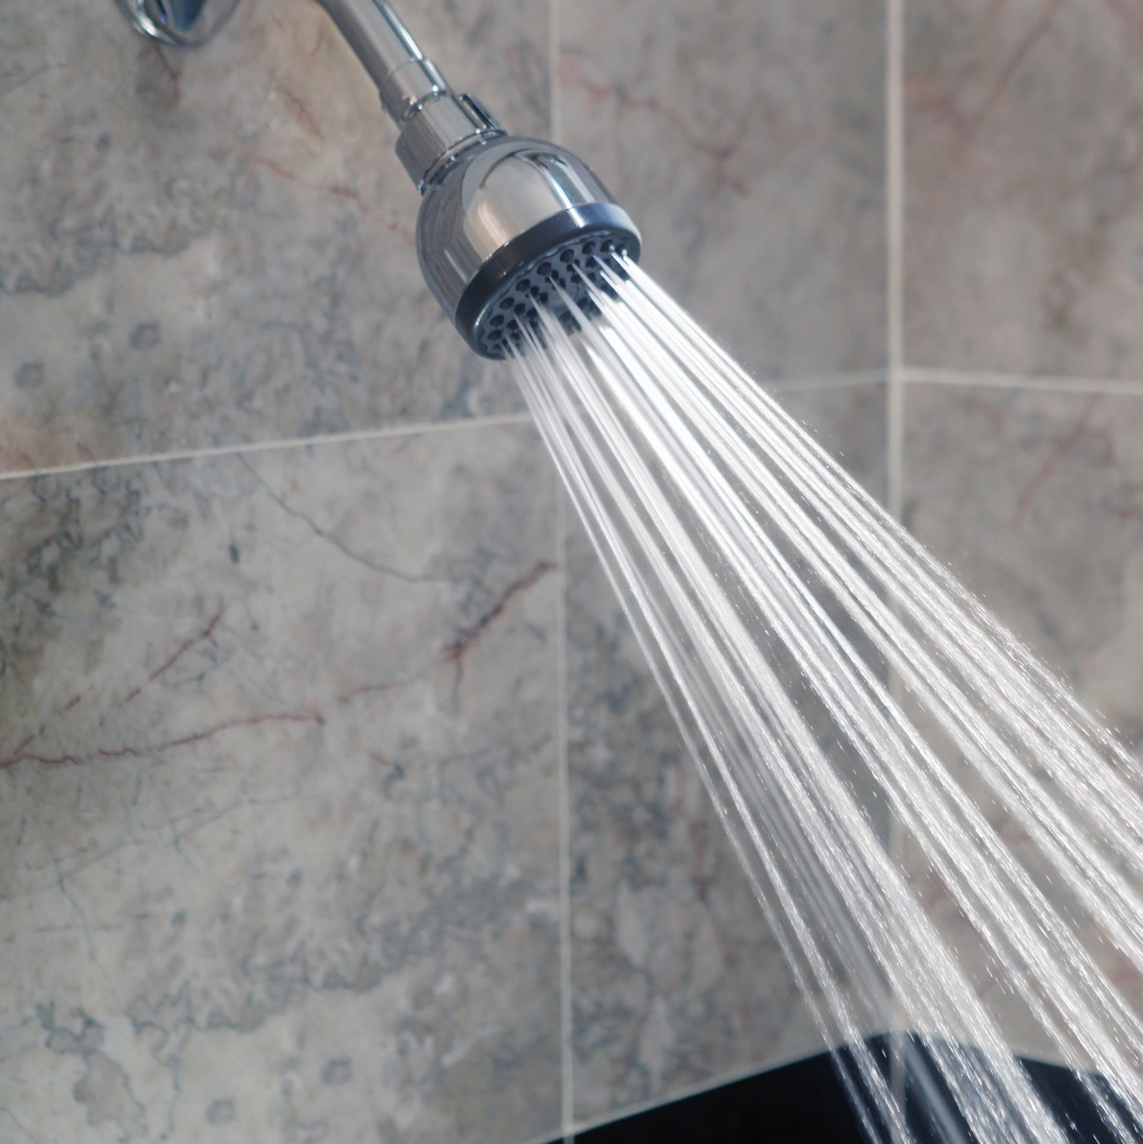
Additive Free
Vs.
Chemical-Based
SafeSoap Research Firm

Table of Contents
- Executive Summary
- Research Project Team
- Problem Discovery and Definition
  - Exploratory Research
    - Secondary Data Research Search
    - Experience Survey
  - Problem Definition
    - Problem Statement
    - Research Objectives
    - Research Question
    - Hypothesis
    - Questionnaire Construction
- Planning The Research Design
  - Methodology
    - Survey
- Selection of Sample Design
  - Target Population
- Collection of Data
  - Pre-Test
  - Main Study
- Data Analysis
  - Editing
  - Coding
  - Analysis
  - Tables and Figures
- Conclusion and Recommendations
- Questionnaire
- *section done*
Executive Summary

Safe Soap Research Firm has conducted a competitive study between natural, organic bathing products and the latter. Our research will assess consumer use, emotional and ethical connection to such products. Our main products of study are Dr. Bronner's Pure Castile Soap and Dove. We will also evaluate similar organic companies such as LUSH to not only add to our narrative but influence our target consumer's next purchase.
( will be added to as project progresses)

*section Done*

SafeSoap Research Firm
Team Profiles

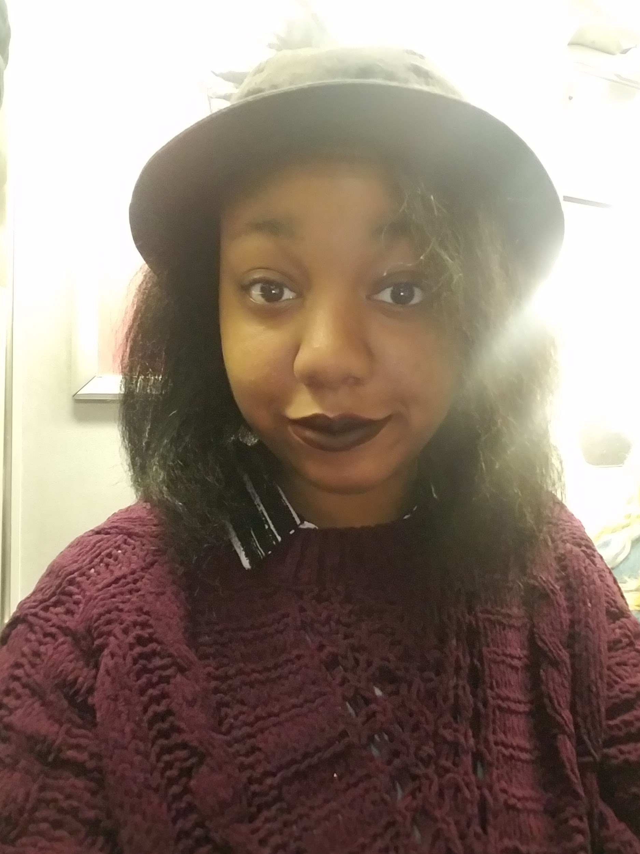
Jessyca Jones - Project Director/ Statistical Writer
She is a senior- level , transfer student at New York City College of Technology. She is currently completing a Bachelor's in Business and Technology of Fashion. She intends to further her education with a MBA in Fashion Management. Her goal is to build a career as a Creative Director of her own brand in the Fashion industry.
As Statistical Writer, her responsibilities included compiling the secondary data for our research , writing the secondary data summary, conducting and recording interviews with personnel of the brands discussed , and writing the experience and main study summaries. As Project Director, she helped define our problem objectives, contributed to the formation of the questionnaire, and oversaw the overall completion of our research project.

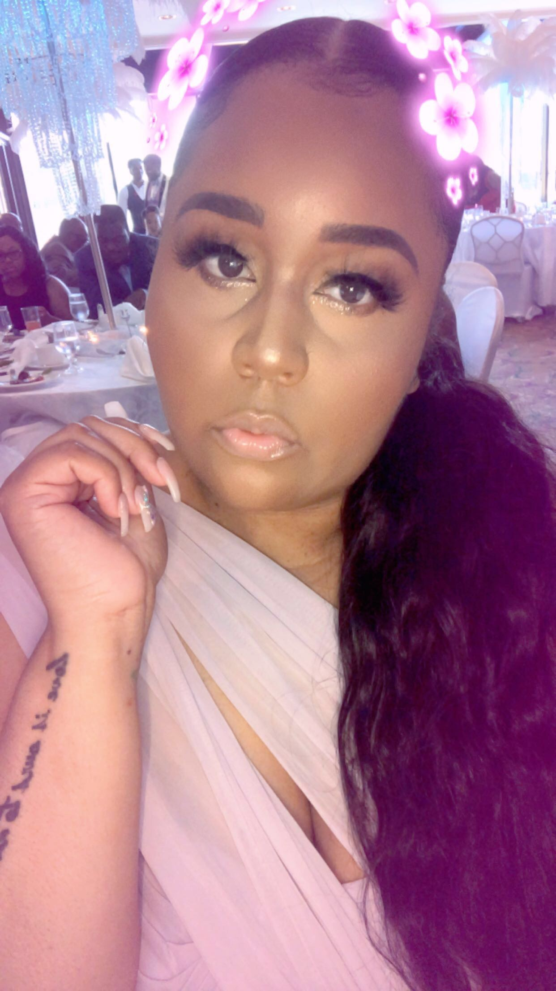
Denique Spencer
Co-Project Director/Statistical Writer
Denique resides in Brooklyn, NY; she currently is a senior attending New York City College of Technology and is studying Business and Technology of Fashion. She has obtained her Associates Degree in Liberal Arts at Kingsborough Community College before transferring to the College of Technology. She intends to further her education and obtain a Master’s degree in Business, all while kick starting her entrepreneurial career an event planner and online fashion retailer. As a Statistical Writer, her responsibilities are but not limited to compiling data research, formulating an informative questionnaire, planning and editing the overall research design. As Co- Project Director, she defined our target market, suggested our conclusions and recommendations, as well as helped oversee the completion of our research project.
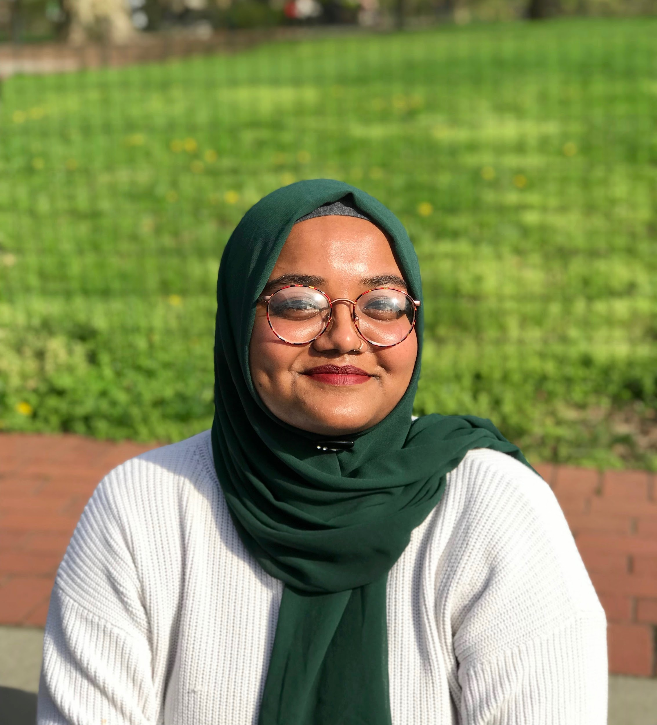

Shafana Begum – Data Analyst
She is a sophomore at New York City College Of Technology, pursuing her bachelor's degree in Business and Technology of Fashion. She plans to get her Masters in Computer Science and later create a Muslim friendly clothing line.
As Data Analyst, she was in charge of editing, coding, computing final numbers, as well as creating tables and figures with team mate, Stefhanie. Her responsibilities also included providing secondary data for LUSH as well as the visual construction of the questionnaire.

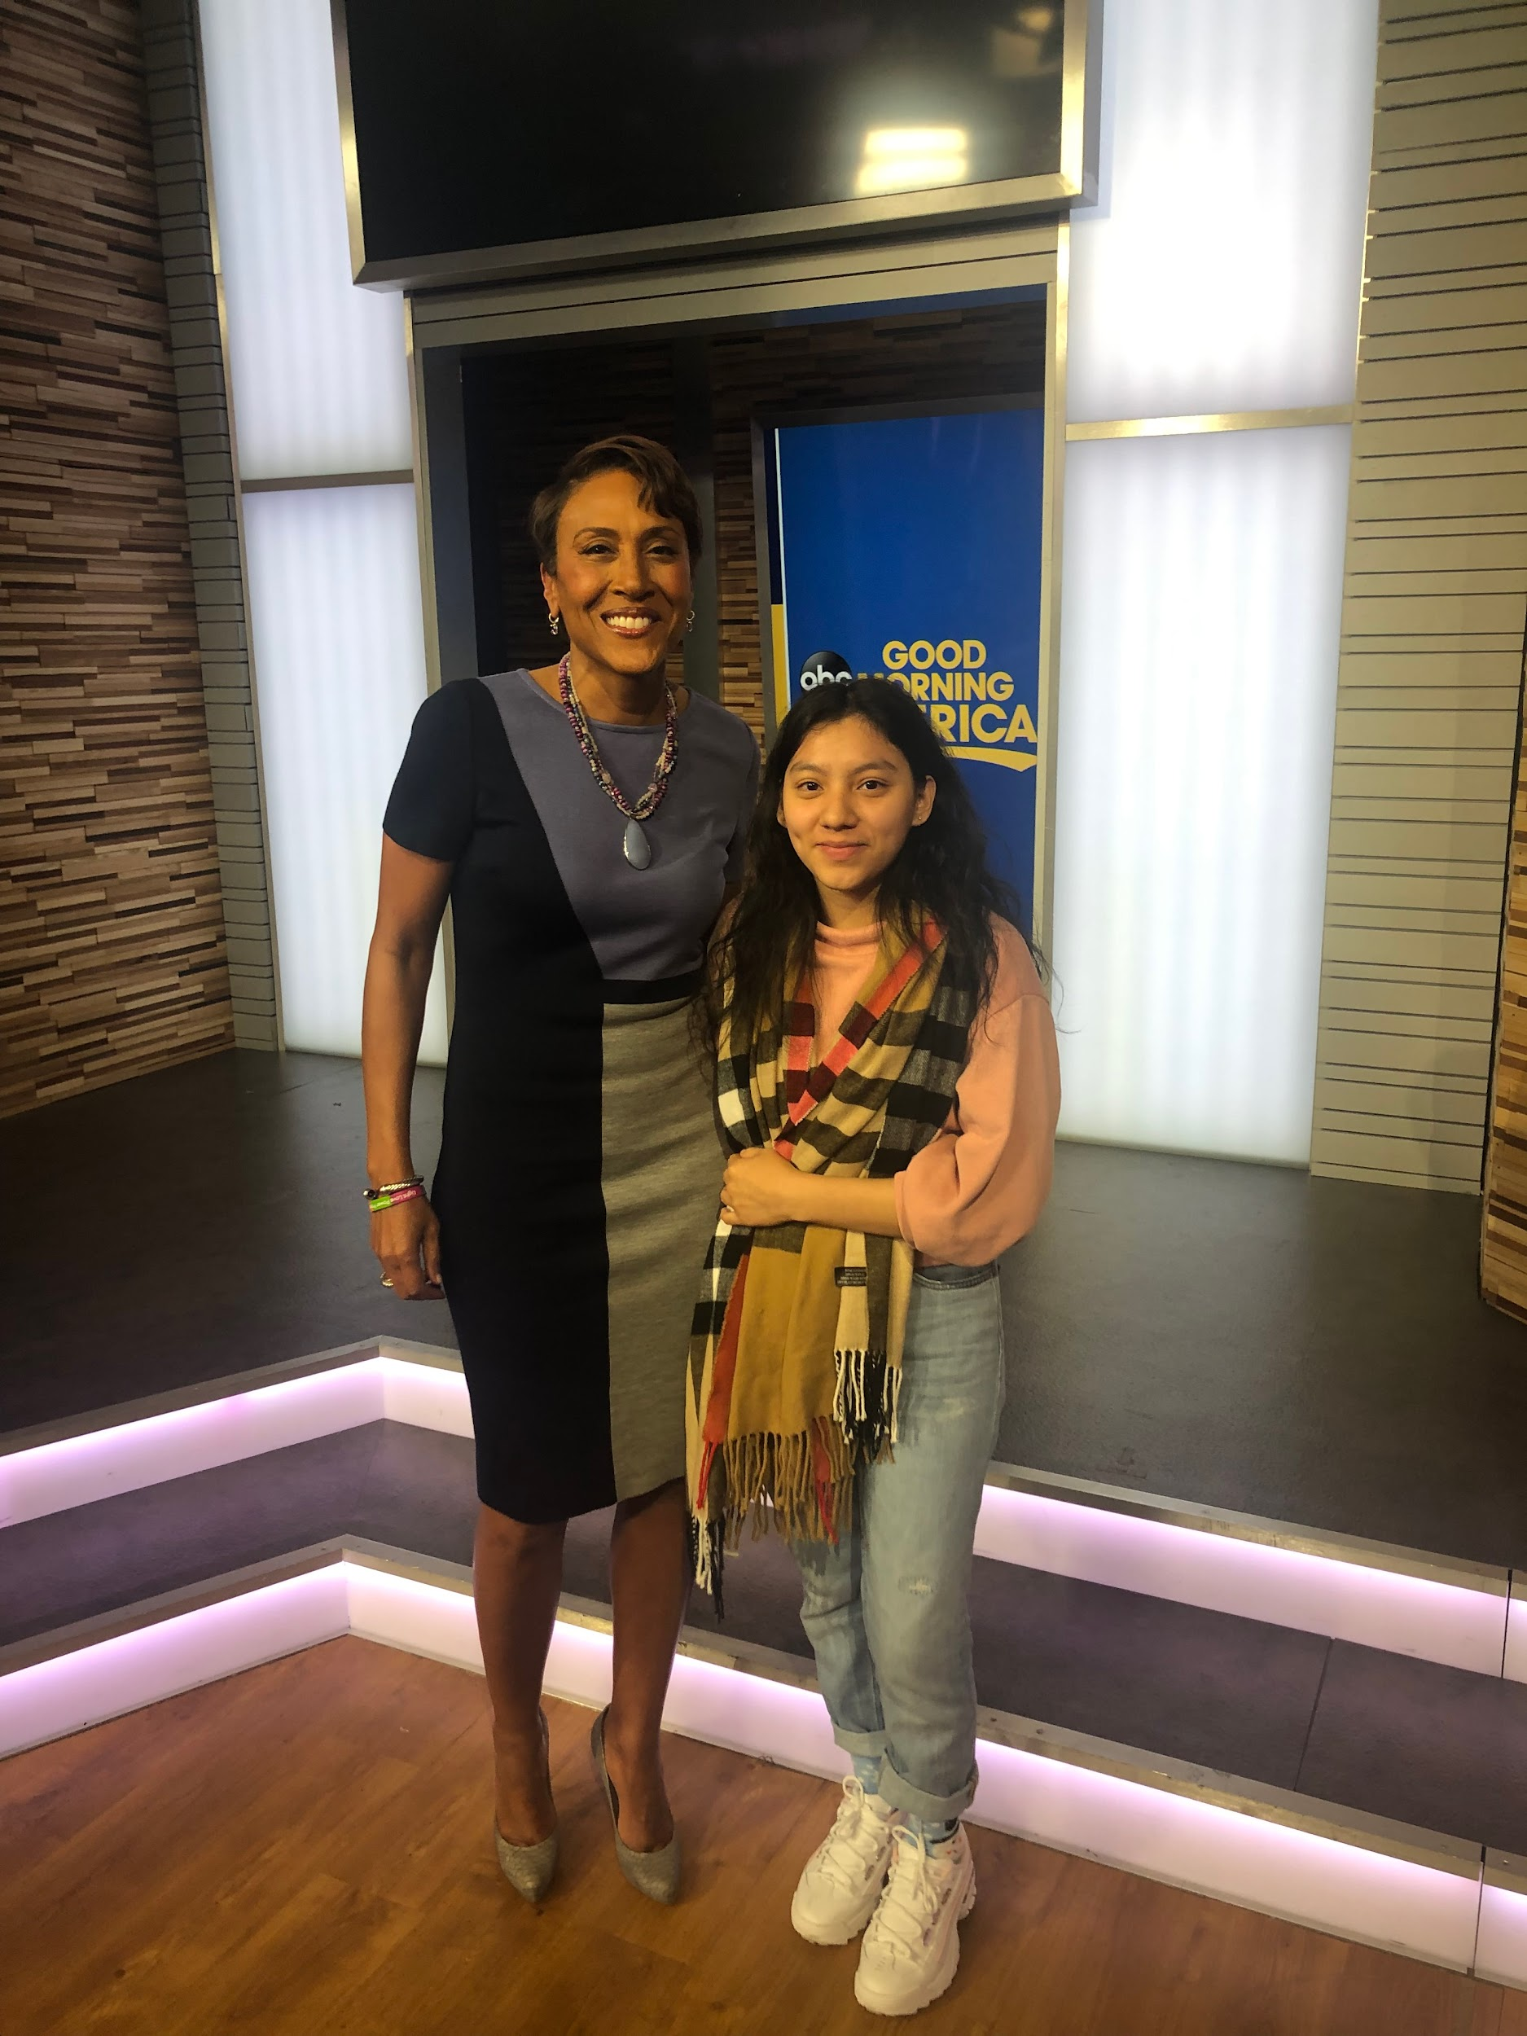
Stefhanie Perez - Data analyst

Stefhanie is a 19 year old who is currently a sophomore at New York City College of Technology. She’s a Business and Technology of Fashion major who is working to get her Bachelors. Her responsibilities to this marketing project is to be responsible for the methodology and conducting the pre-test. As Data Analyst, she developed the graphs and figures for the data that is collected through the questionnaires, working alongside partner Shafana. Lastly, she was responsible for the analysis and the questionnaire.

*section Done*

Secondary Data Summary

We collected our secondary data by delving into the history of each brand. By accessing the company websites of Dr. Bronners, LUSH, and Dove, we were able to compare and contrast each. The websites provided a timeline of each brands history into succession and consumerism. We utilized an outline to better understand the benefits of each product based on consumer reviews and nutrient facts. Our sources also included the Environmental Working Group (EWG) website. The occupation of the website is to give an in depth description of questionable ingredients and their applications. A toxicology report is also provided.

The first noticeable aspect of Dr. Bronner's website is their claim of selling " Socially and Environmentally responsible" products. This statement is at the center front of the brand's image. Dr. Bronner's was founded by chemist, Emanuel Heilbronner in 1948. Since the 1800s, his family had been at the top of the soap making industry. His German- Jewish roots led him to invest in certain ideals. The intention behind Dr.Bronners' claim , 'All- One' is to rally others to believe that unity is vital. Having suffered traumatic experiences, such as losing his parents during the reign of Nazism, he consistently pushed for a peaceful environment.

The first of his many productions was the Peppermint Castile Soap. The ingredients include Tocopherol (Vitamin E) and a range of essential oils. On the label it is advised to be used in moderation and that it is an all purpose cleanser.

Experience Survey

Interviewer: Jessyca Jones
Interviewee: Evelyn Dobson (Whole Body/Nutrition Sales Specialist)
Date : 10/17/2019
Westerly's Natural Market
Location: 911 8th Ave New York, NY

Interviewer: How long have you been employed by Westerly’s?

Interviewee: I’ve been working at Westerly’s two and a half years.

Interviewer: What drew your interest in taking this position?

Interviewee: I’m studying for an MBA in Nutritional and Health. I want to bring awareness of the value of healthy products. Not just those you put in your body, but what you put on the surface.

Interviewer: What are the genders and ethnic groups you notice the most?

Interviewee: Women typically gravitate towards body washes. The average man doesn't care that much, which is why he goes to CVS. However, European men buy ethical.

Interviewer: Why are natural soaps better than pharmaceutical soaps?

Interviewee: Natural soaps do not include sodium lauryl sulfate. Its abrasive dries out your skin. It's a drying agent, and usually the first in those soaps. Active ingredients in the natural soaps tackle different issues. Ingredients such as Aloe Vera juice or Mango seed butter can benefit the consumers one way or another. They have these without the added chemicals. A lot of pharmaceutical soaps have parfum/fragrance which disrupts the endocrine system, lungs, the respiratory tract and lymph nodes. These ingredients are toxic but people love it and the information is never disclosed. These ingredients can become carcinogenic.

Interviewer: What are some of the differences between Dr. Bronners and Dove?

Interviewee: Dr. Bronners is saponified, castile soap. Castile soap is typically used by consumers with oily to combination skin. Dr. Bronner's is also multipurpose in regard to those with psoriasis or eczema. Dove contains sodium lauryl sulfate, which is usually the first ingredient in pharmaceutical soaps. Dove is also soft, because of the residue it leaves on the skin. Ultimately, it dries it out your skin through continued use.

Interviewer: Can you tell me about some of the benefits of Nubian Heritage?

Interviewee: Nubian heritage does not carry any parabens or abrasive chemicals. The added extracts are like the foods we eat.

Interviewer: Do you feel the product is worth the price?

Interviewee: Yes, natural soaps cost more because companies such as Dr. Bronners and Nubian Heritage care about what they are putting in your body. If a fragrance is included its an essential oil blend. Based on customer feedback, they've been prone to give customers a good, lasting, healthier result. Customers feel good buying what has less chemicals and are environmentally harmless.

Interviewer: What does organic mean to you?

Interviewee: Organic means breaking it down to simplest use that your body will not reject. 'You are what you eat'.

Interviewer : Have you noticed any changes within the consumers that shop at Westerly’s?

Interviewee: Some of the changes I've noticed are people are usually dieting and express concern about which products are vegan.

Interviewer: What are the demographics of a Westerly consumer?

Interviewee: The Westerly consumer is usually of higher, middle class.

Interviewer: Who are Westerly’s biggest competitors?

Interviewee: Whole Foods would be our direct competitor and the pharmaceutical stores would be our indirect competition.

Interviewer: Do you think organic can win the battle?

Interviewee: Definitely; there has been a revolution of diets like Keto and Vegan. Word is getting out and people are getting a sense of what ethical products to use. Many of the diseases we face are influenced by the patterns in our body. It can help it or hurt it. As society builds awareness, we can get better.

Problem Definition

- Target Market/Target Population:
Health conscious people who are looking for organic skincare, including:
- Ethnic women
- Mother’s purchasing for their children
- People with sensitive skin and skin conditions
- Young adults (male & female; ages 18-35)
- Elderly people (male & female; ages 60+)

2. Problem Statement :
To determine how many consumers in the New York City Marketplace would prefer to go the ethical and organic route, when it comes to skincare products, particularly if they knew the long term effects.

3. Research Objectives:
- To determine potential demand for ethical and organic body washes or soaps in the New York City Marketplace.
- To find out the products attributes price conscious consumer desire when purchasing soaps or body washes in the New York City Marketplace.
- To discover consumer perceptions of ethical and organic body washes in the New York City Marketplace.

4. Research Questions:
- Is ethical soap limited to consumers in New York City Marketplace, meanwhile nonethical soap can be bought anywhere?
- Do consumers in the New York City Marketplace prefer to buy ethical or nonethical soap?
- Do consumers in the New York City Marketplace pay attention to the quality of their soaps and use more organic based products?

5. Hypotheses:
We believe that people will prefer to use ethical and additive free products instead of synthetic,chemical-based soaps.

- Consumers in the New York City Marketplace will prefer their soap to be ethically sourced.
- Consumers in the New York City Marketplace will prefer all-natural, organic body cleansers to chemical based ones.

PLANNING THE RESEARCH DESIGN
Research Design is defined as a master plan specifying the methods and the procedures for collecting and analyzing the needed information and is framework for the research plan of action. A research design includes: (1) Information sources; (2) The Design Technique; (3) The Methodology; (4) Schedule and (5) Cost. It also provides insights about “how” to conduct research using a particular methodology.
Methodology involves specific techniques that are adopted in the research process to collect, assemble and evaluate data. It defines those tools that are used to gather relevant information in a specific research study. Surveys, questionnaires and interviews are the common tools of research. When conducting Market Research there are five different types of methodologies that can be used which are, focus groups, surveys, interviews, Field Trials, and Observations.
The types of methodologies we here at Safe Soap Research Firm chose to incorporate for our business research were surveys and interviews, specifically personal interviews. Our firm strongly believed using these specific techniques to conduct our project would be beneficial for the outcome of data collected. Safe Soap Research Firm wanted to utilize a swift yet efficient way to gather statistics and by doing so we were able to reach out to significant number of our target population.
Survey is a research technique in which a sample is interviewed in some form or the behavior of respondents is observed and described in some way. These individuals who participate in a survey are called respondents or interviewees. Using a questionnaire with a standardized set of questions we asked our respondents selected for our survey to inform our research firm on their education and spending habits of the soaps frequently used. Overall the advantages our firm achieves from using a survey is the quick response time, inexpensive costs to conduct, and most of all it is undoubtedly efficiently accurate. Asking a sample of our target population informative questions such as: where did you first hear about your current body wash brand, have you ever purchased body soap that is organic/natural, how much are you willing to spend on soap, and what do you find most important when buying any type of soap.
Personal Interview is a marketing research technique used for gathering information through face-to-face contact with individuals. Our job here at Safe Soap Research Firm was to conduct a comprehensive survey handed out to fifty respondents within the New York City Marketplace. Differentiating those who purchase ethical or nonethical brands of body soaps in order to gather primary data through our consumers’. With each member of our research team conducting these personal interviews face-to-face at various locations such as New York City College of Technology, shopping malls, and in-home settings.

SELECTION OF SAMPLE DESIGN
Sample Design is the framework, or road map, that serves as the basis for the selection of a survey sample and affects many other important aspects of a survey as well. A sample involves a small portion of a population to make conclusions or inferences about the whole population subset or some part of a larger population. The larger the sample size the more accurate the result. There are two basic techniques when it comes to using the sampling procedure, which are Probability and Nonprobability.
Our team here at Safe Soap Research Firm used one of the techniques called nonprobability. Nonprobability is a sample in which units of the sample are selected on the basis of personal judgment or convenience; the probability of any particular member of the population being chosen is unknown. There are four types of nonprobability samples that can be used such as convenience samples, judgmental samples, quota samples, and snowball samples. Using this particular technique for our research project made sampling fifty consumers’ in the New York City Marketplace that related to our study topic more manageable and precise.
As well as using the nonprobability sample we chose to use one of the specific types of nonprobability techniques there are called convenience samples. Convenience sampling is a sampling method where the researcher subjectively chooses sample members who are believed to be representative of the target population based on their own experience and personal judgment. An example of this type of sampling would be standing in or outside of a generally populated area like at a school or grocery store and asking people to answer questions. By our team using this sampling technique we were able to swiftly target our specific consumers’.
The survey results conducted from the Safe Soap Research Firm questionnaire concluded that the demographics of the respondents of our research study were mainly (70%) females around the age range of 18-24 (54%).
18. What is your Gender?
{__} Female (70%)
{__} Male (30%)
{__} Other (Please Specify) _________________

19. What is your Age?
{__} 18 and Under (4%)
{__} 18 – 24 (54%)
{__} 25 – 34 (20%)
{__} 35 – 44 (12%)
{__} 45 – 54 (2%)
{__} 55 – 64 (6%)
{__} 65 and Older (2%)
With approximately (46%) of our interviewees being of an African American ethnic background and about (44%) having completed some level of college education.
20. What is your Ethnic Background? (Please choose only one)
{__} African American (46%)
{__} Asian (28%)
{__} Caucasian (2%)
{__} Hispanic/ Latino (24%)
{__} Other (Please Specify) __________________

21. What is your highest level of education completed?
{__} Some High School or Less (8%)
{__} High School Graduate (30%)
{__} Some College (44%)
{__} College Graduate (10%)
{__} Some Graduate School
{__} Completed Graduate School (6%)
More than half of our respondents (74%) stated their marital status as “single”, and (34%) of the results showed the current employment status as a full-time student.
22. What is your current Marital Status? (Please choose only one)
{__} Single (74%)
{__} Divorced
{__} Separated
{__} Married (26%)
{__}Widowed
23. What is your current Employment Status?
{__} Full-Time Student (34%)
{__} Part-Time Student (6%)
{__} Employed Full-Time (30%)
{__} Employed Part-Time (10%)
{__} Self -Employed (4%)
{__} Unemployed (14%)
{__} Retired (2%)
Based on results gathered from our Safe Soap Research Firm survey our team’s interpretation of the average number of people living within our respondent’s household was (38%) stating “5 or more” persons reside in their homes. As well, over half our responses came back with (44%) of our respondents listing “other” for their current occupational status.
24. How many people live in your household?
{__} 1 (4%)
{__} 2 (12%)
{__} 3 (22%)
{__} 4 (24%)
{__} 5 or more (38%)
25. What is your current Occupational Status?
{__} Professional (2%)
{__} Executive (4%)
{__} Managerial (8%)
{__} Administrative (12%)
{__} Sales (10%)
{__} Laborer (6%)
{__} Technical (2%)
{__} Secretarial (2%)
{__} Clerical (4%)
{__} Other (Please Specify) _______________ (44%)
*(Babysitter, PE, unemployed, cook, hairdresser, supervisor, education, doorman, student)

Final results of our Safe Soap survey demographic questions express majority of our respondents (44%) having a total household income of “$50,000 or more”. Our demographic data also revealed a close tie for where respondents reside at, with (40%) being from Brooklyn and (38%) being from Queens.
26. What is your total Household Income?
{__} Under $15,000 (10%)
{__} $15,000 to $19,999 (10%)
{__} $20,000 to $24,999 (10%)
{__} $25,000 to $29,999 (4%)
{__} $30,000 to $34,999 (4%)
{__} $35,000 to $39,999 (8%)
{__} $40,000 to $44,999 (8%)
{__} $45,000 to $49,999 (2%)
{__} $50,000 or more (44%)

27. Where do you currently reside?
{__} Brooklyn (40%)
{__} Manhattan (2%)
{__} Bronx (18%)
{__} Queens (38%)
{__} Staten Island
{__} Other (Please Specify) ____________ (2%)

Target Population
Our Safe Soap Research Firm were tasked with the job to research both males and females within the New York City Marketplace who generally shop for body soaps whether they are ethical or non-ethical products. Targeting our market by surveying ethnic women, mothers purchasing soaps for their children, people with skin sensitivities and conditions, young adults (ages 18-35), and elderly people (ages 60+). From the above demographic questions we would be able to distinguish those target markets that shop for either ethical or non-ethical body soaps, and answer our problem statement.
COLLECTION OF DATA
Pre-Test

Main Study

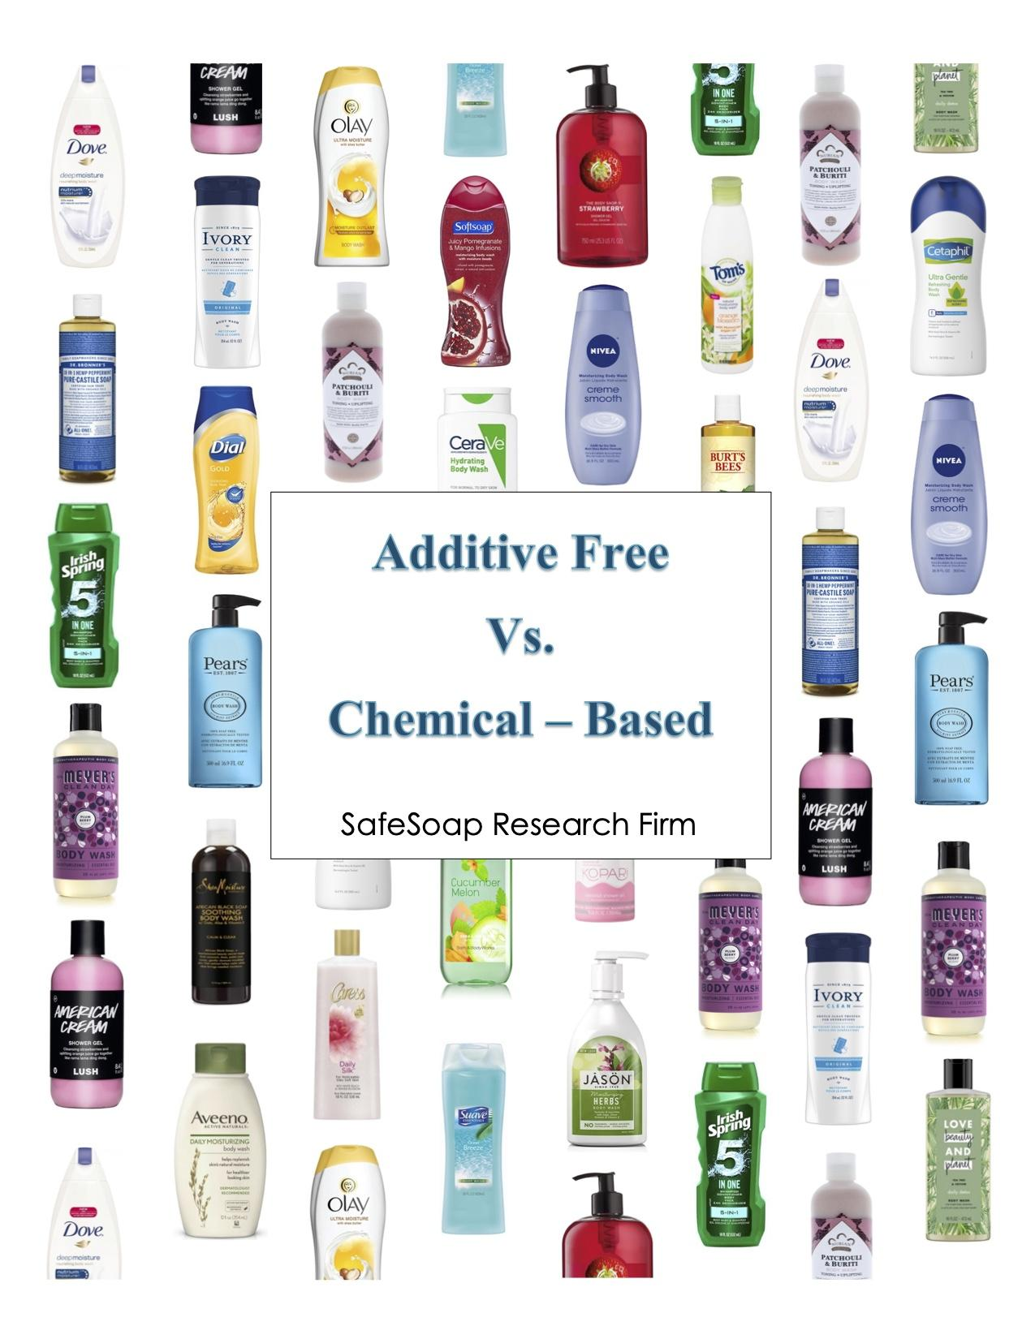
Addictive Free Vs Chemical -
Based body soap

Hello, Safe Soap Research Firm is currently conducting a survey among consumers in the New York City area who purchase ethical or nonethical brands of body soap. Your responses are essential to our research and will be kept strictly confidential. We appreciate your time and effort, and we thank you for participating in this research study!

1. If you were to purchase a body wash, which brand would you most likely choose?
(Please choose only one.)
{__} Dove
{__} Irish Spring
{__} Dr. Bronner’s
{__} Lush
{__} Nubian Heritage
{__} Cetaphil
{__} Other (Please Specify) ____________

2. What do you find most important when buying any type of soap?
(Please rank 1-7, with 1 being the most important - write the numbers 1, 2, 3, 4, 5, 6, 7 next to the choices)
{__} Brand
{__} Price
{__} Lather
{__} Fragrance
{__} Ingredients
{__} Cruelty free
{__} Skin type

3a. In what quantity do you buy soap?
{__} Bottle
{__} Bar
{__} Pack of 3
{__} Bulk
{__} Other (Please Specify) _______________

Please Turn to the Next Page
3b. How much are you willing to spend on soap?
{__} Less than $5
{__} $5 - $9
{__} $10 - $14
{__} $15 - $19
{__} $20 - $24
{__} $25 - $29
Please Turn to the Next Page
{__} $30 - $34
{__} $35 - $39
{__} $40 or more

4a. Have you ever purchased body soap that is organic/natural?
{__} Definitely yes
{__} Probably yes
{__} Probably no
{__} Definitely no

4b. If so, which ones? (Please choose all that apply)
{__} Aveeno
{__} Burt's Bees
{__} Dr. Bronner’s Castile soap
{__} Everyone Soap
{__} Lush
{__} Mrs. Meyers
{__} Nubian Heritage
{__} The Honest Company
{__} Other (Please Specify) _____________

5. During the course of a month, approximately how many times do you purchase a body wash?
{__} Once every week or More
{__} Once every 2 weeks
{__} Once every 3 weeks
{__} Once a month or Less

Please Turn to the Next Page
6. Approximately, how long does your body wash last?
{__} Less than One week
{__} One Week
{__} Two Weeks
{__} Three Weeks
{__} One Month
{__} Two Months
{__} Three Months or More

7. Based on the characteristics listed below, in your opinion, which brand is the BEST?
(Please choose only one brand for each characteristic)

Characteristics | Dove | Dr. Bronner’s | Irish Spring | Lush | Nivea | Nubian Heritage
Advertisements | {___} | {___} | {___} | {___} | {___} | {___}
Availability | {___} | {___} | {___} | {___} | {___} | {___}
Brand | {___} | {___} | {___} | {___} | {___} | {___}
Ingredients | {___} | {___} | {___} | {___} | {___} | {___}
Packaging | {___} | {___} | {___} | {___} | {___} | {___}
Price | {___} | {___} | {___} | {___} | {___} | {___}
Product line | {___} | {___} | {___} | {___} | {___} | {___}
Size of Product | {___} | {___} | {___} | {___} | {___} | {___}

Please Turn to the Next Page

8. How important are each of the following factors related to the body wash that you regularly use? (Please respond to each factor listed below)
Factors | Very Important | Important | Somewhat  Important | Not at all Important
Chemicals | {___} | {___} | {___} | {___}
Skin Type | {___} | {___} | {___} | {___}
Formula | {___} | {___} | {___} | {___}
Hardness | {___} | {___} | {___} | {___}
Cleansing | {___} | {___} | {___} | {___}
Lather | {___} | {___} | {___} | {___}
Long Lasting | {___} | {___} | {___} | {___}
Fragrance | {___} | {___} | {___} | {___}
Color | {___} | {___} | {___} | {___}
Additive Free | {___} | {___} | {___} | {___}

Please Turn to the Next Page
9.How do you feel about the following statements? (Please respond to each statement listed below)
Statements | Strongly Agree | Agree | Disagree | Strongly Disagree
I use products that will benefit my skin without caring about the brand. | {___} | {___} | {___} | {___}
I change my body wash every now and then according to what my skin is going through. | {___} | {___} | {___} | {___}
I care about the ingredients that my body wash contains and will only buy it if it’s safe to use. | {___} | {___} | {___} | {___}
The brand of a product does not concern me, and I use whatever I can afford or products that I can easily get my hands on. | {___} | {___} | {___} | {___}
I prefer to use products that are cruelty free. | {___} | {___} | {___} | {___}
An aesthetically pleasing package is a good indicator of a trustworthy source. | {___} | {___} | {___} | {___}
I look for a product that is multiuse. | {___} | {___} | {___} | {___}

10. What types of body wash do you prefer to use? (Please choose your top 3 most preferred body wash types by numbering them 1,2, and 3, with 1 being the most preferred)
{__} Bar of soap
{__} Castile soap
{__} Liquid soap
{__} Bath bomb
Please Turn to the Next Page
{__} Shower Gel
{__} Other (Please Specify) _______________

11. Where did you first hear about your current body wash brand? (Please choose only one)
{__} TV Advertisement
{__} Seen on shelf
{__} Advertisement on Billboard
{__} Word of Mouth
{__} Other (Please Specify) _______________

12. How Likely or Unlikely are you to look at the ingredient label on your body wash?
{__} Very Likely
{__} Likely
{__} Somewhat Likely
{__} Unlikely

13. Which statement listed below is the most personally relevant to you? (Please choose only one)
{__} My skin is very sensitive
{__} My skin is dry
{__} I have combination skin

14. How familiar are you with the chemicals used to make body washes?
{__} Very Familiar
{__} Mostly Familiar
{__} Somewhat Familiar
{__} Not Familiar At All

Please Turn to the Next Page
15a. Do you currently live an organic lifestyle?
{__} Definitely Yes
{__} Probably Yes
{__} Probably No
{__} Definitely No

15b. If so, about how long have adapted to an organic lifestyle?
{__} Less than 6 months
{__} 6 – 11 months
{__} 1 year
{__} 2 years
{__} 3 years or more

16. How far would you commute to purchase additive free products?
{__} Less than 3 miles
{__} 3 miles
{__} 4 miles
{__} 5 or more miles

17. Where do you typically purchase your body wash from the most? (Please choose all that apply)
{__} Target
{__} CVS Pharmacy
{__} Rite Aid
{__} Walgreens
{__} Trader Joe’s
{__} Convenience Store
{__} Other (Please Specify) __________________
Please Turn to the Next Page
Thank you for taking the time to answer the previous questions. The following questions are personal and will be used for statistical purposes only. The information you provide will be kept strictly confidential.

18. What is your Gender?
{__} Female
{__} Male
{__} Other (Please Specify) _________________

19. What is your Age?
{__} 18 and Under
{__} 18 - 24
{__} 25 - 34
{__} 35 - 44
{__} 45 – 54
{__} 55 – 64
{__} 65 and Older

20. What is your Ethnic Background? (Please choose only one)
{__} African American
{__} Asian
{__} Caucasian
{__} Hispanic/ Latino
{__} Other (Please Specify) __________________

21. What is your highest level of education completed?
{__} Some High School or Less
{__} High School Graduate
Please Turn to the Next Page
{__} Some College
{__} College Graduate
{__} Some Graduate School
{__} Completed Graduate School

22. What is your current Marital Status? (Please choose only one)

{__} Single {__} Divorced {__} Separated {__} Married {__}Widowed

23. What is your current Employment Status?
{__} Full-Time Student
{__} Part-Time Student
{__} Employed Full-Time
{__} Employed Part-Time
{__} Self Employed
{__} Unemployed
{__} Retired

24. How many people live in your household?
{__} 1
{__} 2
{__} 3
{__} 4
{__} 5 or more

Please Turn to the Next Page
25. What is your current Occupational Status?
{__} Professional
{__} Executive
{__} Managerial
{__} Administrative
{__} Sales
{__} Laborer
{__} Technical
{__} Secretarial
{__} Clerical
{__} Other (Please Specify) _______________

26. What is your total Household Income?
{__} Under $15,000
{__} $15,000 to $19,999
{__} $20,000 to $24,999
{__} $25,000 to $29,999
{__} $30,000 to $34,999
{__} $35,000 to $39,999
{__} $40,000 to $44,999
{__} $45,000 to $49,999
{__} $50,000 or more

27. Where do you currently Reside?
{__} Brooklyn {__} Manhattan {__} Bronx {__} Queens

{__} Staten Island {__} Other (Please Specify) ____________

Please Turn to the Last Page

Please feel free to use the space provided below for any additional comments or concerns regarding this important topic.

______________________________________________________________________________

______________________________________________________________________________

______________________________________________________________________________

______________________________________________________________________________

______________________________________________________________________________

______________________________________________________________________________

____________________________________________________________________________


Thank you for participating in our survey! Your time was truly appreciated!

Data Analysis
Editing
Editing is the process of overlooking information and making corrections in order to find the answers we are looking for. Editing was important in this project because we are researchers looking for answers on who prefers an additive free lifestyle to a chemical-based lifestyle. We looked through all 50 questionnaires and checked that all of them were filled out completely. We also found some useful comments and suggestions. We perfected our surveys to get the answers we were looking for.
Coding
Coding is a process by which numerical values or alphanumeric numbers are assigned to represent a specific response to a question. It also requires taking our results and putting them into percentages, charts, or figures. In the process we counted all the tallies for each question and each choice to establish our results. Coding enables us to see the results we gathered from our surveys. Coding was important in this research project because we needed to find the percentages of people who are organic and those who are not; in addition to other important information we asked to help us prove our hypothesis.

o Analysis/Tables and Figures
Our team developed a questionnaire to help prove our hypothesis. Below are the findings of each questions and how it helped us discover our results.

Question 1: If you were to purchase a body wash, which brand would you most likely choose?
Question 2: What do you find most important when buying any type of soap?
Table 1
Factors | 1st | 2nd | 3rd | 4th | 5th | 6th | 7th | Total
Brand | 8 | 8 | 4 | 5 | 6 | 9 | 10 | 50
Price | 7 | 13 | 5 | 9 | 3 | 4 | 9 | 50
Lather | 1 | 2 | 6 | 12 | 8 | 10 | 11 | 50
Fragrance | 5 | 4 | 14 | 5 | 12 | 5 | 5 | 50
Ingredients | 10 | 10 | 8 | 5 | 7 | 5 | 5 | 50
Cruelty Free | 4 | 6 | 8 | 7 | 6 | 13 | 6 | 50
Skin Type | 15 | 7 | 5 | 7 | 8 | 4 | 4 | 50
Total | 50 | 50 | 50 | 50 | 50 | 50 | 50
Source: SafeSoap Research Firm, Additive Free Vs. Chemical-Based.
Respondents were given the chance to rank these factors of body wash from 1 to 7, 1 being the most important. After careful evaluation, the overall rank from most important to least important would be Skin Type, Price, Fragrance, Lather, Ingredients, Cruelty Free, and Brand.
Source: SafeSoap Research Firm, Additive Free Vs. Chemical-Based.

Question 3a: In what quantity do you buy soap?
Respondents were asked how much soap they buy, specifically, in what quantities, 46% said Bottle, 12% said bar, 14 % answered Pack of 3, 22% responded Bulk, and 6% chose Other.
Table 2
Quantity | Respondents | Total
Bottle | 23 | 46%
Bar | 6 | 12%
Pack of 3 | 7 | 14%
Bulk | 11 | 22%
Other | 3 | 6%
Total | 50 | 100%
Source: SafeSoap Research Firm, Additive Free Vs. Chemical-Based.

Question 3b: How much are you willing to spend on soap?
Table 3
Price | Respondents | Total
Less than $5 | 6 | 12%
$5 - $9 | 14 | 28%
$10 - $14 | 19 | 38%
$15 - $19 | 5 | 10%
$20 - $24 | 6 | 12%
$25 or more | 0 | 0%
Total | 50 | 100%
Source: SafeSoap Research Firm, Additive Free Vs. Chemical-Based
When respondents were asked how much they were willing to spend on soap, 12% answered Less than $5, 28% responded $5-$9, 38% chose $10-$14, 10% answered $15-$19, and 12% said they would spend $20-$24.

Question 4a: Have you ever purchased body soap that is organic/natural?
According to the questionnaire, 50% (25 respondents) answered Definitely Yes, 22% (11 respondents) answered Probably Yes, another 22% (11 respondents) responded Probably No, and 6 % (3 respondents) responded Definitely No.

Question 4b: If so, which ones?
Respondents were asked which organic/natural body soap they have purchased, 48% answered Aveeno, 8% responded Burt’s Bees, 20% said Dr. Bronner’s, 18% responded Lush, 12% answered Mrs. Meyers, 6% said Nubian Heritage, 4% responded The Honest Company, and 24% said Other.
Question 5: During the course of a month, approximately how many times do you purchase a body wash?
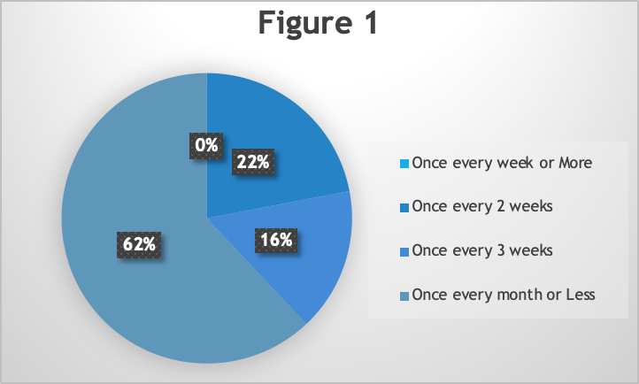
When respondents were asked how many times they purchase a body wash, 62% answered Once every month or Less, 22% responded Once every 2 weeks, 16% said Once every 3 weeks, and 0 respondents chose Once every week or More.
Source: SafeSoap Research Firm, Additive Free Vs. Chemical-Based

Question 6: Approximately, how long does your body wash last?

Question 7: Based on the characteristics listed below, in your opinion, which brand is the BEST?

Question 8: How important are each of the following factors related to the body wash that you regularly use?

Question 9: How do you feel about the following statements?
For the statement, “I use products that will benefit my skin without caring about the brand” , 40% participants Strongly Agreed, another 40% of the participants Agreed, 16% of respondents Disagree, and 4% Strongly Disagree.
Second statement, “I change my body wash every now and then according to what my skin is going through.”,16% answered Strongly Agree, 36% answered Agree, 34% responded Disagree, and 14% responded Strongly Disagree.
Third statement, “I care about the ingredients that my body wash contains and will only buy it if it’s safe to use.”, 42% of respondents answered Strongly Agree, 44% of respondents answered Agree, 10% responded Disagree, and 4% responded Strongly Disagree.
For the fourth statement, “The brand of a product does not concern me, and I use whatever I can afford or products that I can easily get my hands on.”, 14% answered Strongly Agree, 18% answered Agree, 44% responded Disagree, and 24% responded Strongly Disagree.
For the fifth statement, “I prefer to use products that are cruelty free.”, 30% of respondents answered Strongly Agree, 46% answered Agree, 22% of respondents said they Agree, and 2% responded Strongly Disagree.
Sixth statement, “An aesthetically pleasing package is a good indicator of a trustworthy source.”, 12% or participants answered Strongly Agree, 32% of responded Agree, 44% of respondents said Agree, and 12% answered Strongly Disagree.
For the last statement, “I look for a product that is multiuse.”, 8% of respondents answered Strongly Agree, 40% of respondents answered Agree, 34% answered Disagree, and 18% of respondents answered Strongly Disagree.

Question 10: What types of body wash do you prefer to use?

Question 11: Where did you first hear about your current body wash brand?
According to the questionnaire, 32% said they heard of their current body wash from TV Advertisements, 26% seen their current body wash on the shelf in store, 4% of respondents seen their body wash on Billboards, 26% heard of their current body wash from Word of Mouth, and 26% said Other.
Table 4
Choices | Respondents | Total
TV Advertisements | 16 | 32%
Seen on shelf | 13 | 26%
Billboard | 2 | 4%
Word of Mouth | 13 | 26%
Other | 6 | 12%
Total | 50 | 100%
Source: SafeSoap Research Firm, Additive Free Vs. Chemical-Based

Question 12: How Likely or Unlikely are you to look at the ingredient label on your body wash?

Question 13: Which statement listed below is the most personally relevant to you?
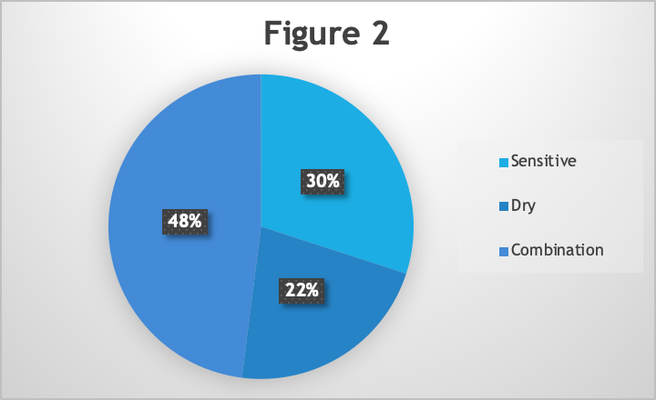
We asked respondents what their skin type is, 48% (24 respondents) answered Combination, 30% (15 respondents) answered Very Sensitive skin, and 22% (11 respondents) responded Dry Skin.
Source: SafeSoap Research Firm, Additive Free Vs. Chemical-Based

Question 14: How familiar are you with the chemicals used to make body washes?
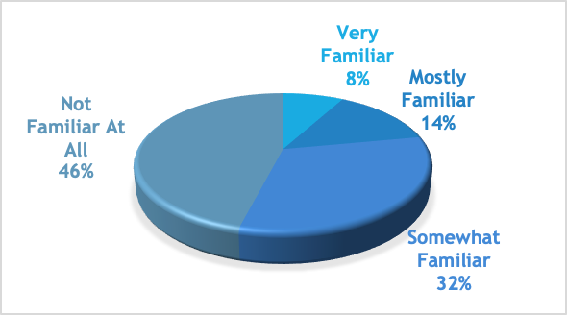
When respondents were asked how familiar they were with the chemicals used to make body washes, 46% answered Not Familiar at All, 32% responded Somewhat Familiar, 14% answered Very Familiar.
Source: SafeSoap Research Firm, Additive Free Vs. Chemical-Based

Question 15a: Do you currently live an organic lifestyle?
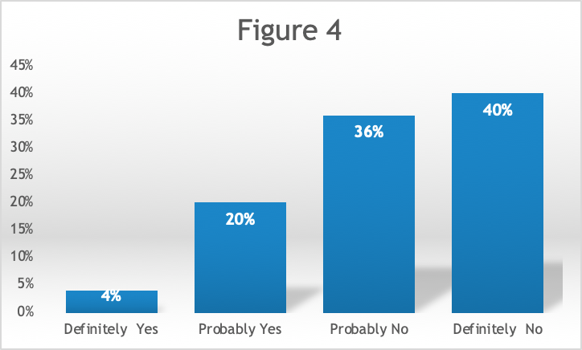
When respondents were asked if they live an organic lifestyle, 4% (2 respondents) responded Definitely Yes, 20% (10 respondents) responded Probably Yes, 36% (18 respondents) answered Probably No, and 40% (20 respondents) answered Definitely No.

Source: SafeSoap Research Firm, Additive Free Vs. Chemical-Based

Question 15b: If so, about how long have adapted to an organic lifestyle?
According to the questionnaire, 18% of respondents answered less than 6 months, 6% of respondents said 6 – 11 months, 4% responded 1 year, 10% said 3 years or more, and 30% of the respondents do not live an organic lifestyle.

Question 16: How far would you commute to purchase additive free products?
When the respondents were asked how far they would commute to purchase additive free products, 66% responded less than 3 miles, 22% answered 3 miles, 4% said they would commute 4 miles, and 8% responded 5 or more miles.

Table 5
Distance | Respondents | Total
Less than 3 miles | 33 | 66%
3 miles | 11 | 22%
4 miles | 2 | 4%
5 or more miles | 4 | 8%
Total | 50 | 100%
Source: SafeSoap Research Firm, Additive Free Vs. Chemical-Based

Question 17: Where do you typically purchase your body wash from the most?
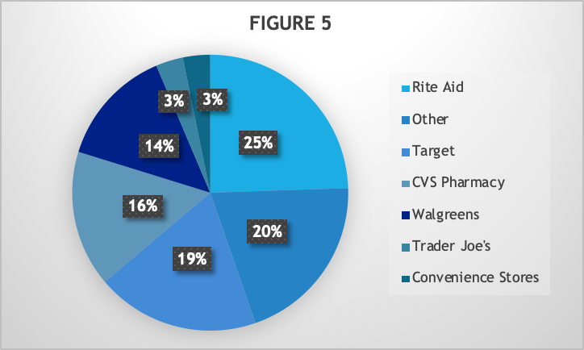
Source: SafeSoap Research Firm, Additive Free Vs. Chemical-Based

