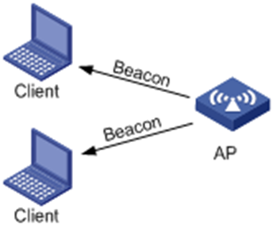

Fig. 4 of 1 H3C (n .d) [wireless ad hoc network]. Retrieved April 9, 2016, from http://www.h3c.com.hk

This image will be on the page 14. It explains the Passive Scanning with precise Access Points

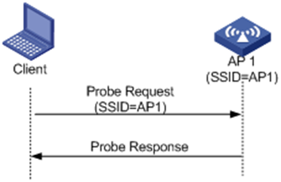

Fig. 4 of 2 H3C (n. d) [Wi-Fi probe request]. Retrieved April 9, 2016, from www.h3c.com.hk

This image will be on the page 15. It explains the active scanning with precise Access Points

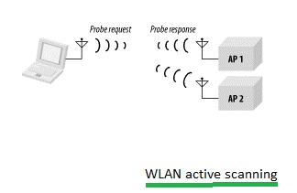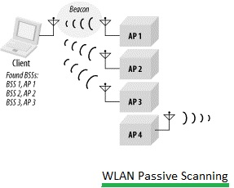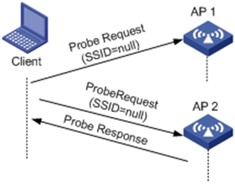

Fig. 4 of 3 H3C (n. d) [Wi-Fi probe request]. Retrieved April 9, 2016, from www.h3c.com.hk

This image will be on the page 16. It explains the active scanning with two or more Access Points

Fig. 4 of 5 RF Wireless World (n. d) [Wi-Fi probe request]. Retrieved April 9, 2016, from www.rfwireless-world.com

This image will be on the page 16. It explains the Passive Scanning with more Access Points

Fig. 4 of 4 RF Wireless World (n. d) [Wi-Fi probe request]. Retrieved April 9, 2016, from www.rfwireless-world.com

This image will be on the page 16. It explains the active scanning with two Access Points