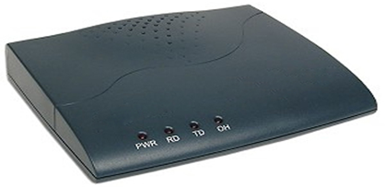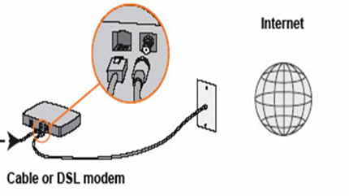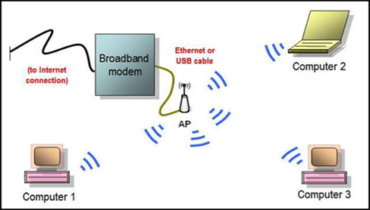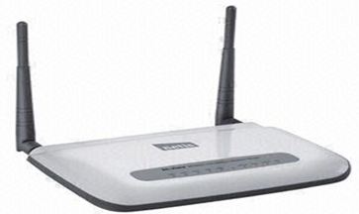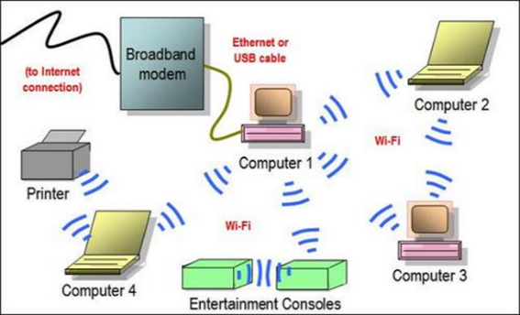

Fig. 3 of 4 (August, 2015) [External modem]. Retrieved March 28, 2016, from http://greatinformer. blogspot.com

Page 11, this is the a wired modem image

Fig. 3 of 1 Louie Wong (December 2010) [wireless ad hoc network]. Retrieved March 17, 2016, from http://www.louiewong.com/wp-content/uploads/2010/12/ad-hoc.jpg

Page 10, showing the wireless ad hoc topology

Fig. 3 of 2 Louie Wong (December 2010) [infrastructure mode]. Retrieved March 17, 2016, from http://www.louiewong.com/wp-content/uploads/2010/12/infrastructure.jpg

Page 10, showing the coordinated wireless topology

<https://www.audioholics.com/>

Fig 3of 3 by Wifi (April, 2009) Establish network wired from ISP from <http://wifiya.blogspot.com/>

Page 11, showing how to plug in the modem to the wall jack

Fig. 3 of 5 (August, 2015) [External modem wireless]. Retrieved March 28, 2016, from http://greatinformer. blogspot.com

Page 11, this is a wireless modem image