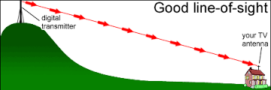
This image will be on the page 3 in chapter 1. It shows how the data travels from a transmitter to a receiver
Fig 1of 2 WSLS.com Staff, TV uhf antenna (February 04, 2013) Retrieve March 2016 (http://wsls.com/2013/02/04/hdtv-info/)
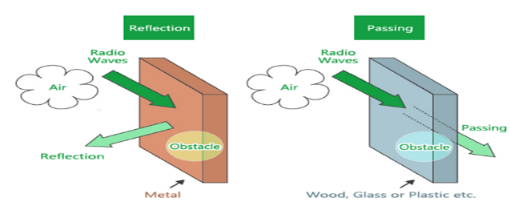
This image will be on the page 7 in chapter 2. It shows the reflection and passing of the radio waves

Fig. 2 of 1 HARADA automotive antenna authority (n. d) [reflection and passing of radio waves]. Retrieved February 07, 2016, from http://www.harada.com/en /innovation/about/radio.html
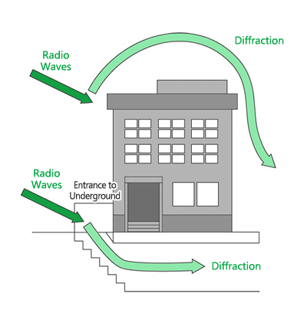
This image will be on the page 8 in chapter 2. It shows the diffraction of the radio waves

Fig. 2o2 HARADA automotive antenna authority (n. d) [diffracting radio waves]. Retrieved February 07, 2016, from http://www.harada.com/en
/innovation/about/radio.html
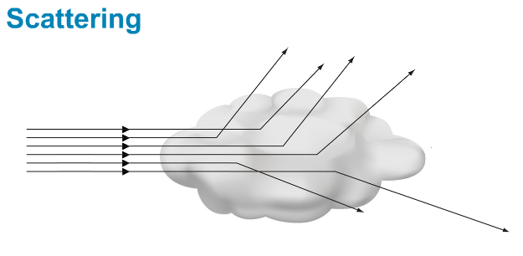
This image will be on the page 9 in chapter 2. It represents the scattering signal

Fig. 2 of 3 image of signal scattering (February 2013). [Signal encounter an obstacle]. Retrieved March 27, 2016, from http://www.enjaztech.com

