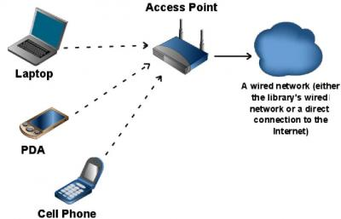
Fig. 1of1 Wireless Networking (n. d)
Retrieved February, 2016. (https://www.google.com/
Search? q=wlan&espv=2&biw=1920&bih=979&source
=lnms&tbm=isch&sa=X&ved=0ahUKEwjN5sqn2u3Kah
VIbT4KHcFNBmQQ_AUIBygC&dpr=1#tbm=isch&q=
wlan+network

Fig. 1of 1 will be on the page 1, chapter 1. I choose this image because it covers all the elements of wireless connection.
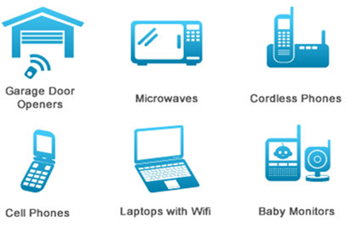

This will be on the page one. It shows the different usage of the radio waves

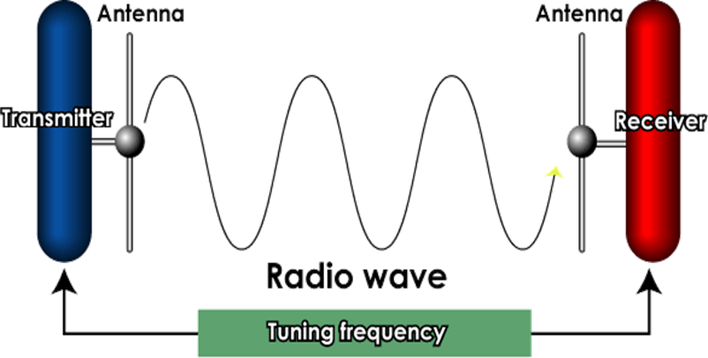
Fig. 1of 2 Radio waves uses (n. d) Retrieve March 2016 (https://www.google.com/search?q=what+is+radio+waves&espv=2&biw=1920&bih=979&source=lnms&tbm=isch&sa=X&ved=0ahUKEwjbjq-Ut4bLAhULNj4KHSX6Bz8Q_AUIBigB#imgrc=_)

This image will be on the page 3 in chapter 1. It shows how the data travels from a transmitter to a receiver

Fig. 1of 3 Radio wave (n. d).Retrieved February, 2016. (https://www.google.com/search?q=radio+waves&espv=2&biw=1920&bih=979&source=lnms&tbm=isch&sa=X&ved=0ahUKEwicvNeamNfLAhWFbj4KHcYlApEQ_AUIBigB)

