Siobhán Lynch
CDMG1111
February 17, 2015

The Letterpress

We often don’t think about printing. It’s so fast and easy to print anything our heart so desires at the press of a button, when this technology was only available to us within the last 100 years. Most of human history went without mass printing of anything. That is until the Gutenberg movable print press was invented. The movable printing press was so important to the course of human history that, without it, history as we know it, would be entirely different. The Gutenberg movable printing press is the one most important invention throughout the ages.
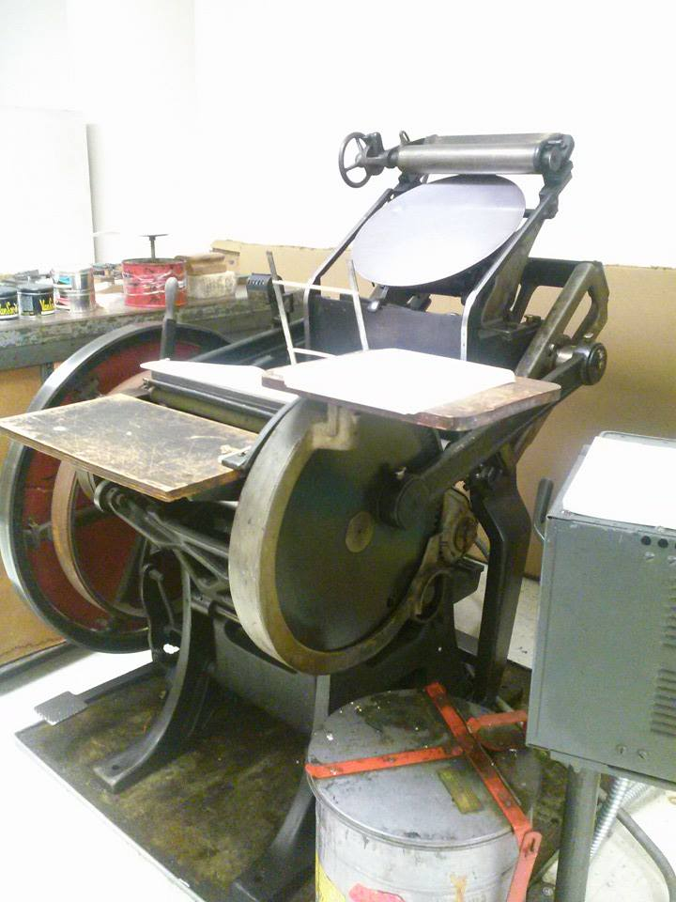
Johannes Gutenberg lived in German during the 15th century. Printing was done through wood cutting, where it was used for type and mostly art in Asia, as well as printing books in Europe. Printing with this was almost used as a stamp to paper, but eventually, these wooden blocks would degrade. Books were very rare and only available to the wealthiest of people, so many did not know how to read. Gutenberg decided on creating a faster and more efficient way to print, so by making metal type that would continually stamp type onto paper and wouldn’t degrade. This made books less expensive, promoting literacy and kick started the Renaissance. This also led to other ways of creating type such as the letterpress.
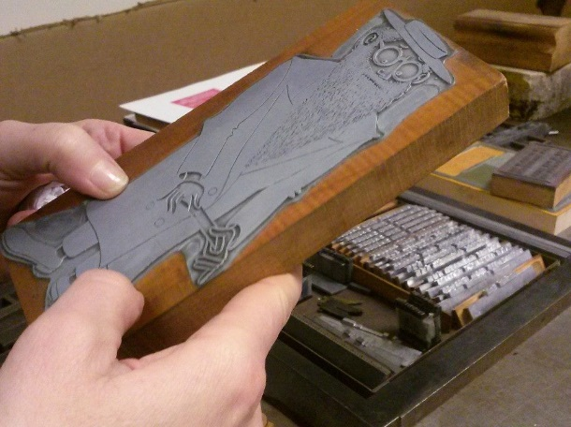
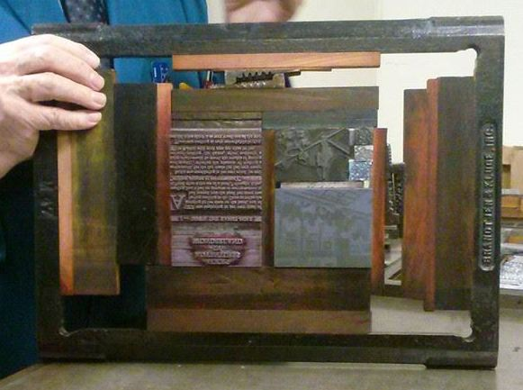
A letterpress uses raised metal type that was invented by Gutenberg for his original printing press in the 1400’s and was used as the main form of communication for over 500 years. Etching became an artists way to have their work printed. They use a special chemical to draw their image onto metal then they soak the metal in acid and it eats away the metal that wasn’t drawn on. To create a print, you first need to set up your metal type and images, if you so desire one. You need to make sure that they are straight and it’s best to make a test print to make sure there are no errors. You then set your metal type to a chase, which is a steel metal frame, and uses wooden blocks, to metal clamps to secure the type and make sure it’s even. Then you choose you ink. Ink can be your traditional black all the way red, pink, yellow, and even gold. Take a scraper and just put some ink onto the metal disc the very top of the letterpress. It’s best to use to little ink thank use to much because you can always add more ink if there’s to little, but you can’t remove ink if there’s to much. When the letterpress is one, the disc rotates slowly and two rollers move up and down the disc, picking up and spreading ink onto it as the disc rotates. The rollers also coat the metal type with ink one the chase has been securely placed into the machine. Once the metal rotating disc I fully coated in the ink, now you can start printing. You need to make sure that paper is straight so the type prints on the paper correctly. Some times you need guided in order to make sure the type presses evenly onto the paper. You can do this by placing paper under the paper to give it more volume. There are also metal guided that help keep the paper straight and hold it in place while printing.
Metal type and artists etching
1960’s Letterpress present at
New York City College of Technology
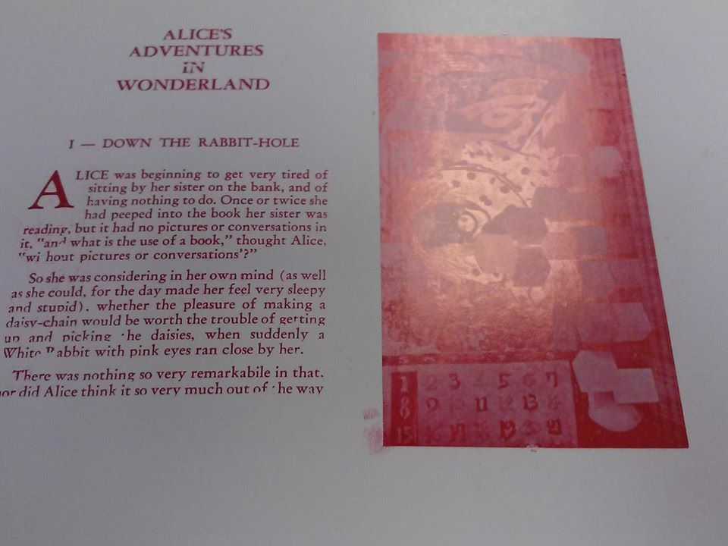
Now it’s time to print! Hold the paper you are printing on between your four fingers. Have you index and pinky fingers under the paper and your middle and ring fingers on top, YOU control the paper, so make sure it’s firm in your hands and straight , not bending. Place the paper onto the guides and then pull the metal lever when the type is parallel the paper so the type presses down and prints. The ink takes a long time to dry so make sure you don’t smudge it. There you have it, you’ve now made your own letterpress print.
The type is places upside down in the chase so the printer can read the print without flipping the paper.
A print for the letterpress. If you look closely, you can see the texture the metal type left imprinted on the page
Although the letterpress is no longer used in mass printing since the digital age, it has recently grown popular for making wedding invitations, business cards and advertisements. Even graphic designers and other kinds of artists use the letterpress to print type and then to pant on the paper that they used. This gives a hand made look to their graphics and what ever they are using the press for. Although it is now very expensive to get invitations, flyers, business cards and other printable media printed of a letterpress, the end product is well worth it and each print is not alike. One might say using a letter press makes a statement about who you are, so the price is worth the outcome.
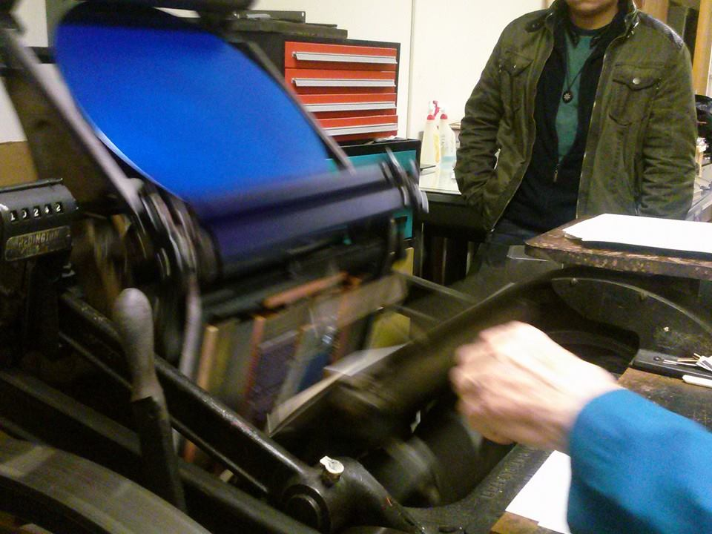
Printing is an art in it’s own. Just like any art form, it takes trial and error to get it just right. The craftsmanship is remarkable and the methods in which type, images and illustrations are turned into print is dumbfounding. Silk-screening, stone pressing, woodcutting, etching, these are all methods to create type and art prints. Print something from a letterpress for the first time is an indescribable experience that is so curiously simpler then you would imagine doing so while thinking about all of prints history. Many say with the digital age that printing is a dying art, but with it authentic and personal feel, I’d say this is only the beginning.
The letterpress in action

Work Cited

"Gutenberg and the Invention of the Printing Press." PowerShow. PowerPoint, n.d. Web. 17 Feb. 2015. <http://www.powershow.com/view/36ae1-Zjc4Y/Gutenberg_and_the_Invention_of_the_Printing_Press_powerpoint_ppt_presentation>.
"The History of Letterpress Printing." Elation Press RSS. N.p., n.d. Web. 17 Feb. 2015. <http://elationpress.com/resources/the-history-of-letterpress-printing/>.
Rebecca. "Letterpress Workshop at Hollander’s." MichiGirls. N.p., n.d. Web. 17 Feb. 2015. <http://www.michigirls.com/2013/06/25/letterpress/>.

