The role and approach of the Dental Hygienist  Gather information to obtain a complete medical and dental history of the patient.  Expose the patient to dental radiographs if necessary as part of the dental examination.  Collaborate with the dentist to provide oral education to the patient prior to chemotherapy treatment, as well as during and after treatment.  Educate the patient to brush their teeth twice a day, floss at least once a day, and avoid using mouth rinses containing alcohol,  Remind patients who use a complete or partial denture that they should clean it with a denture cleaning solution once a day.  Recommend a dental cleaning at least three times a year and provide fluoride varnish or fluoride gel as an essential part of a dental treatment plan.  Fabricate custom fluoride trays for the patient and provide instructions on how to use the trays with prescription fluoride for the prevention of cavities.  Update the patient’s medical history at every dental hygiene visit since the patient’s immune system is altered due to the chemotherapy treatment.  Provide education to patients on the importance of cessation of alcohol and/or tobacco use.  Communicate with the dentist and the patient’s oncologist to see if antibiotic prophylaxis should be used before any dental prophylaxis procedure. | References:  1. Grando, L.J., Mello, A.L., Salvato, L., Brancher, A.P., Morsl, J.A., & Steffenello-Durigon, G. (2015). Impact of leukemia and lymphoma chemotherapy on oral cavity and quality of life. Special Care in Dentistry, 35(5), 236-242. doi:10.1111/scd.12113  2. Hartnett, E. (2015). Integrating Oral Health Throughout Cancer Care. Clinical Journal of Oncology Nursing, 19(5), 615-619. Doi:10.1188/15.cjon.615-619  3. Curtis TA, Beumer J., 3rd . Restoration of acquired hard palate defects: Etiology, disability, and rehabilitation. In: Beumer J, Curtis TA, Marunick MT, editors. Maxillofacial rehabilitation: prosthodontic and surgical considerations. St Louis: Ishiyaku Euro America; 1996. pp. 225–84.  4. Chambers MS, Garden AS, Kies MS, Martin JW. Radiation-induced xerostomia in patients with head and neck cancer: pathogenesis, impact on quality of life, and management. Head Neck. 2004 Sep;26(9):796–807.[PubMed]  5. Diaz-Sanchez RM, Pachón-Ibáñez J, Marín-Conde F, Rodríguez-Caballero Á, Gutierrez-Perez JL, Torres-Lagares D. Double-blind, randomized pilot study of bioadhesive chlorhexidine gel in the prevention and treatment of mucositis induced by chemoradiotherapy of head and neck cancer. Med Oral Patol Oral Cir Bucal. 2015 Feb 7;[PMC free article] [PubMed]  6. Vera-Llonch M, Oster G, Hagiwara M, Sonis S. Oral Mucositis in Patients Undergoing Radiation Treatment for Head and Neck Carcinoma. Cancer. 2006;106( 2):329–336.[PubMed]  7. Yang X, Tridandapani S, Beitler JJ, Yu DS, Chen Z, Kim S, Bruner DW, Curran WJ, Liu T. Diagnostic accuracy of ultrasonic histogram features to evaluate radiation toxicity of the parotid glands: a clinical study of xerostomia following head-and-neck cancer radiotherapy. Acad Radiol. 2014 Oct;21(10):1304–13.[PMC free article] [PubMed]  8. Corsalini M, Rapone B, Grassi FR, Di Venere D. A study on oral rehabilitation in stroke patients: analysis of a group of 33 patients. Gerodontology. 2010 Sep;27(3):178–82. [PubMed]  9. Chen J, Wang C, Wong Y, Wang C, Jiang R, Lin J, Chen C, Liu S. Osteoradionecrosis of mandible bone in oral cancer patients - associated factors and treatment outcomes. Head Neck. 2014 Dec 18; | Chemotherapy and Dental Hygiene  Presented by:  S. Leveque  A. Vargas-Kawalla  V. Marino  APRIL 2019
What is Cancer? Cancer is a disease where abnormal cells uncontrollably divide and spread into surrounding tissues and destroy them.  What is chemotherapy? Chemotherapy is a type of cancer treatment that uses chemicals to stop the cancer cells from dividing. This works throughout the whole body but can have some dire side effects on the oral cavity and these effects are a major cause of illness in patients undergoing chemotherapy  Oral Manifestations from Chemotherapy  - Mucositis: most common, it is the painful inflammation and ulceration of the mucous membrane (soft tissues of mouth like the inside of the cheek) Can result in increased risk for infection and inability to eat due to open sores.  - Mouth bleeding/easy bleeding from brushing: sometimes chemotherapy drugs affect the ability of the blood to clot. Bleeding may be mild or severe, especially at the gum line and from ulcers in the mouth from mucositis. If the patient has pre-existing gingivitis or periodontitis, gingival oozing can be induced even by normal brushing and flossing  - Dysgeusia: changes in taste perception  - Mouth infections and vulnerability to infection  - Xerostomia: dry mouth, however this one manifestation can lead to a whole assortment of serious oral problems. Can lead to increased dental caries (cavities), parotid gland enlargement, difficulty eating, oral candidiasis, salivary gland infection (sialadenitis), and halitosis (bad breath)  - Tongue Pain (glossodynia)  - Osteoradionecrosis: the loss of large areas of bone and soft tissue due to necrosis *  *Only a minority of patients goes on to develop osteoradionecrosis and this is thanks to a multidisciplinary collaboration along with better oral hygiene patient education | Signs and symptoms of Xerostomia  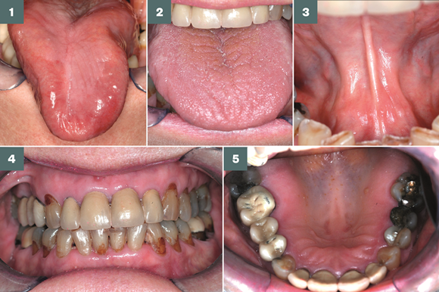  Osteoradionecrosis  Mucositis  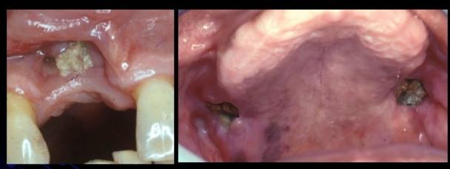  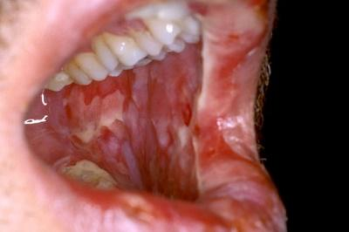  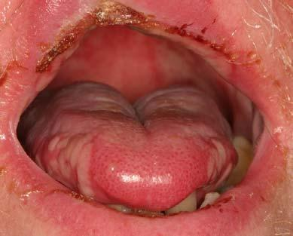 | Oral Care Before, During and After Chemotherapy  Treatment Before: It is important to have a dental visit at least 4 weeks prior to beginning chemotherapy treatment. Why so? Dental care prior to treatment can reduce oral complications by decreasing the number of bacteria in the mouth and reducing the risk of infection.  How is this done?  - Identifying and treatment of existing conditions such as cavities, periodontal disease, endodontic disease and infections  - Removing any source of dental trauma such as ill-fitting dental appliances and dentures  - Providing preventative treatment  - Completing all invasive procedures at least 14 days prior to the start of chemotherapy  Patient education is also a key factor for optimum oral health.  During: Many patients undergoing chemotherapy become immunocompromised and cannot receive dental treatment. Thus, good oral hygiene is a must and should include:  - Brushing twice daily with a soft toothbrush  - Floss and rinse daily  - Eat healthy foods that are low in sugar  - Using lip balm and chewing sugarless gum and sugar-free candy  After: In some cases, oral health problems that arise during chemotherapy treatment can become permanent. Thus, long term surveillance of patients is important and should be done every 3-6 months. *  * Patients need to be aware that invasive procedures should not be performed up to 1 year after receiving bone marrow transplant.  What have some patients had to say about the importance of dental care? “My doctor referred me to the dentist. She said it would be dangerous to begin chemotherapy with my mouth in such bad condition.” “As my dentist puts it, you need to take good care of your mouth now more than ever.”

