Shannon Brown
PHYS 1117.8682
Prof. Acquaviva
12/1/2012

The Hubble Telescope – A History of Discovering the Cosmos and Uncertain Future that Remains

In the beginning, early astronomers viewed the night sky with modest technology. In order to know what exists beyond the stars a device needed to transcend its predecessors. The Hubble telescope was launch into space in 1990, in order to produce detailed imagery for the public viewing of galaxies, planets and stars. However, trials and tribulations plagued the development and post-launch of the telescope. We must examine the Hubble’s history, progress since it was launched into the outreaches of space and what the future holds for it to continue to apply its services or face demise.
The Hubble name originated from Edwin P. Hubble, who noticed through extensive observations through his 100-inch Hooker telescope. In his ground based observatory, where he discovered the universe was in fact expanding and not remaining static. It was through his ground breaking observation’s that astronomers believed it was necessary to place a telescope into space in order to obtain further information for the items we cannot bear witness from Earth without the assistance of a telescope in space. Prior to being sent into Earth’s orbit, the Hubble was consistently delayed in pre and post-production due to trying to obtain government funding, acquiring the proper equipment to be fitted in the telescope and Challenger (1/28/1986) space shuttle tragedy that put a hold on further launches until 1988. Ultimately, after time elapsed NASA deems it necessary to begin the process to release the delayed Hubble telescope into Earth’s orbit.
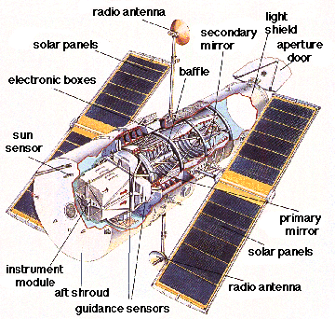
On April 24, 1990, the Hubble telescope was launched with the Discovery space shuttle. From the NASA website, an article entitled “ A Brief History of the Hubble Space Telescope”, which provides an in-depth look at what technology was equipped with the telescope: “The telescope’s original equipment package included the Wide Field/Planetary Camera (WF/PC), Goddard High Resolution Spectograph (GHRS), Faint Object Camera (FOC), Faint Object Spectograph (FOS), and High Speed Photometer (HSP).”(pg 4). The Hubble had the capacity to be the first camera place into space to have unlimited subjects to photograph. After a period of time in the Earth’s orbit it became clear the images being returned from the Hubble were blurred and adjustments needed to be made. NASA was highly disappointed with the results and needed to investigate this error to discover that it stemmed from “a spherical aberration in the primary mirror” (page 3). In 1993, a shuttle was sent to install the new “COSTAR, for Corrective Optics Space Telescope Arial Replacement”(pg 3). This change compensated for the aberration in order for the Hubble’s imagery could be clear. The new images provided clear results that NASA to begin obtaining information about Earth’s surrounding atmosphere. Ultimately, justifying the main reason for having the telescope monitoring the activity in space.
Once the images are processed from the Hubble, they are in black and white and later retouched and color is added to the pictures. This helps to differentiate the important functions of the galaxies, planets, moons and stars. It also aids the public understanding by having the pictures colorized, they can relate colors to certain entities. For instance, the planet Mars has been given the surname of the red planet due to the atmosphere that projects. All planets have been given their own individual color that represents their environmental characteristics.
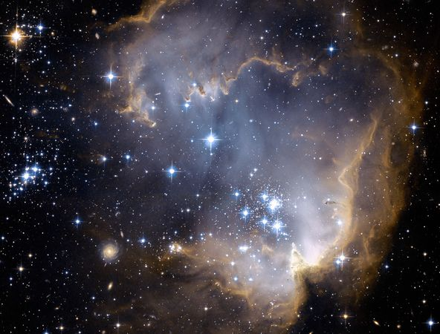
From 1993 – 2012, the Hubble telescope made significant discoveries that have been documented from space. According Dan Stillman of the Institute for Global Environmental Strategies posted on the NASA website the article entitled “What is the Hubble Space Telescope?” which provides information on the discoveries the Hubble made while in space. For instance: “Hubble pictures have helped scientists guess the age and size of the universe. Scientists think the universe is about 13 or 14 billion years”(Stillman, pg 1). Based upon the images taken, it has provided enough information
to determine a vital question of how long has space been in existence? It also provided a better understanding how planets and galaxies evolve. The telescope has discovered black holes, which has the ability to devour anything within its reach that is in its vacuity. Dark energy has also been located that causes the universe to move at an exponential rate as time persists. The Hubble has allowed scientists to learn why explosions occur in space as well as why stars may die. This documented information can assist scientists develop a stronger understanding of why these things happen. So this can be relayed back to the public in order to enforce a better understanding of the universe and how it can relate to everyone. This can determine what the future may hold for the expanding universe and Earth as time persists.
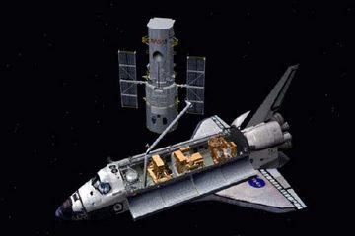
The future of the Hubble telescope has undergone scrutiny, whether it is feasible to continue servicing an aging device. From “Glimpsing the post-Hubble Universe” article by Andrew Lawler, who reflects upon the Hubble telescope history and the persisting issue of whether it is still necessary to keep maintaining old technology when new and improved options are being developed? Lawler continues his argument by suggesting that other means are be created to have devices on the ground to provide the imagery that the Hubble currently delivers. He provides this statement: “ Developing accurate lasers has proved problematic, but they are improving” (Lawler, 2002, pg 4). In time, space based telescopes may not be necessary if lasers can also provide the same results without unreasonable costs or endangering a future NASA crew. Earth bound lasers could also go into the far reaches of space to identify galaxies beyond our scope. If they are developed to the quality that it can match the imagery the Hubble can produce. It will take time before this may become a sustainable option.
Another issue arose; the Hubble telescope has become an expensive piece of equipment that NASA may not want to continue to support. The rising costs to continue to send astronauts into space to fix or update the equipment has become an expense that NASA may not want to support. Continuing from Lawler article, he to explores a multitude of aspects that has to be considered prior to prepare a space shuttle to service the Hubble. He explains, “Planning requires a standing army of technicians and engineers, plus exhaustive training for astronauts who carry out the work. And then there’s the $500 million price tag for the shuttles flight”(Lawler, pg 3). Also, the risks to send astronauts into space requires the men and women to be trained to make updates to a system that was originally created in 1990. Numerous services updates portions of the equipment to be changed when it malfunctions but the ones that are still working are left alone until they expire.
Another issue occurs from the instability of the shuttles and the potentiality of explosion after launch. In 2003, the space shuttle Columbia disintegrated while returning into Earth’s atmosphere, killing a number of seven crewmembers. The lives of the astronauts and the families need to be considered if NASA continues to service the Hubble in the near future. Instead of missions that require astronauts, robots can fulfill the servicing duties to elevate the cost as well as the space shuttle crew. Or another telescope could be sent into Earth’s orbit that has the information that we have learned from the Hubble but with current technology so it can retire.
Possibly, studies can be performed to see what changes in space have developed. Or what new packaging can be designed to make a stronger more durable telescope to the elements so it can survive longer in space with less service updates. If there is no way to resolve this dilemma then the Hubble program may be forced to end if safer options are not obscured. However, the public may continue to show support for the telescope to extend its service in space in order to continue to observe the majestic images it can still acquire. Historically, it reflects the accomplishments we as mankind have ascertained from the 20th through to the 21-century. We as a society have evolved from our predecessors to become beings that can reach alien planets without leaving the comforts of Earth.
The Hubble telescope began its space career with high expectations from both the scientific community and public of what galaxies, planets and star imagery can be photographed. Since the beginning, the Hubble had faced multiple tribulations that stemmed from the telescope’s technology that fell short of supplying flawless images from the outreaches of space. After years of unlimited discoveries, which stemmed from the black holes, dark energy, explosions and stars expiring. The Hubble’s significance is coming into question. When new advances are becoming options from robots to lasers in order to fulfill the duties the great telescope could as well as provide the same outstanding results. Will the NASA still continue to support the project or will the Hubble telescope face demise in the near future? Or will public opinion continue to support the telescope since it reflects our evolution since the beginning of time?

Works Cited
- A Brief History of the Hubble Space Telescope. (2008). Retrieved from http://history.nasa.gov/hubble/printfriendly/index.html
- Lawler, Andrew. (2002). Glimpsing in the post-Hubble Universe. Science; February 22, 2002, Vol. 295 Issue 5559, p1448-1451, 4p
- Stillman, Dan (2010). Feature: What is the Hubble Space Telescope. Retrieved from http://nasa.gov/audience/forstudents/k-4/stories/what-is-the-hubble-space-telescope-…

