Shan Li

DEN 2315 Pharmacology Summer 2020

Summer 2020

   Grapefruit interaction with drug

       The grapefruit is a [subtropical](https://en.wikipedia.org/wiki/Subtropics) [citrus](https://en.wikipedia.org/wiki/Citrus) tree known for its relatively large sour to semi-sweet, somewhat bitter [fruit](https://en.wikipedia.org/wiki/Fruit). Grapefruit is name citrus [hybrid](https://en.wikipedia.org/wiki/Hybrid_(biology)) originating in [Barbados](https://en.wikipedia.org/wiki/Barbados) as an accidental cross between the [sweet orange](https://en.wikipedia.org/wiki/Orange_(fruit))  and [pomelo](https://en.wikipedia.org/wiki/Pomelo) , both of which were introduced from Asia in the seventeenth century. When found, it was nicknamed the "[forbidden fruit](https://en.wikipedia.org/wiki/Forbidden_fruit)". Frequently, it is misidentified as the very similar parent species, [pomelo](https://en.wikipedia.org/wiki/Pomelo). The interior flesh is segmented and varies in color from white to yellow to red to pink (1). It can be consuming fruit whole or as a juice or pulp.

        With changing of people’s eating habits for a healthy diet. As a low-fat dairy product, grapefruit had become one of the most popular fruit. because it is low in calories but contains a range of essential vitamins and minerals which claims will benefit the overall health. According to the research, the high concentration of vitamin C (ascorbic acid) is probably the most significant contribution of Grapefruit to human health and nutrition. Grapefruit providing average vitamin C concentration ranging from 23 to 83 mg/100 g fresh weight. A medium‐sized orange or grapefruit contains approximately 56 to 70 mg ascorbic acid, and an average 225‐mL serving of orange juice typically contains 125 mg ascorbic acid (4).Therefore, grapefruit has to be considered as an excellent source of [vitamin C](http://www.whfoods.com/genpage.php?tname=nutrient&dbid=109) which helps to support the immune system and may help reduce severity of cold symptoms.

          However, grapefruit is not a friendly fruit for dental hygiene. Like all other citrus fruits, grapefruit has a high level of acidity level which has significant adverse effect on teeth.  Eating large amount of it will cause damage to the teeth, because the enzymes in the mouth will decomposed by the fruit acid which will cause the negative effective on the tooth enamel. To keep the teeth in a healthy level, it is very important to gently rinse the mouth and brush the teeth after eating or drinking grapefruit and grapefruit products.

          Besides the negative impact on the oral health, grapefruit also have some drug interactions and potential contraindications. Various studies have demonstrated the ability of grapefruit juice to significantly increase exposure to single doses of triazolam, with associated impairment in psychomotor function and increased drowsiness, although some authors considered this effect to be minor. The USPI advises that grapefruit juice and triazolam should be administered with caution (2). Triazolam is anti-anxiolytics often gave to patient who has dental Anxiolytics before the dental appointment. If the patient take anti-anxiolytics with Grapefruit juice might increase potency of the drug and lead somnolence.

Another interaction of Grapefruit juice is that alters the metabolism of amiodarone with complete inhibition of N-DEA production. As it has been  shown that during the grapefruit juice period amiodarone concentrations reached values exceeding therapeutic concentrations (3).Amiodarone is often use Antiarrhythmics drug , if the patient take with grapefruit juice might increase the risk if QT interval prolongation . It also increases the patient have dangerous arrhythmias during the appointment.

           In conclusion, all food has advantage and adverse sides, even like grapefruit, a healthy food that has always been highly regarded. Grapefruit can help us lose weight and promote the health of our immune system. However, when eaten in large amounts, the acidic substances in it can cause permanent damage to our teeth. Consume it with other medication may also bring negative impact to our body. Therefore, it is very important to understand the scientific characteristics of food intake; control and maintain the balance of our dietary.

References

1. Wikipedia contributors. "Grapefruit." Wikipedia, The Free Encyclopedia. Wikipedia, The Free Encyclopedia, 16 Jun. 2020. Web. 19 Jun. 2020.
2. Seden, Kay, et al. “Grapefruit-Drug Interactions.” Drugs, vol. 70, no. 18, 2010, pp. 2373–2407.

3. Libersa, Christian C., et al. “Dramatic Inhibition of Amiodarone Metabolism Induced by Grapefruit Juice.” British Journal of Clinical Pharmacology, vol. 49, no. 4, 2000, pp. 373–378.

4.  Liu, YuQiu, et al. “History, Global Distribution, and Nutritional Importance of Citrus Fruits.” Comprehensive Reviews in Food Science and Food Safety, vol. 11, no. 6, 2012, pp. 530–545.

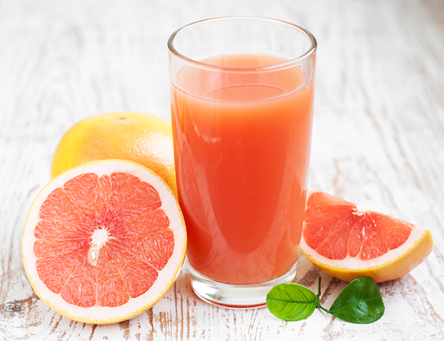

References

1. Seden, Kay, et al. “Grapefruit-Drug Interactions.” *Drugs*, vol. 70, no. 18, 2010, pp. 2373–2407.
2. Libersa, C C et al. “Dramatic inhibition of amiodarone metabolism induced by grapefruit juice.” *British journal of clinical pharmacology* vol. 49,4 (2000): 373-8. doi:10.1046/j.1365-2125.2000.00163.x
3. Wikipedia contributors. "Grapefruit." *Wikipedia, The Free Encyclopedia*. Wikipedia, The Free Encyclopedia, 16 Jun. 2020. Web. 19 Jun. 2020.