iPhone 6 & 6+ Digitizer Replacement
This is NOT recommended as a first project for beginner. Continue at own risk.

IMPORTANT: For this project you must be cautious of any static electricity, whether from everyday friction and from the device itself; as it could result in a small electrical discharge. While non-fatal for a full sized human it could potentially destroy or corrupt resulting in loss of data. Another worst-case-scenario is shocking your logic board could result in total loss of functionality; in either case you can run the risk of bricking your phone so we recommend taking extra precautions such as wearing a technician’s anti-static wrist band especially when contact with any internals.

Side Note: Before performing any DIY repair, you should evaluate all your options. For those that purchased AppleCare+ for their iPhone 6, go straight to an Apple Store or call 1-800-APL-CARE to schedule a mail-in repair. Your warranty covers you for this kind of incident, and it will cost you far less. If you are under apple care protection, opening this phone up, automatically voids all warranties and protection.
***But be warned that AppleCare+ only covers two incidents of accidental damage.***

Further warnings will be in red text.
Notes from Author will be surrounded by (*** ***)
Pictures only are provided where necessary

1. Materials Needed
Total Expense for purchasing all materials (Scale: $-$$$$)

1.1 Replacement iPhone6 Digitizer ($$$):
*** Must have ribbons to connect to iPhone, if no ribbons (pictured below) you purchased just the screen not the digitizer. ***
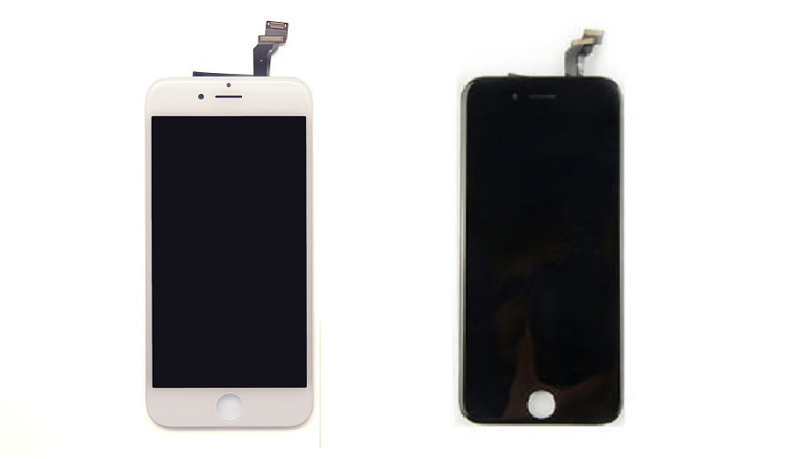
- White & Black Replacement screens (with connectors at top)

1.2 IPhone 6 Repair Kit ($):
***Tools made of steel and plastic***
1 x T4 screwdriver
1 x T5 screwdriver
1 x T6 screwdriver
1 (5-point star) screwdriver
1 Flat head screwdriver
1 Phillips head screwdriver

One (1) Straight or curved tweezers | 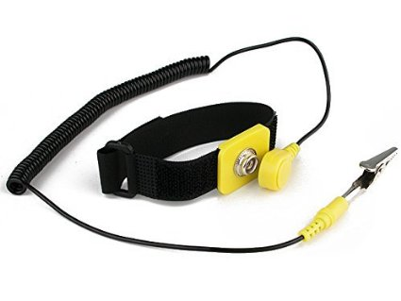
One (1) Pry opening tool
or (1) Triangle opening tool
One (1) Scraper
One (1) Suction cup
One (1) Mask
One (1) Goggles (if screen is broken)
One (1) Anti-Static wrist strap (pictured)
- Anti-static wrist strap (above)

INSTRUCUTIONS

Note: Some people have trouble getting the screen off with a suction cup if it is extremely spider-ed. This is why we recommend picking up a razor blade or pry tools.
*** Wear Mask if screen is spider-ed. ***
- Power off iPhone 6
Before performing any repairs you must always completely power down your iPhone. Press and hold the Power button until you see the Slide to Power Off indicator, slide and full power off.
- Remove 2 Dock Screws
Using your 5-point screwdriver remove the 2 pentalobe screws that sit on either side of the lightning dock. (Next to charger port)

***Set them aside but keep your screws organized as they can get easily confused but the dock screws are different than any other screws. ***
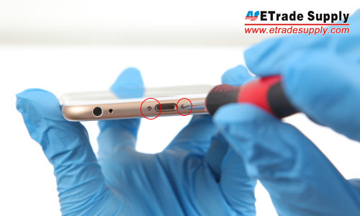
-Picture of the 2 screws to be removed. (Obtained from blog)
- Remove Broken Screen
*** If your screen is spider-ed you must wear glasses and a mask when prying the screen up as glass and broken glass pieces will fly into the air and can damage eyes and lungs. Use a pry tool, or razor blade to get the screen up ***

- Use the suction cup to carefully pry up the bottom of the display. Position the suction cup right above the Home button.
- Take care not to pull up too hard as there are still ribbon cables at the top holding the display to the logic board.
- Pull upwards the reveal the cables at the top that will need to be disconnected.
- Use the Phillips head to remove the 5 screws at the top right (pictured below).
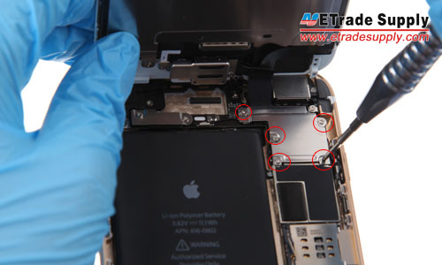
- Picture of 5 screws to be removed. (obtained from a blog)
*** Be sure not to mix up these screws as they are all different sizes and should be put back in the same order. Then remove the display shield with your tweezers.***

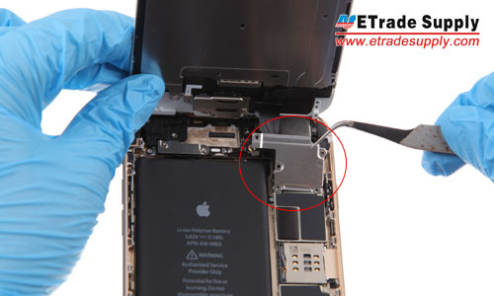
- Picture removing display shield. (obtained from a blog)
- There are 4 ribbon cables holding the display to the logic board, they should pop off rather easily.
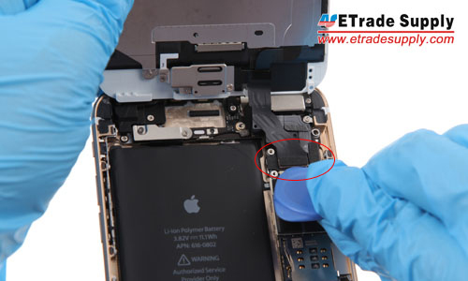

*** Try not to damage the logic board in this step, take care in how you pry. ***
- The ribbons are layered on top of each other so you will need to handle the top row first and make your way down to the last ribbon.
- The first 2 are plainly visible, carefully pry them up.
- This exposes the third ribbon.
- Underneath that is the 4th and final ribbon, which should free the screen.
- Transfer Your Touch ID
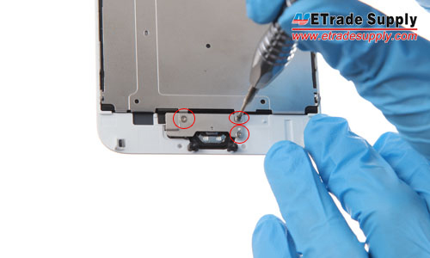
-Picture of removal of Touch ID plate (obtained from a blog)
- On the back of your broken screen, remove the 2 screws on the Touch ID shield.
- You may remove the Touch ID silver shield.
*** Keep track of all your screws. ***
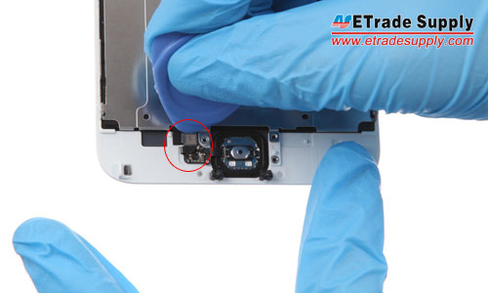
- Picture of connector to take out the Touch ID (obtained from blog)
- Take care to remove the single cable ribbon connecting the Touch ID and Home Button (As pictured above).
- Place the entire Touch ID and Home Button assembly in the new replacement display, lining it up correctly.
- Secure the new screen with the single cable that holds the Touch ID to the front assembly.
- Put back the silver shield and the 2 screws to mount the Touch ID in place.
- Swapping the Speaker and Front facing camera
- Undo the 3 screws that holding the metal cover on the ear speaker.
- Take out the metal plate, taking out the ear speaker and front facing camera (pictured)
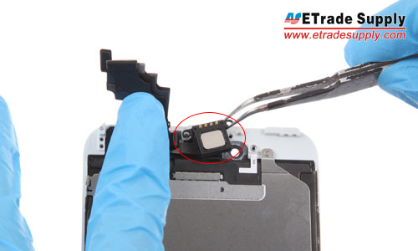
- Removal of Ear Piece (obtained from a blog)
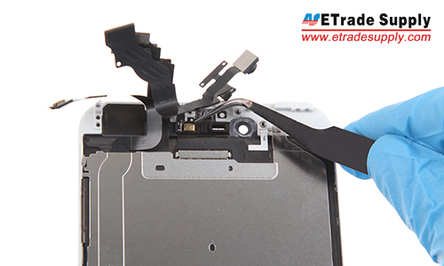
- Removal of Front Facing Camera (obtained from a blog)

- LCD Metal Plate Swap
- Undo the 7 screws that lock the LCD metal plate down
- Then pry up the LCD back plate connector
- Then put on the new LCD, put in the screws, and connect the LCD connector.

- Installing New Display
- One by one secure the four cables on the new display to connect your display to the logic board. In the reverse order of how you removed them. (this time bottom to top)
- Place silver shield back and use the 5 screws that hold it in place with the Phillips head screwdriver.
- Line up the top of the display with the edges of the frame, paying special attention to the indents in the frame. Start with the top and work your way to the home screen.
- Carefully push the display down to align it with the frame, if any resistance is met start again and push down slowly, keep doing this until frame is perfectly aligned.
*** Do not force, this may damage frame. It will gently align right when placed properly. ***
- Replacing Dock Screws
- Replace the 2 screws on the side of the charger port, don’t screw them in too tight, in case you need to open this up and test it out in case you aren’t getting functionality.
- Testing The New Display
- Once your phone is back together and you checked to make sure all the screws were used. When it is all together you can turn it back on, you’re looking for an apple logo.
*** If no apple logo one of the ribbon is misplaced or the digitizer mad be faulty ***
- You can now begin testing functionality of the digitizer to make sure you’re done with your project.
- Test the screen by typing on the keyboard and making sure there are no dead zones.
- Make a call and cover your sensors to test if the screen shuts off during the call.
- Check that you can hear calls from the earpiece.
- Check speakerphone is working.
- Test your Touch ID, fingerprint sensor, and home button to make sure there working properly.
*** If the screen does not turn on or you see black lines on the display, hold the power button and the home button simultaneously. If this still doesn’t work you must re-open your iPhone and ensure that all cables are in place and securely fastened. ***

References
Five Minutes Work to Replace Your iPhone 6 Plus Broken Screen. (December 12th, 2014). Retrieved from http://www.etradesupply.com/blog/five-minutes-work-to-replace-your-iphone-6-plus-broken-screen/

