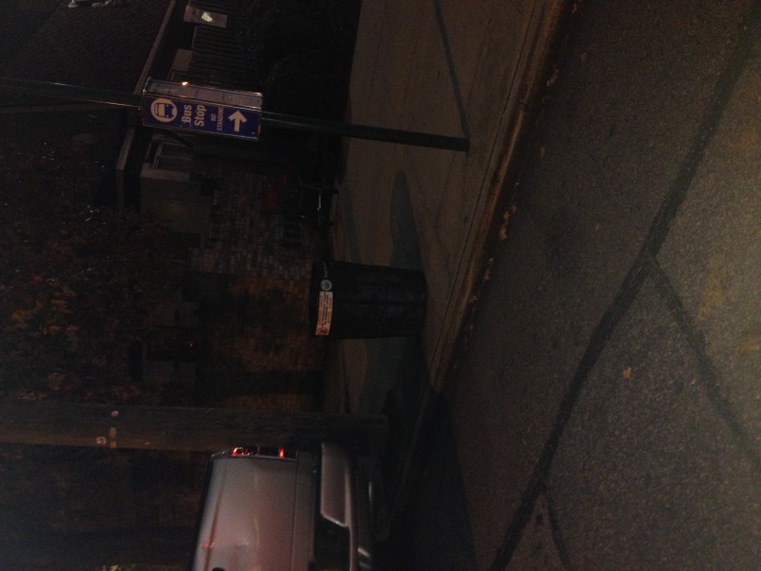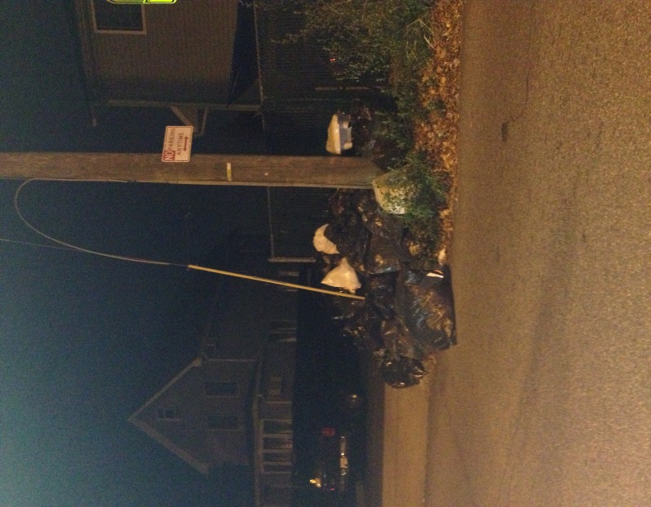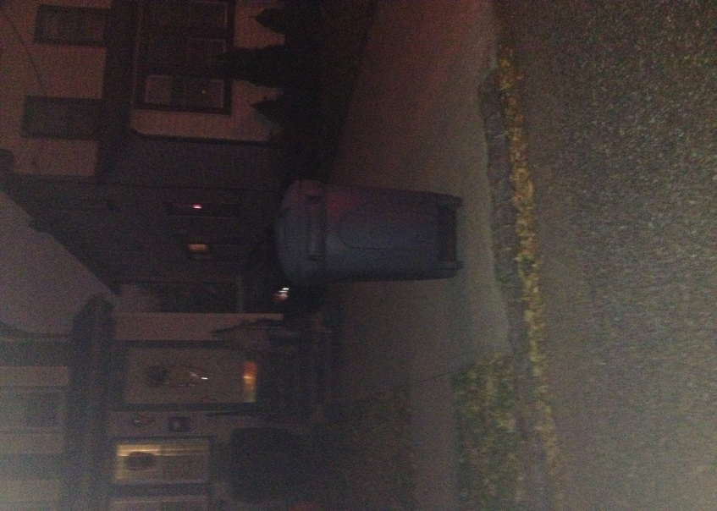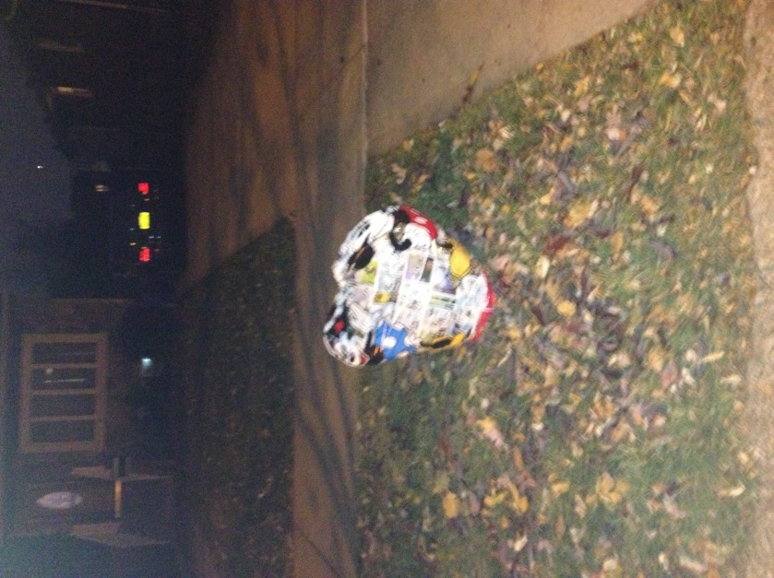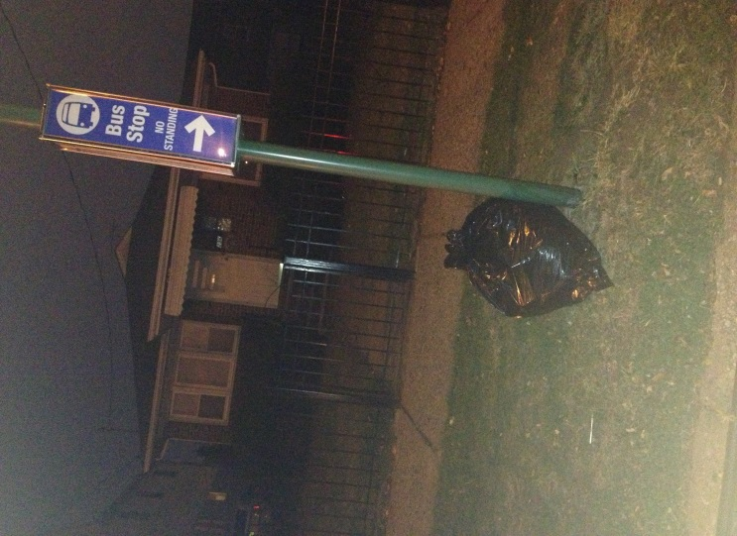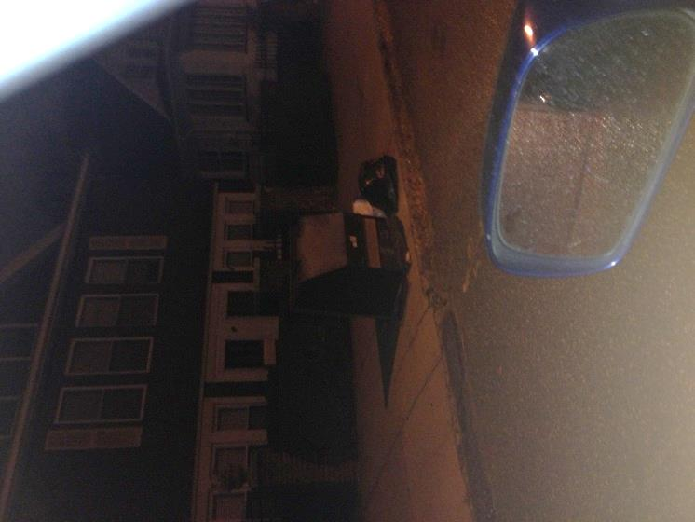
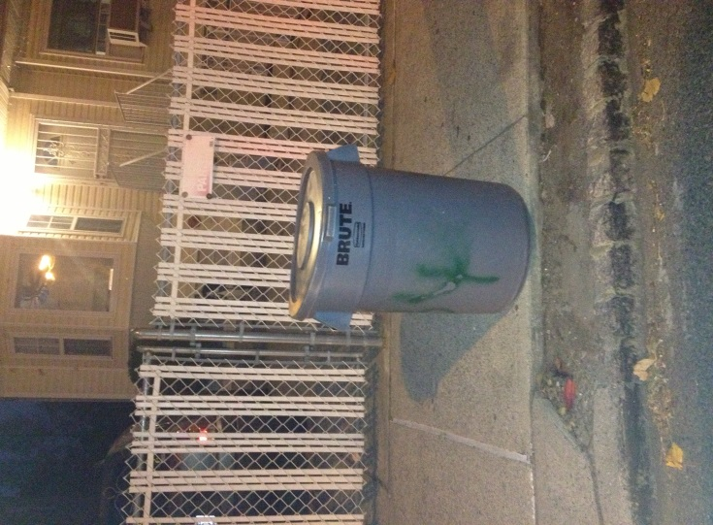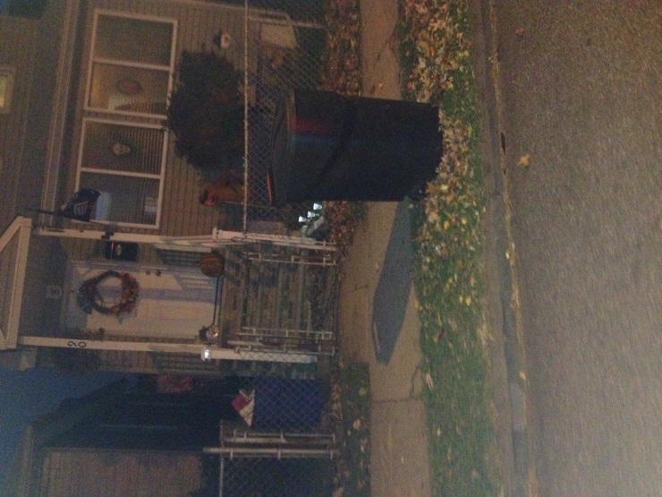

I drove around my neighborhood to take these pictures. I live in the “forgotten borough,” Staten Island. Staten Island is a borough of mainly houses. There’s an extremely small amount of buildings and it isn’t as compressed and crowded as every other borough of New York. Only certain neighborhoods contain chains of restaurant. There aren’t many city garbage cans placed along the streets of Staten Island, but the residents of Staten Island work to keep this borough nice and clean. Only delis were in between some of the garbage cans. Some of the garbage cans were near each other. The Rodent activity is very low in my neighborhood. Rodents we face here are raccoons and possums. They usually just crawl into the garbage cans and take excess food. Rats and mice aren’t much of a factor on Staten Island. I can’t compare my environment to the first article because Staten Island does not have any subway lines. There are a few garden mice that can sometimes make appearances, but I personally have never witnessed a rat in the 10 years I’ve lived here.

