New York City College of Technology
Electrical and Telecommunications Engineering Technology Department

EET 3120 Sensors and Instruments
Field Trip Report

Professor Viviana Vladutescu
Student: MOMODOU NJIE

May 7, 2015

Remote Sensing is the science of getting acquiring information from a distance. Remote sensing can be used from anything from commercial to military. Some examples may be taking images from a satellite that reads weather, or reading the number of boats that may be on a port (NOB). Some of these remote sensing tools are called the LIDAR and ND:YAG. During this essay I will be talking about my field trip to City College, where we were able to experience and see these examples of remote sensing tool is person. we observed and learned about different atmosphere instruments such as CIMEL Sun Photometer, The Multi-Filter Rotating Shadow band Radiometer MFR-7, Microwave Radiometer and others that will be explain as follows.
The first Remote sensing tool we saw was the CIMEL Sun Photometer instrument which measures incoming solar radiation periodically. It has a stepper motor that aligns the sensors to the position of the sun in order to make the measurements. It is critically important to have a clear path to the sun in order to not lose data points. It measures the incoming solar radiation at different wavelengths that can infer characteristics of the atmosphere and its components at the time.
The next instrument we saw was the Microwave Radiometer which measures humidity, temperature and brightness of clouds. It measures vertically about 10km from the surface to the sky. It has a window on top with a sensor that activates a small fan when it perceives rain or snow. When this fan is active meaning that there is rain or snow going on, the Microwave Radiometer does not make any measurement. Also it is worth mentioning that this MWR does not emit detectable radiation that could cause damage to living organism around it.
LIDAR (Light Detection and Ranging), which is a Quantum Cascading Laser. The LIDAR is an active sensor, because it emits its own light. The LIDAR uses light in the form of a pulse laser to measure different ranges/variable distance. It measure distance by measuring the time delay between its signals that it sends in the domain reflections. The LIDAR uses the same principles as a Rader, however with shorter wavelengths, making what you see very different. This laser combined with other tools, such as an airborne systems can create three-dimensional data about a certain area. Most LIDAR systems operate in the near infrared at about 1.05µm. The returning signal is observed with range gates, where the light pulse is sampled in time sequence according to ranges. There are many types of LIDAR systems, some are used for studying aerosols and dust in the atmosphere. Another two types of LIDAR are used for topographic and bathymetric. From what I can recall, the LIDAR that was being used in City College was being tested and adjusted for the purpose of hopefully adding it one day to a vehicle, to be able to tell the distance objects are around it.

The figures shows the examples From the City College website and pictures taken by myself of the instruments.

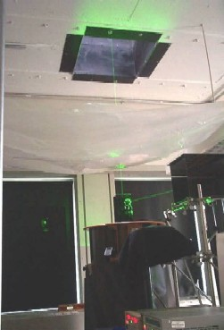

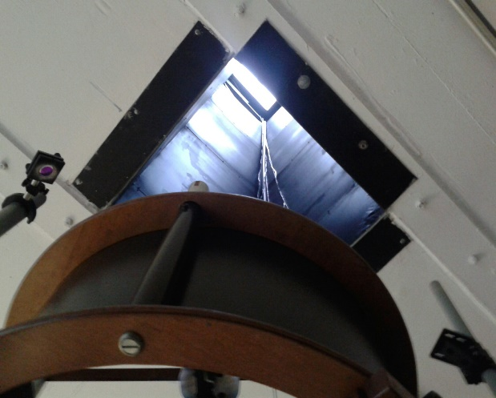

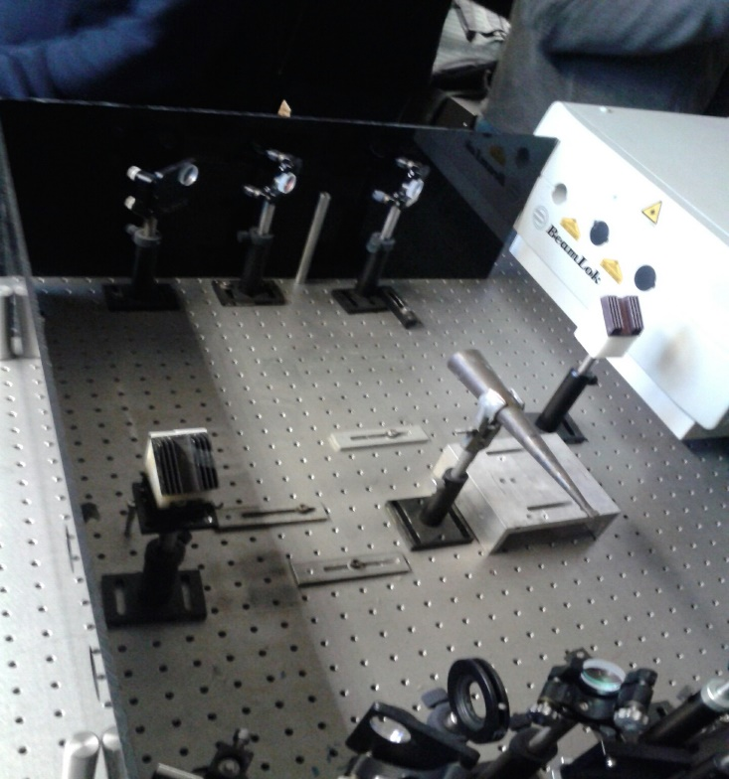

The Multi-Filter Rotating Shadow band Radiometer
This instrument measures the total, diffuse and direct irradiance simultaneously with the same
photo detector by using the photometer. The Shadow band rotates to make measurements of the
global and diffuse solar irradiance components and then its CPU computes the direct irradiance

The second laser we saw on the trip was the ND:YAG. It uses multiple lasers and that uses beam dumpers to block certain beams from being emitting. This system is very large and creates a lot of heat. Therefore it needs constant water running through it. The Nd:YAG emits an inferred signal with a light with a wavelength of 1064nm.
CONCLUSION
These lasers that we saw are very useful and can be used in many applications. From this trip, we learn a lot because we were able to see these lasers in person instead of just reading it in a book. Therefore we were able to get a more detail analyze of what the laser is actually doing.

