Department of Electrical & Telecommunication Engineering

EET-3120
Sensors and Instruments

Home Work # 1

Name of the Student: Faiz Rasool
E-Mail: Faiz.Rasool@mail.citytech.cuny.edu
Date: 02/19/2015
Submitted To: Vivian Vladutescu
Question 1:
The tire Pressure Gauge:
A strain gauge is a long length of conductor arranged in a zigzag pattern on a membrane. When it is stretched, its resistance increases. Strain gauges are mounted in the same direction as the strain and often in fours to form a full 'Wheatstone Bridge’. The diagram above represents what might happen if a strip of metal were fitted with four gauges. A downward bend stretches the gauges on the top and compresses those on the bottom. A pressure transducer contains a diaphragm which is deformed by the pressure which can be measured by a strain gauged element.
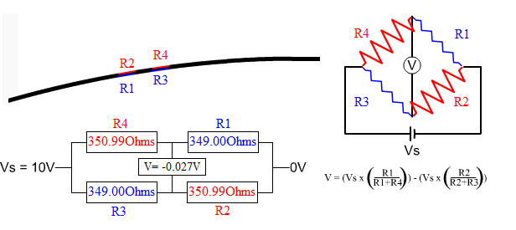

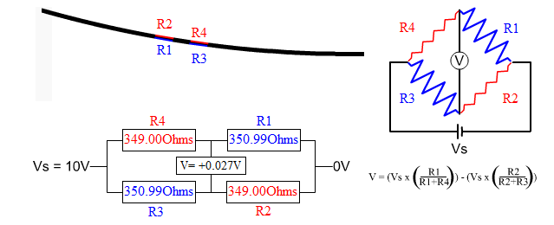
- Toaster:
Appliances that heat up, such as a hair dryer, a clothes iron, toaster, electric toaster oven, or an electric space heater all work on the same idea. They change electrical energy to heat energy.
The devices all plug into a source of electricity. Electric current runs from your wall socket down the wire and into the appliance.
Inside each of the appliances are loops of special mixture of metals. One type is called nichrome. Nichrome is a nickel / chromium alloy.
Electricity cannot pass through this special metal very easily. The metal slows down the electrons and "holds up" the current flowing through it. This is called the "resistance" of the metal. When the resistance of a metal is higher, the metal will get hot because of the friction of the electrons in the current of electricity. For more on resistance.
As the electricity is forced through the wires, the wires begin to heat up and glow very hot. If you look inside your toaster, you'll see those coils or wire glowing orange. It's those coils or loops of wire that cause the bread to brown making your toast.
In older toasters, the hot wires heat up a small device called a thermocouple. When it reaches the right temperature, which is about the same time as your toast is properly toasted, it releases a catch allowing the toast to pop up. At the same time, it shuts off the electricity. In some newer toasters, the thermocouple is replaced by a small timer.
In a hair dryer, a small fan is turned on at the same time the heater coils are turned on. The moving air is forced over the glowing wires, warming the air. The warm air blows out of the front of the hair dryer and causes the water in your hair to evaporate and dry.

Speedometer in Cars:
The digital speedometer is operated by a vehicle speed sensor. It puts out electrical pulses to be processed by the computer. The computer turns on segments of a display to form numbers, which is the speed of the car.
Television Remote Control:
The remote control's job is to wait for you to press a key, and then to translate that key-press into infrared (pronounced "infra-red") light signals that are received by the TV. When you take off the back cover of the control you can see that there is really just 1 part visible: a printed circuit board that contains the electronics and the battery contacts.
The components that you see here are typical for most remotes. You can see an integrated circuit (also known as a chip) labeled "TA11835". The chip is packaged in what is known as an 18 pin Dual Inline Package, or a DIP. To the right of the chip you can see a diode, a transistor (black, with three leads), a resonator (yellow), two resistors (green) and a capacitor (dark blue). Next to the battery contacts there is a resistor (green) and a capacitor (tan disk). In this circuit, the chip can detect when a key is pressed. It then translates the key into a sequence something like morse code, with a different sequence for each different key. The chip sends that signal out to the transistor to amplify the signal and make it stronger.
Battery life-indicator:

It is uses electric sensor. It determines the change in electric sensor signals.

- An electrostatic particle levitator operates on the principle of balancing the electrostatic force, qE , on a particle with its gravitational force, mg .A new, smaller levitator is proposed with both the levitator and particle scaled down geometrically. Assuming the same charge on the particle, determine by using scaling arguments whether or not the smaller levitator will operate the same as the original one.

Electrostatic force = L^{2;} Magnetic force =L⁴; L will reduce by 100
This will be equal to = Electrostatic force 10⁴; Electromagnetic force 10⁸
If these forces are comparable at the conventional scale, then the electrostatic force is 10 times larger than the electromagnetic.

- An archaeologist discovers an ancient length-scale bar on which its smallest divisional marks are precisely 10 cm apart. His colleague argues that the civilization that used the bar could measure lengths to accuracy as small as 0.1 cm by carefully reading in between the precise 10-cmmarks. Is the colleague correct?

NO.

References:
http://www.rdpe.com/ex/hiw-sgpt.htm
http://www.energyquest.ca.gov/how_it_works/toaster.html
http://electronics.howstuffworks.com/inside-rc.htm

