First fluid sensor based on silicon was introduced in 1974. Then after that a lot of fluidics applications were introduced based on different principles like thermal anemometry, Doppler frequency shift, interference from pressure differences and thermal flow.

Due to simple in structure, easy to use and has a lot of applications, we used thermal flow sensor. It’s a hot film or hot wire anemometer uses a thermal element that serves as heater and temperature sensor at the same time. There are a lot of silicon based sensors are used in the market but we used polyamide because it is chemically inert, cheaper than silicon and it is flexible also it loses 2 times less heat than silicon.

The principle of this thermal flow sensor is the heat transfer between electrically heated resistive sensor and fluid flow. The electrical heater feels the heat loss due to the heat transfer to fluid and it has higher temperature then its surrounding. Heat transfer depends on the speed of the fluid.

We use tungsten, platinum, or metal alloys as the sensing element, because tungsten has high-melting point, and Platinum does not have as high a temperature coefficient of resistance, while Pt has good anti-oxidation properties. Considering sensitivity and stability, the thermal elements of our hot-film sensors are made of composite materials. Ni is used as thermal element material, Pt as a cover layer & chromium as a bonding layer between Ni and Pt.

 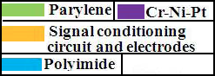

Deposition of parylene.

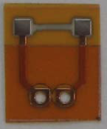 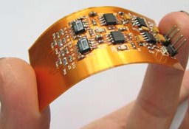 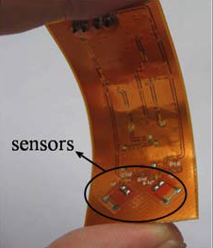

Sensor