Department of Electrical & Telecommunication Engineering

EET-3120/E260
Sensors and Instruments

Workshop

Learn to design Electronic Projects
Introduction to Arduino
(keyboard Instrument)

Prepared by: Faiz Rasool
Section: 35137
Date: 05/08/2015
Room V - 711
Submitted To: Vivian Vladutescu

Table of Content

Introduction 3

Component 3

Procedure 4

Program Code 5

Experimental Results 6-7

Analysis 8

Introduction:
On May 8th, 2015 IEEE Club of NYCCT held a workshop to design Electronic circuits with Arduino. IEEE club advisor Prof. X. Wei give us the instruction how to build the circuit, components needed, and details about programming. IEEE Club also provided us the components and programming code.

Components:
- Arduino Or Chipkit UNO 32.
- Breadboard.
- Desktop computer.
- MPEID or Arduino software
- Jumpers (wire).
- 2 – 10 KΩresistors
- 1 – 220Ω resistor.
- 1 – 1MΩ resistor.
- 4- Switch.
- Buzzer, Piezo

Procedure:
- Connected the Chipkit UNO32 Board to the personal computer.
- Typed the program provided to us by Professor Wei into MPLAB Editor window.
- Made the following jumper connections on the Breaddboard:
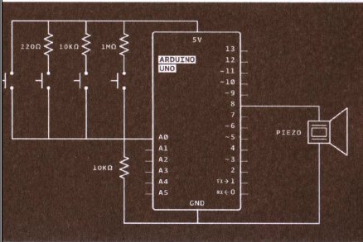

- Program the UNO32.
- Press the switches to check the circuit working.

CODES:

int buttons[6];
// set up an array with 6 integers

int buttons[0] = 2;
// give the first element of the array the value 2 note that it counts from zero

int notes[] = {262, 294, 330, 349};
//corresponds to the notes C, D, E and F

void setup() {
Serial.begin(9600);
}

void loop () {
int keyVal = analogRead(A0);
Serial.println(keyVal);

if (keyVal == 1023){
tone(8, notes[0]);
}
else if (keyVal >= 990 && keyVal <= 1010) {
tone(8, notes[1]);
}
else if(keyVal >= 505 && keyVal <= 515) {
tone(8, notes[2]);
}
else if(keyVal >= 5 && keyVal <= 10) {
tone(8, notes[3]);
}

else{
noTone(8);
}
}

Experimental Results:

Figure # 1 shows the Circuit Diagram

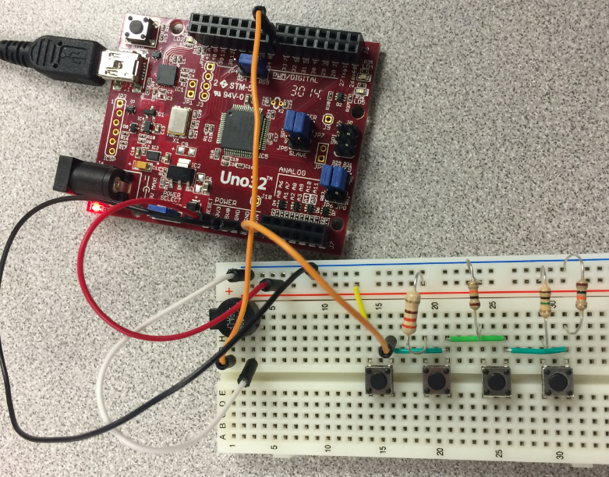
Figure # 2 shows the Keyboard Instrument after wiring

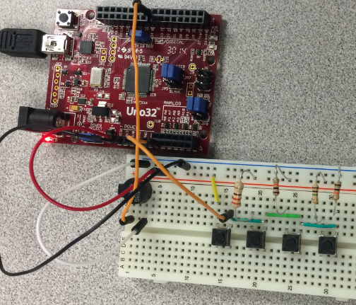
Figure # 3 shows the Keyboard Instrument

Conclusion:
We built a circuit and then we program it to get our results. When we press switches we get sound and by pressing different switch we get different sound. Our project was sucessful.

Reference:

http://en.wikipedia.org/wiki/C_%28programming_language%29
http://www.herongyang.com/Computer-History/C-Language-What-Is-It.html
http://fresh2refresh.com/cprogramming/c-language-history/

