Antonio Garcia
Professor Schmerler
English 1121-D402
May 10, 2020

UNIT III- Learning from Each Other: Affinity, And Inquiry.

Table of Contents:
Section 1: YOUR SKILL/INTEREST DURING CONFINEMENT/ WITH SOURCES

Section 2: Inquiry -- YOUR INVESTIGATION OF OTHERS’ SKILLS AND WHAT YOU LEARNED TOGETHER

Section 3: REFLECTION AND SELF-ASSESSMENT

Section 1: Skill During Confinement;
Antonio Garcia
MY SKILLS/ACTIVITIES ARE…
- Baking
- Cooking
- Fitness Routines

Here you will tell us a little bit about WHAT YOU ALREADY KNEW BEFORE the confinement/what your experience has been with this skill/activity.

I never thought I would find myself loving how to learn to bake. I never really had the chance to actually try to bake anything before the quarantine started. I think before the virus I never actually had time to bake something, I would basically just be at school, go to class, go home drop my books off and straight to the gym and then off to work. Now that I have more time being at home I actually have the chance to try baking and so far I think I’m doing a great job. I actually used to see different baking shows that would play on TV and I’ve always wondered if baking was really hard to do. I now think baking all depends on the recipe you're trying and just making sure you get all the ingredients mixed together correctly. Some shows I remember watching once in a while were, dessert games, kitchen nightmares, and the great holiday baking show.

Here You where you tell us SOMETHING NEW you learned about during this confinement period. If you haven’t learned anything new, then go out now and find out something(s) that you didn’t know about it before.

Something new that I’ve actually learned is how to bake and now having the time to experiment, I get to see how my baking turns out to be. I never actually saw myself having the time to try baking, but now that I have managed to try a few times it’s really fun and definitely a skill to learn. I now know I have to follow the recipe step by step and try not to substitute any of the ingredients I am missing because it might not come out as well. It happened to me once before as I tried to substitute baking soda for baking powder. The banana bread I was baking didn’t rise much, but to me it still tasted great even if it came out flat ha-ha!

Here You Will Give credit to THE SOURCE(s) of this new information and tell us a bit more about this/these sources and why you like them. Show us where we can go to find them.
Besides learning and giving props to TV shows and different recipes online, I know I learned some skills as well from my father since he used to take me into work when I was younger and I used to be able to observe him as well. He worked as a chef/baker and I remember the good part about going with him was free food and actually helping him at times. I have tried these few recipes and I know Betty Crocker sometimes suggests her expert tips on choosing special brands on certain items or healthier options as well.
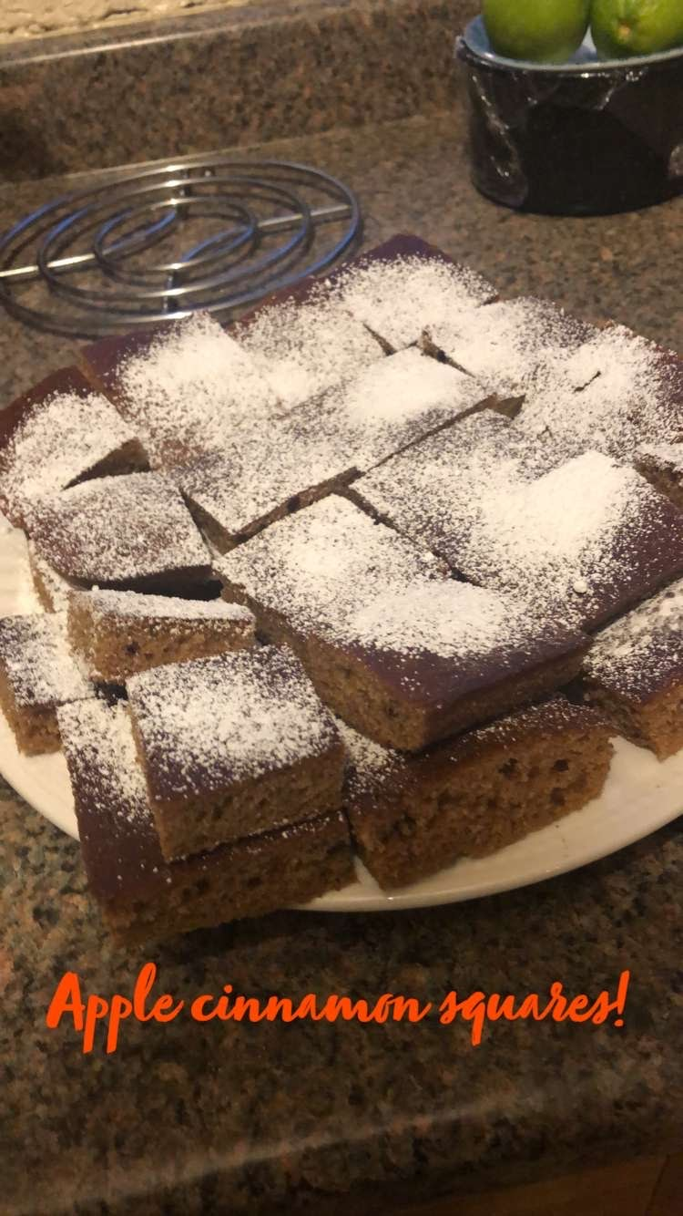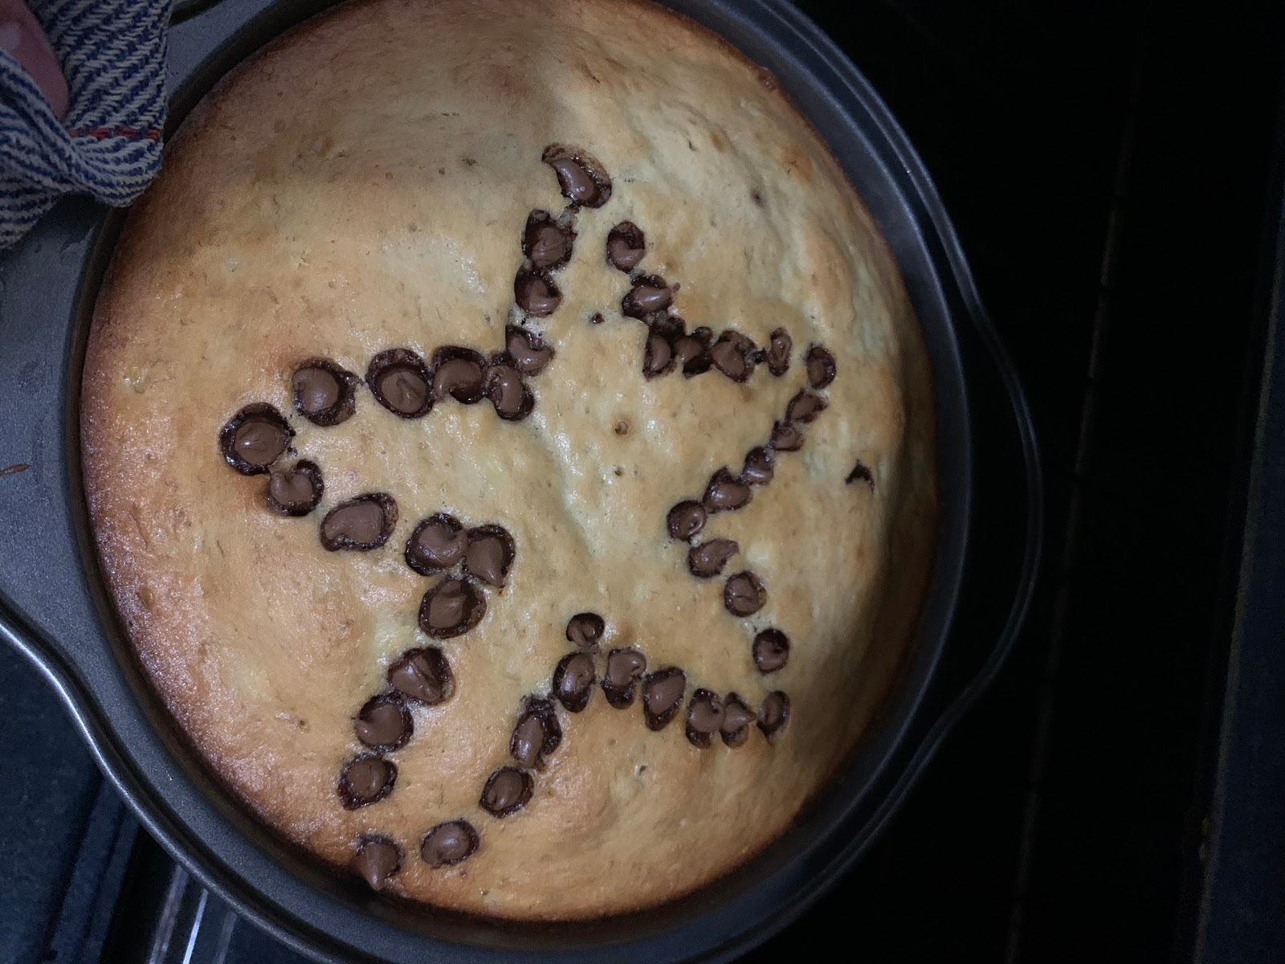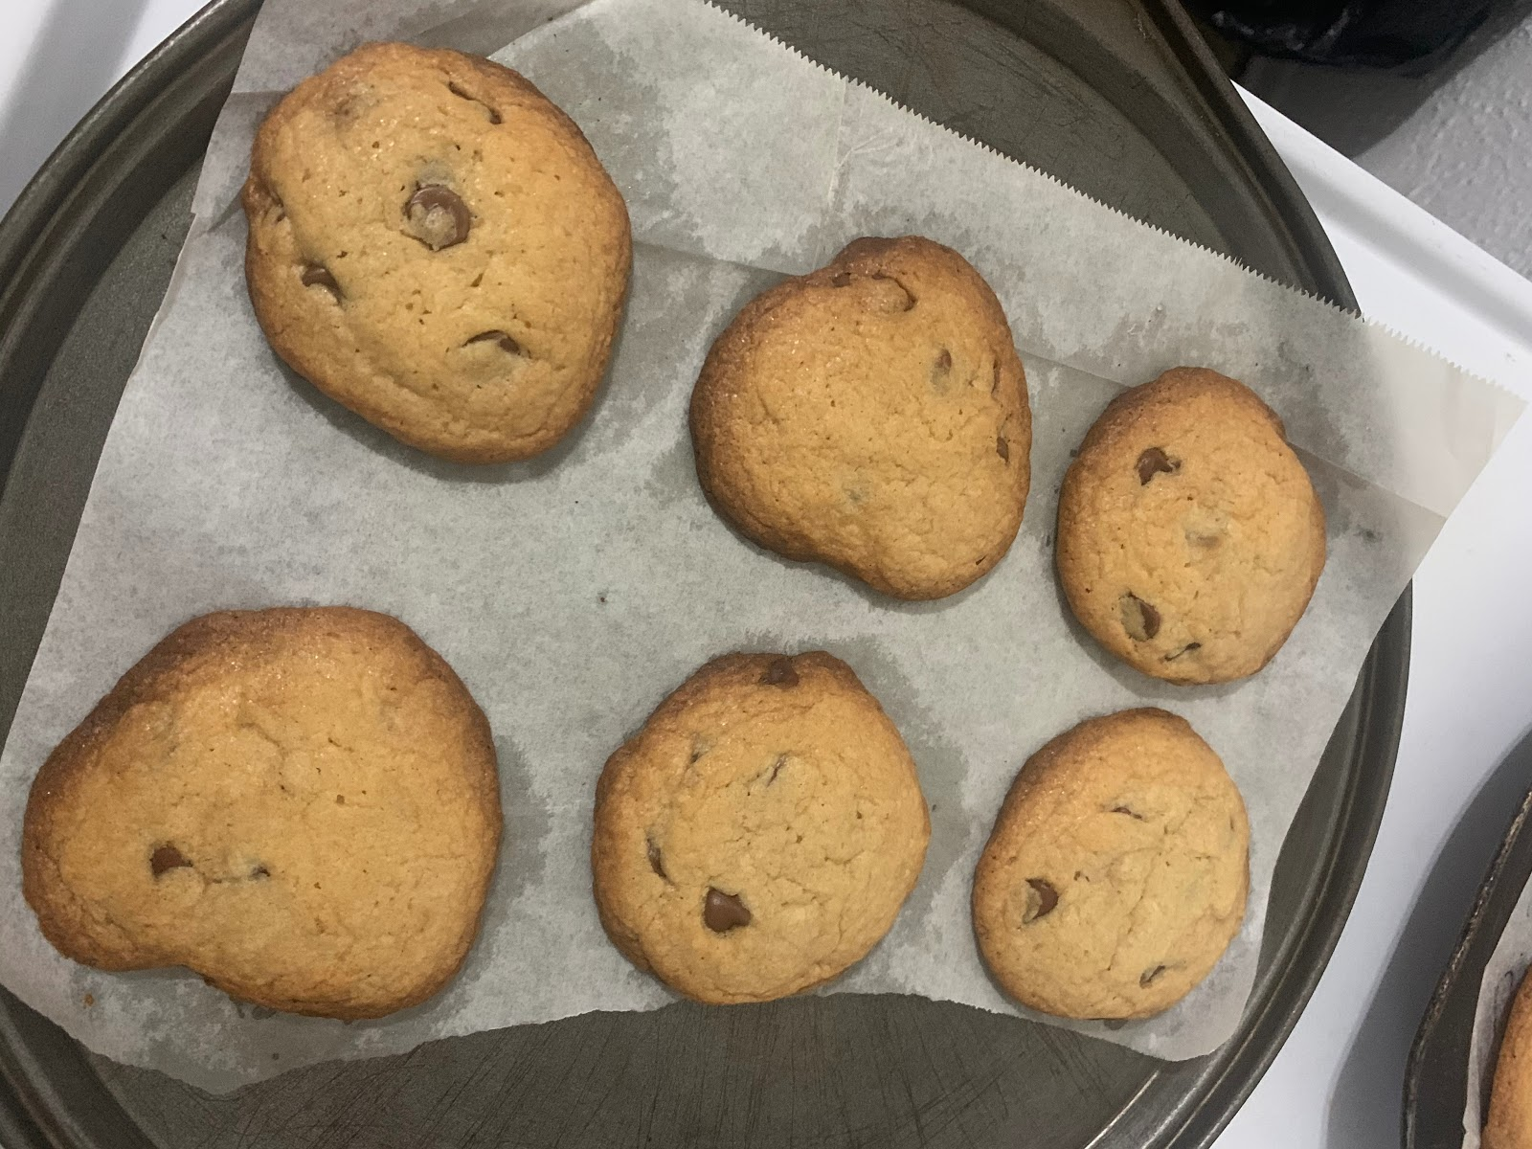
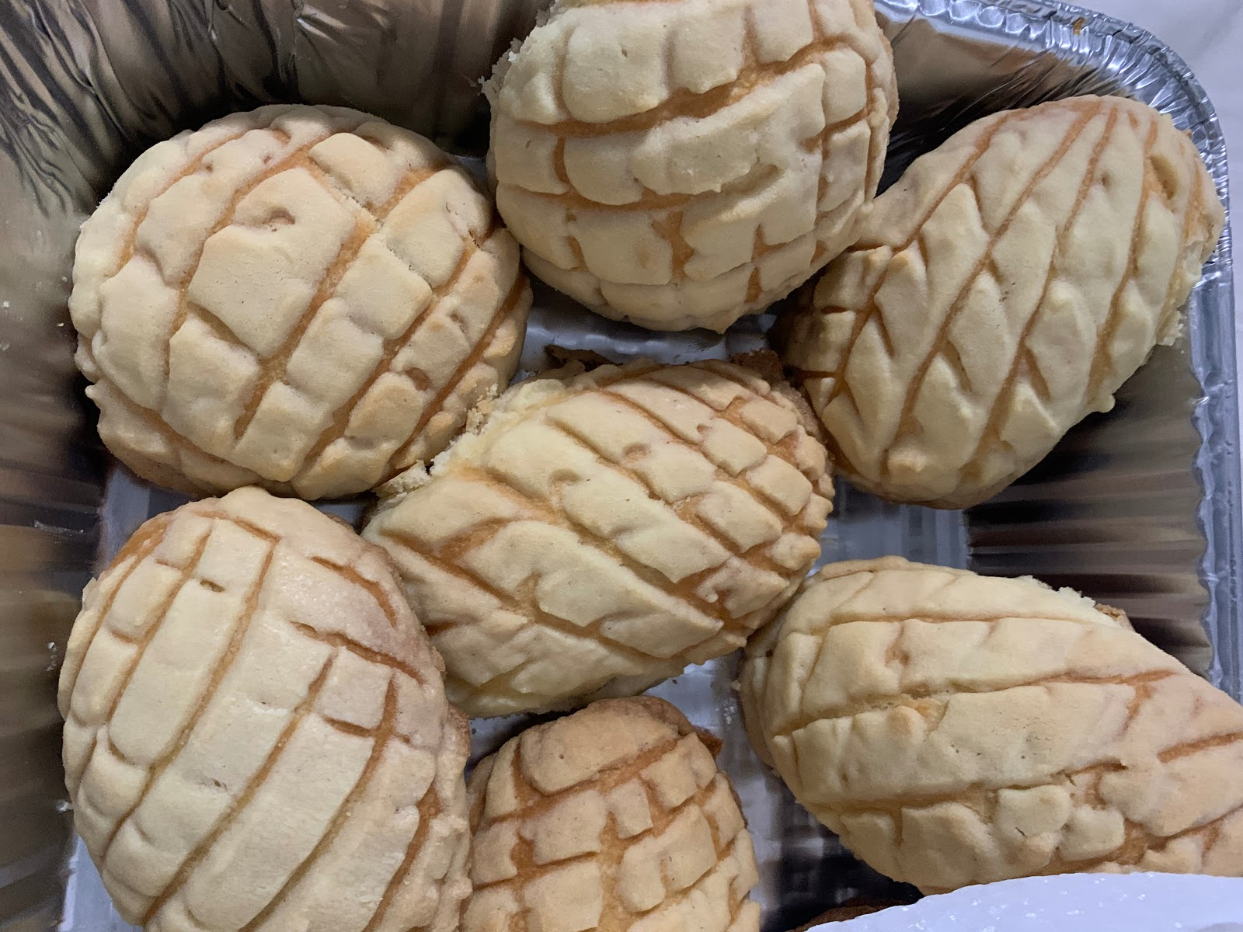

Here are some of the links of the recipes I have actually got a chance to experiment and bake myself;
https://www.thekitchn.com/how-to-make-banana-bread-the-simplest-easiest-recipe-139900 (Banana Bread)
https://www.bettycrocker.com/recipes/ultimate-chocolate-chip-cookies/77c14e03-d8b0-4844-846d-f19304f61c57 (Chocolate Chip Cookies)
https://www.bettycrocker.com/recipes/apple-cinnamon-bars/0a39c60c-5e39-479b-bebd-e0efd42bb1de (Apple Cinnamon Bars)

Context/Brief explanation to explain your skill/interest.
I consider baking to be similar to cooking because you need ingredients for both tasks, I know sometimes for cooking it’s a little more flexible because you can actually at times change the ingredients around depending on how you want to marinate or cook your meal. I know I want to try and continue baking and maybe even try to make a cake one of these days, it would be a great way to learn more about baking and I just hope it all goes well. I definitely would recommend baking for anyone to try, especially just starting anything as easy as doing a banana bread, you would be able to enjoy the bread as a breakfast with a cup of coffee/juice or perhaps even as a snack to have throughout the day.

Section 2: Investigation of partner’s skill and what we’ve learned together.

Hey Antonio, it's Raghda. Looks like we're partners again and this time we'll learn much more about each other :)

I'll ask you a couple of questions below, they are going to be random lol :
- Where were you born?
- What school did you go to? When did you graduate?
- How many siblings do you have?
- Did you end up watching the movie I told you about when we were getting to know each other? Because I didn't :/

So I know that you bake, I do too. But, I actually don't like cooking or baking the way that you do lol. I do it cuz I have to I guess.
I cook almost everyday and bake every other day. I can show you a couple of desserts or actual meals that I've made but what I really know is those bread looking things you made. I wasn't sure what it was, they were like pastries/ bread.

Hey Raghda, YAY! Sounds great to me.

I was born in Jamaica hospital in Queens. For high school I ended up going to Middle college high school, not sure if you heard about the school before, had a great experience especially because that’s where I found some really great friends and we’ve become like brothers. I have three sisters and one brother, and I’m the oldest one out of us (not fun at times haha). I think the movie was Motherless Brooklyn right? I did get a chance to see the movie, and it was a good movie.
That is correct I started to bake, since now I have plenty of time to do so. I’m just starting and learning but I liked it so far.. Is similar to cooking, I would say just the difference in baking is more pastries and who doesn’t love them right!? Anything in particular what you like to cook or bake? Awesome job with your decoration, the set up was amazing, must of took you awhile to get yourself organized and set up. The photos came out great too, as if they were taken with a real professional camera.

How about yourself;
- How have you and family been doing being stuck quarantine?
- How many siblings do you have?
- What school did you go to? And what did you enjoy the most at school?
By the way, I hope you're having a blessed Ramadan.
- I honestly don't know anything about queens, the only place i kind of know is Jackson Heights. I did a paper on the community they got going on there. It was very diverse.
- I started watching, 10 min to the movie and stopped because my parents kept calling me to do/get stuff for them. There’s wasn’t time :/
- I actually liked baking when I was little. My mom would always leave me in charge of the cake when we would have a party or a gathering somewhere. I have two older brothers but I’m the oldest girl(if you know what I mean). Being the oldest girl came with a lot of responsibilities. I always acted/ treated bigger than I ever was, my little sister wasn't much help, even though we're only 3 years apart, she would always run away from chores. Anyways, going back to baking. yeah I liked it when I was a teen basicly. When I got to college, I guess you can say different activities popped into my life and there wasn't time for baking anymore so I lost interest in it.but lately since ramadan started, I started baking again I posted them already, they were part of the decor lol.
- Surprisingly! My family is doing well during quarantine. I always thought if we all stayed home we’d always be yelling at each other or fighting all the time, But they are bored. We're 4, 2 boys, 2 girls and I'm the third child.
- I think I mentioned it in class before but, I went to a private school. I too made great friends. They are like family to me, Wala is one of them. We’ve known each other since forever, basically we started as family friends then we went to the same school and became lifetime friends lol.

I agree with you, Jackson Heights is very diverse but is an awesome neighborhood especially when it comes down to picking food choices. I have lived in the neighborhood for quite a time now, so I think I have a clear map in my head of where most things are. Especially some of the good food options at least to my taste lol. I agree with you being the oldest has pros and cons, but I went through the same as my siblings were growing up. I had to look out for them, or sometimes help around the house with anything my parents would ask for. So for me I barely got to bake or even cook, I would just observe my mother and see how she would do things in the kitchen. At times she would allow me to help around with washing vegetables, mixing ingredients, basic things. The only one time I won’t forget was when I was in the lookout for the chicken that was in the oven, I was paying attention but I think I got distracted with cartoons and the chicken got burned.
Now I definitely get to bake, I’m getting better at baking slowly, definitely takes patience and maybe a few tries. I know the first time I did banana bread I forgot a small detail, I forgot to add some butter on the pan before adding the mixture so some of the bread got stuck afterwards. But at the end the bread was delicious, that’s what counted.

Lmao yes, my mother still makes my 23 year old brother watch out for the chicken or anything she leaves in the oven, I'm gonna tell him he's not the only boy to watch out for food in the oven now. But the good thing about him is he has a clean record of not burning it, which is weird because he plays games 24/7 you would think he would lose track of it but thank god that day didn't come yet.
I'm gonna say this to you now before you get frustrated in the future, you will always forget to add ingredients while baking. I'm telling you this from experience. I've done my fair share of baking and almost every single time I backed I forgot to add something. Not major or anything like that really, just a minor detail like your butter on the pan thing. But in my defense my mom kept changing the recipes all the time, when i would go make something she made she would pop in and say, “You didn't do this, i did this last time and it tasted better this way.”

How does baking make you feel?

Baking makes me feel unstressed, happy, and definitely makes me express my creativity. Especially when the end result of baking turns out great, I think that’s the best part because your hard work into making your recipe pays off. Also being able to share my results with family or friends, and getting their honest feedback helps a lot because I learn from them in case a pastry is too sweet, or missing sugar, or maybe use this instead of that. I take their opinion and learn for the next time I decide to make the recipe again. Gaining the satisfaction that my family and friends request more of the bread, must mean that I am doing something right, I think? Lol. With the virus going on a lot of the pastry places were closed around our neighborhood, I think just this week some are re-opening. At times my family laughs and calls me weird because I bake these breads, pastries but I only usually take a small piece and then give the bread away to my family. I only do that because I myself don’t eat a lot of bread and try to avoid it, but at times can’t help to eat some.

How about you, how does decorating make you feel?

I love it. So much so that I get carried away doing it. Sometimes I lose track of time decorating not knowing when I even started. I just start and it pulls me in, it's like decorating makes me fly reaching out to it, moving like we're both in sync with the same song.

After you communicate* with your partner, this is what you will both tell us in your shared PAIR document:

1.What you have in common -- where you meet on common ground on a deeper level, as well

- Were both the older siblings in a way he's the oldest of 4, 3 sisters and 1 brother. I on the other hand am not the oldest child but I am the oldest sister. Technically I do have two older brothers, but my parents treat me like the oldest child. I basically do everything in the house after my mom of course. Anyways Antonio is this same too, he takes care of his siblings….. “ I went through the same thing as my siblings were growing up. I had to look out for them, or sometimes help around the house with anything my parents would ask for. ” Only those who themselves are the oldest children would get it, were like their second parents.
- Another common thing we both have is baking. Antonio just started baking while I've been doing it since I was 14. He finds it fun and I don't, not anymore. It was at first, but I got bored of it, I still do it from time to time though. Antonio sounds and looks like baking is his passion, the results, how they end up looking, the excitement. That moment is everything. Well that's how I felt when I first started to bake. His pictures say it all. “I asked him how baking made him feel and he said, “Baking makes me feel unstressed, happy, and definitely makes me express my creativity. “and there you go that someone who loves and has passion for their skill.

- Definitely a common thing I found to have with Raghda, was even if she isn’t the oldest sibling from her family, she has been the one that has been like a second parent to her siblings. I feel the same way but I believe I didn’t have a choice since I was the first one to be born, so I couldn't say no.
- As Raghda mentioned she has used to like to bake as well, she had been baking since she was 14, but eventually she stopped baking and might bake from time to time. Either way I feel like she has a great passion to decorate and she does an amazing job. I think decoration is just her way of expressing a passion she has at the moment. Especially her photos were proof of her hard work and showed what she is capable of.

2.What new thing(s) you learned from each other.
- Something I learned from Antonio was, it's never too late to start something new in your life, you just gotta make time to try something new from time to time, because you never know you might be really good at it. He started baking because he was stuck at home with nothing to do. In the end he ended up liking it and actually having the skill for it.
- I would have never guessed from Raghda that she would love to decorate, is a great passion of hers and she does an AMAZING job. After talking with her and seeing her pictures you can tell how much effort and time she will put into decorating. Like she says decorating for her feels like she is in sync with the same song.

3.What new thing the other person pushed you to learn about your own skill

- Talking to Antonio made me feel like I'm actually doing something people like. Because I'm always trying new things, I don't know how it feels for others. Getting Antonio's feedback, him telling me that my hard work is paying off makes me feel happy.
- Raghda gave me her honest feedback, and even though she hasn’t tried a pastry or bread of mine I know she was happy at the great job I did in making them. Gave me a confidence boost that not only my family and close friends think what I do is great, but also Raghda thinks baking became a great hobby of mine.

4.What new perspective you gained from doing this exercise

- What I gained from this exercise is talking to known/random people about what it is you're into is a great way for your mental health because you never know what people might be thinking about themselves or what others think about them. Talking to Antonio gave me a clear perspective of that.
- A new perspective that I gained was that sometimes when you talk with people/friends that you don’t usually speak to in your everyday life, they can offer criticism that is valuable and honest which gives a person a greater sense of confidence. At times you even find yourself to be more alike than you would have thought.

Section 3: REFLECTION AND SELF-ASSESSMENT

I was paired up with Raghda and I will say that it was so easy to work with her even though we aren’t in a classroom, but we were able to communicate and get work done easily. We noticed right away that we both had a connection when dealing with family, when it came to having to be a grown up and watch for siblings, or anything as simple as helping our parents out. I know she isn’t the oldest in her family but she feels like she is, even a second mom to her siblings. The same thing goes for me except I actually am the oldest of my siblings so I did have to help around. After some time it wasn’t as bad, especially when I had to look out for my siblings once they were a bit older because I was able to play with them a bit.
I was able to learn a bit about Raghda’s background, including how she also used to enjoy baking, but eventually she lost interest. Raghda offered advice like when she told me not to stress when I forgot an ingredient or even forget to put butter on the pan (like I did) she reassured me that those typical accidents will always happen. Raghda also gave me advice on how avoiding moments of frustration, by remaining calm, stay relaxed and hope for the best. Raghda’s skill at the moment is decoration, and just by looking at the pictures she shared with the class on Google Drive, she does a great job at decorating. Decorating is her current passion at the moment, and like she told me there’s something about decorating that gets her lost in her own world and sometimes she could spend hours just making sure the decoration is perfect.
During the beginning of the semester I had the chance to speak to Raghda in person, as we worked on an assignment that Professor Schmerler assigned to us on her birthday party celebration, about getting to know a neighbor in class and learning something new from them. I remember I had the chance to interview Raghda and I learned that she loves the color pink because pink is her favorite color. Raghda’s a great fan of Starbucks, I know this because she usually came into class drinking what I assume was her favorite refreshers. Now I’ve had the chance to learn more about her, like learning that she attended a private school. During this time she made a lot of memories and that’s where she met some of her lifetime friends. One of those friends included a common friend I had just met during the previous semester in my math class. The friend was Wala, and I would’ve never imagined that Wala and Raghda were lifelong friends. I also would’ve never guessed that when she was young she was a baker too, she used to love baking and she had the chance to make some great things, which included a cake. As previously mentioned her current skill is decoration, and how she loves how great her end results turn out.

Section 3B- Overall Reflection on this Project and Grade.

At first I was a bit nervous about sharing my skill. My first thought was debating whether baking could actually be considered a skill? This was because it seemed like anyone can have a go at baking. In the end I decided to go with baking and to just share my experiences with everyone so they could see what I had been up too. Overall I was just hoping for any positive feedback or recommendations as well and little did I know that I would get great comments from fellow classmates and a few of them also baked, while many others cooked, played video games, did makeup, or even art as their own skill.
Being paired up with Raghda was great because she was happy about the hard work I put into baking and she even noticed the passion I currently had for it. I know it might not last forever, but for the moment since I have the time to bake why not, right? Getting the chance to share my skill with the class made things interested because my skill showed people of what I’m currently up to during this quarantine, and also part of my likes and dislikes.
At first I was confused on how we were translating this new unit. I wasn’t exactly sure what a skill meant, but once I started to hear more about the professor and how she was trying to learn how to hula-hoop that made things clearer for me, which helped me to narrow down what I considered as a skill that I was just learning or already good at. Once I chose my skill of baking I knew things would just flow and come easily, just like making a recipe, you start with step 1, then step 2 and so on. So putting everything together was just like a puzzle and all I had to do was put all the pieces together and BAM! I would get my final product by explaining and showing pictures of my baking skills. Something that I would’ve liked to try and that I didn’t think of until Professor Schmerler suggested, was to make a video of baking a recipe? I would’ve never thought about doing this because it isn’t something I’ve ever done before. I know I’ve put pictures up to show the end result, so maybe a clip of how to get all the ingredients together and prepare them would show that it isn’t that hard to bake and that anyone could try to bake.
The affinity unit has allowed me to continue working hard, despite the current circumstances we’re all in. At first it was definitely a struggle to work from home instead of in a physical classroom with the professor and fellow classmates, but I know I had to adapt and make this work as best as I could. Some ways in which I’m improving my writing is just by practicing on writing more, and reading books that offer advice on how to improve mistakes that I easily tend to make, whether they’re grammar errors, sentence fragments, or even punctuation. A grade that I believe I’ve achieved for this current unit would be an A.

