Final Portfolio

Masha Sukkur
Eng 1121 Sec402

Submitted by: Masha Sukkur COURSE: ENG 1121 Section 402
PROFESSOR: Schmerler
DATE: 05/17/2020

Table of contents:

MY JOURNEY
"My Journey” – my Narrative as a Student in English Class this Semester

UNIT 1
(selections of your best work)
UNIT 1 REFLECTION
(your reflection on unit 1 and the grades you received on your work in this unit)

UNIT 2
(selections of your best work)
UNIT 2 REFLECTION
(your reflection on unit 2 and the grade you suggested and the grade you received)

UNIT 3
(selections of your best work)
UNIT 3 REFLECTION
(your reflection on unit 2 and the grade you suggested and the grade you received

MY JOURNEY

Dear Prof. Schmerler,
My journey for Eng. 1121 has been splendid. From the first day of school to the last week of school, I’ve enjoyed each and every single moment of this course. I really liked how you would play Michael Jackson or other types of songs before starting class. I was never in such an English class where the professor tells you to grade yourself, which was a nice experience. Professor, I’m thankful for all the feedbacks and advices I received from you. The inner and outer journals that I had to write for this class was a great experience. Even though it was weird to look at my surroundings and writing what I observe at the same time and stares I had to deal with from people, it was something that I’ve never done before. Doing this exercise helped me think out of my comfort zone. During quarantine, we had to write diary entries everyday and some days I didn’t have anything to write, I also enjoyed doing this too because in those journal entries I was able to describe my thoughts about the pandemic situation we are in and express my feelings. Overall, this class has been my favorite English class since I started college. Thank you for everything you’ve done for me. Thank you for being understanding when I was sick and was not able to write many diary entries for midsemester genre. Thank you for giving me the grades that I deserved based on the work I submitted to you.

Sincerely,
Masha Sukkur

UNIT 1

Selection of my best work:

My Writing Journey
Growing up, writing essays or a journal was challenging for me. My ethnicity is Bengali, but I was born and raised in America. When I was 6 or 7 years old, my parents decided to take me and my siblings to Bangladesh and teach us their culture, traditions plus language for speaking, reading, and writing. As I was learning my second language, somehow, I slowly started to forget how to speak English or write a proper sentence in English.
After 4 years, my parents decided to take me and my siblings back to America to get a better education. I was 13 years old at that time and I was in 7th grade. At that time, I could speak a little bit of English, yet my pronunciation was very bad. It sounded as if I came to America for the first time and I was foreign to this language even though I wasn’t. Since I was not speaking English properly, I would get bullied a lot. It was a tough time, but I did not give up on learning my native language. During my free time after school, I would read a lot of books, but those books were mandatory to read for my English class. My favorite book was “The Great Gatsby” by F. Scott Fitzgerald. I liked the beginning of the book where the author uses foreshadowing when he says, “foul dust that floated in the wake of (Gatsby’s) dreams.” because it gives the audience an indication about what’s going to happen by the end of the book. I also enjoyed reading this book because it helped me improve my vocabulary skills. After reading the book, my teacher assigned an essay to write about a different ending for the book “The Great Gatsby” and I had to write it in Gatsby’s point of view. I was very thrilled about this because I had a perfect ending in my mind to write in this essay. This was the first essay that I had written since I started going to school. Although there were a lot of spelling errors and grammar mistakes, my teacher understood what I was trying to write and complimented my essay. I was told to rewrite it again and do revision before handing it in. When I rewrote the essay again and revise it, I handed in and received an A as a grade.
After writing my first essay, I was very passionate about writing. For me, Journaling became a hobby. There are certain things that happened in my life that I can't share with anyone such as a few events that occurred in the past or my personal thoughts. Journaling for me was like healing myself. It was very helpful; I would write short stories about certain events and poems. One of my favorite poets that I wrote was called “Let me be '' and this poem was dedicated to everything I had been through in the past and how I healed from it. It was very meaningful and some of my friends enjoyed reading that poem. Some of them even related themselves to that poem and that's what writing does. It connects your heart and soul to a piece of paper where you are free to express your thoughts and feelings without feeling insecure or judgmental.

UNIT 1 REFLECTION

Few things that I struggled with was gathering all of my ideas and organizing it in a way that it makes sense for my written assignments. Not having any grammar mistakes and paragraph structuring was also challenging for me. Some of my successes was being able to have sufficient amount of ideas and information’s to write my written assignments. Getting good feedbacks and comments for the journals I had written on the train while going to school helped improve my writing.
This unit was fun for me because I enjoyed writing the journals, it helped drive my drowsiness away and refresh my brain before entering class. This work was very different to the way I learned and wrote in high school because in my high school, I was taught differently. I was not taught to write a personal narrative story or use my past experiences in an essay. I was not taught the right way to cite my work or write in MLA format. I would have liked it if we discussed about the essays more in class so I could get more advices from other students. I learned not to use words such as it, just, basically and the in sentences a lot so that way the sentences are simpler. What surprised me about UNIT 1 was writing journals of what I noticed around me in the morning and discussing in class. That experience was very different from anything I’ve done in my previous English classes. I was not very interested in the first reading we had to do for homework. It was from the book “Bird by Bird” but I enjoyed reading “Internal Revision” since I was taught a lot about revising my paper before handing it and ways to revise it.
For my grading, in reading work I think I should get a grade of 9/10 since I finished all the reading except for reading the rest of the chapter from the book “Internal Revision” by Donald Murray. For my short writing assignments, I think I should get a grade of 10/10 since I completed all of my assignments. For the essay, I think I should get a grade of 9.5/10 since there was a few grammar mistakes and issues with organizing my paragraphs. For discussions in class, I believe I should get a grade of 10/10 because I always participated and read my papers aloud so my classmates can give me their feedbacks. Furthermore, I hope to improve my mistakes that I learned in UNIT 1 and write my essays after revising my drafts.

UNIT 2
Selection of my best work:

UNIT II--Mid-Semester—GENRE
PLUTO: March 30th,2020, 4:30PM
TABLE OF CONTENTS:

Section 1: EXTENDED DIARY EXCERPT

Section 2: REFLECTION AND ANALYSIS OF DIARY READING

Section 3: REFLECTION ON UNIT II AND GRADE

Section 1: EXTENDED DIARY EXCERPT

2020 DIARY OF A PANDEMIC, NEW YORK CITY
MASHA SUKKUR, ENGLISH 1121 402
MARCH 25-29, 2020

MARCH 25, 2020- FOSTER AVENUE, BROOKLYN, NEW YORK CITY
2:52PM

Dear Diary,
I am writing this during the afternoon. I did not eat lunch yet since my mom is not done cooking so while I’m waiting for my mom to finish cooking, I thought about writing this diary entry. I took a Snapple from my refrigerator and started drinking and went on YouTube to play Beethoven 9th Symphony - Movement IV - "Ode to Joy”. (I will attach the link of what I’m listening to after writing this) Nothing special happened recently, every day I hear more people deceased due to this virus. I feel very depressed for those people that lost a family member.

Lately, I’ve been feeling a little frustrated with how my online classes are going. I feel like professors are assigning more assignments now than they did in a face to face class. I’m trying my best to not be affected by it and calmly finish up all of my assignments on time. Online classes have been a positive and a negative experience for me. It was positive because for some of my classes, I learned more about a topic than I did in school. However, it was also negative because of the amount of assignments that are piling up and a few of my professors are not familiar with online classing so it’s hard for them to teach and for me to understand what they are teaching.

It’s almost 3:45PM and I’m almost done writing the diary entry for the day. I guess one interesting thing I did today was watching food competition videos on YouTube. It was very funny and entertaining, so I enjoyed watching that a lot and another thing I did today that I regret so much is posting an embarrassing old picture on Instagram. It was a challenge so I had to do it and the rules are if any of your followers post an embarrassing picture of themselves on Instagram with a caption “until tomorrow” and if you liked it, that person challenges you to post an embarrassing picture of yourself. It can be an old or a new picture.

Here’s the link of what I was listening to while writing this:
https://www.youtube.com/watch?v=hdWyYn0E4Ys

MARCH 29, 2020- FOSTER AVENUE, BROOKLYN, NEW YORK CITY
4:33PM

Dear Diary,
I am writing this during the afternoon and I’m about to go eat something since I’m starving. After eating, I continued writing my diary entry. For the past few days, I was not able to record what I was doing throughout the day because I had extremely bad stomach cramps. This has nothing to do with the virus, it was my monthly menstrual cycle.
I didn’t really do much, other than be on my phone, on social media’s and talk to my boyfriend. Me and my boyfriend got bored, so we installed UNO on our phone and started playing. We kept losing all of our money but then gained back all of the money. It was like playing poker.
I haven’t worked on any assignments yet. The situation that everyone is facing right now, I really don’t feel like focusing on school. I don’t have enough energy to finish up my work like every minute, I get distracted and use my phone and then after 30 minutes I start working on my assignments again. I just can’t focus on anything I do. Even when I was writing this diary entry, I kept getting distracted. Other than that, nothing interesting happened recently. The only thing I’m really concerned about is the deceased rate going up and no recovery rate from those who got infected so I’m hoping soon we get to see some improvements because I’m really losing my mind staying home every day. This all I have to say for today.

April 4, 2020- FOSTER AVENUE, BROOKLYN, NEW YORK CITY
10:00AM
Dear Diary,
I finally recovered from being sick after a week. I had a high fever, extremely bad headaches and was feeling weak. My condition was so bad that I had to email all of my professor that I won’t be able to attend class for those days that I was sick. Thankfully, I recovered sooner and was not infected to coronavirus because my parents believed that I had the coronavirus and I was very scared thinking about it. As I started recovering, I had so many assignments piling up. Finishing up those assignments and handing them in before deadlines was challenging for however, I was able to submit all my assignments on time.
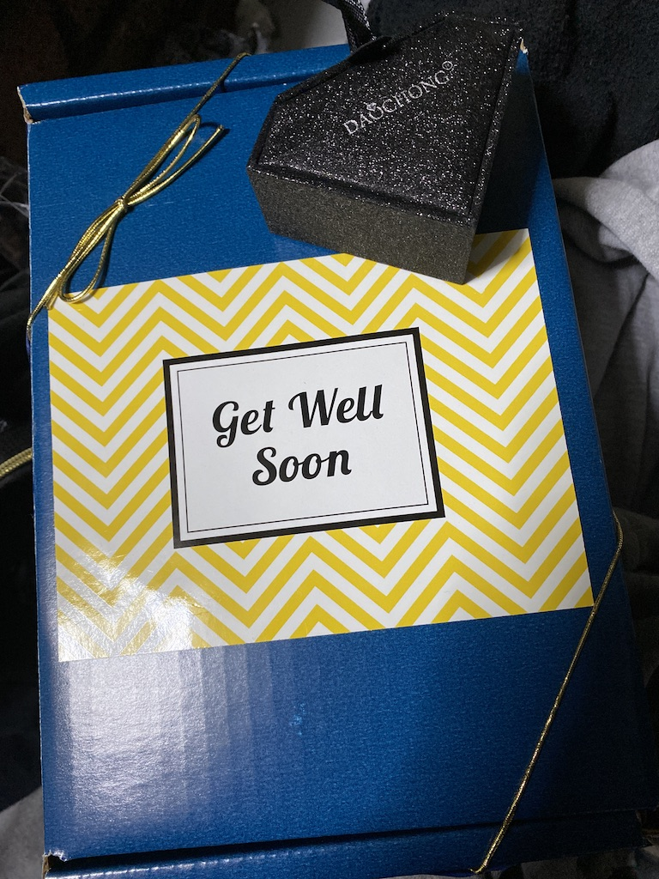

This is a picture of what my sister bought me when I was sick. There is a necklace inside of the diamond box. She knew how much I loved wearing jewelries and got me this necklace. This was a very thoughtful thing my sister did for me especially since I was sick.

Section 2: REFLECTION AND ANALYSIS OF DIARY READING

If I had read “Diary of a Wimpy Kid” when I was in middle school, I would have enjoyed my English class so much. The pictures and Illustrations of what Greg Heffley drew in his diary to give the readers a sense of what he was writing about seemed interesting to me. Before he starts writing he wrote, “TO MOM, DAD, RE, SCOTT, AND PATRICK” and this shows that he was writing this diary as a letter for those people as he describes that it was his mom’s idea not his. He seemed carefree about what he was writing which is like a new thing I’m visualizing about how my writing would sound if I didn’t put too much thoughts into it.

I like how Greg uses a humorous tone in his writing, it doesn’t make me feel bored while reading his personal diary. His writing style inspires me to make my diaries less emotional and more entertaining for the readers to enjoy it. His diary seems to be his experience during middle school, and he talks about his experiences with girls which was kind of funny and sounded like those experiences you witness in movies. Greg talks about how his brother tricked him to go to school at 3 am in the morning for his first day back to school after summer vacation. I can relate to that because in the past, my siblings pulled a lot of pranks on me and in the end, I was the one that got in trouble.

I really enjoyed reading “Diary of a wimpy kid”. It was really entertaining, and it reminded about some childhood memories. I wished I started writing diaries in an early age so I can express how I really felt during middle school days. This reading really inspired me to put some humor into my writings to make it appealing for the reader.

Section 3: REFLECTION ON UNIT II AND GRADE

This unit went by pretty fast. I think one thing I struggled with was keeping up with writing diary entries. I suddenly started feeling sick and because of that, I wasn’t able to write as any diary entries that I wanted to. Honestly, I enjoyed writing these little diary entries and talk about how I was feeling during this quarantine. It felt like somebody out there was reading how I was feeling or what I was feeling or doing without judging me or criticizing me. I was content with all the comments I received for the work I submitted for this unit; those comments showed how much I improved since UNIT 1. I learned during this unit that I enjoy writing and I love expressing my thoughts and feelings about everything that’s going on in those writing, and writing improved my grammar and vocabulary. I think I need to improve on my writing more, so it sounds more professional and I believe I need to make drafts on my work before handing in as a Final Portfolio. I enjoyed reading other people’s work, I learned that everyone has their own writing style. Some of them express their writing in a very detailed and thoughtful manner while some people just simply state what they do for the whole day. For grading, I think I should get a B for how much work I submitted but overall I think I should get a grade of A with the amount of efforts I put in each diary entries that I was able to write and the reflection I wrote for the diary reading.

UNIT 3
Selection of best work:

UNIT III – Learning from Each Other: Affinity, and Inquiry

TABLE OF CONTENTS:

Section 1: YOUR SKILL/INTEREST DURING CONFINEMENT/ WITH SOURCES

Section 2: Inquiry -- YOUR INVESTIGATION OF OTHERS’ SKILLS AND WHAT YOU LEARNED TOGETHER

Section 3: REFLECTION AND SELF ASSESSMENT

SECTION 1: YOUR SKILL/INTEREST DURING CONFINEMENT/ WITH SOURCES

MY SKILLS/ACTIVITIES ARE...
- Playing badminton
- Cooking
- Acting

1. Here You will tell us a little bit about WHAT YOU ALREADY KNEW BEFORE the confinement/what your experience has been with this skill/activity.

Playing badminton has been my favorite hobby since high school. I started playing this sport during junior year of high school. It’s quite easy to play badminton if you follow the instructions thoroughly. In this sport, you play with a racket and a birdie. The main thing about this game is to hit the Birdie across the net. I enjoy playing badminton a lot. Whenever I used to be stressed, I would ask my friend to play badminton with me and that really helped me relieve a lot of stress.

2. Here You will tell us SOMETHING NEW you learned about it during this confinement period. If you haven’t learned anything new, then go out now and find out something(s) that you didn’t know about it before!

There are a few laws about playing badminton that I didn’t know before doing my research. Since I played badminton for fun, I did not really pay attention to those rules. Some of these laws are:
- A match consists of 3 games of 21 points.
- The side winning a game is able to serve first in the next game.
- When the leading score reaches 11 points, players have a 60-second interval

3. Here You Will Give credit to THE SOURCE(s) of this new information and tell us a bit more about this/these sources and why you like them. Show us where we can go to find them.

This new info is by a website called badmintonbc.com. This website seems to be very helpful. Even i learned a few things about badminton on this website. This website teaches beginners or experts about how to play badminton, the rules, and the scoring. I like this website because it explains everything about badminton in a way that’s easy to understand.

Here’s the link:
The Laws of Badminton

4. Context/Brief explanation to explain your skill/interest*

Playing badminton is one of my interests in sports that I can never erase from my memory; Learning how to play badminton was a little challenging for me since it was new to me during high school. Because of my high school friend who was an expert in playing badminton, she taught me all of the skills and rules that I had to learn. As I became more familiar with badminton, I joined the badminton team in high school. The challenges and fun times that I have dealt with during that time changed my high school experience completely. Playing badminton with those who were more skilled than me was challenging for me. There was this rule that every week, all the newbies will play against students that were more skilled to see how far the newbies were in playing badminton and there would be competitions. Each game in the competition consisted of 21 points. If you won one game, you switch partners and play with another player who’s 2x more skilled than the last one. Every time you lose a game, you have to play against another player who also lost and keep doing that until you win all of the games you played. These competitions helped us win against other high school badminton teams. My coach was very strict with all of the players but there were times where my coach would buy us food for training a lot so It was a great experience. I learned a lot in my high school days and one of it was to never give up no matter what.

SECTION 2: Inquiry -- YOUR INVESTIGATION OF OTHERS’ SKILLS AND WHAT YOU LEARNED TOGETHER

[Here is where you present the findings from your affinity pair. If you worked in the PAIRS folder on GoogleDOCS, then you simply cut and paste what you both wrote there in this section. If your pair was actually a group, that’s fine. Everyone just pastes that document here. Length: 500 words, minimum.]

This is a conversation between Masha and Ying
Ying Ying: Heyy, I rather text you here sooo...let's get to know each other
- What’s your favorite color?
- How many siblings do you have?
- Which borough do you live in?
- What do you want to become?
- Are you working right now? If yes what job?
- Birthday?

Masha:
My favorite shade is black since Prof. Schmerler said black is not a color lol. I have 2 siblings. I live in Brooklyn. I want to become an actress. Yes I am working right now and I work at Starbucks. My birthday is on July 14
Tell me about yourself as well!!!

Ying Ying:
My favorite color is pink, I have 2 younger sisters and 1 younger brother, I live in Brooklyn. I want to become a teacher. I'm working as an after school teacher at p.s 124 and my birthday is April 29. :)
Ohhh for siblings, you only have one brother?
Because i have 2 sisters and 1 brother and I’m the oldest
And tell me more about yourself if there is anything else

Masha:
I’m the youngest. I have one older sister and older brother. I love cooking and I love to watch Kdramas. My favorite food is pasta (Shrimp Afredo), sushi and Korean food. I always wanted to try black bean noodles.

Ying Ying:
You should tru this. My friend made it once and I’ve eaten it ever since
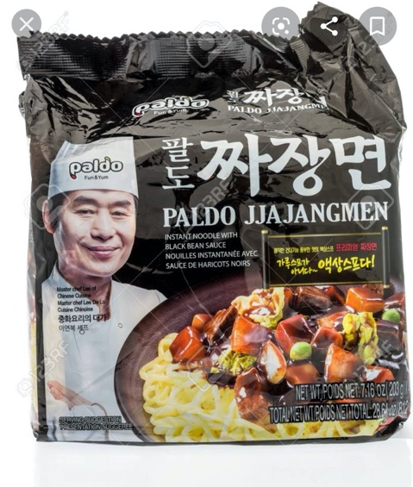
Masha:
What are you majoring in?

Ying Ying:
Liberal art right now. I want to transfer to Brooklyn College.

Masha:
My major is computer science. I also want to transfer either to Hunter or Brooklyn College

Ying Ying:
Niceeee!! I’ll see you there if we both get into Brooklyn College :D

Masha:
Facts lmaooo but I don't know which major to take though. What do you want to major on?

Ying Ying:
Below are the majors Brooklyn College offers. I want to major in childhood education.
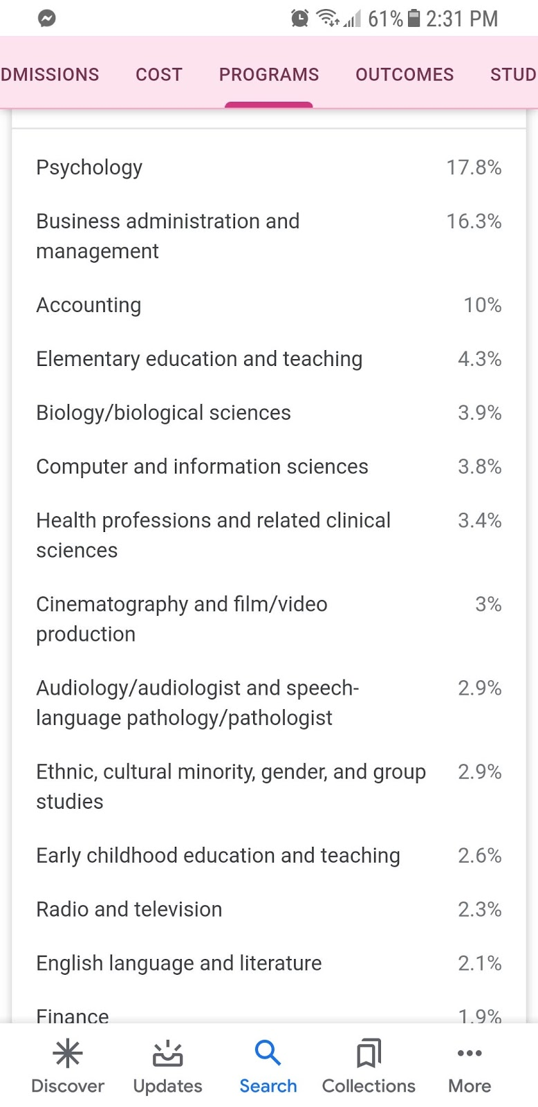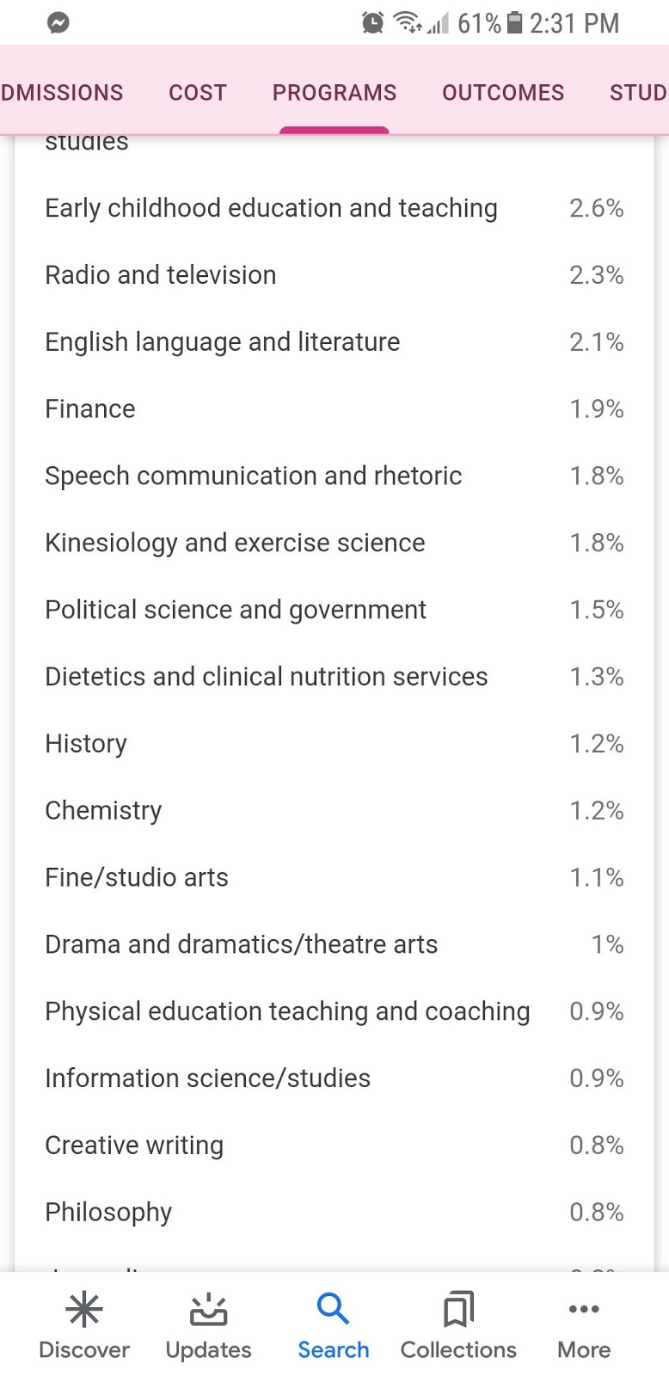
**End of conversation**
Daniel T.
- My favorite color is Blue because the sky is blue.
- I have two brothers and a sister and the third in the family. I have an elder brother, elder sister and a younger brother.
- I live in Crown Heights in Brooklyn.
- I am studying to become a Computer Web Designer.
- Yes, I work as a computer Engineer Technician for New York City Board of Education. Since the Coronavirus pandemic, I have not been able to work because schools are closed.
- Yes, I am a Gemini and my birthday is around the corner, 24 May.
Masha:
Hey Daniel, I’m sorry for not being able to contact you to learn more about yourself. One thing we definitely have in common is web designing. I also love to do web designing. I took a coding program outside of school called America on Tech. It was every Saturday and It was located in Manhattan. In that program, I learned how to create websites using JavaScript, HTML and CSS.

Hi. Masha. I completely understand, it's been a long week. I just shared about myself to help our group come out with this project. Masha. I would like to know what your Major? Coding program is what every student need even if you are not a computer major because at a certain part of your life, you will need it. I wish you can study more coding because you may earn a lot of money by just creating websites. Masha. When can we chat today? DT.

Just a little bit more about myself so we have more info to write:
I was born in China, came to America when I was 6 without knowing any English. I used to be a pharmacist assistant for almost 3 years before I found the job I am working at right now with kids. I'm 11 years apart from my younger sister. I have a pet turtle and fish :) - Y.Y

Questions for partners:

1.What you have in common -- where you meet on common ground on a deeper level, as well

Me and Ying Ying like kdramas(Korean dramas), we love sushi and Korean food. Me, Yinging also live in Brooklyn. Me and Ying Ying also have 1 brother, we play badminton, and we want to transfer to Brooklyn College. Me and Daniel T love parmesan cheese and Italian pasta. We are both also majoring in computer science and love web designing. What me, Ying Ying And Daniel have common in is that we all live in Brooklyn. One thing we all have in common is that our skills match our interest. For me, I enjoy playing badminton a lot, it’s probably the only sport I enjoyed playing a lot during high school. Ying Ying loves teaching little kids, she has the patients to listen and teach little kids. Daniel T. has a passion for cars. He enjoys driving his car a lot and he also likes to do web designing, it seems like a hobby for him.

2.What new thing(s) you learned from each other
Masha can cook and she really wants to try black bean noodles.
Ying Ying is the oldest in her family and she wants to become a teacher
Daniel T. is the third in the family and would like to become a Computer Web Designer. DT
I asked Daniel if he would starve for one entire day in return he gets 1 million dollars. His response was: Yes I would and use the one million dollars the next day to eat.
Daniel also compared this question to companies losing millions of dollars due to this pandemic. M.S

3.What new thing the other person pushed you to learn about your own skill?

Nothing.

4.What new perspective you gained from doing this exercise

I have learned that people have common goals in life that they might never know about it until they start talking. DT
Having common goals can bring us together and create a conversation that we would have never imagined. M.S

Section 3a: REFLECTION ON YOUR PAIR

Ying Ying and Daniel T. was in my group. Working with both of them was pretty amazing. Me and Ying Ying had a casual conversation as you can see above and Me and Daniel talked on the phone and asked one and other a lot of questions that can be helpful for this project. I used to think before that Ying Ying is a quite type of person, but I was wrong, She’s very social and pretty fun to talk to. The things I learned about Ying Ying that I found interesting is that she wants to major in Childhood Education and She also enjoys watching Korean Dramas just as I do. One interesting thing I learned about Daniel T. is that his favorite movie is fast and furious because he enjoys driving and likes fancy cars.

Section 3b: OVERALL REFLECTION on this PROJECT AND GRADE

At first, I was confused about what to write but then when I went beyond my comfort zone and did research about my skill, it was becoming a bit easy to work on. The comments that Professor or other students gave me really helped me out. I knew what I did good on or what I need to include in my skill document through those comments. This project was fair, It was a little challenging since nobody wants to do work during this quarantine but it was interesting for me. I was able to share some high school experiences in my skill documents and the researches I found regarding badminton rules. For this Unit, I think I deserve a grade of A. Last unit, I wasn’t able to put a lot of effort but for this unit project, I wanted to put more effort and be more creative, so you’ll enjoy looking through my project. As you can see in the section 2, I didn’t put all the info’s of mine, Ying Ying, and Daniel’s in a paragraph, what I did was copy and paste the conversations I was having with them, and the questions we answered at the end of the conversation.

