**UNIT 1**

**Section 1: Journey to writing paper**

**Section 2: inner out assignment**

**Section 3: UNIT 1 REFLECTION**

**UNIT 2**

**Section 1: Diary Expert 1&2**

**Section 2: Diary of a wimpy kid**

**Section 3: UNIT 2 REFLECTION**

**UNIT 3**

**Section 1: Your skill/interest**

**Section 2: pairs assignment**

**Section3: UNIT 3 REFLECTION**

**Section 1: Journey to writing paper**

Dear professor,

This was a crazy semester was a bit crazy. I never thought that I would have to do my classwork and participate online. This turned out to be a pretty hard experience. My internet wasn’t functioning as well, classes where giving too much homework. I was pretty much a exhausted. I do feel like this semester would’ve been better if we could’ve been in a classroom. Also, I would’ve like to have spoken to more of my classmates because I think I could’ve made more friends.

As for my work, I feel like I could have done way better. I really do not know why I didn’t do as much. Was it because I was tired all the time? Maybe I could not focus enough? I think I need to think what the problem was so this will not happen again. To end this off, I been taking your class for a almost year now, and learned so much on how I can improve with my writing (even though I need some improvements). You made the class fun in person and through zoom. I hope we can meet again after the pandemic. Thank you.

-Jordy

P.S.- I going to do figure art next semester

**Section 2: inner out assignment**

My relationship with writing? I never thought that I would write about

me and my writing. The only thing that I remember with My writing is that I

never cared about my writing throughout middle school and high school.

Main reason is because no one bother to help me and at the time I was a

kid who thought that I was a failure cause people never believed in me but

the only memory whether it good or bad was in elementary. As I was going

into elementary, I did not even know what the word “writing” meant, but the

teacher told me to write the word “comma”. (They told us to write a comma

because we were learning how to use grammar). In my head I said in a

questionable voice “comma”? As I proceed to write the word comma and as

I am trying to sound it out, I ended up with “comio” in which I spelled ate.

She did not tell me if I got it right or wrong, she just kept giving me more

words to spell. Until she told me to stop. Then she gets up and tells me you

got two out of twenty correct. In my head

I said “Two out of twenty”, unless she is giving two out twenty pieces of

candy, so I am like, “oooooo I’mma get 22 pieces of candy”.

As I followed her, I was looking forward to this candy but instead there

was Russian lady with glasses, red lipstick, brown hair, and she was

dressed in formal clothes waiting outside the door. She says in her Russian

accent to my teacher

“Oh, this is the boy”.

 My teacher said “yes he is struggling with……”

I lost my train of thought because I was confused on whether I am going to

get candy. As she slouches down and says

“Hi, my name is Ms. Bartoluzzi, what’s your name”?

I said in a Spanish accent “Jordy or shordy cause my mom calls me that”. (

My mom calls me that because she calls my sister name a lot, so she gets

confuse and puts the “sh” in my name, and this continues happen till this

day)

*Laugh* “Okay well I’m your new teacher and I will be helping you with your

English, so for now on you are part of my ESL class and I will pick you up

when you will have English.

My teacher said “you need help with learning on how to not get confused

with English and Spanish be….”

“No, it's called Spanglish not English”.

 “What, that’s not a word it's just something you made up”.

*Mumbling* “No me and my cousin found the word on a T.V. show”.

“So next week Ms. Bartoluzzi will pick you up and take you to the third floor

and that is where you will get help with English as well as reading. I did not care

at this point because I had a feeling that I will not be getting candy.

*Next week has arrived*

So, I am sitting there waiting for my new teacher Ms. Bartoluzzi to take me up

stairs so I can fix my writing even though I feel like my writing is the best

writing as ever. *Knock Knock*

My teacher say’s “come in”.

Ms. Bartoluzzi says” is Jordy here today”.

“Yes, he is sitting over there in the back”.

“Oh alright, come on Jordy let’s go”.

I got up and left the classroom with her and as we walked to the third floor I

saw so many kids who are older and taller than me. I was scared because I

have never been to the third floor. I was thinking that maybe I could make

friends but I knew that no one would want to be friends with a short kid with

long hair. When I was thinking about all these things, we arrived at her

door. She told me that we will find out how much English I know, and see

what word I can write. She said

“Okay I'm going to read the word one by one and you try to write them

down, the ones you get right you will have to write it down three times for

today so you will not forget and the one you get wrong I will have you write

them down five time with the definition and some explanations.”

“that sounds like a lot of stuff to do but a one on one is way better than

teaching to a whole class”

*One week has past *

Then one day she surprised me with a quiz, no heads up or nothing. I said

Ms. Bartoluzzii did not even practice or anything.

“If I told you there would be a quiz you would have study a lot, and this is

better because it tells me if I'm teaching you right or wrong”. The quiz will

be 20 questions and you have until the big hand goes to 12.

As I was writing some of these words, I felt like I knew them as if I was

making some progress. Then I gave in my paper with confidence I did not

know what my score was but I knew that I spelled, judge, another,

cellphone and teacher correct but the only four out of all the rest. I was

confident until she had it for a couple of mins.

“Jordy you got……… “

“Why did she not say anything? Did I fail? Why doesn’t she tell me?”

“You got a nine out twenty”.

“Uhm candy??? No is not or is candy coming, hmmmmmm.”

“You have improved in your spelling now let us write sentences with the

words you have made, let say you must write two sentences”.

I wrote those two sentences about candy because that is what I would like to

have now. As she is checking my sentences, she sees that there are still

some sentences that are in reverse, so she gave me a comic book to read

and see how my sentences are formed and when I finished with the book, I

would get a new one. Until one week later, another surprise quiz but this

time I needed to write a short summary on it and what is going on. As I was

doing that she looked over my head and nodded. She proceeds to tell me,

“Your improving young one, now you keep reading and focus on the

publication and still look at how the sentences are formed so you can

excel.”

“Okay, but can it be comics again?”

“Sure, but later you will have to leave it so you can see how people write

more sophisticated and so you can be sophisticated as them, but because

you are improving you can take some candy.”

UNIT 1 Reflections and Grade

Unit 1 was good unit to start off with even though I have struggled with putting the

punctuation in the right place, trying not use slang in my writing, and knowing when to use me

verb tense. I feel like using verb tense is something I have a little problem, with but I did feel

like I have improved on my verb tense since 1101. There are still some minor errors I need to work

on. Even though I am still trying to correct my mistakes it was fun remembering how I learned

how to read and write and how much I love candy back then. This would be something that

none also high school teachers would have done. All they would do is correct me on my grammar

and punctuation. They never told me anything on verb tense, but I would’ve love to understand

when I am using past tense wrong. I know I could buy the book, but I feel like I learn better with

having a one on one. Also, if I had a question, I would get my answer. Even though my teachers

never told their where more mistakes to writing, I have taken what I learned from them with me

throughout my life. Honestly, I am surprised that I remembered all the details they taught me.

And what they taught me came all to the essay I did. I did have some mistakes with how I was

using my slang in some parts of the essay but those are some things I need to work on. Not only

I learned from myself, I also learned from listing to me classmates and how it was hard for all

us to learn how to read and write. Everyone had different experience, some had the same

problem I did, and some did not, but I felt like I connected with everyone. Now for my grade, I

know that I have been coming late to class lately and that is no excuse, but I always try to find a

way to do the classwork I missed. I do participate in class and I try to improve on all my writing.

If I feel like I need some help I will always ask some friends to help me revise it and comment on

my mistakes. As for my homework, I always do the inner and outer and I do my best on trying

to make it clear and visual for everyone. So, I feel like good start can be a B.

UNIT II -- Mid-Semester -- GENRE

Uranus

Section 1: EXTENDED DIARY EXCERPT

March 25, 2020

3:00 P.M.

I needed to study for this exam. I do not really know what to study, so what I did was read the whole chapter. The chapter has about 39 pages. Two hours later I just finished studying for now. If you are taking a class with this textbook, I hope you do not have to read it a lot remember it all.

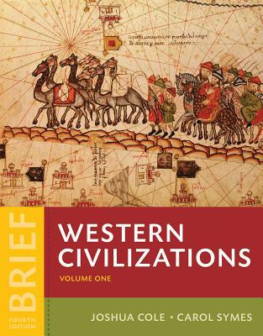

5:30 P.M.

Trying to find something to watch but there was nothing to watch. I hate it when I cannot watch something because there is nothing good on.

7:00 P.M.

I checked my email, I got some notification about when my class discussion starts for math, and when my exams starts. After that I did some math homework in which the whole class does not understand since she is teaching it online. She does not explain it well online. she does not use zoom. she uses blackboard in which it does not help. she just does and example and then gives us an example to do, then she does class discussion on it the next day. But what do we discuss? never got a good response.

8:20 P.M.

I am so lost, what I got to do. Well its college if I dont know something I got to find a way to learn about it in my own way. People always tell me this and so I believed it. Ate dinner, I know kind of late for dinner. Then an hour later I worked out.

9:40A.M.

got up took a shower and brushed my teeth and cleaned my room. I was so sore that I did not want to wake up, but I knew that I had to. My math teacher said be on blackboard at 10:00 to start the discussion.

10:00-11:29A.M.

this was something that I did not understand and to be honest I am good at math. What happen to my math skills lol? Did it go away or something? I was good in math when I was in high school Dam just took the exam. I passed though it feels good, but I wanted higher.

1:00 P.M.

My dad asks me to help him with his computer and to help him with setting an account So we setup an account for no reason. Four hours gone to waste. Uhhhh…. you know what I could have did with four hour al lot of things.

April 2, 2020

Did not sleep at. I had to get up at 9:45 in the morning so I thought that it was better if I did not sleep until 12:45. Why 12:45.well I had another test around 11:15. So I went to go study until my next class.

April 3,2020

11:15 A.M

Studied so much this is the class that I really want to pass now I was thinking that I focus too much on homework and studying that I had not had time for myself. So, what I did was spend more time on doing things that I like to do then stay home and study. After this though that I had I went to sleep.

12:00 P.M.

As I was reading the diary of the wimpy kid it took me back to my childhood day and why I like the book so much. Then something popped in my head something that I love so much was Pokémon. Pokémon is an animated tv show that I use to watch. It is about people catching wild animals that can be around a village forest water and deserts. Once they have caught them, they would use the animals to battle each other. This was a competitive but friendly thing they did. I loved the show so much that I would buy the card packs. Each pack would come with 10, so it would be 10 for 1 dollar. The number of cards that I had was about 500 of them. As I am thinking about this, I thought why I would not buy the game to see if I still have the same love for it as I did back then. So, I brought Pokémon shield.



5:00 P.M.

After playing the game for some hours I knew why I liked Pokémon back then. the game is so full of action and adventure. And the story tells you how and what happen in the region. They would first say that they are myth but once you go deep in the story the myths become true. I really do not know how to explain it because I just started but when I get further into it, I could explain it better.

April 4, 2020

So, I was thing about going to my aunt’s house because being trapped this house 24/7 is too much. She only lives a block down for me, so I was like whatever. So, I got ready and as I was about to leave my father said if you leaving you got to take a hand sanitizer. A hand sanitizer. See I understood it that you know, but the next thing was scary. When I got to my aunt house, they said hey was sup, Jordy how is it staying at home. As I was walking, I was going to say it bad until he said stop. Jordy you got to take off your shoes. Ummm, why? When I come here, I would never take off my shoe. He said it is because some people like to spit on the ground and stuff and the virus could be on your shoe. Lol I could not believe he told me that. He told me to clean them. I did not know what to think of this I do not know if they are smart for this or if they are over doing it? I need an answer are they t trippin (trippin mean if I am crazy) or should it I really be taking this seriously.

April 5, 2020

1:00 P.M.

Had to help my dad again. On the computer in which he always has a problem with. The funny things are that he always asks him to help him with the computer or his phone. My sister uses those things more than me so why will not he ask her.

7:00 P.M.

As I was doing, I was doing homework my math professor puts up 13 assignments for math in which it was all about Normalcdf, Normalcdf and invnorm (These are probability problem by the way). She has 5 examples of Normalcdf, Normalcdf and invnorm, the 7 videos of them in which we need to understand by Thursday which is crazy.

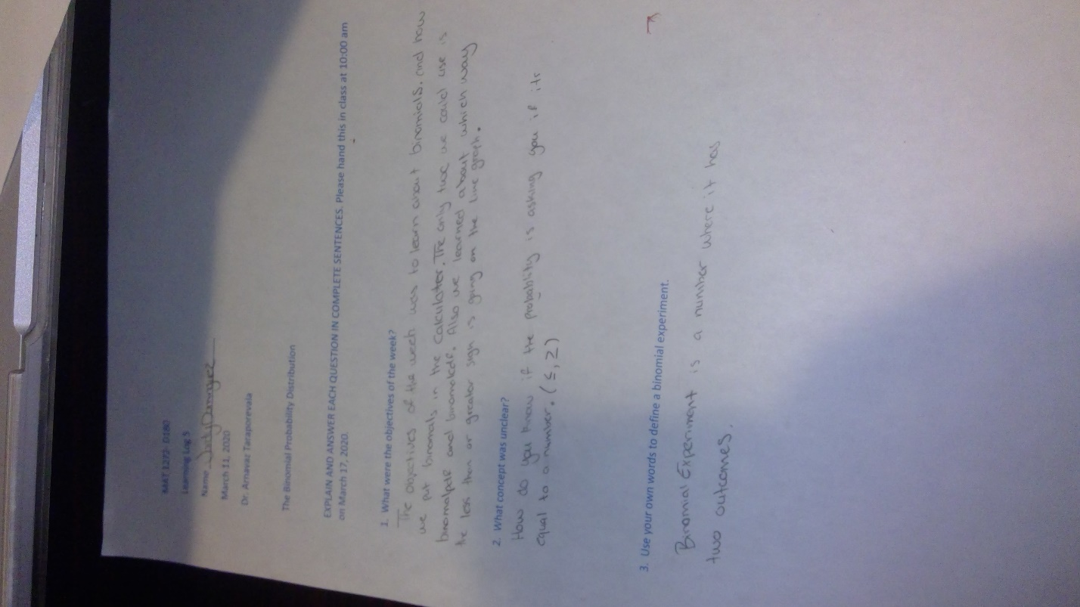

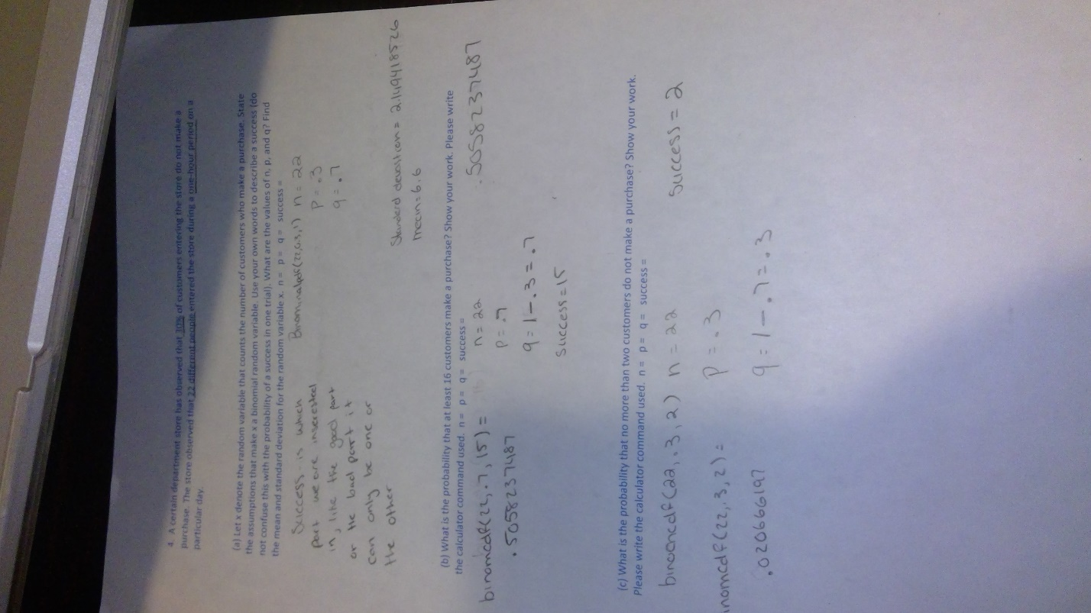10:00 P.M.

As I’m trying to understand the video, my mother told me that three of my cousins has this virus one did get it because she was helping a patient that had it but the other two are brother’s I don’t know 100 percent if they got tested or what not but their mother is still looking into it, to see if they got it. Not sure how to feel about it, but I do hope they are ok.

April 6, 2020

12:00 P.M.

I woke up this morning not knowing where my dad was at. I looked and he was not here. Asked my mom where he was, and she said he was working. (Wow his job opened, are not all the jobs supposed to be closed).

5:00 P.M.

He came home and I said are not all the jobs supposed to be closed. He said yes, they should be closed but if the company calls me and ask if I can go, of course I am going to say yes. I cannot stay here doing nothing. I like going to work. I wish I could go to school because this online class is not it.

7:00 P.M.

My sister asks me to help her with her math. She says that her math teacher does try to help her, but she does understand completely. Good thing that this is high school math I can really do this math. So, as I helped her, she wanted me to help her with the test that is coming up, so I did.

Section 2: REFLECTION AND ANALYSIS OF DIARY READING

I decided to read the "Diary of the Wimpy of a Kid", because I love reading books that have some type of comedy to it. Also, I have read some of the books when I was young. I have read the green one and the yellow one. I do not remember the titles these books, but I know the colors (each color is a different type of book). I still have not read the first one until today. I know what you’re going say " how could you read the third and the fourth book and not read the first one", well I didn't know it was the first one until I was in middle school. I saw the book in my library after I got out of school. I could have gotten and read it, but at the time I did not like reading. I was more into video games and going to the park. Now that I am in college the book showed up again. Maybe I was meant to read this book all along.

As I'm reading this book it reminds me when all the kids wanted to read this book and the only way to get your hands on it was to buy it though the bookstore that was in the library. When they got it, they would show it off thinking like the cool kids. I did not care though because I knew that if I would have brought it, I would most definitely have not read it. So, what I did was write a diary myself to see if it was funny or fun writing it. Here what is funny I only wrote five pages and stop because I did not want someone else to say "look you spelled something wrong" or your say something about my punctation.

As I am reading more, I knew why I brought two books. the book is so goofy and funny to anyone who reads it. And this is him only talking about his daily life and what goes on in his house, friend’s house, and school. The diary is highly organized, it tells me the date of when he wrote it and he explain things very well. Not only that, this also reminds me of the dairys that we are currently doing since we are on lockdown. We talk about what have we been doing since the lockdown and posting it through open lab.

Section 3: REFLECTION ON UNIT II AND GRADE

Wow unite two, I this untie went fast. Mostly because of this virus. I never thought that I would have to all my schoolwork at home. This is the first time that this has ever happen to me and this was difficult. Not only this was hard, but my internet did not have my back throughout this experience. And because of this I was late on some assignments. It not only

happened in some of my assignments it also happens on zoom. When I was on zoom it keep try to reconnect to the internet in which it kept kicking me out of the call causing me to rejoin back about three times. That is not the only that, I could not access open lab either I tried to contact them, and it took them three days to response. This was a lot to take in at the start in which this gave me real struggle for me.

There are still some errors I need to work on but even with the mistakes. I am probably still using some slang words in my writing and I do not even know it but for the unite two I felt like ive need to put detail in my writing. I need give more detail more so that the reader can until what it is that I am talking about. Even though I am still trying to correct my mistakes this unite was honestly fun I learned from myself, on what I do in my daily life, I also learned from what classmates and professor do too. It shows that besides doing classwork and studying they also do different things in their spare life. Especially during this crisis. And even though we are going through this I like the way that my professor is still trying to keep us connected with openlab and zoom. Some of my professors are not doing that, but this is something that I like. As for one of my homework’s being late and for the late open lab account, I still do try to comment on some of my classmate’s diary and response to the one has given me comments undermine post. This is also something new for me Ive never did any online classes before, so I feel a bit weird about it. I never really speak to my classmate through zoom or open lab, but this is something That I must get us to. Not everything in life goes your way people tell me. As for me grade I think maybe a b is something clam. Just because I feel like I could’ve did more and did things better.

**UNIT III - LEARNING FROM EACH OTHER**

**AFFINITY AND INQUIRY**

**SECTION I; YOUR SKILL / INTEREST DURING CONFINEMENT / WITH SOURCES**

**SECTION II; INQUIRY**

**SECTION III; REFLECTION AND SELF ASSESSMENT**

MY SKILLS/ACTIVITIES ARE...

1.Video games

2. Art

3. Basketball

**1.Here You where you tell us a little bit about WHAT YOU ALREADY KNEW BEFORE the confinement/what your experience has been with this skill/activity.**

So, my skill is video games. As for what I play on is my Nintendo switch. What I already know about my Nintendo Switch is that it comes with two controls, one for the right and the other for the left. As for that some of the games are 60 dollars and down. The switch has no background features, the games that you have purchased will be in the dashboard. Also, you cannot search the web, but it has news for when a new game comes out or if there is an update to a game you already have. If you would like to play online, then you would have to pay 20 dollars for internet. Which is a steal cause PlayStation and Xbox being 60. Also have a screen shot button. It is a handheld device, but you can also plug it into your tv.

**2. Here You where you tell us SOMETHING NEW you learned about it during this confinement period. If you have not learned anything new, then go out now and find out something(s) that you did not know about it before!**

The things I did not know about the Nintendo switch if one of the controls are missing you can find. You just need to go to the control locator app, but it will need to have a battery and make a buzzing sound. Also, you can adapt one of the new controllers like the PlayStation 4 or Xbox. You can also use an old controller as well. What was shocking to find out and what I did not know was that it has google maps. Lastly is the keyboard, you connect a keyboard to the Nintendo switch in which may people did not know including myself.

   
**3. Here You Will Give credit to THE SOURCE(s) of this new information and tell us a bit more about this/these sources and why you like them. Show us where we can go to find them.**

I watch a YouTuber named “The Gamer” who has around 1.61 million subscribers -- so as you can see, he is popular.

His channel is all about games and consoles and he explains what the new features to new consoles or games that are are coming out and what time they will be coming out. The reason why I go to him if I have any issues is because he explains them very well and if he does know how to fix it he tries to find it out by using other sources and putting a link under the video

If you would like to check him out here is the link to his channel

https://www.youtube.com/channel/UCX77Km4pLRsU9OFYEMdIvew

   
Another youtuber I really suggest is BeatEmUps, he is currently 912 k subscribers. He only talks about the Nintendo switch so if you have any other consoles it might not help you out with your console but you should still watch him because he pretty entertaining and gives out information on the games that are coming out and which games he suggest you spend your money on Not only that he also talks about when there are good sale that is happening in the Nintendo shop. Nintendo shop is where you find different types of games. He also explains how long it takes to finish the games and gives them a rating; he rates them one out of ten.

https://www.youtube.com/user/BeatEmUps   
 

**4: Context/Brief explanation to explain your skill/interest\***

As a switch player or any gamers out there, we may not know. We may not know which games are coming out, what new features comes out on the console, and different technician things that may come. So, we look for people online to see what they have learned, and this help us player understand what some of the issues we are facing. YouTube is the platform I go to the most because there are different people that can help. They do this for a living, this is thing they love to do and we, as gamers we have problems. We may know something but everything

Hi Jordy, do not know if you remember exactly who I am but I am Wala and I guess we are partners :)

Yea we are, and I do know who you are. I found out that we do have some things in common. Well, I did not put it as my number one skill, but I think this is fine. I love doing art and you like doing makeup.

Some things I found in common was that makeup and art does take some skill, is that you are trying to show off what you did to the people around you. Also, they both have to do with color. You can also practice or take some classes. And they both do trial and error. You can both get compliments.  And yea this is all I got.

As for what is different, I feel like in makeup you got to make the eyebrows on point, the cheekbones with the right color, I guess cause if its bad people are going to start violating. As for art you can have some weird art project and some people will like it (This is probably not true). Make is limited and art is not, it can stay longer than 5 hours. Must buy different products for makeup, as for art you can have a pencil and paper.

QUESTIONS FOR WALA.

How much are the products you buy, on an average?

Well it all depends on the budget you are at, like in the drug store, foundation costs around $8, but in Sephora it is like 50$ for a small bottle. Or for lipstick, in the drugstore it will be around $5 and in high brands sold in Sephora, it will be around $20.

When I started makeup, the drugstore used to be the only place I could go to because I didn’t have money like that, but now that I have a job and have a good amount of it, I started popping into Sephora here and there. But the prices are dragged, sometimes the product do not be even good, so the money goes down the drain.

   
 

How many times do you do makeup? Cause my sister does it as if it is her job or something.

Lol, usually for me, I wear light makeup to school or a nice girl's day, but for parties or weddings I wear a lot.

Other times, if I am on YouTube and I watch a video I love, I get up and re-create it. The only thing I do hate is having to clean my brushes, it takes a hot minute just for it to be used again.

Response: oh because I know some people that puts it on every day of the week. It is crazy. I wonder how much money they spend.

I would say if someone wanted to join the makeup crew, and they have nothing makeup related, they will have to spend around $200-$300.

How many brushes do you need?

There’s a brush for every step you do, for foundation you need a big brush to blend it all over your face but for me I like to use a beauty blender, I feel like it has more of a better finish to it.

And the same goes for eyeshadow, blush, contour, highlight etc., there is a brush made for each of those.

In total, there’s like I would say 10 steps to it, so I’d say you’ll need like 15 brushes in total, but us makeup freaks, we like to be extra and have more, from eye brushes to face brushes

Response: I thought it would be as much because my sister has about 15 or 20 brushes. I still think it is too much.

Yeah, these makeup idols drag it when they show their collection of makeup brushes. You do not need over 200 makeup brushes unless you do makeup on other people as clients.

 

And Is make up art to you?

Indeed, it is, you can do so much. People that are into drawing, love to draw it on paper or paint it onto a board and the same goes for makeup. But we like to draw it on our face lol.

An artist can wake up and say, “oh I want to draw a sunset today” and grab all the right tools and colors and get to work. Same goes for makeup but rather than drawing it onto paper, we will create it on our eyelids.

Response: I am on both sides; I've people say it is art and people say they are not. I am kind of on both sides right here even though a few days or weeks I said it is.

QUESTIONS FOR JORDY.

At what age did you start taking art seriously?

When did I start? I started around fifth grade when my art teacher did some graffiti. I took an interest in it because I love the way it had so many curves and design. So, after school I would do art and practice on graffiti, but he wanted me to start off with bubble letters and that was the beginning.

How long does it take you to finish a drawing/painting?

It takes hours for me to do art. Maybe a day or two. I like to take my time when I do art. Need to know what colors to put on, if I should add more etc.

What are the things you enjoy drawing the most?

I love doing graffiti. It is something that I grew up with and something that I am immensely proud of.

What type of tools and products do you need?

The tools I use are a piece of paper, pencil, and markers. These are the products I use but some people might use something else.

How often do you draw? And do you have a specific spot? Because for me, my favorite spot is in my room, doors locked so no one can disturb me and has the best light so I can see my work clearly.

I stopped drawing for a while because it was time consuming and I did not have any ideas on what to do. I also do this in my room because I have all the space I need here. But must have my music on because it is better to focus.

QUESTIONS FOR WALA.

What do you know about video games?

I do not know much; I mean my brothers are into it. Their favorite game now is COD

What was the first or favorite game you have played?

The first was Mario kart when the PlayStation 64 was still a thing and it was a constant routine, wake up, eat breakfast, and play for the rest of the day.

My second game was call of duty the zombies, I felt like a pro playing it because I was a beast at it lol

What is your major?

My major in the beginning was nursing, but just the semester I changed it to biomedical. Nursing started becoming too competitive and I did not want to change my major outside of the medical field, so I went with biomedical.

What you like and dislike about video games?

What I like about games is how it can relieve anxiety or any type of stress. But what I dislike about it is how addictive it can be. I can start around 2pm and somehow time flies and it will be 10pm without realizing.

Have you played video games since this whole issue had started?

To be honest, I played it less. We have the Nintendo switch with so many games, but everyone is just on their phones entertained on their own.

Hi, my name is Daniel do you guys mind if I join your group?

Sure

Sure, which Daniel?

QUESTIONS FOR JORDY & DANIEL.

Where were you born?

Jordy: I was born here in America, but my parents are from dir.

Wala: I was born in Brooklyn and my parents are from Yemen.

How many siblings do you guys have?

I have on sibling and that is my little sister

Wala: I have 5 siblings, 3 brothers and 2 sisters. We are a total of 6.

What high school did you guys attend?

I the high school I attended was East New York Family Academy, or in short ENYFA

I attended a private school that was Al-Madinah. The guys and girls were separated.

How are you guys doing with this whole quarantine thing?

What I have been doing is my homework which takes a lot of my time, but when I am not doing homework, I am either playing video games or sleeping

Wala: Since Ramadan started, I stay up from 8pm to 5am to eat before sunrise then sleep till 4pm and wake up to gather the food. But before that I used to stay consistent with classwork and watch movies/shows.

What movie that you have watched would best describe you?

I really do not watch a lot of movies. Movies are not really my thing, but I would say I am a fun person

Wala: Lol all the sudden I do not know any movies, but I am into drama, action & horror. My favorite that I love and can rematch so many times is “brotherly love.”

   
Section 2

So, what I learned from Wala is that make up for her was never a thing for her when she was a kid

And how she did not like it as much because she never knew how to do it. And when she puts makeup on, she feels a little better and have more confidence (In my opinion I have always told my sister that you are beautiful without makeup, in which she still doesn’t listen). She also learned makeup from watching YouTube and role models. By watching the videos, she found she need to buy some products to do makeup in which she says that it was a waste a money. And I can tell that Wala has been doing this for a while. She learned from the source she uses and practice on it. She knows what she is doing and what she is talking about when it comes to putting on foundation, shading etc. Learning from Wala, I see why my sister do makeup. The reason she does makeup is because this makes her feel more confidence in how she looks. I do think makeup can be put on here and there, but in my opinion for Wala, my sister and others people who put on makeup, you don’t need makeup to make yourself feel better your beautiful the way you are.

As for Daniel, he joined the group late, but I did not mind him joining. Daniel is into drawing and so was I, so it was fun to see how another person got into drawing. He started when he was young, and he has made some mistakes while doing it. In which I agree with because I have been doing a lot of mistakes when I was little and because of those mistakes I was able to learn be more creative. Daniel also talks about how drawing is a skill and how we always think about finishing what we started. This something true I always think like this. To me Daniel does know what he is talking about when it comes to art, but one thing I would say is to keep it up.

Reflection

So, this was uniting 3. I did not expect that Unite 3, I had to connect with some of my classmates. Not saying that it was a bad unite but this unite I like it, I liked that we connected with each other, even though we are in our homes every day.  What I've done in unite 3 I feel like I do put in the best effort when it comes to class participation and help out people with like their skill or if they are missing a partner as well. Also tried to connect with my partners as well. Not only that I come to zoom meetings if I have any questions. I help with the professor when she feels like she cannot explain it or if the class would not understand I found find some ways to help them. I also try to understand what my assignments are needed. I found it much easier to do. If had a question I would get it and some of my classmates would give some opinions to help as well. As us I do feel like we should do small groups when it comes to zoom because I think people should speak out more than letting the same people do so and maybe occasionally do a group meeting. As for a grade I would give myself a b plus or a b.

`