Final Portfolio

Submitted by: Antonio Garcia
Course: Eng. 1121, Sec. 402
Professor: Sara Schmerler
Date: May 20, 2020

Content:
My Journey to English 1101
Unit 1:
- Section 1: Journey to writing paper
- Section 2: Inner Outer Assignment
- Section 3: Unit 1 Reflection
Unit 2:
- Section 1: Diary Excerpt 1 & 2
- Section 2: Anne Frank’s Diary Reflection
- Section 3: Unit 2 Reflection
Unit 3:
- Section 1: Your Skill/Interest
- Section 2: Pairs Assignment
- Section 3: (A) Reflection on your pair (B) Overall Reflection

My Journey

As the semester began, I was ready, excited, curious, I had a mix of feelings about what I would learn in this new English class. Not only that, but I was curious about the kind of professor I would have, would it be a professor that assigned us a lot of essays to write or a professor that would teach their students something new about writing. My main perspective of an English class was as students we must do essays and read assignments.
When the semester started, Professor Schmerler talked about herself, the background she came from, how she’s an artist, but is now teaching English. It was pretty cool to know that my professor had more than one profession, because I never would’ve imagined that. As we went more into the semester before we had to start online learning due to the corona virus, we were doing all types of new writing, at least it all felt a bit new to me because I had not done that type of writing in years. Some activities we got to do was circle time with the whole class, share our own personal writing diaries, where we wrote about our everyday life, aside from being students at City Tech college.
There were some challenging times, especially when I had to “try” to write in a train with a lot of people on the train car being as squished as a sandwich, as a bunch of strangers just continued to pile up. However, I did manage to pull it off, I learned from this and got to share some of my morning adventures. One thing I found in common amongst most students was we all rode the train, whether it was the A, E, F, 2, 3, or C train we were all coming from different neighborhoods and using our lovely MTA transportation to reach the same destination. Everyone in the class was just starting to get to know each other more and even the professor helped us individually with mistakes we had made in our writings from grammar, punctuation, run off sentences, and incorrect pronouns. Somehow, we all struggled, no one was perfect, we all have flaws.
The corona virus became more serious as people all over the world were getting more sick, which caused CUNY to decide that for everyone’s safety all classes would transition to online. At first this might have sounded great for most students, but we all knew there were going to be struggles, especially not being able to be in a classroom and be face to face among peers and the professor. We all had to adapt and learn how to teach ourselves without the physical help of our professor. By keeping up with the diaries through our pandemic life it was very interesting, personally it felt like I was writing my own journal as I included most of my day to day activities. As I read other classmates’ diaries, it reminded me that everyone was going a bit crazy or tired of being at home, and that online classes were turning into a real struggle for some students.
Due to class being transitioned online, and not getting to accomplish what Professor Schmerler had prepare for us for the rest of the semester, I was really curious to find out what new activities or adventures we would work on to improve our writing skills. The work that I did pairing up with Raghda and getting to know her more than what I did in the beginning of the semester, was a nice experience, especially learning about her special skill of decorating. Even though I think being in a physical class would have made that task more fun. As a student this journey has being like a small roller coaster, learning how to fix my mistakes in writing, has had its successes and failures, especially in terms of grammar, verb tense or some run on sentences. I know that even now it still remains a challenge, which I have to constantly improve on every day, but it’s a challenge I’m willing to accept in order to correct and learn from my own mistakes.

Unit 1
English 1121-Sec. 402

Antonio Garcia
Eng. 1121 D402
Prof. Schmerler
2/15/2020
“My Writing Experience”

My experience with my writing sometimes causes my ideas and thoughts to seem like they’re all over the place. This means that at times I have my ideas all written down in my notebook depending what the topic is about or if it’s an important lesson that I will have to review later on. I take some time to brainstorm and try to organize and see how I can put those short phrases or ideas in larger sentences to make sense later on for myself. All ideas I put them in my book even if it looks a hot mess that at the time I don’t understand or comprehend. At time I will use color pens, so I know one idea is more important than the other one. Doesn’t always work that way for me for everything; at times I just start to type and let my idea’s flow. In the past all my writing was on my notebook or a loose-leaf paper to start somewhere, even if at times half the things that I write don’t make sense or I have to re-read it to myself and learn how to make my thoughts better.
Now a days if not possible for me to use my notebook in the middle of the street trying to write, I use my phone and type in notes. If I am in class of course I write down all ideas in my notebook. Some areas that I know at times I struggled while writing, I tend to repeat a thought/idea that I already mention, just is in different way. I notice also at times when I type things to fast and don’t get a chance to proofread my work, I easily make grammar mistakes that I shouldn’t be making.
I know in the past I never was a great writer; even if that means just summarizing a story or just writing an essay for class. Especially in middle school English class I remember struggling through class, because I would get confuse how to combine sentences or using the correct verb. I would need a few drafts and help from my teacher, but I’m glad my teacher had patience and help me get better. I would feel bad at times because it wasn’t nice seeing other kids getting good grades and here myself I was just getting ok grades. I did my best to always learn to be and get better at writing. At times learn I would learn from my fellow classmates on how or what they’re doing different. I definitely learn that they where brainstorming more than me. So, from that I learn that maybe I needed to find a way how to brainstorm my ideas a little bit better. They used a separate notebook just to put any ideas related to the topic. From those ideas they learn what to use and how to use it to, and put them into a good sentences.
Definitely I love writing about short stories, or short novels, or also novels that involve a crime or an unsolved mystery. In my English 1101 with professor Albert Angeloro we went through a lot of short readings and after that we would talk about what we though about the story and compare it to ether an event on real life or to any other story we had read already. I know when he used to grade our papers and give them back he will leave comments as good analysis, good ideas, good organization. But he would correct my grammar mistakes I would make, or things that were extra and tell me to remove them. I still remember the time he told us, maybe on the second day of class, “no writing is bad writing you write to write, and no one can judge your work. Just put the effort and time and you can produce a hell of an assignment.” He made sure to tell us that anyone can submit an essay but doesn’t mean that it’s a perfect one. Not everyone can or has the ability to be able to handle an essay with full with exciting details, concepts and beliefs.

Section 2: Inner Outer Assignment
January 31, 2020
Riding the bus there was a young teenager humming what I believe was a favorite song of his. He was making different sounds like “uhh-uhh, dinn-dinn, bom-bom, tsk-tsk, and dann-denn.” To me all those sounds just sounded funny and confusing noises. Waiting for the train I had a guy with his little puppy inside a bag. The dog breed was like a shiatzu type I think, not 100% sure but I know was small, with brown-ish black hair. The dog all of a sudden was making some weird “meo-meo” type of sounds, for a moment I double check and stared because I though was a cat instead ja-ja. Once the F train arrive, I went inside, and I spotted a woman with her daughter. The girl was maybe around 3-4 years old; she was short with curly, blonde, semi-long hair. The girl was trying to read her numbers, she kept saying chu (for the number 2) and fo (for number 4).

February 1, 2020
Saturday morning, is 7:05am, as I’m walking to the train to head to work ( I know work on a Saturday how boring zzz HAHA) a cat appears from an alley and starts to Me-Oow, Me-Oow” at me. I kept walking minding my business and I notice the cat walk behind me, was following me or walking with me to the train station. I’m allergic to cats, so I started to walk faster because I didn’t want to start sneezing, maybe the cat was just looking for food? A block away from the train station I noticed the cat finally gives up on me, and starts to follow someone else, finally I’m cat free. I make my way down the station, as I’m waiting for the subway, I can see a drunk man sitting in the platform seats with a beer still in his hand. The R train arrives, and he wakes up he goes inside the train car as well. I hear the conductor speak “stand clear of the closing doors.” The drunk guy takes a huge sip of his beer and out of the blue starts to sing. Even if he is not making sense at the words he’s trying to sing/mumble, I manage to understand a few words which say “te extrano mucho” that stands for “I miss you a lot.” Off he goes to another train car.

Section 3: Reflection
Within the past couple of weeks in my English class, I have learned a couple of new things that I thought I wouldn’t benefit from. As I heard my classmates share their own experiences and struggles, I was able to learn that everyone shares a common trait and that somehow they all try to improve and make something better out of it.
So far I can say that I’ve enjoyed my English class and I’ve felt that it has shown me how to become a better writer. Any struggles that I’ve come upon were explained to me upon class, either by my Professor Schmerler; giving us examples of what she wants us to learn or learning from fellow classmates. A struggle I had was I did not understand a few terms from the readings we were assigned. When this occurred, I had to google the word or find it in the dictionary to understand the meaning, or find a similar word that I did comprehend. Even though some success did occur because of the readings, for example the reading of Donald Murray “Internal Revision” at first glance I would’ve never figured that the writing process itself is such a great task to learn from and achieve. In order to get a great piece of writing you must struggle at first and learn to find a way to understand where you’re taking your story, in order for your audience to understand the point you’re trying to make.
In my previous English courses including in high school, I was never taught the importance of revision and that doing many drafts is an important factor in getting where you want to be. In high school it was more about writing papers about stories we read, and handing an essay afterwards, receiving a grade with notes of what I did wrong whether it was grammar, punctuation, or verbs missing. I never had an actual one-on-one with my teacher on how to improve those factors or on how to make my work better. From time to time the teacher would say that I wasn’t the only one struggling and that it takes time to improve, would give me a few pointers, but that was all.
My college professor last semester was almost the same, but he did explain himself more and I definitely loved reading his short stories, and watching some of the films he put in class. I would say some of his stories were about murder, mystery, and suspense so that made it pretty interesting. The part that was less interesting was writing about it in an essay based on questions he assigned us. We definitely would include our topic and ideas, but it was mostly based on answering questions. Once we received back our papers he would just check for common errors and from time to time he would make us read short passages in front of class because he thought we could make an outstanding analysis.
I would say I love the readings I was assigned because it’s something new for me. I honestly don’t recall having to read something similar to those readings so for me, this was a first time experience, which I greatly benefitted from and now I know how to use those methods in any of my upcoming writing tasks. Like I previously mentioned, I have learned, that I can’t expect to achieve greatness on my first try. I need to be patient, hear my peers out, and learn from them as well. At the end of the day, we are all in class to learn from each other and hear each other’s experiences whether good or bad.
A way I could have made my literacy narrative better is by definitely giving myself more reminders of my struggles in middle school, since I was a boy in ESL. It was hard to comprehend and focus on my writing in paper at times. I would constantly find myself lost on how to start or have trouble confusing words in English with Spanish ones. I know I was helped a lot back then by teachers who constantly encouraged me to become better at class since I wasn’t the only one was being stuck. I also know that I had friends struggling as well and at times we would help each other out. Even if this meant being wrong, at least we communicated and share ideas. After hearing my classmates’ narratives I learned that we all went through struggles, and sometimes they were the same or at least similar ones. It was especially the struggle of coming from different backgrounds where it involved speaking more than one language.
If I were to grade myself based on the work I’ve done in class, I would give myself an A-. I think I still have much to learn but I’m always trying my best in class, whether is trying to participate more, using what I learned in my writing and just staying away from old habits.

May 20, 2020
As I re-read my first unit, I can tell all those tiny mistakes I made, and maybe still making until now but I’m trying to improve my writing and get better little by little. One step at a time, I think I’ve grown compare to how I started in the beginning of the semester. For this unit I got a B+ as my grade, I didn’t get a chance to improve the grade because that’s when the virus issue started.

Unit 2: Genre
Content:
- Section 1- Diary excerpt 1 & 2
- Section 2- Anne Frank’s Diary Reflection
- Section 3- Unit Reflection

Section 1___My Diary Excerpt:

Elmhurst, New York
March 23, 2020

7:30am

Dear Diary,
I just woke up feeling a bit tired than usual. I got up knowing that classes resume online, even though I have a weird feeling about this. It feels like these online classes might be a bit of a mess in the beginning because everyone will be all over, as they won’t know how this will all work, and most importantly how this will impact our grades. Hopefully all goes well not just for myself, but also for all students.

8:15am
Got my day started with a cup of black coffee and in the mood of making some chocolate chip pancakes, before my French online class starts. I mix all the ingredients up and start making the pancakes. Once I’m done I refill my cup of coffee and my day officially begins.

12pm
French class ends, and class was a little bit confusing, especially for the professor because he is still confused about this online concept. He is trying his best though, we are using the app Zoom to see the professor and make sure we are repeating after him the words that he is teaching us. He makes the lesson fun.

2:20
I open a bag of crackers and start to eat them with some peanut butter and banana slices. I was thinking of what to cook, even though I was already eating snacks ha-ha. So for the moment I was working on my math homework as well since I have some homework pending and some of them are a bit confusing.

5:30pm
I started cooking some dinner today and I decided to make some whole wheat pasta with vegetables. A dinner that’s nice and easy to do in a matter of minutes. Meanwhile the pasta is in the water and the vegetables are in the oven cooking, I resume back to my Netflix show.

Elmhurst, New York
March 24, 2020

8:10am
I woke up a bit later than my usual time, I get up to brush my teeth. I put two slices of toast on the toaster and serve myself a cup of orange juice. Meanwhile I turn the television on and watch the news for a while. Everything that they talk about is on COVID-19. I listen for a bit for any new information I might need to know.

9:15am
I start my workout routine with the weights and equipment I have at home. I usually do about an hour workout since I have no gymnasium to go too.

11:30
My biology lecture online class starts; let’s see how this hour goes by hopefully this internet isn’t lagging and is working good.

1pm
Doing some reading on the biology slides that the professor went through in class, rewriting all my notes since I wrote them all fast and they were a bit sloppy. I try to have everything organized, so that when it’s time to re-study my notes for test it’s easier to do so.

3pm
I am taking some time off studying and going over notes to get prepared to cook some tofu with some vegetables and rice. I will be back shortly after cooking.

4:30pm
I have finally had some dinner with a glass or two of wine. Also while having dinner I continued to watch a show on Netflix that I got hook on called “Money Heist.” It’s a really good show; I’ve already finished watching two out of the three seasons that they have so far.

Elmhurst, New York
March 25, 2020

7am
I woke up early because I kept hearing a few ambulances passing by, maybe about 2-3 ambulances I could hear their noises (wee-oow, wee-oow, wahh- wee-ooww) from a far distant but they manage to wake me up. I get up to go to the bathroom and brush my teeth, change into my workout clothes and start an early morning workout.

8:30am
I am out of the shower after a good workout, I’m ready to cook some protein breakfast to get my day started and see how my online classes go today. I make a spinach and mushroom egg omelet with some parmesan cheese on top. Along side my omelet I have my cup of black coffee in one of my favorite mugs, a Game of Thrones mug. (For any Game of Throne fans out there)

10am
I am going over my French notes and old assignments since I have my quiz #2 even though he didn’t tell us what to study on. The professor said he would tell us today in about an hour when it’s time to take the test. It doesn’t sound like so much fun not knowing what specifically to study on, but I am going over the past two weeks of notes, hoping the quiz will be on that.

11:30 am
French quiz # 2 here we go, wish me luck.

1pm
The French quiz wasn’t bad at all knowing that I studied my notes and it was an easy quiz for this time. He didn’t want to put too much pressure on us he said knowing that we’ve been having a crazy week. So for now I’m just waiting for math class and writing some questions that I was confused on in the last lecture, hoping he can explain it to us all in better details.

2:30 pm
Time for this math online class, let’s see how it goes.
4 pm
Well my questions to the math class got answered and explained in better details. It was nice knowing that I wasn’t the only one confused; some of my peers also had the same questions. We finished a new lecture and now I’m going over my notes to see the one or two more questions pop out. I am hoping to YouTube this and maybe find the answer I seek or I’ll try Google too, since Google knows everything right?

6pm
It’s time for dinner. For today’s dinner I will be having some penne alla vodka with broccoli and string beans (I know it sounds a bit too healthy and boring right? Haha) but it tasted way better than it sounds. It’s time to continue watching Money Heist on Netflix and to I’ll try to finish season three.

8:15 pm
I stop watching Netflix to continue doing some math homework before I call it a night and go to bed. Some of these math problems are driving me insane; they look so easy yet there are like 10-15 steps to do before actually getting the answer. Whoever says math is fun, it really isn’t, it takes time and patience to learn.

Elmhurst, New York
March 26, 2020

8am
I didn’t have a great sleep, I kept hearing a few ambulances driving, and my guess they were rushing to the hospital. I felt a bit freaked out, but I hope that all the patients make it out well.

8:30am
Time for my biology lab & lecture class until 12:45pm.
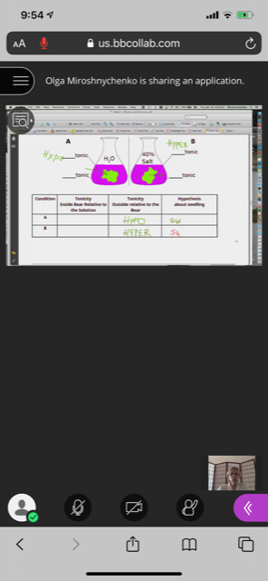 (My biology lab class)
3:30pm
Just eating some crackers and snacks after going over all my notes for the biology class I just had. Just getting all the notes organized. It was a fun class, even though my Internet lagged a bit during lab class so it felt like it froze a few times. Lecture biology went good, but he was a bit confused himself, not knowing it we were having another recess or if he would continue to teach.

7:30pm
I’m just having a glass of wine and watching The Office on Netflix. It’s a funny show I love most of their episodes. I’m just going to relax for the rest of the night and continue to watch Netflix, probably will go to sleep early tonight.

Elmhurst, New York
March 27, 2020

9am
Getting off bed this morning felt like a nightmare, I got plenty of sleep and rest but it was so comfy in bed that I didn’t want to get up. Eventually I got up went to the bathroom and brushed my teeth to get the day started. For breakfast I drank a cup of orange juice with a piece of almond bread.

11am
Now time to continue working on homeworks I have for math and English of course. I have a few assignments to do for math and some of them are very confusing so that means I will have to use my friend Google for help or YouTube. Either way whatever works to get my homework done and for me to have a better understanding.

3:30pm
Taking a break from all the homework I’ve been dealing with, I think I even got a slight headache from seeing too many numbers and explanations ha-ha! The good thing out of this is that I understand the work because of the help of YouTube videos, so that’s a good sign that I’m learning something new.

8pm
I decided to make some banana bread since I had a few bananas that were ripe and my sister Michelle decided to give me a hand and help me out. We just used a Google recipe and found one from the “kitchn.” Let’s see how it goes, hopefully it comes out delicious in the meantime I’m in a conference call with a few friends catching up.
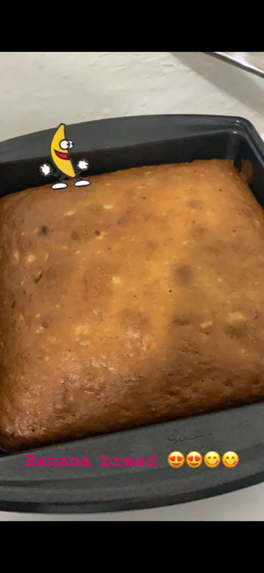 (My banana bread results)
Elmhurst, New York
March 28, 2020

8:45am
Woke up thinking how much I miss running with my running club, or even going to the gym either to do weights or go for a swim. We can’t do things like this for the moment because of the virus. I hope this sci-fi movie we are currently living in will end soon and I hope everyone is taking all necessarily precautions needed to stay safe. I get my day-started, brush my teeth and have some coffee with a slice of bread.

11am
I have a workout conference with a few friends, this is fun and exciting something new we are all trying. We try to make the best of the situation and make it fun as well.

12:30pm
Workout was fun, was a total success even if I did not have the correct equipment, we used anything we had at home for weights for example wine bottles, canned food or even chairs. It was nice to socialize with friends after being far apart from each other, but we’re still managing to get a nice workout done.

3:30pm
I’m having a piece of my banana bread from last night that came out very delicious, would definitely recommend the recipe if anyone wants to try it out. https://www.thekitchn.com/how-to-make-banana-bread-the-simplest-easiest-recipe-139900 I posted the link in case anyone wants to try.

6pm
I’m spending the rest of the night just watching movies and catching up to some news to see updates around the world. Hopefully some good news out of this pandemic. Eating a bit of junk food as well having some chocolate and chips, I know weird combination but very tasteful.

Elmhurst, New York
March 29, 2020

9am
I got to sleep in today, felt great especially after staying up and watching TV. The last movie I remember watching was Star Wars: The Last Jedi. I’m a star wars fan so definitely enjoy the movies. After brushing my teeth and waking up, I got up and toasted a bagel with some cream cheese and had a cup of cranberry juice.

10:30am
Now after getting my day started and having breakfast, I have to start doing some chores. I have to get started by cleaning the house and doing some laundry right after that.

4pm
After a long day cleaning and being proactive, finally caught up to everything and now time to make some food. I was undecided on what to make, so instead of cooking I decided to just put a frozen cheese pizza in the oven. I wasn’t in the mood to cook and wanted to just relax in the sofa, so I put the pizza in the oven and while I waited had some tortilla chips with salsa.

Elmhurst, New York
March 30, 2020

8am
I woke up early to get a morning workout done especially since we are in another school recess for the moment until Thursday. So I get up to go brush my teeth put some water to boil and have a cup of tea. Right after that it’s time for my workout to start so here it goes.

11am
After a good long hour workout and out the shower, I’m toasting some bread to make a PB&J with banana slices and a cup of orange juice. As I’m eating I go over my French class notes so I can practice the language and not forget what I’ve have learn for the moment.
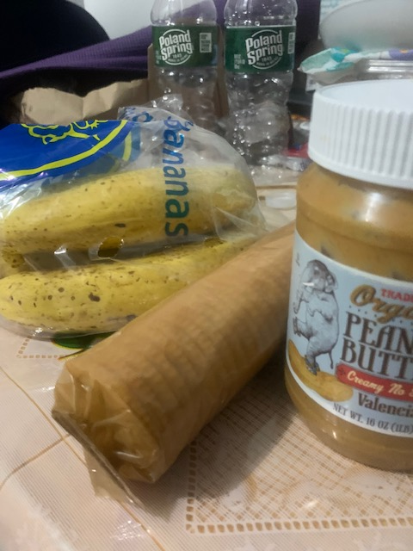

2:30
I went out for a quick grocery run just to get essentials I was running out of, it was lonely seeing the streets so quiet and mostly without people walking around. It was good thing to see, since people aren’t supposed to be outside socializing and are staying home being safe.

6pm
I made some quick noodles with broccoli to have for dinner, and now going to join a few of my friends on face time chat to just talk and catch up and see how everything is going from their houses.

Elmhurst, New York
March 31, 2020

8:15am
Day number ….!?! In the house just going a bit crazy today, want this whole virus to be over already! I got up, went to toothbrush and I was ready to start the day. Definitely today was one of those days where I was feeling a bit lazy. For breakfast I decided just to have a bowl of cereal and some cold brew coffee. I think today I will just be watching “The Office” on Netflix.

5pm
Lost track of time had a meeting with my English professor and some classmates at 1:30pm it was nice to have a quick meeting via online. She answers or helps us with any concerns or assignments that we have done until now. Also after my meeting was done I started to watch The Office and I was having a good time laughing, that I didn’t realize it was time to prep for dinner until my stomach started to growl. No idea what I will be having tonight probably might heat up some mozzarella sticks and carrots with hummus. Also will make a quick avocado salad as well.

Elmhurst, New York
April 1st, 2020

8am
Woke up early to start the day and making some pancakes for breakfast today. For some strange reason my stomach was growling today so I decided to have a good breakfast. I decided to have a fruit smoothie as well to go along with my pancakes. I made my smoothie by adding some frozen berries, some lactic milk, and some peanut butter too.

11am
Enjoying a delicious breakfast, but now its time to study and do some math homework and catch up to some problems I have to solve. Some of these math problems I left until now because I didn’t understand them, even though I was trying to find help it still wasn’t helping at all. After a while I did find a way to solve and find a solution for them.

7pm.
I’m catching up to math homework and having a great virtual workout with friends, now it’s time to eat some dinner. Dinner’s menu for today is tofu with noodle and red peppers and carrots with a glass of wine. For dessert I will be having a slice of carrot cake that I managed to get from Martha’s Bakery. Besides that I will keep enjoying watching The Office until I fall asleep.
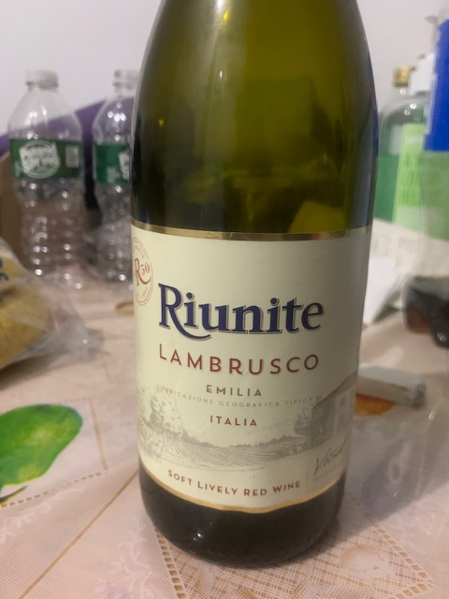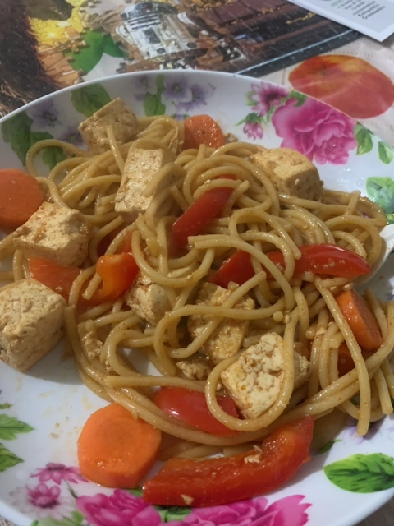(Tofu & wine)

Elmhurst, New York
April 2nd, 2020

7:20am
Waking up a bit earlier than usual because today I have my biology lab class to take later on at 8:30. So as usual going to have some quick breakfast before going into blackboard to have class online. Making a quick peanut butter & jelly sandwich and putting some water to boil to enjoy my sandwich with coffee of course to start the day right. As I wait for class and enjoy my coffee I listen to some music, I play a random spotify playlist the top 50 songs. Some of the songs I recognize and other songs I haven’t heard of them, but can’t complain till now every song is catchy whether because of their beat, rhythm or song lyrics.

12pm
After having a good biology class it is now time to enjoy some snacks and a cup of cranberry juice. I’m enjoying some Ritz crackers with almond butter, something quick before I get started on some French homework and get into my cardio workout routine. Just in case I’m still hungry I have a Hershey almond bar or sour gummy bears, yeah it sounds like a crazy sugar rush.

2pm
Just lying down on the sofa after a good hour and a half workout just so I don’t stay lazy and do nothing. Now all I can think off is food I wish I could just pop a meal into the microwave and BAMN! Out comes a hot meal. For the moment I just wash some grapes and an apple enjoying this snack until I get into the mood to cook some rice and prep some tofu.

630ish pm
After a while just watching Netflix and talking to a friend on the phone for a while I prepare my tofu to eat, now is time to enjoy some dinner. For tonight I will be having tofu with brussel sprouts, broccoli, tomatoes and some brown rice. Also I will continue to watch the Office because why not right? For dessert I might have a couple of homemade chocolate chip cookies with an ice tea.

Elmhurst, New York
April 6, 2020

9am
I haven’t been writing for the past few days because of a recent death in the family. My grandmother just passed away on Friday and I’m still in shock about it and trying to process what happened and how it happened. I’m just trying to be a support for my mom and as well as my aunt because that was their only parent left. I’m blessed that I held so many memories with her and I got to be with her through a lot of fun times. Wherever she may now be I hope she rests in peace and will look out for me and for my family as well, especially during these hard times, that not only I’m going through but a lot of New Yorker’s losing loved ones due to the virus. I know my grandmother was super sweet, loving, happy and maybe bossy at times but her memories will stay with us forever.

10am
This morning I’m just having a bit of honey nut cheerios for breakfast this morning I wasn’t in much of a mood to eat but I know I have to eat something. So I’m enjoying a healthy bowl of cheerios. I’m flipping the channels as well, trying to find something to watch; so far I mostly see news, comedy shows, cartoons and a few movies that I don’t know. I decided to watch The Avengers; it is a nice classic super-hero movie. I lay in bed enjoy my cereal and watch the movie while outside I see the sun is shinning bright and it feels like there’s nice weather outside.
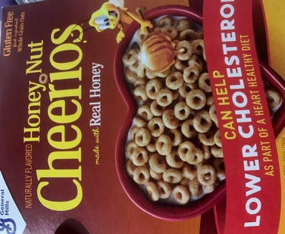

1pm
I just finished my French class and today learn how use the verb “Avoir” which stands for “to have.” The verb is used in present terms sentences, it is a way to express possession and sensation towards things. The sentence I used to participate in class was “j’ai une chemise noire” which is I have a black shirt. I can tell that French is just going to get a bit harder every time, but I’m going to try my best and make the best of this class to learn this new exciting language.

4pm
Finally I’m done with math class online today, the topic today was a bit hard. So like always I will have to go to my other notes and maybe over the recording of the class to try to see if I understand the lecture by playing it slower. Who said math is fun? because not on this level of math I’m taking which is pre-calculus, hopefully I can get a good grade at the end of this hectic online semester. In the meantime I prep dinner some tofu marinated in a spicy sauce, accompany to that will be some red peppers and kale. For the meantime while the tofu absorbs the sauce flavor will be working out some cardio to let time fly.
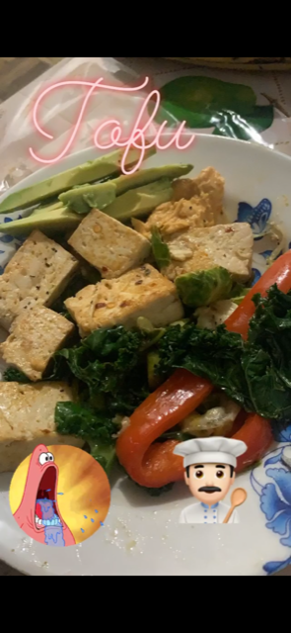 (Patrick’s expression said how hungry I was.)

730-ish pm
After a workout and shower I cook my meal now to sit back relax, enjoy The Office and enjoy dinner. I noticed that exactly at 7pm people from my building were finally clapping and trying to make noise using pans, pots or anything that made loud noise. I even heard someone screaming “wooo-hooo” I found it really nice for people in my building acknowledging the hard working nurses, doctors, police, EMTs, and all essential workers that are out in this battle against the virus and still working trying to keep NYC safe and sound.

9pm
Took a break from Netflix and was just reading my book “Educated” it is a nice way to keep my brain learning and it also helps me become a better reader. Reading this book I compare myself to the character Tara because she is teaching herself how to educate herself. She learns to teach herself math and improve her grammar. So I relate to how during this online class courses that we are currently having is how we have to teach ourselves the subjects we are learning, because at times our professors are hard to understand. For example my pre-calculus class if I don’t understand a specific topic I have to go out of my way and try to find help from Google, YouTube, Khan Academy, email the professor, or even ask a friend, anything to find a way to learn myself. Now with that being said it’s time to go to bed and call it night. ZZZzzz.

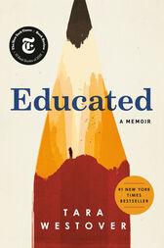 (My reading for tonight.)
Elmhurst, New York
April 7, 2020

9am
I woke up today with a headache no idea why, but maybe I just had a bad night of sleep. I know I was tossing and turning and I wasn’t able to fall asleep right away as I usually do but eventually I did. So I woke up brushed my teeth and served myself a bowl of cereal, today I will be having honey bunches of oats. I also toasted some toast and added some strawberry jelly. While enjoying breakfast I turn into the cooking channel and was watching “grocery games” it is a fun show and sometimes the food they make in such a short time looks super delicious makes me drool ha-ha.
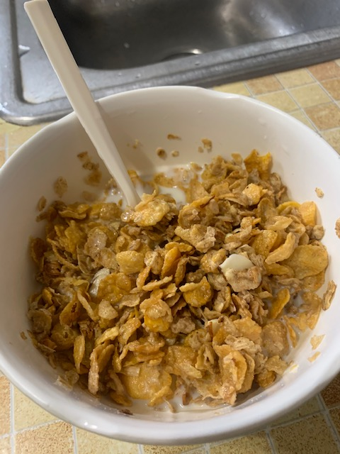
1pm
I’m done with French class, we went over notes and read some small passages, besides that he gave us a choice of giving us homework or none. Of course majority of students said no, he just said to review notes and keep practicing the language because on our next test he will test us on how our pronunciation is. I know I will have to practice a bit more especially because at times I get confused on how to pronounce certain words or forget that in some words ending in e, t, x are silent.

3:30pm
Just having a bit of blue corn chips with some salsa while I wait to have a workout online routine with friends. While enjoying some chips I’m watching The Office. I love this show it always makes me laugh. I’m having a relaxing afternoon even though I would of love to be outside enjoying the weather since the weather felt nicer. Once this virus is over and things get back to normal hopefully everyone can enjoy spring weather especially summer is coming soon too. We can only just be patient and wait until the virus is finally gone for good I hope.

7pm
Time to enjoy some penne with broccoli avocado, spinach for dinner. Good delicious protein after a good workout I had with friends. Now just time to sit back and eat food yummy yummy yum. Also I turn on the TV and I just started watching a movie called 13 hours: The Secret Soldiers of Benghazi, I know I’m pretty late on watching the movie but so far I can say WOW! Great movie that my friend recommended a while ago by my sister but never had the chance to actually watch the movie, so we watched it.

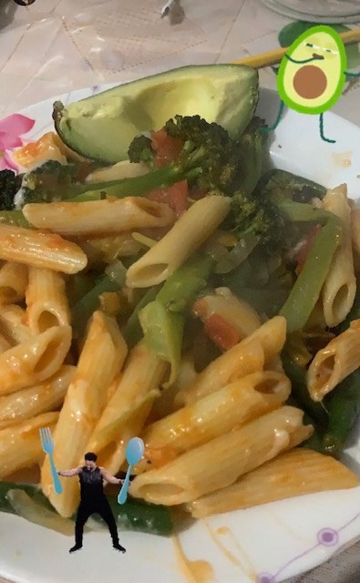 (Protein dinner)
9:20pm
Finished the movie and got to enjoy my strawberry mochi ice cream. I must say I give it two thumbs up and recommend the movie to everyone. I enjoyed the movie and it showed a glimpse of how six soldiers protected their base and diplomats. Now it is time to finally get ready for bed. I will just probably stay up and check if anything else is interesting on TV, if not I will probably just read for a while and then go to sleep.
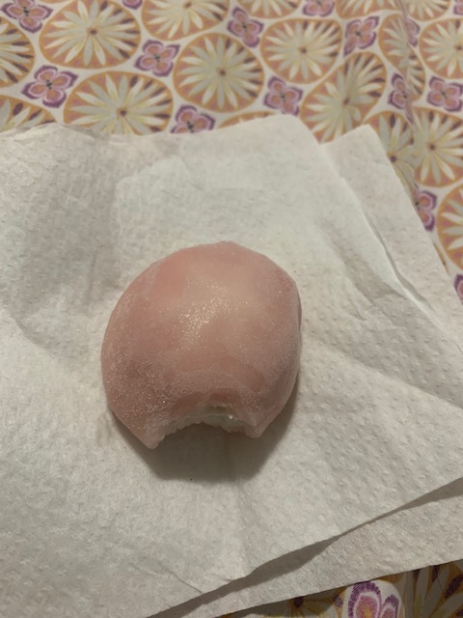(Strawberry mochi)

Section 2__Reflection & Analysis Of Diary Reading:

I started re-reading the Anne Frank diary, I was previously assigned to read a few pages back in high school. I don’t remember what exactly I read in high school, but I know learning about her was a good experience. So given the chance to re-read, felt like would be interesting to remember a little about Anne’s life and what she went through. Would help me focus and compare her writing to the way I write on my English diaries.
Reading through her diary I remembered how well she would describe everyone, as she was very specific in her writings. She basically gave a glimpse of how she would spend her time, either with whom or where. I found that very thoughtful because makes you can imagine yourself as part of her diary too, even if was years ago. Something Anne wrote that I found very inspiring was “the finest thing of all is that I can at least write down what I think and feel, otherwise I would suffocate completely.” It was nice to see how Anne wrote her letters to her friend Kitty. Kitty was an imaginative friend she came out with and directs her letters too, just like if she was writing to a real friend of hers. Anne though us all how religion, race didn’t mater and that all people should be treated equally. She was a wonderful girl with great dreams, goals, and just like any girl growing up wanted a boyfriend.
I like how Anne wrote her letters in a very organized way and in a lot of details, she didn’t leave any detail out. She would write her diary entries, each having a beginning, middle and end, she would pick off from where she left off in her last entry. Of course even if she and her family was going through a horrible situation, she always seem happy, and full of joy. Anne just like us had typical fights with her sister Margot and just any other girl she would be at times jealous of her. Comparing to how Anne wrote her diary, it seems a bit similar to my own way in that I try to be specific on what I’m doing during specific hours of the day. This keeps my writing more organized and it gives the reader a sense of how my day is going and what I’m doing through out the day. What we can agree on is that just like Anne where she writes all her experiences and thoughts in her diary, the same way I try to do as well. To write in as much details and include some pictures so the audience has a bit of feeling of how my day is going.

Section 3__Reflection On Unit II & Grade:

During this phase of learning there have been ups & downs in learning like a rollercoaster ride. I know for myself that was enjoying waking up Monday’s and Wednesday preparing my coffee and excited for another day at English class has not been the same due to the virus we are facing. As a whole group we are adjusting and facing reality that this is the new way we will be learning, but I know we have the support and guidance from our professor Schmerler and she will help us in any way as needed.
So changing to this new topic Genre, I though would be an easy transition but then the virus hit and we get inform that everything will change to online and we have to get used to this for the rest of the semester. I know I would be facing a new challenge but I will find the motivation to do a great job at this and give my best effort. A few things that surprise me while doing this writing was that I always have a lot to say, even if I’m just writing about my day and is about being home all the time I always have something to do. The good thing about this is how I describe my day in as much details possible just enough so the reader isn’t lost or gets bored through out my day.
Most of my classmates readings are similar to mine because we are all stuck at home, ether watching TV, playing video games, listening to music, we all have in common that we are missing the outside world as well. No matter the obstacle I will face, I know I will give my 100% to continue to learn and adapt into this new world of online learning, isn’t as fun to learn this way but we are born to learn new things. With that being said I think the grade I would give myself would be an A or A-, overall I know that my work still needs improvements but I’m learning little by little on how to get there.
The grade that I received for unit 2 is a A/A-.

Unit 3: Affinity & Inquiry
Content:
- Section 1: Your skill/interest
- Section2: Pairs Assignment
- Section 3: (A) Reflection on your pair (B) Overall Reflection

Section 1: Your Skill/Interest

Section 1: Skill During Confinement;
Antonio Garcia
MY SKILLS/ACTIVITIES ARE…
- Baking
- Cooking
- Fitness Routines

Here you will tell us a little bit about WHAT YOU ALREADY KNEW BEFORE the confinement/what your experience has been with this skill/activity.

I never thought I would find myself loving how to learn to bake. I never really had the chance to actually try to bake anything before the quarantine started. I think before the virus I never actually had time to bake something, I would basically just be at school, go to class, go home drop my books off and straight to the gym and then off to work. Now that I have more time being at home I actually have the chance to try baking and so far I think I’m doing a great job. I actually used to see different baking shows that would play on TV and I’ve always wondered if baking was really hard to do. I now think baking all depends on the recipe you're trying and just making sure you get all the ingredients mixed together correctly. Some shows I remember watching once in a while were, dessert games, kitchen nightmares, and the great holiday baking show.

Here You where you tell us SOMETHING NEW you learned about during this confinement period. If you haven’t learned anything new, then go out now and find out something(s) that you didn’t know about it before.

Something new that I’ve actually learned is how to bake and now having the time to experiment, I get to see how my baking turns out to be. I never actually saw myself having the time to try baking, but now that I have managed to try a few times it’s really fun and definitely a skill to learn. I now know I have to follow the recipe step by step and try not to substitute any of the ingredients I am missing because it might not come out as well. It happened to me once before as I tried to substitute baking soda for baking powder. The banana bread I was baking didn’t rise much, but to me it still tasted great even if it came out flat ha-ha!

Here You Will Give credit to THE SOURCE(s) of this new information and tell us a bit more about this/these sources and why you like them. Show us where we can go to find them.
Besides learning and giving props to TV shows and different recipes online, I know I learned some skills as well from my father since he used to take me into work when I was younger and I used to be able to observe him as well. He worked as a chef/baker and I remember the good part about going with him was free food and actually helping him at times. I have tried these few recipes and I know Betty Crocker sometimes suggests her expert tips on choosing special brands on certain items or healthier options as well.
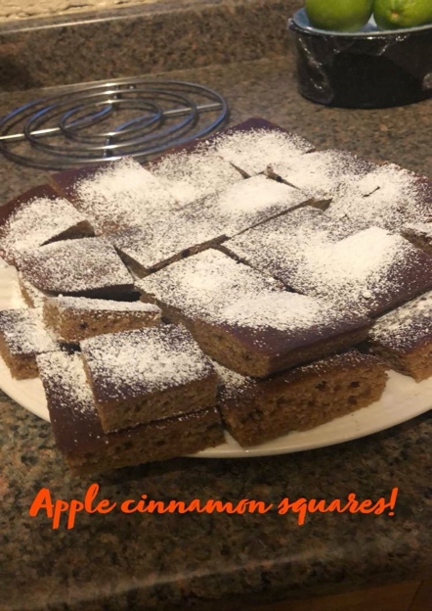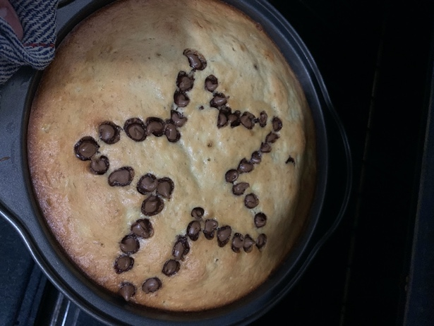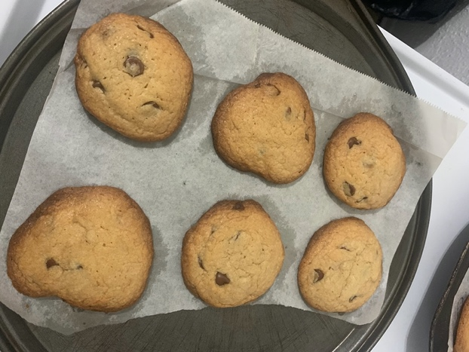
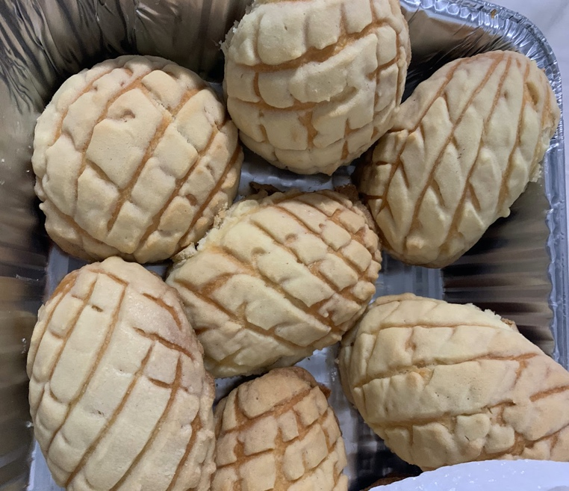

Here are some of the links of the recipes I have actually got a chance to experiment and bake myself;
https://www.thekitchn.com/how-to-make-banana-bread-the-simplest-easiest-recipe-139900 (Banana Bread)
https://www.bettycrocker.com/recipes/ultimate-chocolate-chip-cookies/77c14e03-d8b0-4844-846d-f19304f61c57 (Chocolate Chip Cookies)
https://www.bettycrocker.com/recipes/apple-cinnamon-bars/0a39c60c-5e39-479b-bebd-e0efd42bb1de (Apple Cinnamon Bars)

Context/Brief explanation to explain your skill/interest.
I consider baking to be similar to cooking because you need ingredients for both tasks, I know sometimes for cooking it’s a little more flexible because you can actually at times change the ingredients around depending on how you want to marinate or cook your meal. I know I want to try and continue baking and maybe even try to make a cake one of these days, it would be a great way to learn more about baking and I just hope it all goes well. I definitely would recommend baking for anyone to try, especially just starting anything as easy as doing a banana bread, you would be able to enjoy the bread as a breakfast with a cup of coffee/juice or perhaps even as a snack to have throughout the day.

Section 2: Pairs Assignment (Partner-Raghda)

1.What you have in common -- where you meet on common ground on a deeper level, as well

- Were both the older siblings in a way he's the oldest of 4, 3 sisters and 1 brother. I on the other hand am not the oldest child but I am the oldest sister. Technically I do have two older brothers, but my parents treat me like the oldest child. I basically do everything in the house after my mom of course. Anyways Antonio is this same too, he takes care of his siblings….. “ I went through the same thing as my siblings were growing up. I had to look out for them, or sometimes help around the house with anything my parents would ask for. ” Only those who themselves are the oldest children would get it, were like their second parents.
- Another common thing we both have is baking. Antonio just started baking while I've been doing it since I was 14. He finds it fun and I don't, not anymore. It was at first, but I got bored of it, I still do it from time to time though. Antonio sounds and looks like baking is his passion, the results, how they end up looking, the excitement. That moment is everything. Well that's how I felt when I first started to bake. His pictures say it all. “I asked him how baking made him feel and he said, “Baking makes me feel unstressed, happy, and definitely makes me express my creativity. “and there you go that someone who loves and has passion for their skill.

- Definitely a common thing I found to have with Raghda, was even if she isn’t the oldest sibling from her family, she has been the one that has been like a second parent to her siblings. I feel the same way but I believe I didn’t have a choice since I was the first one to be born, so I couldn't say no.
- As Raghda mentioned she has used to like to bake as well, she had been baking since she was 14, but eventually she stopped baking and might bake from time to time. Either way I feel like she has a great passion to decorate and she does an amazing job. I think decoration is just her way of expressing a passion she has at the moment. Especially her photos were proof of her hard work and showed what she is capable of.

2.What new thing(s) you learned from each other.
- Something I learned from Antonio was, it's never too late to start something new in your life, you just gotta make time to try something new from time to time, because you never know you might be really good at it. He started baking because he was stuck at home with nothing to do. In the end he ended up liking it and actually having the skill for it.
- I would have never guessed from Raghda that she would love to decorate, is a great passion of hers and she does an AMAZING job. After talking with her and seeing her pictures you can tell how much effort and time she will put into decorating. Like she says decorating for her feels like she is in sync with the same song.

3.What new thing the other person pushed you to learn about your own skill

- Talking to Antonio made me feel like I'm actually doing something people like. Because I'm always trying new things, I don't know how it feels for others. Getting Antonio's feedback, him telling me that my hard work is paying off makes me feel happy.
- Raghda gave me her honest feedback, and even though she hasn’t tried a pastry or bread of mine I know she was happy at the great job I did in making them. Gave me a confidence boost that not only my family and close friends think what I do is great, but also Raghda thinks baking became a great hobby of mine.

4.What new perspective you gained from doing this exercise

- What I gained from this exercise is talking to known/random people about what it is you're into is a great way for your mental health because you never know what people might be thinking about themselves or what others think about them. Talking to Antonio gave me a clear perspective of that.
A new perspective that I gained was that sometimes when you talk with people/friends that you don’t usually speak to in your everyday life, they can offer criticism that is valuable and honest which gives a person a greater sense of confidence. At times you even find yourself to be more alike than you would have thought.

Section 3 (A)- Reflection on your pair.
I was paired up with Raghda and I will say that it was so easy to work with her even though we aren’t in a classroom, but we were able to communicate and get work done easily. We noticed right away that we both had a connection when dealing with family, when it came to be a grown up and watch for siblings, or anything as simple as helping our parents out. I know she isn’t the oldest in her family, but she feels like she is, even a second mom to her siblings. The same thing goes for me except I actually am the oldest of my siblings, so I did have to help around. After some time, it wasn’t as bad especially when I had to look out for my siblings once they were a bit older because I was able to play with them a bit.
During the beginning of the semester I had the chance to speak to Raghda in person, as we worked on an assignment that Professor Schmerler assigned to us on her birthday party celebration, about getting to know a neighbor in class and learning something new from them. I remember I had the chance to interview Raghda and I learned that she loves the color pink because pink is her favorite color. Raghda’s a great fan of Starbucks, I know this because she usually came into class drinking what I assume was her favorite refreshers. Now I’ve had the chance to learn more about her, like learning that she attended a private school. During this time she made a lot of memories and that’s where she met some of her lifetime friends. One of those friends included a common friend I had just met during the previous semester in my math class. The friend was Wala, and I would’ve never imagined that Wala and Raghda were lifelong friends. I also would’ve never guessed that when she was young and she was a baker too, she used to love baking and she had the chance to make some great things, which included a cake. As previously mentioned, her current skill is decoration, and how she loves how great her end results turn out.

Section 3: (B) Overall Reflection
At first, I was a bit nervous about sharing my skill. My first thought was debating whether baking could actually be considered a skill? This was because it seemed like anyone can have a go at baking. In the end I decided to go with baking and to just share my experiences with everyone so they could see what I had been up too. Overall I was just hoping for any positive feedback or recommendations as well and little did I know that I would get great comments from fellow classmates and a few of them also baked, while many others cooked, played video games, did makeup, or even art as their own skill.
Being paired up with Raghda was great because she was happy about the hard work I put into baking and she even noticed the passion I currently had for it. I know it might not last forever, but for the moment since I have the time to bake why not, right? Getting the chance to share my skill with the class made things interested because my skill showed people of what I’m currently up to during this quarantine, and also part of my likes and dislikes.
At first I was confused on how we were translating this new unit. I wasn’t exactly sure what a skill meant, but once I started to hear more about the professor and how she was trying to learn how to hula-hoop that made things clearer for me, which helped me to narrow down what I considered as a skill that I was just learning or already good at. Once I chose my skill of baking I knew things would just flow and come easily, just like making a recipe, you start with step 1, then step 2 and so on. So putting everything together was just like a puzzle and all I had to do was put all the pieces together and BAM! I would get my final product by explaining and showing pictures of my baking skills. Something that I would’ve liked to try and that I didn’t think of until Professor Schmerler suggested, was to make a video of baking a recipe? I would’ve never thought about doing this because it isn’t something I’ve ever done before. I know I’ve put pictures up to show the end result, so maybe a clip of how to get all the ingredients together and prepare them would show that it isn’t that hard to bake and that anyone could try to bake.
The affinity unit has allowed me to continue working hard, despite the current circumstances we’re all in. At first it was definitely a struggle to work from home instead of in a physical classroom with the professor and fellow classmates, but I know I had to adapt and make this work as best as I could. Some ways in which I’m improving my writing is just by practicing on writing more and reading books that offer advice on how to improve mistakes that I easily tend to make, whether they’re grammar errors, sentence fragments, or even punctuation. A grade that I believe I’ve achieved for this current unit would be an A.

The current grade I got for Unit 3 is an A/A-.

