Antonio Garcia
Professor Schmerler
English 1121-D402
April 8, 2020

Unit II—Mid Semester-Genre
Planet – Uranus
Table Of Contents:
Section 1: Extended Diary Excerpt
Section 2: Reflection & Analysis of Diary Reading
Section 3: Reflection On Unit II & Grade

Section 1___My Diary Excerpt:

Elmhurst, New York
March 23, 2020

7:30am

Dear Diary,
I just woke up feeling a bit tired than usual. I got up knowing that classes resume online, even though I have a weird feeling about this. It feels like these online classes might be a bit of a mess in the beginning because everyone will be all over, as they won’t know how this will all work, and most importantly how this will impact our grades. Hopefully all goes well not just for myself, but also for all students.

8:15am
Got my day started with a cup of black coffee and in the mood of making some chocolate chip pancakes, before my French online class starts. I mix all the ingredients up and start making the pancakes. Once I’m done I refill my cup of coffee and my day officially begins.

12pm
French class ends, and class was a little bit confusing, especially for the professor because he is still confused about this online concept. He is trying his best though, we are using the app Zoom to see the professor and make sure we are repeating after him the words that he is teaching us. He makes the lesson fun.

2:20
I open a bag of crackers and start to eat them with some peanut butter and banana slices. I was thinking of what to cook, even though I was already eating snacks ha-ha. So for the moment I was working on my math homework as well since I have some homework pending and some of them are a bit confusing.

5:30pm
I started cooking some dinner today and I decided to make some whole wheat pasta with vegetables. A dinner that’s nice and easy to do in a matter of minutes. Meanwhile the pasta is in the water and the vegetables are in the oven cooking, I resume back to my Netflix show.

Elmhurst, New York
March 24, 2020

8:10am
I woke up a bit later than my usual time, I get up to brush my teeth. I put two slices of toast on the toaster and serve myself a cup of orange juice. Meanwhile I turn the television on and watch the news for a while. Everything that they talk about is on COVID-19. I listen for a bit for any new information I might need to know.

9:15am
I start my workout routine with the weights and equipment I have at home. I usually do about an hour workout since I have no gymnasium to go too.

11:30
My biology lecture online class starts; let’s see how this hour goes by hopefully this internet isn’t lagging and is working good.

1pm
Doing some reading on the biology slides that the professor went through in class, rewriting all my notes since I wrote them all fast and they were a bit sloppy. I try to have everything organized, so that when it’s time to re-study my notes for test it’s easier to do so.

3pm
I am taking some time off studying and going over notes to get prepared to cook some tofu with some vegetables and rice. I will be back shortly after cooking.

4:30pm
I have finally had some dinner with a glass or two of wine. Also while having dinner I continued to watch a show on Netflix that I got hook on called “Money Heist.” It’s a really good show; I’ve already finished watching two out of the three seasons that they have so far.

Elmhurst, New York
March 25, 2020

7am
I woke up early because I kept hearing a few ambulances passing by, maybe about 2-3 ambulances I could hear their noises (wee-oow, wee-oow, wahh- wee-ooww) from a far distant but they manage to wake me up. I get up to go to the bathroom and brush my teeth, change into my workout clothes and start an early morning workout.

8:30am
I am out of the shower after a good workout, I’m ready to cook some protein breakfast to get my day started and see how my online classes go today. I make a spinach and mushroom egg omelet with some parmesan cheese on top. Along side my omelet I have my cup of black coffee in one of my favorite mugs, a Game of Thrones mug. (For any Game of Throne fans out there)

10am
I am going over my French notes and old assignments since I have my quiz #2 even though he didn’t tell us what to study on. The professor said he would tell us today in about an hour when it’s time to take the test. It doesn’t sound like so much fun not knowing what specifically to study on, but I am going over the past two weeks of notes, hoping the quiz will be on that.

11:30 am
French quiz # 2 here we go, wish me luck.

1pm
The French quiz wasn’t bad at all knowing that I studied my notes and it was an easy quiz for this time. He didn’t want to put too much pressure on us he said knowing that we’ve been having a crazy week. So for now I’m just waiting for math class and writing some questions that I was confused on in the last lecture, hoping he can explain it to us all in better details.

2:30 pm
Time for this math online class, let’s see how it goes.
4 pm
Well my questions to the math class got answered and explained in better details. It was nice knowing that I wasn’t the only one confused; some of my peers also had the same questions. We finished a new lecture and now I’m going over my notes to see the one or two more questions pop out. I am hoping to YouTube this and maybe find the answer I seek or I’ll try Google too, since Google knows everything right?

6pm
It’s time for dinner. For today’s dinner I will be having some penne alla vodka with broccoli and string beans (I know it sounds a bit too healthy and boring right? Haha) but it tasted way better than it sounds. It’s time to continue watching Money Heist on Netflix and to I’ll try to finish season three.

8:15 pm
I stop watching Netflix to continue doing some math homework before I call it a night and go to bed. Some of these math problems are driving me insane; they look so easy yet there are like 10-15 steps to do before actually getting the answer. Whoever says math is fun, it really isn’t, it takes time and patience to learn.

Elmhurst, New York
March 26, 2020

8am
I didn’t have a great sleep, I kept hearing a few ambulances driving, and my guess they were rushing to the hospital. I felt a bit freaked out, but I hope that all the patients make it out well.

8:30am
Time for my biology lab & lecture class until 12:45pm.
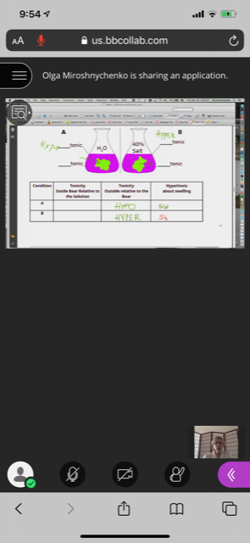 (My biology lab class)
3:30pm
Just eating some crackers and snacks after going over all my notes for the biology class I just had. Just getting all the notes organized. It was a fun class, even though my Internet lagged a bit during lab class so it felt like it froze a few times. Lecture biology went good, but he was a bit confused himself, not knowing it we were having another recess or if he would continue to teach.

7:30pm
I’m just having a glass of wine and watching The Office on Netflix. It’s a funny show I love most of their episodes. I’m just going to relax for the rest of the night and continue to watch Netflix, probably will go to sleep early tonight.

Elmhurst, New York
March 27, 2020

9am
Getting off bed this morning felt like a nightmare, I got plenty of sleep and rest but it was so comfy in bed that I didn’t want to get up. Eventually I got up went to the bathroom and brushed my teeth to get the day started. For breakfast I drank a cup of orange juice with a piece of almond bread.

11am
Now time to continue working on homeworks I have for math and English of course. I have a few assignments to do for math and some of them are very confusing so that means I will have to use my friend Google for help or YouTube. Either way whatever works to get my homework done and for me to have a better understanding.

3:30pm
Taking a break from all the homework I’ve been dealing with, I think I even got a slight headache from seeing too many numbers and explanations ha-ha! The good thing out of this is that I understand the work because of the help of YouTube videos, so that’s a good sign that I’m learning something new.

8pm
I decided to make some banana bread since I had a few bananas that were ripe and my sister Michelle decided to give me a hand and help me out. We just used a Google recipe and found one from the “kitchn.” Let’s see how it goes, hopefully it comes out delicious in the meantime I’m in a conference call with a few friends catching up.
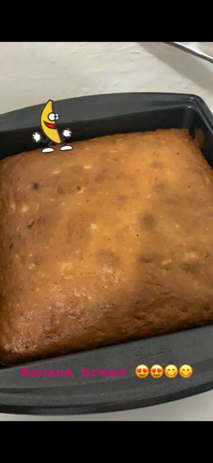 (My banana bread results)
Elmhurst, New York
March 28, 2020

8:45am
Woke up thinking how much I miss running with my running club, or even going to the gym either to do weights or go for a swim. We can’t do things like this for the moment because of the virus. I hope this sci-fi movie we are currently living in will end soon and I hope everyone is taking all necessarily precautions needed to stay safe. I get my day-started, brush my teeth and have some coffee with a slice of bread.

11am
I have a workout conference with a few friends, this is fun and exciting something new we are all trying. We try to make the best of the situation and make it fun as well.

12:30pm
Workout was fun, was a total success even if I did not have the correct equipment, we used anything we had at home for weights for example wine bottles, canned food or even chairs. It was nice to socialize with friends after being far apart from each other, but we’re still managing to get a nice workout done.

3:30pm
I’m having a piece of my banana bread from last night that came out very delicious, would definitely recommend the recipe if anyone wants to try it out. https://www.thekitchn.com/how-to-make-banana-bread-the-simplest-easiest-recipe-139900 I posted the link in case anyone wants to try.

6pm
I’m spending the rest of the night just watching movies and catching up to some news to see updates around the world. Hopefully some good news out of this pandemic. Eating a bit of junk food as well having some chocolate and chips, I know weird combination but very tasteful.

Elmhurst, New York
March 29, 2020

9am
I got to sleep in today, felt great especially after staying up and watching TV. The last movie I remember watching was Star Wars: The Last Jedi. I’m a star wars fan so definitely enjoy the movies. After brushing my teeth and waking up, I got up and toasted a bagel with some cream cheese and had a cup of cranberry juice.

10:30am
Now after getting my day started and having breakfast, I have to start doing some chores. I have to get started by cleaning the house and doing some laundry right after that.

4pm
After a long day cleaning and being proactive, finally caught up to everything and now time to make some food. I was undecided on what to make, so instead of cooking I decided to just put a frozen cheese pizza in the oven. I wasn’t in the mood to cook and wanted to just relax in the sofa, so I put the pizza in the oven and while I waited had some tortilla chips with salsa.

Elmhurst, New York
March 30, 2020

8am
I woke up early to get a morning workout done especially since we are in another school recess for the moment until Thursday. So I get up to go brush my teeth put some water to boil and have a cup of tea. Right after that it’s time for my workout to start so here it goes.

11am
After a good long hour workout and out the shower, I’m toasting some bread to make a PB&J with banana slices and a cup of orange juice. As I’m eating I go over my French class notes so I can practice the language and not forget what I’ve have learn for the moment.
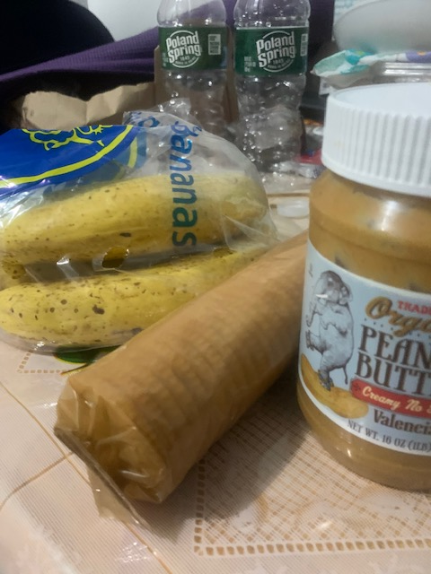

2:30
I went out for a quick grocery run just to get essentials I was running out of, it was lonely seeing the streets so quiet and mostly without people walking around. It was good thing to see, since people aren’t supposed to be outside socializing and are staying home being safe.

6pm
I made some quick noodles with broccoli to have for dinner, and now going to join a few of my friends on face time chat to just talk and catch up and see how everything is going from their houses.

Elmhurst, New York
March 31, 2020

8:15am
Day number ….!?! In the house just going a bit crazy today, want this whole virus to be over already! I got up, went to toothbrush and I was ready to start the day. Definitely today was one of those days where I was feeling a bit lazy. For breakfast I decided just to have a bowl of cereal and some cold brew coffee. I think today I will just be watching “The Office” on Netflix.

5pm
Lost track of time had a meeting with my English professor and some classmates at 1:30pm it was nice to have a quick meeting via online. She answers or helps us with any concerns or assignments that we have done until now. Also after my meeting was done I started to watch The Office and I was having a good time laughing, that I didn’t realize it was time to prep for dinner until my stomach started to growl. No idea what I will be having tonight probably might heat up some mozzarella sticks and carrots with hummus. Also will make a quick avocado salad as well.

Elmhurst, New York
April 1st, 2020

8am
Woke up early to start the day and making some pancakes for breakfast today. For some strange reason my stomach was growling today so I decided to have a good breakfast. I decided to have a fruit smoothie as well to go along with my pancakes. I made my smoothie by adding some frozen berries, some lactic milk, and some peanut butter too.

11am
Enjoying a delicious breakfast, but now its time to study and do some math homework and catch up to some problems I have to solve. Some of these math problems I left until now because I didn’t understand them, even though I was trying to find help it still wasn’t helping at all. After a while I did find a way to solve and find a solution for them.

7pm.
I’m catching up to math homework and having a great virtual workout with friends, now it’s time to eat some dinner. Dinner’s menu for today is tofu with noodle and red peppers and carrots with a glass of wine. For dessert I will be having a slice of carrot cake that I managed to get from Martha’s Bakery. Besides that I will keep enjoying watching The Office until I fall asleep.
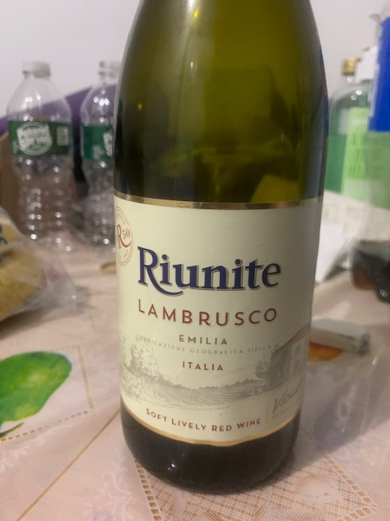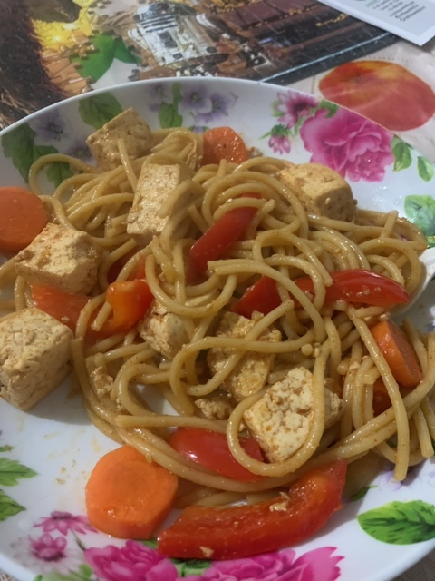(Tofu & wine)

Elmhurst, New York
April 2nd, 2020

7:20am
Waking up a bit earlier than usual because today I have my biology lab class to take later on at 8:30. So as usual going to have some quick breakfast before going into blackboard to have class online. Making a quick peanut butter & jelly sandwich and putting some water to boil to enjoy my sandwich with coffee of course to start the day right. As I wait for class and enjoy my coffee I listen to some music, I play a random spotify playlist the top 50 songs. Some of the songs I recognize and other songs I haven’t heard of them, but can’t complain till now every song is catchy whether because of their beat, rhythm or song lyrics.

12pm
After having a good biology class it is now time to enjoy some snacks and a cup of cranberry juice. I’m enjoying some Ritz crackers with almond butter, something quick before I get started on some French homework and get into my cardio workout routine. Just in case I’m still hungry I have a Hershey almond bar or sour gummy bears, yeah it sounds like a crazy sugar rush.

2pm
Just lying down on the sofa after a good hour and a half workout just so I don’t stay lazy and do nothing. Now all I can think off is food I wish I could just pop a meal into the microwave and BAMN! Out comes a hot meal. For the moment I just wash some grapes and an apple enjoying this snack until I get into the mood to cook some rice and prep some tofu.

630ish pm
After a while just watching Netflix and talking to a friend on the phone for a while I prepare my tofu to eat, now is time to enjoy some dinner. For tonight I will be having tofu with brussel sprouts, broccoli, tomatoes and some brown rice. Also I will continue to watch the Office because why not right? For dessert I might have a couple of homemade chocolate chip cookies with an ice tea.

Elmhurst, New York
April 6, 2020

9am
I haven’t been writing for the past few days because of a recent death in the family. My grandmother just passed away on Friday and I’m still in shock about it and trying to process what happened and how it happened. I’m just trying to be a support for my mom and as well as my aunt because that was their only parent left. I’m blessed that I held so many memories with her and I got to be with her through a lot of fun times. Wherever she may now be I hope she rests in peace and will look out for me and for my family as well, especially during these hard times, that not only I’m going through but a lot of New Yorker’s losing loved ones due to the virus. I know my grandmother was super sweet, loving, happy and maybe bossy at times but her memories will stay with us forever.

10am
This morning I’m just having a bit of honey nut cheerios for breakfast this morning I wasn’t in much of a mood to eat but I know I have to eat something. So I’m enjoying a healthy bowl of cheerios. I’m flipping the channels as well, trying to find something to watch; so far I mostly see news, comedy shows, cartoons and a few movies that I don’t know. I decided to watch The Avengers; it is a nice classic super-hero movie. I lay in bed enjoy my cereal and watch the movie while outside I see the sun is shinning bright and it feels like there’s nice weather outside.
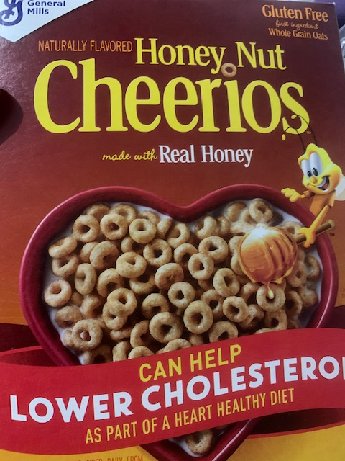

1pm
I just finished my French class and today learn how use the verb “Avoir” which stands for “to have.” The verb is used in present terms sentences, it is a way to express possession and sensation towards things. The sentence I used to participate in class was “j’ai une chemise noire” which is I have a black shirt. I can tell that French is just going to get a bit harder every time, but I’m going to try my best and make the best of this class to learn this new exciting language.

4pm
Finally I’m done with math class online today, the topic today was a bit hard. So like always I will have to go to my other notes and maybe over the recording of the class to try to see if I understand the lecture by playing it slower. Who said math is fun? because not on this level of math I’m taking which is pre-calculus, hopefully I can get a good grade at the end of this hectic online semester. In the meantime I prep dinner some tofu marinated in a spicy sauce, accompany to that will be some red peppers and kale. For the meantime while the tofu absorbs the sauce flavor will be working out some cardio to let time fly.
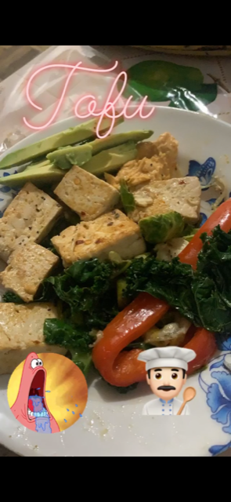 (Patrick’s expression said how hungry I was.)

730-ish pm
After a workout and shower I cook my meal now to sit back relax, enjoy The Office and enjoy dinner. I noticed that exactly at 7pm people from my building were finally clapping and trying to make noise using pans, pots or anything that made loud noise. I even heard someone screaming “wooo-hooo” I found it really nice for people in my building acknowledging the hard working nurses, doctors, police, EMTs, and all essential workers that are out in this battle against the virus and still working trying to keep NYC safe and sound.

9pm
Took a break from Netflix and was just reading my book “Educated” it is a nice way to keep my brain learning and it also helps me become a better reader. Reading this book I compare myself to the character Tara because she is teaching herself how to educate herself. She learns to teach herself math and improve her grammar. So I relate to how during this online class courses that we are currently having is how we have to teach ourselves the subjects we are learning, because at times our professors are hard to understand. For example my pre-calculus class if I don’t understand a specific topic I have to go out of my way and try to find help from Google, YouTube, Khan Academy, email the professor, or even ask a friend, anything to find a way to learn myself. Now with that being said it’s time to go to bed and call it night. ZZZzzz.

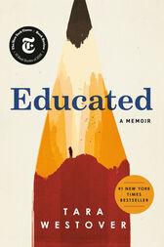 (My reading for tonight.)
Elmhurst, New York
April 7, 2020

9am
I woke up today with a headache no idea why, but maybe I just had a bad night of sleep. I know I was tossing and turning and I wasn’t able to fall asleep right away as I usually do but eventually I did. So I woke up brushed my teeth and served myself a bowl of cereal, today I will be having honey bunches of oats. I also toasted some toast and added some strawberry jelly. While enjoying breakfast I turn into the cooking channel and was watching “grocery games” it is a fun show and sometimes the food they make in such a short time looks super delicious makes me drool ha-ha.
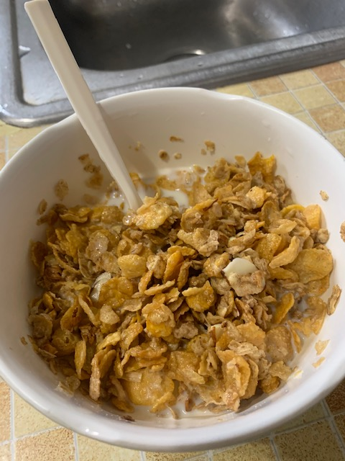
1pm
I’m done with French class, we went over notes and read some small passages, besides that he gave us a choice of giving us homework or none. Of course majority of students said no, he just said to review notes and keep practicing the language because on our next test he will test us on how our pronunciation is. I know I will have to practice a bit more especially because at times I get confused on how to pronounce certain words or forget that in some words ending in e, t, x are silent.

3:30pm
Just having a bit of blue corn chips with some salsa while I wait to have a workout online routine with friends. While enjoying some chips I’m watching The Office. I love this show it always makes me laugh. I’m having a relaxing afternoon even though I would of love to be outside enjoying the weather since the weather felt nicer. Once this virus is over and things get back to normal hopefully everyone can enjoy spring weather especially summer is coming soon too. We can only just be patient and wait until the virus is finally gone for good I hope.

7pm
Time to enjoy some penne with broccoli avocado, spinach for dinner. Good delicious protein after a good workout I had with friends. Now just time to sit back and eat food yummy yummy yum. Also I turn on the TV and I just started watching a movie called 13 hours: The Secret Soldiers of Benghazi, I know I’m pretty late on watching the movie but so far I can say WOW! Great movie that my friend recommended a while ago by my sister but never had the chance to actually watch the movie, so we watched it.

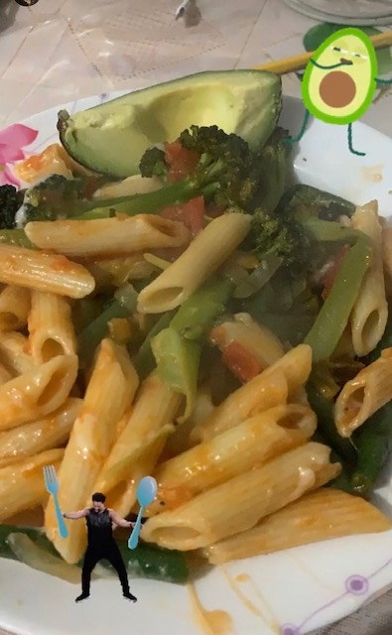 (Protein dinner)
9:20pm
Finished the movie and got to enjoy my strawberry mochi ice cream. I must say I give it two thumbs up and recommend the movie to everyone. I enjoyed the movie and it showed a glimpse of how six soldiers protected their base and diplomats. Now it is time to finally get ready for bed. I will just probably stay up and check if anything else is interesting on TV, if not I will probably just read for a while and then go to sleep.
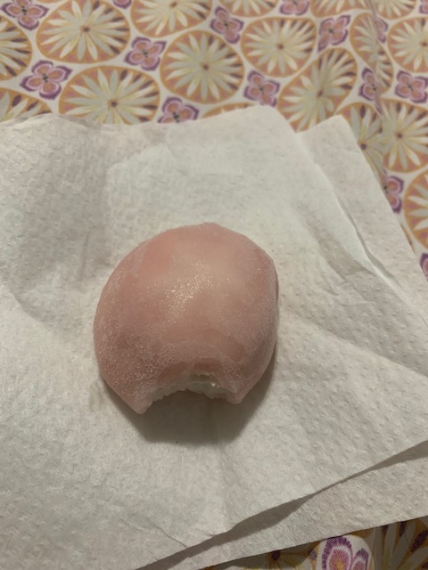(Strawberry mochi)

Section 2__Reflection & Analysis Of Diary Reading:

I started re-reading the Anne Frank diary, I was previously assigned to read a few pages back in high school. I don’t remember what exactly I read in high school, but I know learning about her was a good experience. So given the chance to re-read, felt like would be interesting to remember a little about Anne’s life and what she went through. Would help me focus and compare her writing to the way I write on my English diaries.
Reading through her diary I remembered how well she would describe everyone, as she was very specific in her writings. She basically gave a glimpse of how she would spend her time, either with whom or where. I found that very thoughtful because makes you can imagine yourself as part of her diary too, even if was years ago. Something Anne wrote that I found very inspiring was “the finest thing of all is that I can at least write down what I think and feel, otherwise I would suffocate completely.” It was nice to see how Anne wrote her letters to her friend Kitty. Kitty was an imaginative friend she came out with and directs her letters too, just like if she was writing to a real friend of hers. Anne though us all how religion, race didn’t mater and that all people should be treated equally. She was a wonderful girl with great dreams, goals, and just like any girl growing up wanted a boyfriend.
I like how Anne wrote her letters in a very organized way and in a lot of details, she didn’t leave any detail out. She would write her diary entries, each having a beginning, middle and end, she would pick off from where she left off in her last entry. Of course even if she and her family was going through a horrible situation, she always seem happy, and full of joy. Anne just like us had typical fights with her sister Margot and just any other girl she would be at times jealous of her. Comparing to how Anne wrote her diary, it seems a bit similar to my own way in that I try to be specific on what I’m doing during specific hours of the day. This keeps my writing more organized and it gives the reader a sense of how my day is going and what I’m doing through out the day. What we can agree on is that just like Anne where she writes all her experiences and thoughts in her diary, the same way I try to do as well. To write in as much details and include some pictures so the audience has a bit of feeling of how my day is going.

Section 3__Reflection On Unit II & Grade:

During this phase of learning there have been ups & downs in learning like a rollercoaster ride. I know for myself that was enjoying waking up Monday’s and Wednesday preparing my coffee and excited for another day at English class has not been the same due to the virus we are facing. As a whole group we are adjusting and facing reality that this is the new way we will be learning, but I know we have the support and guidance from our professor Schmerler and she will help us in any way as needed.
So changing to this new topic Genre, I though would be an easy transition but then the virus hit and we get inform that everything will change to online and we have to get used to this for the rest of the semester. I know I would be facing a new challenge but I will find the motivation to do a great job at this and give my best effort. A few things that surprise me while doing this writing was that I always have a lot to say, even if I’m just writing about my day and is about being home all the time I always have something to do. The good thing about this is how I describe my day in as much details possible just enough so the reader isn’t lost or gets bored through out my day.
Most of my classmates readings are similar to mine because we are all stuck at home, ether watching TV, playing video games, listening to music, we all have in common that we are missing the outside world as well. No matter the obstacle I will face, I know I will give my 100% to continue to learn and adapt into this new world of online learning, isn’t as fun to learn this way but we are born to learn new things. With that being said I think the grade I would give myself would be an A or A-, overall I know that my work still needs improvements but I’m learning little by little on how to get there.

