Dear Professor Schmerler,
This semester was different for all of us, the students, and you as a professor. It was a new form of teaching and learning. It must have been hard for you and it was most definitely hard for me. You asked us about our journey in class and how we have formed to become better writers. This semester might have been the hardest. Not because of my classes but because of the obstacles I faced outside of class. Before the semester started I had lost my job due to my schedule. I couldn't commit to the hours they had asked me for. Finally in the beginning of December I finally found a job literally right before my classes started, but again I lost my job. I was laid off because of “ too many workers”. I honestly just don't think they liked me. I haven't been working since February and I hate it because I like to stay busy. I also dealt with the loss of my grandfather. Although we may have not been closed I knew my mom suffered a great deal. She was wearing all black for 3 months straight and recently started wearing colors again. When I started this class I kind of thought it was weird. I have never been given assignments like this class has given me. we learned how to write without using ascending and without using descending letters. I couldn't write more than half a page. it was probably the hardest assignment I was given. And the rest of the assignments forget about it. I wish I could have done better and I know I could have. If I use my free time I could have gone to office hours but I prefer to stay home and do some other things. Although, I don't think I did a bad job.

Yours truly,
Cindy Gonzalez

For Unit 1 we wrote about fear, but wait there was a catch. We could not use descending letters. Then we had to write about how we faced our fears without using ascending letters. For me it was the hardest part in Unit 1. It made me realize that my vocabulary needs to improve. I couldn't write more than half a page which to me is a serious problem.
What do I fear? What am I afraid of? I don't know. Is it that show I watch of Untold Stories of the ER? The one where an insect crawled into that man's ear? Because I hate insects! I'm sure that won't be used to torture me. I don't understand how humans have tarantulas as a domestic animal. Tarantulas are not cute or the best cuddlers. What human would like that? Not I. What else am I afraid of? When I'm in a room full of humans and have nowhere to move. Anxious. Some individuals are afraid of death which I can see how since none of us know how or when it'll occur. I'm not as scared of death itself, but what I'm most afraid about is when I die I'd abandon Matthew. Who is now 56 months old. Will Matthew be safe? Will someone raised him as if he were their own? I'd expect his aunt or his abuela to take him in, but it's still worries me. A kid needs their mom. Matthew needs me.
Creepy, gross, no arms? In my ear? Mmm no. One way I can remain serene is ignore ignore ignore. A puppy. Now a puppy I can caress. Many many men many many women. No space. Man, women gazing. Grin. Nice. Passing. My son is awesome. Gma is awesome. Gma cares so my son is it good.

We wrote about what freedom mean to us. Everyone has their own perspective and definition on freedom here is mine:

Unit 1
A New Home
Everyone has their own definition of freedom. Whether it is the “American Dream”. A big house, a new car, a good job, and family. Or freedom of speech like saying we need better gun laws in the U.S. For me freedom means something entirely different. For me the first step to my freedom was moving out of my mom's house. And to get there seemed like an impossible mission and what I’ve done to get there was crazy. Although moving out was the first, I'm not sure where to go from here. Maslow's hierarchy of Needs seems like the right place to start, but is it what would give me complete freedom?
Although my mother Delia help me with my son, she also drove me crazy and I'm glad I moved out. Moving out of my mom's house gave me the start to my freedom. Living with her was not only hectic, but unbearable. I understand that I was not only a teen mom, but first time mom, and she just tried to help, but sometimes she did a little too much. She always told me how I needed to raise my son, and I was not okay with that. If my son threw a tantrum because I said something like “no more toys it's time to eat” she would butt in and allow him to play instead and say something like “he’s not hungry”. This would happen on a daily basis and I grew tired of it. In my heart I knew as much as it would hurt both me and my mom that it was time for a change.
When I moved out of my mom's house it gave me this sense of freedom because I was finally able to enjoy some time alone. When I lived with my mom she would always question where I was going and if it wasn't something like an errand she would say no. In other words if I wanted to hang out with friends…. Not possible. My sister Maria is 6 years older than me my cousin Jessica is 9 years older than me and her younger sister Katherine is 4 years older than me. Maria, Jessica, Katherine and I went out once to Dallas BBQ, and I was surprised my mom even allowed me to go. She called me within an hour and told me to go back home because my son Matthew wasn't sleeping yet. When I was in high school, school ended at around 2:30, and she told me that I could have a 5-minute conversation and had to go straight home. If I wanted to hang out with my friends she said it was okay as long as they came over to my house which I didn't want to do all the time because she watched us like a hawk. No freedom. I couldn’t talk about the crush I had or my friend Destiny’s girlfriend Natalie because my mom would judge Destiny for being a lesbian. And if I wanted to leave the house with them for a little while she said I could only go to the pizzeria at the corner and I only had half an hour. That Pizzeria was the worst Pizza I’ve ever had I wasn’t taking my friends there. This lack of freedom caused me to rebel against my mom.
At 2:30 when the school-day was over I stopped having my 5-minute conversation and stayed as long as I wanted I didn’t get home till about 5. This drove my mom crazy. And in the 10th grade when I had a boyfriend, Edwin all I wanted to do was spend time with him. Because of this, I started to cut school. I even lied to my mom that we had Cheerleading practice after school to stay with him longer. Things started to get worse between my mom and I at this point, but I didn’t care. I started to sneak out the house in the middle of the night and go to Edwin’s house and stay there the whole day. This turned into weeks when I’d stay at his home and later months. This drove my mother crazy which I understand now. She filed a police report for missing child even though she knew exactly where I was. I’ve gotten arrested three times for running away and sent to ACS. It’s crazy to believe that the lack of freedom my mother gave me caused me to do all those crazy things and eventually led to me moving out of her home.
Although I’ve moved out of my moms house, I don’t believe that I’ve found my whole definition of freedom. I do believe that I’m heading in the right direction. Now that I’ve moved out our mother-daughter relationship has improved. Although, she still tries to tell me how I need to raise my son, but since I only see her over the weekends I’ve learned how to keep cool and just nod my head. What will be my new steps into finding complete freedom? I’m not quite sure, but Maslow’s Hierarchy of Needs seems like a good start.

For Unit 2 I believe I did good. It took me a while to figure out what was going on and I’m honestly not completely sure I understand it fully. We were asked what we were good at. I’m good at doing special effects makeup. We then had to create a recipe on the thing we are good at.

1. My skill is special effects makeup also known as SFX.

2. Example of Sephora.com genre review
Reka
Age: 35-44
Eye color: blue
Skin tone: fair
Update: w/primer and setting power
Flash colors used as eyeshadow can last more than a day with primer and powder! Using LORAC behind the scenes under the flash colors and MUFE high def powder on top, I've gotten this to last overnight (sleeping), all day, another night and again the next morning. After that, it starts looking weary! The powder gives it a polished matte look and keeps it from getting on my pillow and the primer keeps it stuck to my eyes. All in all, an amazing performance! Incidentally, the person who said that any color can be mixed from yellow, red and blue is really only right in theory. With pure colors, it's more or less possible (not including the fluorescents) but these aren't pure colors. The yellow is actually kind of orange, and the blue is slightly red. Surprisingly, the nearest thing to pure blue in this pallet is the turquoise color, so you'll want to use that as a mixer instead. I'm not sure what the undertone in the black is, I haven't used it much, but all blacks have one, which is why brown is often used to darken colors instead of black. No matter what color you're trying to make, start with the closest pan (e.g. for green, start w/green, for purple, start w/fuchsia, etc) and then correct it w/other colors. Good luck and have fun with this!!
NOT HELPFUL (2) HELPFUL (23)

3. Analysis of Sephora.com genre review
In this Review it explains a Sephora customer named Reka’s experience when buying a product from makeup forever. Reka age range is from 35 to 44 she has blue eyes and her skin is fair toned. She explains that she used primer to keep the makeup on longer and setting powder to keep the makeup in place. She used this palette for eyeshadow purposes and says that with primer and setting powder it lasted longer. But after a long period of wearing the makeup it started looking what she considered “weary”, but she still believes that her experience with this product was amazing. The colors in the palette can also be mixed, but she warns that the undertones of each color might not be what you would expect.

4. On the SFXSinclaire.com website millions of customers learn how to create awesome special effects makeup using the companies makeup. This company was created by Sara Sinclaire and she used natural ingredients to create these products. The company was created to tech people who are interested in learning sfx makeup. The products that are being sold on the website has reviews and pictures of the items so that the customers can see what is being sold and if it’s worth the price or even worth purchasing at all.

Review on SFXSinclaire products:
Stephanie Cortez
Age: 20-33
Eye color: green
Skin tone: medium bronze
Special effects makeup holds a special place in my heart. I learned how to do special effects makeup in 2017. Halloween was coming up and I wanted to do something cool something scary. There I was watching some videos, but I mostly tried it on my own. I went to one of those Halloween stores that sells costumes and makeup once a year. The fake blood was terrible and I got that zipper that goes down the persons face (pictures) bellow. It didn’t look bad for a beginner, but any sfx artist will know that it was probably one of my first pieces. I wanted to improve and I came upon the SFXSinclaire products. The tutorials were GREAT it helped me improve so much and I learned how to use things from home too! I bought the scar wax and also the fake
stage blood and boy did it help improve my SFX makeup! Not only that but it had natural products in it too and I’m allergic to alot of things. Thank you Sara Sinclaire for creating these products!
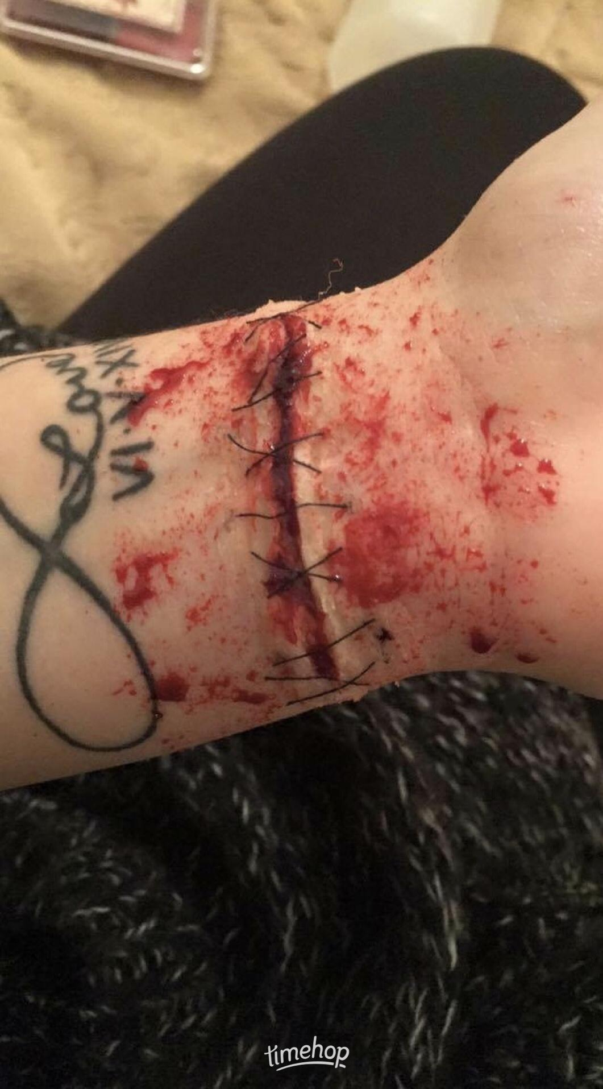
Review on SFXSinclaire product:
Damon Salvatore
Age: 20-33 (technically..not really)
Eye color: blue
Skin tone: medium beige
I bought the fake stage blood and it was disgusting! It seriously tasted like mint like it says it would, but it smells terrible and stains really badly. At least when I bite my girlfriend Elena I could put this over her neck and people would think its fake because of its smell. Overall it worked great although it looked real people thought it was fake because of its smell and taste.

Review on SFXSinclaire product :
Elena Gilbert
Age: Under 20
Eye color: brown
Skin tone: medium
My boyfriend bought this for me so that when he bites me people wouldn’t suspect anything because of the monty smell and taste. He is so smart for buying this even though he can just compel people to not even notice or forget so in my opinion it was not a very good investment. Good job Damon.

We as a class also created recipes on what we’re good at. Here is my recipe:

Creating a Cut
What you’ll need- Liquid glue, Skin tone Foundation or concealer, scissors eyeshadow or sfx make-up, tissue paper, SFXSinclaire fake stage blood, flat tapered liquid foundation brush, and a q-tip.
Optional- blow dryer
Time- about 15- 25 mins
Step 1: Apply glue answer desired area (best if you apply it where there's no hair). spread the glue according to the size you want it to be.
Step 2: Apply tissue paper and pressed down in order for it to stick. Let it dry for about 1-3 minutes. If you want to speed things up you may use the blow dryer.
Step 3: Repeat steps 1 and 2 about 5-8 times.
Step 4: When you're done applying the last tissue paper, wait a few minutes for it to dry. If you want to speed things up you may use the blow dryer.
Step 5: With your flat tapered liquid foundation brush apply foundation or concealer (that best suits your skin tone) onto the paper and on to your real skin so that it blends.
Step 6: With scissors cut down the middle or however you would prefer to create your cut
Step 7: Using your eyeshadow or sfx make-up pallet. apply red and purple on the inside of your cut and a little bit of black.
Step 8: Finally, using a Q-tip apply some SFXSinclaire stage blood On the inside of your cut and go as crazy as you like with it.
In Unit 3 we had to research out Genre topic. In my case it was done on Special Effects Makeup. We had to look for problems people face with our topic. In my case it was pretty difficult because there are not many problems or dangerous one may face in this field. Here is what I wrote:

Research Proposal
As a special effects makeup artist I haven't noticed many difficulties or problems that you have to face, but there are a few. Although, not special effects makeup artist may know the basics before beginning. In my opinion, special effects makeup just like regular makeup is a sort of talent and art. There are people born with this talent to create this sort of Art and others may not know a thing about makeup or special effects makeup, but it just takes time, practice, and patience. Become a special effects makeup artist you could use things around the house and don't necessarily have to buy many tools. Although, you need to know how to use these tools in a safe way.
If you invest in special effects makeup there are a few things you would need to know. One of the most important things that you need to know is if you're allergic to any of the ingredients in the makeup itself. Especially if you're doing makeup on others. Not many people know that although you may not have allergies you may get them in the future at any given point of your life. If you are doing special effects makeup or an actor on a movie or a TV show and they tell you that they do not have allergies you cannot take their word for it. They need to go get proof from a doctor. Because for example if they tell you they do not have allergies and you put something like liquid latex (that is usually known to cause allergies) on them and they start to get an allergic reaction you can be in very big trouble.
Some Sfx make-up cannot be worn for long periods of times. Like those who contain chemicals. There are pallets that are activated with 99% alcohol which is not good for the skin. some people are even allergic to 99% alcohol. And there are also products that on the bottle has a warning that says for external use only. Some people might not even read the label on the bottle and it could cause some serious health problems. For this reason companies have created things like edible stage blood that tastes like mint.
There are not many dangers special effects makeup to cause. As long as you read the label you should be fine. And as long as you get regular check-ups to make sure you have no known allergies you should also be fine. When using sharp tools like scissors or knives make sure you cut carefully. Finally, you should make sure you do not apply any products around your eyes, nose, lips, and any sensible areas that may harm you. Sfx makeup isn’t really known to be dangerous, but you should still be careful when doing sfx.
Sources
http://www.makeup-fx.com/health.html
https://naomidlynch.com/2012/08/02/sfx-makeup-artists-and-duty-of-care/

In Unit 5 we created a different form of genre. I created a youtube tutorial on how to create a cut.
https://youtu.be/vwwKhh4sQik

