Juvanie Piquant
Professor Schmerler
ENG 1121 #E106
“My Journey”
Dear Professor, Schmerler
It has been a challenge I must say learning in a new way and taking on extremely different assignments that require another level of thinking. I have learned more about life than anything else in this class, which I think is a great thing. I’ve had a lot of confusion adapting to such a different style of learning. I often feel even when I am trying my best, I am not really delivering the demands of this course. This has class has led me into thinking so much more than I usually do, it’s been extremely fun but a challenge indeed.
I jumped into many different challenges as a freshman in college not being sure of what I was getting myself into. I was extremely scared, but everything I feared helped me grow the most. My downfalls this semester helped me grow the most and which caused me to learn more about myself a lot. I found my true passion in life and tried to make valuable use of my time. The academics so far have been challenging but manageable. I thought getting through my classes was going to be the biggest challenge to overcome but staying on top of my academics while wanting to help humanity in any and every way I can was the biggest challenge of all.
As I’m approaching the end of my semester, I must admit I’m feeling extremely overwhelmed and stressed but excited to have a break. I try to clear my mind but that doesn’t always work. A million things run through my mind, and it is hard not to think about, when thinking is the only thing that will lead us to answers. Professor Schmerler I must admit this semester has taught me the importance of utilizing what is learned in the classroom and transferring it into the real world. The biggest challenge is figuring out how can we transfer academic curriculums into real life projects. The strategies and theories learned in this semester such as writing constraints, genre switching, and more were just more than an assignment. Those assignments taught me how to utilize what I know and create it into something bigger and purposeful that others can relate to and understand.
This summer I have a lot to focus on in terms of student advocacy and other responsibilities I have as a student. The most important thing I will be doing this summer is reading, like you said if we want to learn more “read”, if we want to become better writers “read”, if we want to develop our vocabulary “read”. It seems as if reading is the answer to most things in life, so I will be doing just that this summer. I would like to thankyou for being an extraordinary professor and changing the lives of many students. I hope you enjoyed this semester as much as I did, and I will continue to use what I have learned from you throughout my life. Thankyou Professor Schmerler, I wish you the best of luck !

With Love,
Juvanie Piquant

Unit 1: Literacy Narrative
Unit 1 was when I stepped into the loop of confusion. I was honestly lost. You told us to write but with constraints. I have never done anything like this before in my life. When humans think we do not think with limitations, we are like a free bird soaring with our thoughts. It was extremely hard gathering my thoughts with constraints, but I got the job done. This assignment forced me to expand my vocabulary and read more. Ever since our second class, I never go out without a book in my bag. I wasn’t too sure as to how I did in this unit I was just going with the wind hoping my writing made sense. My favorite assignment in Unit 1 had to be writing about my fear but with constraints. I was extremely excited that I got to express myself in a way I don’t often have the chance to.

Assignment 1: Fear Writing with Descending Letters Constraint
I fear failure. I know that it cannot be avoided, and it will come often. This fear that I have cannot be fixed or removed. I will encounter dear once in a while. I realized what cannot be altered doesn’t deserve focus. What needs focus is the faith I have within me, to intertwine reflection and evolution within all the failures I have and will encounter in this life. All situations cannot be avoided what’s beautiful in life is what I’ve learned from those mistakes to cultivate a narrative of who I am as an individual.

Never in my life I have been asked to think about freedom nor write about it. I was extremely excited to share with you my thoughts on freedom and how it has played a role in my life. It was my first essay this semester, so I just wrote how I’ve always written essays in my academic life. I was surprised when I received my grade, and I decided to go to office hours. It helped me a lot in terms of understanding what you are looking for in an essay. I learned the importance to content over quality and you wanted our writing to have meaning, that could be felt and understood not only by ourselves but by others.
Assignment 2: Freedom Essay
Freedom is what frees us from misery, freedom is what makes us feel like wholesome individuals despite what others may think of us. When we find freedom within ourselves, is when we can help others find freedom. Living up to the concept of freedom is easier said than done. It takes a great amount of courage and persistence but is achievable. My story of obtaining freedom was a bittersweet journey but, freedom was the most content feeling I have ever felt in my life.
As one can only do, I can only speak for myself. I found my freedom throughout the hardest periods of my life. During my sophomore year in high school, I did not know what my purpose was. I’ve always had a fascination with law, humanity, philanthropy and would gravitate towards those things in every aspect of my life. It is easy to think that we cannot help changing the world and the most we can do is offer our “thoughts and prayers” when tragedies arise. I realized small effects lead to bigger effects, focusing on the present and making a difference in the smallest way creates change and I have seen it firsthand. I would have a journal where I would write in everyday ways, I would like to help the world. I started researching how I can get involved in my community and make a real impact.
I joined the varsity track & field team and searched for volunteer opportunities in my local community hoping to find my passion. Being a part of the track & field team helped me tremendously in developing my mental strength. My passion for sports grew immensely which gave me the motivation to become a better me and indulge in new activities. The summer of my sophomore year I began volunteering at Teen Court which is an organization that focuses on youth advocacy in the criminal justice system for juveniles. For three years I served as a Teen Court youth attorney playing the roles of prosecution or defense advocating for the youth who’ve been caught up in the criminal justice system. I discovered true passion and freedom in helping others. Seeing the joy on someone’s face knowing that I’ve helped someway is such an amazing feeling of content that’s indescribable. What many did not realize was that despite a youth getting in trouble with the criminal justice system they still had an entire life ahead of them and having a criminal record would only hinder their success. Advocating for a purposeful cause and creating change is what freedom is to me.
What I began to see in those I’ve helped is what I began to see within myself. The youth I met throughout my time volunteering at Teen Court were going through struggles internally and externally, but they would overcome. Seeing them hit rock bottom and getting back up even stronger was freedom to me. I saw that my words and empathy had power but most importantly I saw a change. Despite any obstacle that I’ve faced I persisted through the tough times, which was where I learned the most valuable lessons of life that made me stronger. It was inspiring to see that my strength, has given others strength and inspiration in their own life. To anyone reading this you may obtain your freedom during one of the darkest moments in your life, but freedom is what will lead you into the brightest days you will eventually see. Malcolm X once said, “The future belongs to those who prepare for it today”. The most important thing is not focusing on experiencing freedom, but it is trusting yourself within the process to obtain freedom.
Unit 2 Rhetoric, Genre, Discourse
In my perspective everything we’ve done in class has such a greater meaning to it that intertwines with life or maybe I’m just a deep thinker. Focusing on genre in Unit 3 forced me to take a closer look not at what something is but how it became what it is and the concept it behind it. Unit 2 made me realized everything has a genre to it and genre is powerful. Just changing the genre of an assignment but keeping the same concept changes the assignment’s entire vibe.like every other assignment it was a challenge, because it is something that I have never done before which forces me to think in a way that I have never thought before. It was like thinking outside the box but trying to dive into another box. I must admit I started off with my first genre assignment with something basic because I was afraid to venture off into such a distinctive genre.

Assignment: Switching Genres with Same Topic
Topic: Leadership
Genre: Trip Advisor Entry
Mentor Text
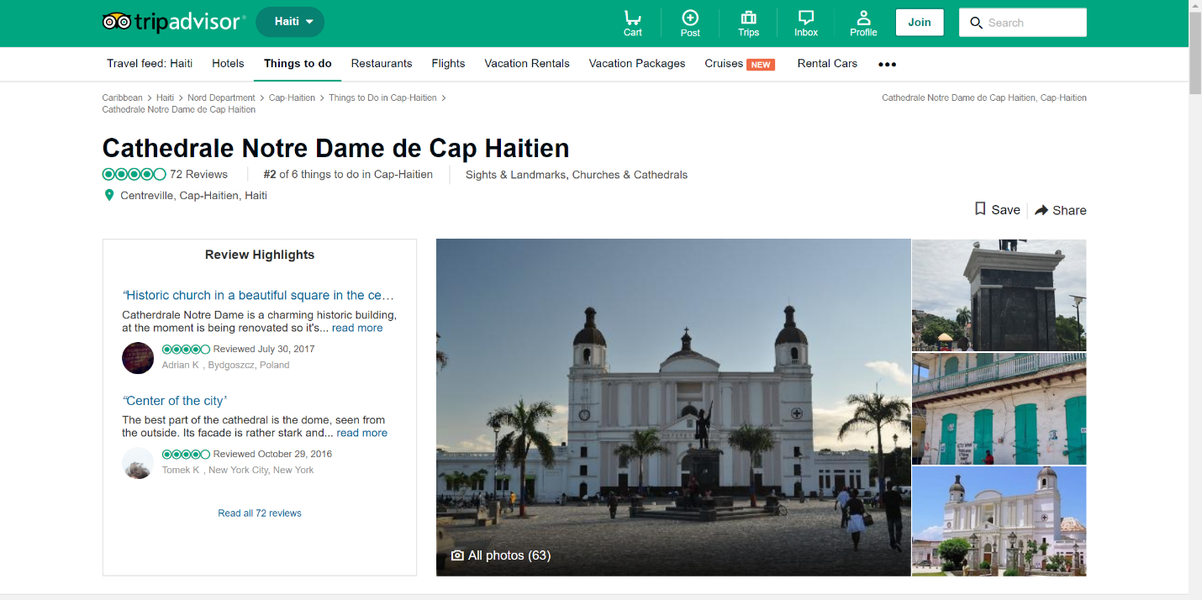
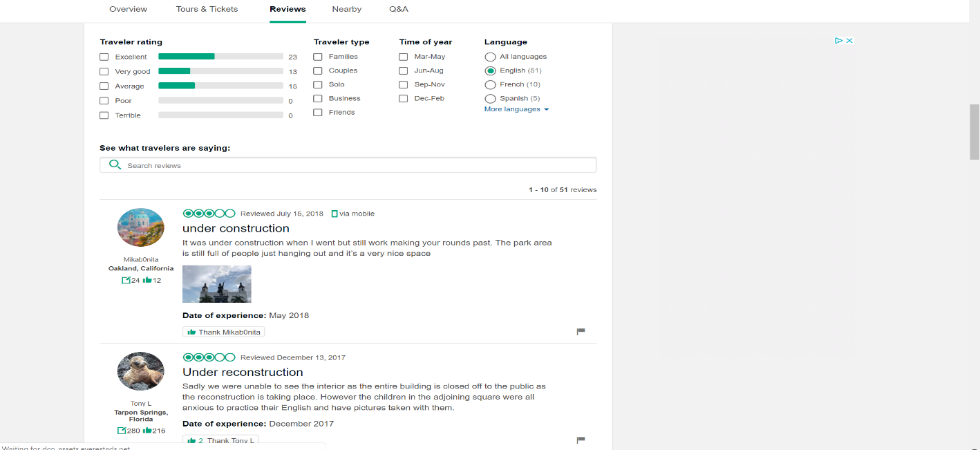

Overview:
Be a part of many organizations and provide valuable substance and involvement for example a non-for-profit organization. Meet many likeminded individuals who may share the same beliefs or interests as you. At times frustration may come along the way or a bit of confusion may tackle your brain, but it is manageable. Be prepared to talk to many different types of people coming from many different walks of life and learn as much as you can about them. You will be in many situations that you have never experience which will force you to learn and grow as you go on. Go to many conferences and meet many influential people, receive some awards or recognition for the wonderful work you’ve done throughout your leadership journey.
What to Expect:
After joining an organization that focuses on leadership. Be prepared to host events, reach out to likeminded people like you. Read a lot of books about people you may perceive as influential to you. Go above and beyond in anything you do and be visionary in everything you do within that organization. Develop a purpose or a motive for being apart of an organization. Practice self-reflection and see how you can improve yourself for others. Working with others is very important skill that you will be utilizing while being involved in a leadership organization.
Important Information:
-Sign Up is usually at the beginning of the semester, be on the lookout for club fair to gain more information as to what leadership organizations you would like to join.
-Leadership Organizations usually are in effect all semester long besides summer term

Additional Info
Be prepared for a life changing experience and get ready to make a change and meet amazing people.
Cancellation Policy:
It is okay if you decide not to be a part of an organization due to personal reasons but always know your help was and is always appreciated and noticed.
Reviews:
“*” Represent the Stars
Cathy: Amazing experience. I would do it again if I could *****
Allice: Very stressful do it if you actually care for others and you have a purpose ***
Candice: Great resume builder!!*****

Genre Analysis of a Receipt
Any sort of business entity or entrepreneur may be writing a receipt to show what was purchased as a type of document to show record. The general audience for this type of genre would be a consumer. Any person who buys or receives something usually receives a written document to show what was purchased or given to them as a record. The purpose of this document would be for record, reference or reminder that can be used to help someone look over any expenses they’ve made or services that were provided to them. If there may be any complications or questions a receipt can be used as a point of reference to provide clarification. Receipts are effectively written in a list form very minimal wording, so it is easy to understand. A tittle, address phone number, date and time are always provided on a receipt. Keywords such as total, discount, coupon, thank you and more are usually seen on receipts. Receipts aren’t a type of documentation to provide only reference they are used as advertisement as well. Phrases such as “see you again”, “5% off your next purchase” are tactics used to gain customers and convince consumers to stop by again. (Insert ethos pathos or logos).

Genre: Leadership Receipt
Leadership Supply & Co.
351 Jay St. Brooklyn, NY 11201
718-999-888
Date: 8/26/18 Time: 8:07:36 AM
Item Count: 13
- Innovation $0.00
- Momentum $0.00
- Persistence $0.00
- Bravery $0.00
- Ambition $0.00
- Organization $0.00
- Communication Skills $0.00
- Delegation $0.00
- Empowerment $0.00
- Optimism $0.00
- Honesty $0.00
- Commitment $0.00
- Accountability $0.00
Subtotal: $0.00
Thank you for Shopping with Us!
See you Soon!
“At Leadership Supply & Co Leadership is Priceless Leadership Doesn’t Cost a Thing”

Unit 3 Inquiry Argumentative Project
I really enjoyed this assignment because I can see the thought that was put in while creating an inquiry-based research proposal. I felt as if you really wanted to see who we are as individuals and allow us to express it in a form that would be beneficial to society. The term “transfer” was utilized effectively with this assignment because it showed students like me how we can take something from the classroom and develop it into a real-world project. When you think of real world and inquiry it can be extremely hard to narrow your thoughts down into one specific thing which for me was the biggest challenge. Having a one on one conversation with Professor Schmereler helped me narrow down my thoughts into a concept that I can transfer to others in a way they would understand. It was extremely important in this assignment to develop and propose our thoughts in such way others can grasp it. Unit 3 showed me how it is okay to have a strong opinion about something, but it is important when relaying that information to others it is done in a way your audience can understand.

Assignment: Unit 3 Brainstorming your Research Proposal
I feel that it is important to open further discussion on the importance and urgency of leadership and advocacy within the collegiate level. Students may see a Student Government Association President and think to themselves there is no way that they would be able to achieve that. Many students feel as if they are not capable do doing such extraordinary work or will never be able to reach that level.
There is an immense amount of power in someone that can help a student realize their capabilities and strive to fulfill their purpose. The importance of making students feel valuable and purposeful in an institution that they are a part of is extremely important. Leadership and advocacy do not only teach you how to lead and stand up for others for the greater common good. Leadership and advocacy teach you many life lessons such as; finding yourself, problem solving, failure and more. The skillset used to develop yourself into a leader is not as simple as it sounds, it comes from within and wanting to grow and become the best you can be.
This inquiry will benefit the percentage of students who feel as if they don’t have a purpose at City Tech, address the faculty and staff members whose duties are to ensure a cohesive support in the promotion of student involvement within campus. The economic benefice students will receive is having valuable skills that can help with interviews in a decent profession. Leadership and advocacy support the notion that it is not about what you know overall it is about what you can do with what you know. The satisfaction of personal development in someone’s technical and personal life can be a social benefit that can be gained with implementing the urgency of advocacy and leadership in a student’s everyday life.
The implementation of leadership and advocacy can be a wonderful concept, but it shall be incorporated within schools in a right and sustainable way. A proposal to the college administration to incorporate a leadership and advocacy class as a required course to incoming students (freshman) will increase student involvement and more. Additionally, it will provide an opportunity for students to learn fundamental skillsets that cannot be learned in any type of course study. The importance of presence to students will make them feel as if they are worthy and feel an abundant amount of confidence to achieve all that they’ve aspired to achieve.

Unit 4: Repurposed Multimodal Project
For my final portfolio repurposed multimodal project I wanted to bring emphasis on the importance of leadership incorporated in educational institutions at the lower level not only at the graduate level. When people think of the concept “leadership” it is often associated with being this remarkable person, with no imperfections. Truth is everyone’s a leader in their everyday lives. Leadership is practiced through everything we do, so why aren’t we being taught something that can help us in every aspect in our lives? It is important that in any educational system we are taught ways to develop ourselves that will beneficial to us for many years to come.
Media: Prezi Presentation & Ted X Video
Tittle: Leadership 101
My objectives:
1.Why aren’t we being taught everyday skills “that will help us in our everyday lives”?
2. Finding your purpose
3. How does one transfer knowledge into purpose?
4. Benefits of institutional leadership being taught
5. How does leadership change the world?
Link: https://prezi.com/qswcwpfcwoaw/?utm_campaign=share&utm_medium=copy

