Submitted by: Maria Partsevsky in lieu of Final Exam, ENG 1121
Section #: E106
Date: 05/19/2019

My Journey

Dear Professor Schmerler,

You asked what does “My Journey” mean for each of us? “My Journey” as “The reason of the life” is a very philosophical question. I think about it as an ability to learn something essential for ourselves; to leave after ourselves something essential as well; to do good things; not to make other people and creatures suffer; to raise our kids as good and valuable elements of society. My Journey is the ability to explore our planet, different cultures, places, traditions, rare and amazing things. To become someone about who your kids and the next generation of your family will say: “He/She was an amazing person, I adore and respect him/her a lot!” To live a happy life that you will never regret about at the end of your life journey – that is what we want to achieve.

A lot of different factors affect us in our lives and some of these effects are positive and inspiring and productive and some of them are negative, disturbing and can easily ruin a lot in your life. Sometimes we get overwhelmed with all the stress in our lives and don’t pay enough attention to what we are doing, making mistakes that we will regret about later.

Sometimes when we are trying to write something, we are not always straight up with our thoughts due to some struggle in our life. The stress or some hard situation in our life could lead to some consequences that we would be regretting about. Especially when students have to write some papers the mind is filled up with totally different thoughts. We cannot come up with any idea or inspiration. So, what do we do? - we start reading someone's works, essays, thoughts so that we could have an idea to write. Unfortunately, the idea is not yours. We feel that it is very hard to write, especially to make up some untrue stories. So, what do we do next? We copy some parts of the text or paraphrase it. And we don’t put citations. And it is called “stealing.” One moment of weakness and you would be hanging on the edge of the suspension from the school or failing the class. Plagiarism is dangerous for our life. Not only because you might be suspended but also because you would not ever have an opportunity to think for yourself; what is it that you think is right, what is really interests you - basically your identity would not be yours.

When I was writing the essay paper, I had an idea/notes page that I use to write down ideas that I get, and ideas and sometimes quotes that I find when researching a topic. This is something I have done since I was small, it is the process I use to do larger homework assignments. That quote that appeared in my essay paper was indeed a quote I had on the note pages. I usually, label quotes so as to either reference them or make sure I understand they weren't my own words. Unfortunately, I completely messed up and put the quote in the paper. To say I feel horrible about this would be an extreme understatement. It is not an excuse but my only thought is that the recent stress I have had from my biological father who I don't see anymore has been affecting me.

My father brought me to America about 7 years ago and after being mentally abused by him here and in Russia, he kicked me out of the apartment after only 2 months being in America without even my clothes I brought from Moscow. I have no relationship with my father and after him harassing me for some time I thought he left my life for good. I have not talked to my father for many years now but recently got an email from him - saying how much he is disappointed in me and he is so happy to announce that he is removing me from his will. He is always saying that he will do everything in his power to make sure I cannot graduate from college and get an education. He attempted to contact the college before trying to get some personal information about me. I put a restriction so he would not be able to get it. For all my life he has been treating me like I am not his daughter and I don't deserve even a good word. He keeps saying that he is surprised that I survived by myself in the USA and even made it to 28 and didn't end up being a prostitute.

I know it does not excuse me but him recently contacting me after all this time and these old thoughts really interfered with my studies recently and made me feel depressed. I really love my profession and what I am studying for, I have been doing my best getting good grades and I was excited to only have a semester to go so I can get a job and start paying for my debts. I want to prove my father and myself that I am worthy and I can finish college and get the profession I love.

My Journey with English II class started in Spring 2018 but had to drop it because I missed two classes due to my sickness and later couldn’t catch up with this class. That class was too difficult for me. And when I took this English II class with you I was very scared at the beginning. I thought I would not understand what is going on. And for the first couple of classes, I had this feeling. But then I realized this class is completely different from anything that is called “English class.” We had so many irregular assignments and writings, so many interesting conversations and discussions, so I was really enjoying every class. The free writings, writings without strict rules and boundaries, creative expressions, and a lot more to mention. When we were reading our writings out loud, I was scared and nervous. Could I deliver what I meant? Was I clear? Do they understand me despite that English is not my native language? But later I stopped worrying and started listening more and reading more. I learned how to listen because language is everywhere around us. I learned how to write and make corrections. I learned what plagiarism is and I learned how it could ruin my life and my dream about education in one moment. I learned my lesson and I regret that I did it, truly, deeply regret. I really appreciate what you have done for us, students, and especially for me this semester. It was one of the most challenging but enjoyable classes I have taken since I moved to the U.S.A.

Sincerely,
Maria Partsevsky

Unit 1

For Unit 1 the biggest challenges for me as for a foreign student were reading that we had to read. It took me three times longer than others (I mean native speakers) to read, to translate unknown words, to understand the meaning of a text. To write without some letters (descending and ascending) was interesting, but also pretty hard me because I realized that my vocabulary is not that broad to be able to easily find synonyms avoiding restricted letters. I also must mention that my experience with an essay about freedom taught me a lot. I made a big mistake. I took somebody’s words without quoting them. I regret a lot. I learned my lesson and I am very thankful that you, my Professor, believed me and believed in me and gave me a chance to rectify the situation.

Constraint Writing

Fear: I know I have a lot of different fears. Some of them I learned how to live with, some of them I aim to avoid, but one of the scariest of them holds the heart of mine with its cold fist - the fear to be left all alone, without beloved ones, without those who I care about and cannot live without. The whole world wouldn't make sense and each action would be done for no one and dedicate to no one. We come to this world alone, but we meant to find here on this earth our “shoulder”, the person who we will spend our life with, to live in blessedness. Thus, if in one moment we will find ourselves without our beloved ones, our soulmates it will be the most fearful situation that can happen to us as I could state.

Cure: never give up, spar, move, remain going, see a new way, a new reason, experience new.
Essay
What is it to have Freedom?

There are seven point five billion people in our world who has their own opinion, thoughts, regulations, abilities, and most important – their viewpoint. People tend to strive for their own paradise that they are trying to achieve. Each person creates laws for themselves to forbid something or in opposite to allow themselves to fulfill the desire. That particular desire that each individual has is called freedom. Of course, every desire (freedom) is different for each individual. Freedom is not about what is right or what is wrong, it is about seeing things that would make a person happy, special and proud of what this person has or achieved.
Freedom is invisible, we cannot touch or feel it, we cannot see or hear it, but we can understand the presence of freedom. From ancient times, people thought of freedom as a flight of a bird in the sky, a bird which soars over the world. That bird has a freedom that all people dream about, but people are grounded to the earth with one anchor called society.
People have freedom as their congenital right since the moment they are born. A free person is one who has the right to a certain behavior, bestowed in their country’s Constitution. This idea is about regulated freedom. The more developed a country’s democracy is, the more rights its citizens have.
A popular saying says: “Freedom of one person ends where another's begins.” In terms of ethics, a person’s freedom is declared in their ability to express their will. It is more correct to talk about the possibilities to freely perform certain actions if they do not pose a threat to the life or health of other people and does not encroach on their honor and dignity. Otherwise, the people around are also free to prevent someone’s immoral behavior by their actions. This situation would turn into a vicious circle.
We all have our own thoughts and ideas about being free. I think there are two main concepts of freedom: physical and mental. To be physically free is to be able to make movements and actions according to your own perspective, your own desire, and will. To be free to travel around the world, to study and work the way you want, to make decisions, to have money for all of your desires. That is what makes you feel that you are physically free. For some people money equals freedom. Being wealthy is limitless because almost everything can be bought with money – even love and fame. You can live anywhere in the world, have breakfast in Paris and later in the evening listening to an opera in Italy. You wake up and there is a new day full of freedom and joy for you and you don’t have to worry about if there would be a roof above your head tomorrow and something to eat. You are financially and physically free. The whole world is open for you and there are no boundaries or people to stop you.
Internal, mental freedom is more important than physical freedom for me. It is the opportunity of choice. A free person is, first of all, a person free from stereotypes, open to understanding the inner world of themselves and of others. The possibility of unhindered willful expression is extremely important for everyone. Even if circumstances take away the freedom of movement, no one can take away the freedom to dream, to think, to analyze or to learn.
Back in the days when I was younger, it was always hard for me to make my own decisions. I was led by my mother who was an authority for me, and I was even happy about it because I had no responsibilities for my decisions. Throughout the time I managed to overcome obstacles to become a free person. It was the hardest step in my life, but it gave me the opportunity to see things from a different perspective, which helped me to become a strong and independent person. In our head we all as free as our world view allows us. People may respect the opinions of other people, but mindlessly following other people’s opinions is not desirable. Parents, grandparents, friends, colleagues can sometimes suggest the right things. But, everyone has their own life and how to live it is an individual choice.
A serious problem that prevents many people from gaining their independence is the fear of independence. One of the reasons is ignorance, which holds people like real shackles. Very often, someone becomes dependent on others just because they know no other way. By learning more about the laws of the world, understanding their own capabilities and rights, people are getting the most powerful weapon in the fight for their freedom. Fear appears in response to misunderstanding. Thus, the expansion of our worldview can open freedom for us, and this is the first step on the path to it.
The question of freedom has been pondering over the years. How we define freedom is our own individual choice. But, in addition to thoughts, it is desirable to project them onto your life. If you want to be free – be free! There is a number of barriers on this path, but most of them are in our heads. Therefore, the first step towards liberation is positive thinking and a proactive stance.

Unit 2

For Unit 2 I believe I did a good job. I researched how different genres sound and look like, how to change a genre and not to lose the context you are trying to deliver to an audience. I really liked to imitate the Yelp reviews and create my own, I wrote one four-stars and one one-star for the same facility, one under my name and one - my husband’s. It was fun. I like sometimes to feel myself in someone else’s shoes.

My skill / Something I do well - Drawing and Painting

Recipe “How to draw or paint”

What you need / Ingredients:
- Basic knowledge of geometry, anatomy, color relations, mixing techniques, proportions, depth, volume, composition, light and shadow, balance, etc
- Artsy-vision
- Good-quality paper, paints, pencils, eraser, brushes, water in a cup
- Inspiration
- Quiet, well-ventilated and well-lighted place

Directions:
1) Sit down and place the paper in front of you.
2) Concentrate. Think of what you want to draw or paint.
3) If you are drawing or painting “from nature/life”, then look at the object or subject and try to understand how will you execute it into your paper.
4) Try to feel the forms and proportions.
5) Try to paint or draw according to your own vision and style. If you don’t have one yet – try to develop it, to create it.
6) Every few minutes squint and stand up to look at your paper from a distance to see the whole picture and search for mistakes or disproportion.
7) Try not to “over-do” your art piece, know when to stop. Don’t make it “well-done”, keep it as “medium-rare.” There is no perfection.
8) When you are done, wait until it is fully dry if it is a painting. Clean after yourself.
9) Now, go make yourself a nice cup of tea and you even can take a brownie. A small one. Don’t go crazy. It was just your first masterpiece. Bravo!
10) Give your masterpiece as a present to your parents or beloved ones and walk around proud that you are such an Artist!

The examples of the genre I chose to write in. Yelp reviews
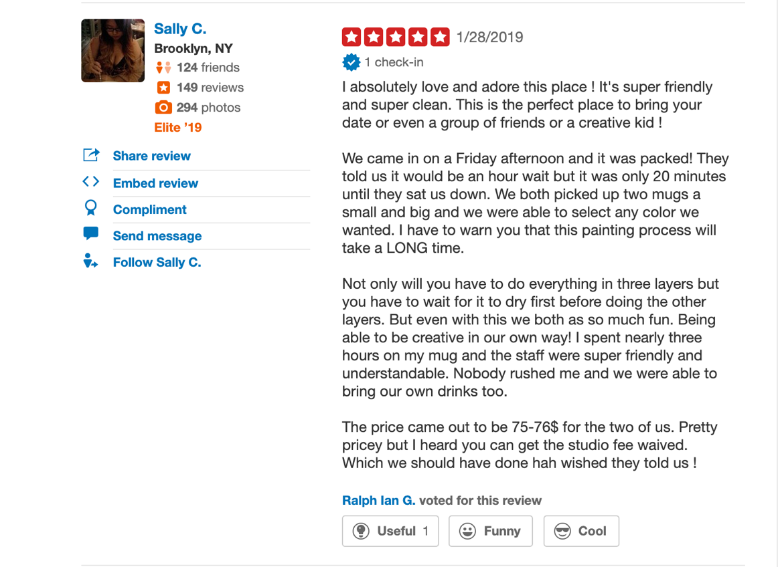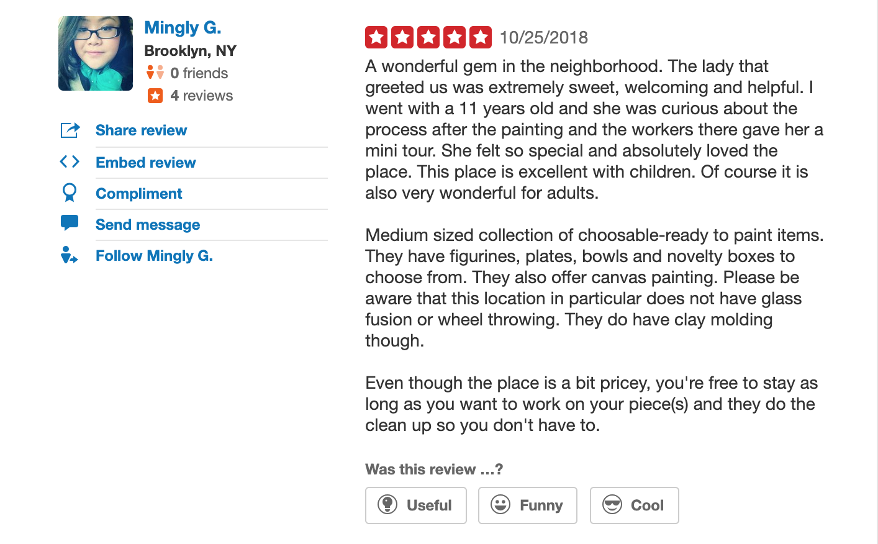

The analysis of the genre (Yelp review)
Painting-your-own-pottery

Who wrote it/the speaker: people who tried this activity before and share their experience, so that other people will follow their advice or could be aware of what might happen, what to expect.

The audience: people who are looking for activities and how to spend their free time in the art field and something for memories made by your hands.

The kind of community that is invested in or impacted by this writing: mostly parents with kids, the reason is to show them something new to do, spend time with them in a different environment, plus to introduce kids to a new stage of art activity to become more creative and to feel what it is like to make something with your own hands.

The purpose of this writing: the ability to be in someone’s shoes, people read about the pros and cons of this particular activity, they decide which place is better to consider to go to.

Some key vocabulary or language terms you might find (if any) that are common in this form of writing: Metaphors; lots of exclamation marks!!!!; CAPITALIZED LETTERS AND WORDS; numbers in the usage of prices and time; LOL; smiley faces ☺

The sorts of ways that people try to write effectively in this genre: they try to write as many reviews as possible to become a reliable and trustworthy person, that others would see tags like “local expert” or “elite” next to the people’s names. People try to organize their reviews into paragraphs for easy reading. They include personal pictures of the experience or the product. They write about their feelings and emotions to become closer to a reader. There are also many fake reviews and paid reviews, so people who read them must be aware of it.

Genre: Yelp review. Paint-your-own-pottery

Maria P.
Brooklyn, NY
27 friends
13 reviews
Share review
Embed review
Compliment
Send message
Follow Maria P.

∗∗∗∗
10/13/2018

One weekend I wanted to do something interesting with my husband, something that we have never done before. So, I found this place where you can paint on different kinds of ceramics and potteries using different colors. So, basically, you make your own cup, plate or vase unique from others by applying different textures, colors or even some words, stamps or little creatures :)
I really liked the variety of colors and types of paints that I could use for my masterpiece. The staff has always changed the water, so it would be clean, and I would not mix the colors together. However, and it was the only cons, the ceramics there were all quite the same, so the variety was weak. Well, I chose the cup that appears to be a fat guy with a big beer belly, whom I paint a pink bra and a nice pink thong to LOL :))))
After painting, we put it inside the stove for several hours to make paint attached and glaze to the surface of the cup, and it looked amazing! The colors were so bright that the pink underwear was almost shining in the glance of the sun haha! We really enjoyed the experience of painting and the cup that forever would stay in our memory and on a kitchen shelve.

Was this review…?
Useful Funny Cool

Oleg K.
Brooklyn, NY
13 friends
7 reviews
Share review
Embed review
Compliment
Send message
Follow Oleg K.

*
09/22/2018

NO, NO, NO. First of all, the atmosphere there is not healthy and clean. They pour paints into small plastic cups and reuse them. The brushes are sitting in dirty water and nobody rinses them, the shape of them is terrible!!! The ceramics they offer to paint are crazy expensive starting $19.99. FOR WHAT??? :-o The assistants are not assisting!!! They do not offer help and when they are asked for help acting aggressive and belligerent. The piece you paint they take from you and put it into their paper bags while it IS STILL WET, so all your work (or your child) is just RUINED (*facepalm.) My four years old daughter was disappointed, so did I.
DON’T GO.

Was this review…?
Useful Funny Cool

Reflection on “Shitty First Drafts” by Annie Lamott

and “Navigating Genres” by Kerry Dirk

Normally I write one draft. I write down all thoughts and everything I know or heard about the topic, then I read it again, replace parts, write more in some parts, edit it. I wasn’t surprised about the title, it sounded to me obvious, so I kind of knew what it would be about. I don’t think my writing of drafts will change a lot, because I feel like suffering every time I have to re-write it or change it, it takes concentration and patience which I don’t really have, unfortunately.

I used to use Facebook a lot and post and share lots of my feelings, thoughts and private events of my life. But I stopped doing so because I realized one day that it is read not only by my friends and family members, there are people who I don’t want to see my posts and my life and they somehow hack my posts and everything become public. Also, I agree with one saying: “happiness loves silence” – meaning if you are happy and you don’t want your happiness to be ruined – keep your life private. There are plenty of people who are jealous and who would just want you to lose everything you cherish.

I don’t think someone older than me feels less comfortable using Facebook. It all depends on how well you’re aware of the content and programs. There are people who deal with social media and computers, in general, every day and do it better than some young people due to their experience in working with them. For instance, my grandmother knows computer programs for artists and designers very well because it was required for her to know and her job was tightly connected to them, while I don’t have almost any knowledge of them because I was never taught them. She also uses Facebook and feels pretty comfortable in navigating there, but she doesn’t really post much, because it takes time for her to type.

I usually care more about how to make my text more coherent and looks not like separated thoughts. This is the hardest part for me. I don’t like rules, structures, and restrictions and don’t think that the writing as a kind of art can be put in these restrictions, rules, and structures, it has to be the way you express it, you feel it, it is as unique as fingerprints.

I decided to include Outer and Inner Dialogs here as well. It was a very interesting experience for me to write. The voices in my head and around me were so loud and were running so fast, it was not easy to catch them and put them down on a paper. I think I did a good job, it is pretty interesting to read and to imagine, it came out like short stories. I am used to writing down my thoughts when I am worried, depressed, anxious or happy. But here I also heard what was going on around me.

Creak of train wheels; Squeak of rats on train paths; Screech – the train is stopping...
Crunch of chips… God, I would just grab it from him, I’m so hungry...
Groan of an old man; yawn of a kid; hiccup of a baby in a baby stroller...
This is Nevins street, the transfer is available to the 2 and 3 trains…
Rustle of plastic bags… Next stop is Atlantic Ave Barclays center...
I’m tired… and pissed.. he could easily just text me once during his work day… at least once.. he has been always doing it...
Coughing… My stop... getting of.. which exit do I need?
4/5 train, Friday 3 pm

It’s an expensive restaurant… It’s usually right… You buy something and...
This is Bergen St… Wheels… killing me…
Carol usually just says… This is Coney Island bound F local train… Stand clear…
My head is killing me… I think when I was smoking I didn’t have migraines that often.. weird.. Smoking 12 years and quit because I fell in love… This is Carol street...
Now I have to go to Ave P instead… How to open this car… Smith 9th street… why the car locked with keys inside again.. oh god, I remember how I hit my head last time trying to open the car from the trunk… I almost ended up in hospital.. or I thought my head cracked…
These white spots in front of my eyes, the doctor said it’s an aura of migraine.. f*ck...
This is Coney Island Stillwell ave bound F local train…
wheel screeching… Next stop is Fort Hamilton Parkway… stay clear…
These white flashes in front of my eyes are torturing me…
It’s only Wednesday yet.. can we make it to a doctor today? The appointment is at 4:45… or 3:45?… no, 4… Fort Hamilton… why it takes soooo looooong…
attention all passengers, we will be moving shortly…
it’s like a razor blade cutting my brain in pieces… would my daughter or son have migraines as well? Poor baby…
April 3rd, 2:30 pm, F train

Today is my mom birthday... Can’t believe she is 50 now! How come? She just turned 38, didn’t she?
These trains are so slow on weekends... I would rather be in a car in traffic...
And can you imagine, he just left her, right there! What an as*hole!
3 girls speaking Chinese.. hmmm, it always sounds so rough and unpleasant to hear.. like German..oh I can imagine how I sound for them when we speak Russian…
The next stop is Avenue J… stay clear… interesting, Avenue J because Jews live here?:) haha…
Allochka, I am telling you, just buy this sundress, you won’t regret at all… 2 Soviet-looking ladies straight from 70es discussing loudly something...
Krrrrrrrrrrr……. next station is Newkirk Plaza…
April 6th, 10 pm, Q train

Unit 3
Unit 3 was challenging for me. I did a genre writing about painting-your-own-pottery, but research on some problems in this particular activity got me stuck, and I realized that I should do my research writing about painting and drawing in general as fine art and what problems artists face in this field. For the first several days or even a week, I was struggling and nothing was coming into my mind, and then, suddenly, I sat down and wrote the whole paper and it was feeling so good that text was coming out of me naturally. I hope I could deliver the message and my text is interesting to read as well.

Inquiry/Research on Difficulties that Artists face

Art is everywhere around us. And if you ask people around “Who is the greatest Artist?” probably, everyone would answer – “Nature.” People from the ancient times were interested in painting and drawing, sculpting and crafting. They were trying to preserve in times their emotions, their memories, and significant events. Since the beginning of times, people wanted to express themselves and did it in dancing, music, fine art, and other genres. Now, people do art as their hobbies, stress relief, as a need to express their feelings, to deal with depression, and to make a profit of it.

People who chose Art as their profession stepped on a challenging path. Most likely, almost everyone’s artist’s parents told them not to do that. It is very easy to explain – parents are afraid that their kids will have many difficulties in finding jobs and making a stable amount of money. Plus, the Art market is a very, very competitive place. To be in high demand, artists always must learn new and grow in their knowledge. The technologies are not staying in one place, and we have to keep the pace. That’s why to be a good and demanded artist people need to educate themselves. Most of the art and design schools are extremely expensive and whoever wants to make art as their profession must keep in mind that bachelor and especially master programs require to be able to pay an enormous amount of money, so first thing people must do is to think really hard – is that what they want to do for their life? How they will be paying for their tuition? Is this profession will “feed” them and pay off their bills and student loans?

While I was researching for this topic, I remembered what kind of obstacles and issues I personally faced in my life and what my artist family members have shared with me. We are our own biggest critics. We, artists, are never happy with our work. We always feel that we could do better and our art is not good enough. Enough for what? – I am always asking myself. Or for who? Self-doubt is the Number-One-Enemy, but we learn how to live with such a “neighbor.” The artists have to learn how to not to let anyone tell that what you are creating is not valid. We spent years of practice and education to shape ourselves, to know the value of our knowledge and to know that our art will be remarkable for the future generations, it will leave a mark in the Art history. The success will be always judged by other people, most of the times who are irrelevant, incompetent in that field.

The other problem is what to do with your art? How to present it? How to sell it? How to find your clients? The artists are having difficulties when they are looking for display space, galleries or collectors. To be able to produce and present art in a marketable way can be way too expensive. The galleries, shipping fees, printing copies, etc. – there are many things that will be trying to take their portion, their piece on your work. Artists need to market themselves. And here everything depends on networking and how good your communicational skills and social media usage are. Inability to find a job in the art field pushes many artists to find other work for income and leave art as a hobby.

The one fear that I personally face every single time I try to do anything, either it is related to drawing, painting, writing, cooking, reading or even traveling is – how to start? And here comes the fear of the white paper. I feel my hands are not mine, they are not obeying me, in my mind I know how to do it, I see it is coming, but when I try to start, when I do the first couple of strokes I feel like someone else is doing it and my mind is screaming: “Nooo! Not like this!” I don’t like what I see and I erase it and try over and over again. Without everyday practice, you lose your skills. The same way with languages – if you don’t use them daily – you forget them. But once started artists have to learn how to stop. In pursuit of the ideal masterpiece, we can lose the great work we have done. It will never be ideal. My Master in fine arts college used to say “Don’t make it 'soapy', know when to stop, the Best is the enemy of the Good, your painting has to 'breathe', has to be fresh and crispy.” He called this technique “Alla Prima”, wet-on-wet. I think it is good advice for life in general. To know when to stop. Whatever you do – make it fresh, crispy. And remember it will never be ideal.

There will be always challenges on your way to your growth. These challenges will shape you as an artist, as a person. You will not face them just once and never meet again. You will be going through them over and over again if you really want to grow and to conquer new heights. And the last but not least advice – grow a very thick shell instead of your skin, it will protect your inner You and your priceless inner Art against rejections, and never give up, keep walking!

Bibliography:

“The Five Challenges of an Artist.” The Torch Theatre, 10 Feb. 2012, www.thetorchtheatre.com/2012/02/09/the-five-challenges-of-an-artist/.

“What Are the Challenges Facing Young Artists Today?” Apollo Magazine, 7 July 2015, www.apollo-magazine.com/what-are-the-challenges-facing-young-artists-today/.

Baranovsky, Yuri. “Contact Protocol.” Yuribaranovsky.com, 16 May 2012, www.yuribaranovsky.com/9-problems-of-being-an-artist/.

“What Are the Challenges Facing Young Artists Today?” Apollo Magazine, 7 July 2015, www.apollo-magazine.com/what-are-the-challenges-facing-young-artists-today/.

RedDotBlog, reddotblog.com/many-challenges-artist-faces/.

Contributor, Quora. “What's the Biggest Challenge Artists Face?” Slate Magazine, Slate, 6 Nov. 2015, slate.com/human-interest/2015/11/whats-the-biggest-challenge-artists-face.html.

Unit 4

When I first time heard about this Unit, I was in a panic. First of all, I didn’t understand what are we supposed to do? And how? I had so many questions and zero answers in my head. Until almost the last day I didn’t know what this video will be like. And then, I decided to show how I (and I think all artists) deal with stress, depressions, anxiety, and disagreements with myself and with others. I decided to show how I am painting at home, with my husband exercising behind my back while watching TV series in English and with a little help of our “son” – our cat Karkas.
For the best quality, choose 1080 in settings before watching. It is time-lapse and it is unfinished due to lack of time, but I hope, I showed the idea.

https://youtu.be/g0J_sj2vKlE

