Stephanie Flores
ENG 1121- D439
Professor Schmerler

Final Portfolio
UNIT 1
What My True Feeling of Freedom Is

What is freedom to me. That’s a hard question to answer. Many people have given this idea great thought but to me it feels like moving forward,no matter what the obstacle or challenge.
When I think about freedom I think about the right to express myself however I feel with no judgement or hesitation to move and continue to grow and change as I do without being confined to a single space or ranking system that holds anyone or anything down beneath themselves to me it makes no sense to pass judgment on anyone for what they have done in the past cause that is not the future they have decided on. They make the change for themselves here and now.
My family and friends stayed by me through it all it gave me the strength to stay beside them to through all of the good times and the bad to each point in my life I have been given small but powerful piece from the people who truly knew me that have made me who I am today. I have spent my life growing and learning to be better than I was yesterday not for anyone else but for myself in order to truly understand what my place is. I have always thanked them for what they have given me and shown me just how much there presence in my life has pushed me to reach out and grab my dream and hold my hand out for them when I am feeling lost and alone to the point I needed them the most and they came to me. I want to say something and I know everyone is thinking it my type of freedom is not your type of freedom but we can relate in some way or another. There is a place that each of us hold in our hearts or our minds that we go to. A place that we dream of could be our world right now. A place that we want so badly that we can almost reach out and touch it . We picture it so clearly in our minds and heart that this place is our peace our home. It is freedom more than anything we have ever know.
My freedom came to me and I never want to let it go because when you finally find the answer or the big question you are looking for the goal or thing that makes your world finally complete an you feel like all is coming into place the path you are one and the words you have spoken finally made sense it feels like a dream the moment you closed your eyes you saw a place that your mind knew would make you feel safe and truly free that is what freedom is to me.

++Fear
I believe that I don't have fears. I've been hurt by insects. Some even made me lose consciousness. However, there is one fear I have which is fireworks. I know a friend that his face reconstructed because of denotation. Chunks of meat and flesh had to be removed from the floor and walls in case it was needed later on.
++Cure
Stay away from that explosive.
UNIT 2
++Rip Recipe
Ingredients
1 white onion
1 red onion
2 garlic cloves
2 tbsp olive oil
½ tsp chilli flakes
110g dark soft brown sugar
600g tomato ketchup
110g dark soy sauce
Salt and pepper
1 rack of ribs

Step 1: Preheat the oven to 150
Step 2: Peel and cut the onion, then crush garlic
Step 3: On medium heat in a frying pan until it’s hot add in the oil, onion and garlic. You are going to up to 4 to 5 minutes until it soft.
Step 4: Add chilli if you like spices,then mix with tomato ketchup and brown sugar up to 1 to 2 minutes. (Reminder if you cook it for too long it will be really hot)
Step 5: Add everything with the soy sauce and tomato ketchup and stir fry up to 1 to 2 minutes.
Step 6 : Put in the rib into a deep pot and place into the oven for 40 minutes.

++Respond to “Shitty First Drafts”
When I write essay my initial routine is to write many thoughts that I have. I was not surprised by the chapter’s title at all. As I read the title I knew I was going to able to relate to the author. When she described that she would sit down with her notes reminded me of the steps I take to when writing essays. In my opinion changing the way I write won’t have to change at all in order to write a “shitty first draft”.
++Navigating Genres
To be honest I’m not very confident in writing a piece based on the genre of Facebook. Yes, i might have more knowledge about this type of social media than an adult. Some parents and grandparents are not familiar with even using a phone because “it’s a lot of technology for me” what my mom says all the time. Unlike us millennials who are attracted to ours phones. Older people might have difficulty communicating through Facebook unlike us who can text four people in different social media. My favorite tiptoe from Dirks newspaper The Onion would be “Myspace Outrage Leaves Millions Friendless” which made me laugh a bit because I remember that during that time it was one of the most popular social media and now mostly everyone forgot about it.
++Genre Switch 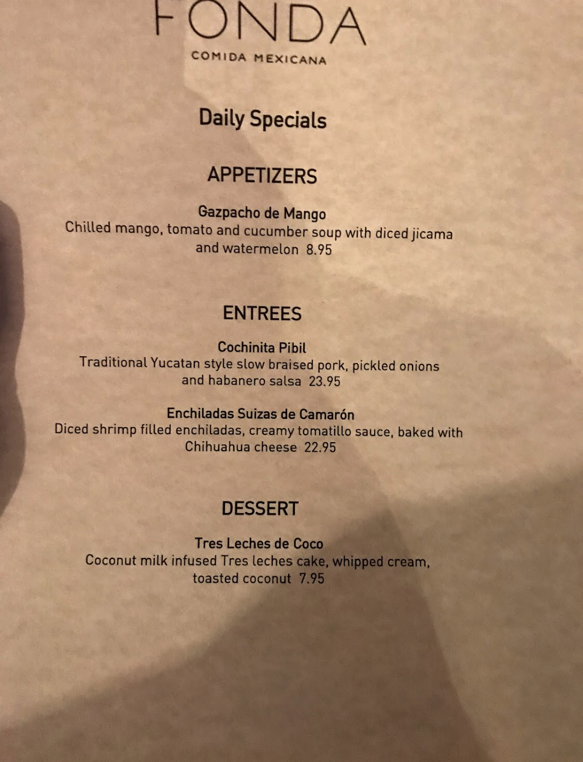
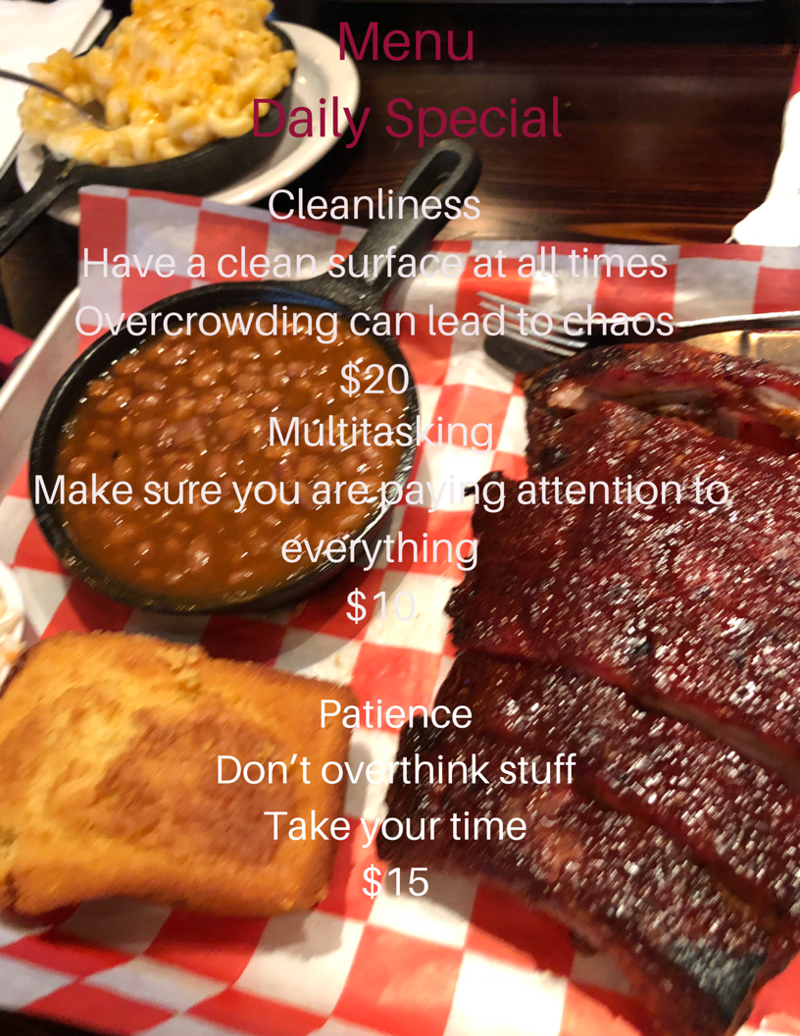
UNIT 3
+Proposal For Research

Everyone knows the challenges women face in industries. Women get looked upon as weak or useless. In the cooking industry many will prefer men the take power and leadership of the kitchen. Do we ever think about the challenges men face working in those conditions? Why don’t we worry about the stress and circumstances men go under?

Being in the kitchen the for extended amount of can bring physical health complications. According to “The potential Health Risks Being a chef” by Total Food Service” , being up their feet for a prolonged time can cause foot injuries. Staying up all day and having to carry heavy pots can add to the pain. According to the article men can suffer from “Hallux rígidas”. This causes them pain on the toe that can an obstacle for them to move around easily.

Suffering from extreme stress and pressure can some men to take their own life. According to the article “ Why working in the restaurant industry can be hard on your mental health “ by Kara Baskin, states that two successful men in the cooking industry took their own life. Who would ever think that men would shot themselves to escape from their misery? Men shouldn’t be exposed to extreme pressure that pushes them to edge of committing such painful choices.

Work Cite

Baskin, Kara (2016). Why Working In The Restaurant Industry Can Be Hard On Your Mental Health . Retrieved May 24, 2019, from https://www.bostonglobe.com/lifestyle/food-dining/2016/02/29/why-working-restaurant-industry-can-hard-your-mental-health/NaqWdSHvKJtZQCoberbLjP/story.html .

The Potential Health Risks Of Being A Chef. (2013). Retrieved May 24, 2019, from https://www.bostonglobe.com/lifestyle/food-dining/2016/02/29/why-working-restaurant-industry-can-hard-your-mental-health/NaqWdSHvKJtZQCoberbLjP/story.html .

UNIT 3
https://www.youtube.com/watch?v=Ch3P1Cfly30

