Amani Shihadeh
ENG 1121 – D439
My Journey – Final Reflection

Dear Professor Schmerler,
This semester probably was one of my most difficult, with both being in school and work full-time it was hard to keep up at times. School has always been very important to me and no matter how hard it gets I always end up toughening it out because I care about my performance and grades. This English class had to be the most interesting English class I’ve taken, I definitely did not expect sitting around in circles sharing our creative writings, thoughts and ideas. At first I was not comfortable with it because, I’m more a sitting through lectures type of student. But being in this class has helped me in many ways, I can’t speak for the rest of the class but I definitely feel more confident in my writings and expressing my ideas because you taught us there is no such thing as a “wrong” piece of writing/idea and to just write anything that comes to our minds. I was able to dig deep and explore the many ideas I always had but was never able to express them through writing because I didn’t know how.
Although I recently encountered something I’m not proud of and there is no excuse, because of a lot of stress due to my workload I had taken a paper that wasn’t mine and submitted it as one of my writings. I know how much that can risk my education. After speaking with you professor I really did have a wakeup call, and I understand the consequences of my actions which is why I greatly regret doing something like this. I thank you for encouraging me to be able to express my writing and apology.
I’m not the best person to write essays, but in this class you allowed us to pretty much write whatever we wanted however we wanted and without the stricter guidelines that allowed us to write sounding like ourselves. Which why I see now it was really foolish of me to do what I have done when all you want to hear is our true thoughts and expressions. Writing constraints was my favorite and least favorite, because just the idea of writing without certain letters seemed impossible but it definitely wasn’t, and hearing the many writings from my classmates just wowed me to believe that the more we dig deeper allowing our creativity to shine, anything is possible.
UNIT 1
In unit one we explored writing exercises as a warm up to the semester. I liked that were able to express our fears and cures in writing, at the time I wasn’t sure what to write about I know I’m scared of many things but out of everything I chose spiders to write as my fear. Although I am seriously afraid of them, I wish I can go back and chose something else maybe like death or aging. I never was asked to write about my fears, so it did interest me when we were asked to write on it. We also discussed our influences like TV shows, books, music etc. and placed them on our “shelf” which was also fun to talk and write about.
FEAR
When I see it, I run. Others scream, when I look further its fast to run and hide. They come in all shapes and sizes, more legs than others, I fear arachnids. Arachnids are little creatures that can be found indoors and outdoors. When I see them, I call someone else to come kill it but the second you turn around its gone. I wish arachnids didn’t exist.

CURE
Surely we know there is no cure. Maybe putting all of them in the same room with me will help but that is very unlikely and will never work.
TV SHOWS/ INFLUENCES
Greys anatomy: By Shonda Rhymes – This show has taught me many life lessons, not to take anyone or anything for granted. It shows us how fast life can change within seconds and overall it speaks to your heart and makes you want to grab “your person” and hold onto them for dear life.
Power: By Courtney Kemp – This show has changed my perspective on New York City and all its drug dealing truthfulness. There is some serious life lessons within every show. It has also taught me the many devious doings of our justice system.

FREEDOM INTERPRETATION
Freedom to me is about everything we are able or want to express. Whether its freedom of speech, freedom of thought and opinions, freedom of rights. Its all perceived the same, but different to each individual. Growing up from a strict-ish family, I never truly understood the word “freedom” the word freedom meant nothing to me. When I was younger I didn’t know what I had, and I know now that it was parents who cared for me and wanted the best for me. They wouldn’t let me do or go certain places and I never understood why, but as I got older I understand it perfectly. In today’s world there’s so much harm and violence, my parents weren’t doing a crime they just wanted to protect me and keep me safe as possible. So I’d like to appreciate what I am today and how I was brought up, especially in today’s society. Freedom to me is whoever we want to be, the way we are able to express ourselves.

UNIT 2
In unit two we were asked to write an essay on what freedom means to us, which I enjoyed doing because freedom has a universal value. It can mean all different ways to all different people, and everyone in class wrote about how they perceive freedom. We also explored different types of genres and wrote recipes. Writing recipes was easy and fun and genres was a bit confusing to me because I actually never thought about the different types of genre and ways to further break it down. So we had to choose our favorite genre, I picked wikihow because I am always looking up how to do things and wikihow makes it easier with the little pictures along with the instructions.
GENRE ANALYSIS
The type of genre I chose is WikiHow, which is a website made for people when they’re looking up how to do a particular activity like, how to roast marshmallows or how to exercise. Many people nowadays are always looking for new things to do or try whether they already know it but have never tried or it’s completely new to them so they look it up. I chose to do my genre in WikiHow, writing on how to apply makeup. Wikihow is meant to be an easy step picture guide on how to achieve a particular activity, which makes it simple and convenient for people to follow. In my case, my audience would be makeup lovers, beginners, influencers or anyone who simply interested can use this greatly as a tool to learn or teach.

Amani Shihadeh
ENG 1121
Professor Schmerler
Genre: WikiHow

How to Apply Makeup
If you ever applied makeup before, all the products can be intimidating. Don’t worry this will walk you through step by step on how to apply makeup.

Preparing the face
Step 1: When applying makeup its necessary to start with a clean palette. You should always start with using moisturizer and primers for your skin.
- Keep in mind you should always remove your makeup at the end of the day; sleeping with your makeup can clog pores and cause blemishes and wrinkles.

Applying Foundation
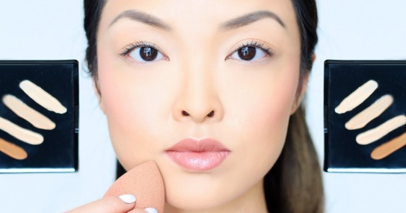
Step 2: There are all different types of foundations but they are generally applied the same way. Foundation is like creating an even base for all your other makeup. Use a brush or a damp beauty sponge to apply the foundation and blend all around your face and neck for a seamless look.
- You can use a concealer brush to add a little extra foundation to cover up stubborn areas and blemishes.

Applying Concealer
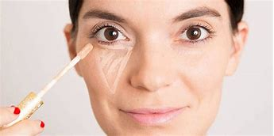
Step 3: Apply concealer under the eyes, chin and forehead. Then blend your concealer so it seamlessly blends into your foundation.
- The purpose of concealer is to even out uneven skin tone like dark circles and blemishes.
- You can use a concealer in a shade lighter to brighten dark areas.

Setting Powder
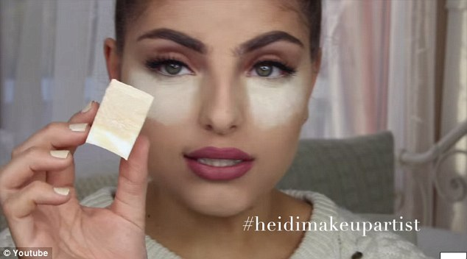
Step 4: Set your foundation and concealer. Use a damp beauty sponge to apply the powder under your eyes, forehead and chin, use a brush to remove the excess powder.
- If you’re looking for a long lasting, crease free makeup you should use a setting powder to hold your foundation and concealer in place.

Contouring/Highlighting
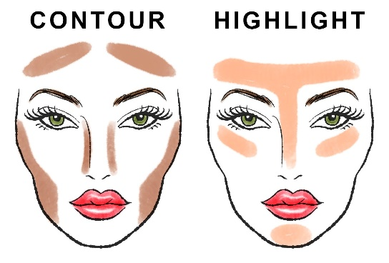
Step 5: To give depth you’ll need to create the illusion of highlights and shadows. Contouring is using a shade darker than your skin tone, applying it under the cheekbones, sides of your nose, under your jaw line and next to your hair line. Buff it out to blend it. Apply highlighter above your cheekbones, down your nose, chin, inner corners of your eyes and eyebrow bone. This will make your face look more bright and awake than it would.

Applying Eyeshadow
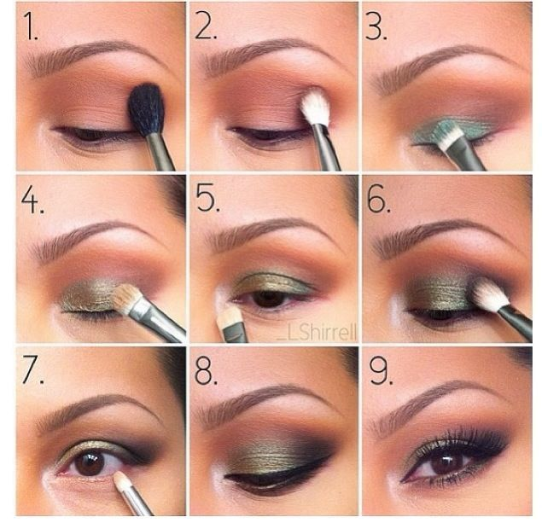
Step 6: Using an eyeshadow brush, apply the darker color on the outer eye and blend inward and outward and the main color in the middle of the eye. Make sure colors are blended together to prevent any harsh lines.
- If you’re using multiple colors of eyeshadow make sure to blend them together.

Applying eyeliner/mascara
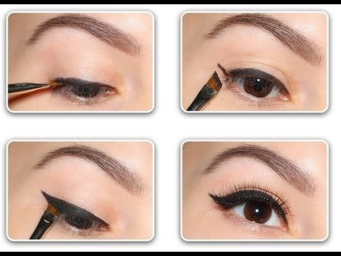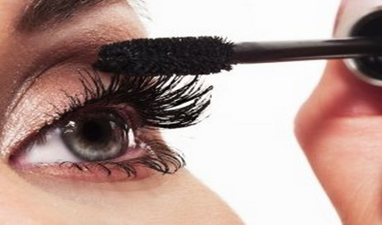
Step 7: Apply eyeliner to provide the illusion of a fuller lash line. Follow your lash line as a guide to help draw your liner, and extend your wing outward and upward. Finish off your eye look with mascara. Looking straight forward, apply it to the top lashes with upward strokes and bottom lashes with downward strokes.
- Some helpful tips, wiggle the brush as you apply it to grasp every strand. And never appy more than two coats of mascara this will create a clumpy unnatural look.

Applying lipstick
w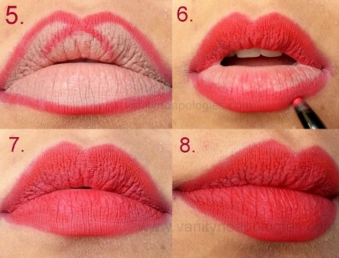
Step 8: To finish off your look apply lipstick. You want to outline your lips first to make it easier to apply the lipstick. Apply your lipstick or lip gloss start in the center of your lip and blend outwards.
- Be sure to apply the color as close to the edges of your lips without overdoing it and going outside your lip line.

RECIPE – How to Have a Successful Relationship
Ingredients:
- Serves minimum of two people
- Compassion (1 Gallon)
- Communication (1 ½ cup)
- Understanding (1 ½ cup)
- Trust (1 Gallon)
- Emotion (1 Gallon)
Instructions:
Always be yourself and love yourself first before loving another.
You need to be able to always communicate about important topics (good communication)
Be understanding towards another
Always try to make time for one another
Building trust is very important
Being a good friend comes first
Have good listening skills

NAVIGATING GENRES
I never really post on Facebook just like most people, I am not comfortable with anyone knowing my business. Occasionally, if I feel passionate enough to share/repost a video – something probably related to politics, education or just a meaningful life lesion video because I enjoy those. I feel like older people on Facebook love to write anything, even if its too much information or misspelled. My grandmother for that matter doesn’t, she just likes to scroll and watch videos. I do believe that are some older people who are better than young kids on social media.
My favorite title was “I Am Under 18 Button Clicked For First Time In History”
Rules I carry are that essays, writing pieces, thesis statements, etc., are supposed to be formally structured yet that’s the thing I find myself to struggle in, to properly structure and not have it look like scattered thoughts.

SHITTY FIRST DRAFTS
Depending on the assignment I normally do two drafts, reading this article made me realize that I’ve always been doing “down drafts, up drafts and dental drafts” without even realizing but someone finally put it in words. I wasn’t surprised by the title I think it was pretty straight forward. Shitty first drafts are supposed to be somewhat shitty, so I don’t think that will change. But I can see myself now focusing on lowering the voices when writing.

UNIT 3
In unit three we had to do more research on genres and create and inquiry based argumentative project. If I had known choosing makeup as my genre would lead to creating an argumentative project which requires a solution I would have picked a different topic. Although I do think it turned out okay with all the issues today’s society has with makeup. This was probably the hardest one to work on, but with discussing with other classmates and following the worksheets guided questions it help a little.

UNIT 3 Worksheet 1 – Inquiry Project
My general area of study is: Makeup
- After doing some preliminary research. I am able to note elow at least one argument/discussion/problem that surrounds my area of study:
- Women often have a conflicted relationship with makeup because of today’s society and makeup shaming
- The people or community of people most affected by this problem are..
- Makeup artists, enthusiasts, influencers, young girls and boys.
- Key terms or phrases that associate with this issue.
- “Low confidence”, “too much makeup”, “personality”, “confidence”
- Here are sources I have used so far to read about and otherwise learn about this issue
- https://blushmagfit.com/makeup-shaming-it-still-exists/
- https://www.youtube.com/watch?v=a4Ov8qvZ2_w

Unit 3 Worksheet 2
Many people wear makeup as a form of expression. Makeup is a type of art. The looks that people create with makeup are incredible, and seeing those looks encourages other people to come up with their own while portraying a person’s mood, culture, personality, and even their thoughts. Makeup means, a form of expression, not a means to hide.
Makeup is more than just business and products, it allows one to feel like the best version of themselves. The current issue with makeup is how women often have a conflicted relationship with makeup, for some a lipstick is just a lipstick, but for others, it’s a source of strength, creativity, and expression. People use makeup as their tool to craft and showcase their strengths fueling confidence. I personally love makeup and everything about it, from buying it, to applying it and how it makes me feel, I find it therapeutic. Many people like to think you’re masking who you are, these concepts about makeup are embedded in our society and have created “makeup-shaming” and despite all these perceptions, the idea that makeup is an art form that people engage in solely for themselves is being introduced and embraced.
Such discussion would bring the following potential benefits whether you wear makeup or not, male or female, it’s your freedom of choice to choose how you want to express yourself. It’s not about the insecurities if wearing makeup makes you feel better, than you should.
Everyone should feel comfortable in their own skin; makeup isn’t there to hide who you are but there to embrace your best self. With encouragement and kindness, everyone will have the confidence to experiment with it.

In this source it talks about how one shouldn’t feel insecure to wear makeup but encourages you to do so, if it makes you feel good about yourself.
Audrey K. (2017) The Aragon Outlook Makeup: A Form of Expression, Not a Means to Hide
In this source it explains another reason why woman shouldn’t feel guilty or ashamed to wearing “too much makeup” and list why no one should listen to the makeup shaming comments and how to further express yourself.
Antley D. (2017) Is Makeup a Form of Self-Expression or Yet another Unfair Standard for Women?

Unit 3 Final Inquiry
Makeup means a lot to most than others, and nowadays makeup-shaming is a real situation. Many woman struggle to find their true self or just something that makes them feel good about themselves because of today’s society, unfortunately some people still vocally judge women for wearing “a lot of makeup” with the common misconception among those who don’t wear makeup often is that they feel like those who do wear makeup must feel “insecure” or like “they need to impress someone.” When in all honestly we do it to feel and look good or simply be creative artists. Makeup is an outlet for creativity and to make yourself feel beautiful, with the ability to wash it off and start all over.
In today’s society one is never pleased with themselves, so they feel like they have to shape themselves into what society wants them to look like, and it’s a shame. This is has led to many controversial topics, with specifically makeup. Yes, you don’t need makeup to prove your self-worth, or to believe that it is the reason for your “beauty”, or to have society take control of how you think you should look like. Makeup is a lot more than that. There’s another side to this topic in which I strongly believe in, and that is that makeup truly is a type of art. It’s a type of art that many women can interpret differently and can create their own.
Woman are in this constant battle with themselves on deciding how they want to express themselves, leading to a conflicted relationship with makeup. Social media can play in a good role with creating the awareness to end makeup shaming, many makeup artists and bloggers have shared stories on how they had the courage to just be able to express what they love and enjoy it. Being the influencers they are, encourages and uplifts most to be able to learn how to express themselves in their own ways. Most influencers have made the effort to end the makeup shaming business, by creative inspirational videos ending the stigma.
Many more people need to see that wearing makeup isn’t masking who you are, it’s expressing the best version of yourself. People use makeup as their tool to craft and showcase their strengths fueling confidence. Despite all the perceptions our society has embedded in us, the idea that makeup is a form of art that people engage in solely for themselves is being embraced. To be more open minded and to allow other be themselves is all the makeup world really needs.
This discussion would bring potential benefits whether you wear makeup or not, male or female, it’s your freedom of choice to choose how you want to express yourself. It’s not about the insecurities and the shaming it’s about helping yourself and others express your true self and love it. Everyone should feel comfortable in their own skin makeup isn’t there to hide who you are but to embrace your best self. With encouragement and kindness, everyone will have the confidence to experiment with it.

UNIT 4
Unit four is the multi-modal project, first time hearing that and I had no idea what that was. The introvert in me panicked and I thought it was nerve wrecking to hear maybe we had to create our own video because I’m not tech savvy. Thankfully I found a perfect YouTube video that brings up today’s issue with makeup from one of my favorite makeup artists.

In this video by NikkiTutorials, she expresses her concern for today’s generation with makeup shaming and she shares her concern for how some people may feel ashamed to say they love makeup or they love to wear it and put it on for fun. When it’s not something to hide, if you love it, do it.

https://www.youtube.com/watch?v=a4Ov8qvZ2_w

