Original Genre
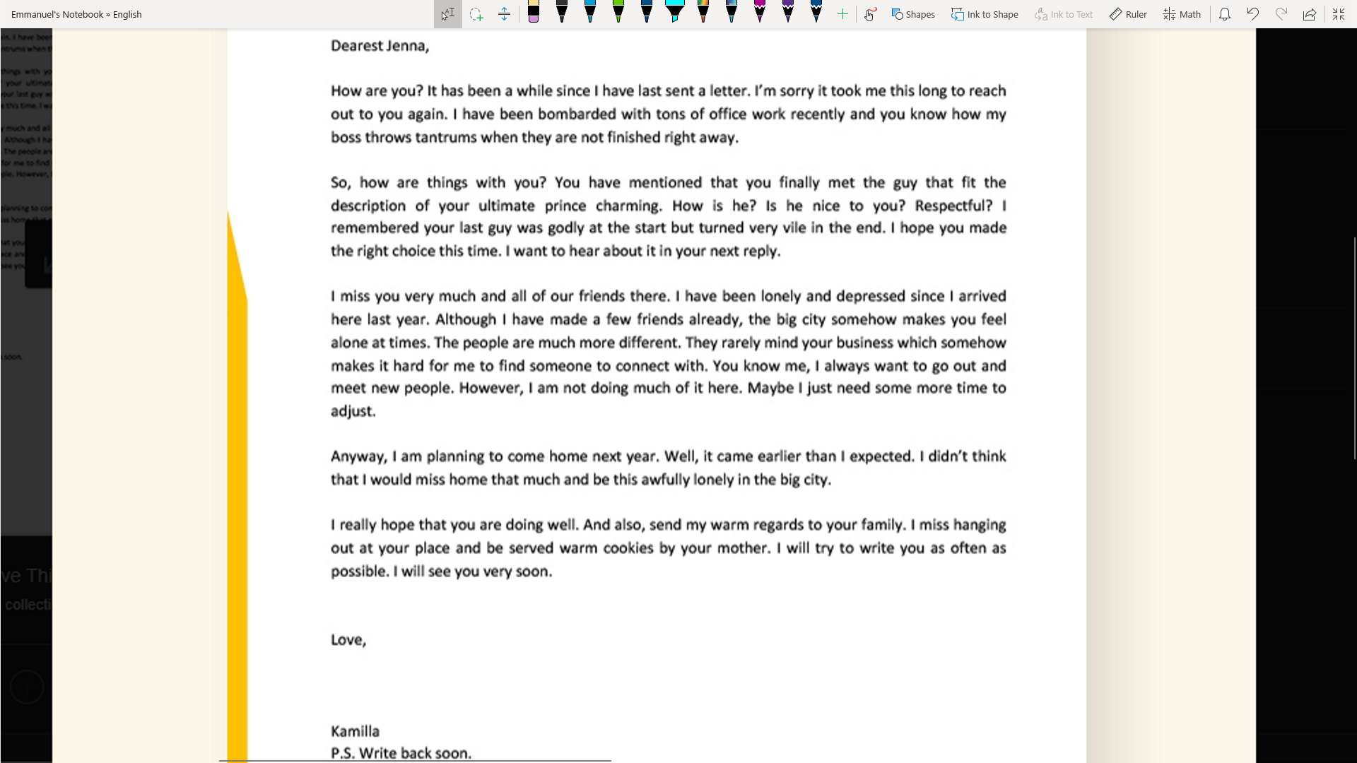
Summary pf genre:

This is an informal letter; Informal letters are usually written to friends or family members. Like the one above, these types are like a conversation (except you are supplying all of the content until the sender gets a reply). The letter starts off with A greeting. It could be followed up by a question like “How are you?”, or a statement like, “I hope everything is well with you.” Then it gets into the meat of the conversation like the one above. Kamilia is talking to Jenna about a conversation that they had previously. She then goes on to get personal with Jenna. The letter then ends with a sweet conclusion to the conversation and the senders name. Some time there will be an extra note along with the letter.

My version:

Re: What I do very well

Dear Comrade,

From the recent letters that we do not send to each other, I am going to answer the question you proposed to me last time. Come closer and listen up, this is very important. You cannot tell anyone about this. You see, I am very interested in nothing. Now I know what you are going say, but hear me out, and maybe you'll be interested in it too. Nothing to you may seem boring and a very improper way to answer your question, but trust me its far beyond any of us. Its so vast.. Compare to that bottomless hole you told me about a couple months ago. I said that I wanted to visit it with you cause it reminds me of nothing. The one thing in my life hat I cannot escape. Doesn’t matter how many times I find something, nothing is always lurking behind. So instead of avoiding it, how bout I embrace it right? I just love its silence. Nothing is peaceful to me.

Regards,
Me

Hello again Comrade!

I can see from my last letter that you didn't buy the bullshit answer that I gave you. I really thought that you'd believe that I am interested in nothing, but your are smarter than I thought you were. So, no more bullshit. I will tell you what I am really interested in and do not judge. It is porn. Okay that was my last joke I swear. My interest is jokes. I think that you can see I'm not joking about this one this time. I mean look what I just did to you my precious Comrade. I really sat at home and wasted ink, trees, and some of the precious minutes I had left on this planet to write you a whole letter that was just a meaningless joke. Its cause I cherish the art of jokes. It helps me bring optimism to any situation. I hope that now you'll understand me better.

Regards,
Me, Again…

PS: I know this has nothing to do with what you asked me, but I want to tell you anyways. There is a difference between horseshit and bullshit. A guy once told me to put the things in a hierarchy,

