The New YOrker

WHERE I LEARNED TO READ

by Salvatore Scibona JUNE 13, 2011
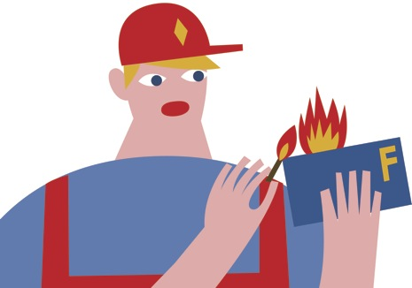

I did my best to flunk out of high school. I failed English literature, American literature, Spanish, precalculus, chemistry, physics. Once, in a fit of melancholic vanity, I burned my report card in the sink of the KFC where I worked scraping carbonized grease from the pressure cookers. I loved that job the way a dog loves a carcass in a ditch. I came home stinking of it. It was a prudent first career in that I wanted with certainty only one thing, to get out of Ohio, and the Colonel might hire me anywhere in the world. The starting wage was $3.85 an hour. I was saving for the future.
But wasn’t it far-fetched, this notion of a future, when I could hardly get through eleventh grade? I always showed up at that job; why couldn’t I show up at the desk in my room and write a C-minus summary of the life of Woodrow Wilson? The television stayed on day and night, singing like a Siren in the crowded house. “Come sit by me and die a little,” it said.
I didn’t know what I was doing or what I believed in, except the United States of America and the Cleveland Browns. Sometimes, to break my addiction to the tube, I spent the night in a derelict shed with mushrooms growing from the rafter boards. Back-yard rehab. I used to read in there, or, anyway, swing my eyes over the pages of library books: “Out of Africa” (the girl I was in love with loved the movie); Donald Trump’s autobiography; Kierkegaard; “Leaves of Grass”; a book about how to make a robot from an eight-track player. As long as nobody had assigned the book, I could stick with it. I didn’t know what I was reading. I didn’t really know how to read. Reading messed with my brain in an unaccountable way. It made me happy; or something. I copied out the first paragraph of Annie Dillard’s “An American Childhood” on my bedroom’s dormer wall. The book was a present from an ace teacher, a literary evangelist in classy shoes, who also flunked me, of course, with good reason. Even to myself I was a lost cause.
Early senior year, a girl in homeroom passed me a brochure that a college had sent her. The college’s curriculum was an outrage. No electives. Not a single book in the seminar list by a living author. However, no tests. No grades, unless you asked to see them. No textbooks—I was confused. In place of an astronomy manual, you would read Copernicus. No books about Aristotle, just Aristotle. Like, you would read book-books. The Great Books, so called, though I had never heard of most of them. It was akin to taking holy orders, but the school—St. John’s College—had been secular for three hundred years. In place of praying, you read. My loneliness was toxic; the future was coleslaw, mop water; the college stood on a desert mountain slope in Santa Fe, New Mexico, fifteen hundred miles from home; I could never get into such a school; my parents couldn’t pay a dollar. And I loved this whole perverse and beautiful idea. I would scrap everything (or so I usefully believed) and go to that place and ask them to let me in. It felt like a vocation. It was a vocation.
Reader, I married it.
The summer before I started, the dean had the arriving students read the Iliad and memorize the Greek alphabet. A year before, I had not known that ancient Greek still existed. I had assumed that all we knew of the Greeks was hearsay. The other students came from Louisiana, Alaska, Malaysia. I could not recognize any of the splintery plant life here. After Greek, we would learn to read French. A teacher, a soft-spoken giant from Colorado in a yarmulke and a worn wool jacket, pointed to a figure in a differential equation from Newton’s “Principia” and said, “This is where our upper-middle-class prejudices about time and space begin to break down.”
Loans. Grants from the college and the government. Jobs from asbestos remover to library clerk. I carried bricks and mortar to rooftops during the summers, but if I hadn’t made time to read the night before, my legs wore out by noon. Even my body needed to read.
By senior year at St. John’s, we were reading Einstein in math, Darwin in lab, Baudelaire in French tutorial, Hegel in seminar. Seminar met twice a week for four years: eight o’clock to ten at night or later, all students addressed by surname. On weekends, I hung out with my friends. The surprise, the wild luck: I had friends. One sat in my room with a beer and “The Phenomenology of Spirit,” reading out a sentence at a time and stopping to ask, “All right, what did that mean?” The gravity of the whole thing would have been laughable if it hadn’t been so much fun, and if it hadn’t been such a gift to find my tribe.
In retrospect, I was a sad little boy and a standard-issue, shiftless, egotistical, dejected teen-ager. Everything was going to hell, and then these strangers let me come to their school and showed me how to read. All things considered, every year since has been a more intense and enigmatic joy. ♦ ILLUSTRATION: OLIMPIA ZAGNOLI

http://www.newyorker.com/reporting/2011/06/13/110613fa_fact_scibona?printable=true

