Two Student Examples—Essay 2, the Photo Essay

Two Sides of Nature

When running and jogging through Forest Park in Queens, I often am surrounded by nature. It is a peaceful environment, and one that I associate with happiness, and this is why I chose to photograph two nature scenes in Pennsylvania. While nature photos may seem to only capture a moment, they actually tell a story as well. “A picture is worth a thousand words,” is an idiomatic expression that is commonly known and conveys this very point. Two photographs “Pathway into Nature,” and “Sunlight Between the Leaves” will be compared and analyzed for their own particular “story.” Both moments have several similarities when it comes composition and an overall feeling, which was peacefulness.
The photograph “Sunlight Between the Leaves” is a photo in full, vibrant color. The photograph was taken in the Poconos, Pennsylvania. The area is known for the scenic imagery and a sort of “get away” from the states of New York and New Jersey. The studium in the picture can be described as, a view with trees that are towering over the grass, and stretching to the sky. The trees have very thin trunks, but as you look there are more trees in background. This causes the trunks in the background to be covered by leaves and almost disappear. The color in the lower background becomes darker within the trees because little sunlight hits the floor. The sky above the trees is very calm and blue. The sky is also filled with clouds. At the angle this photograph is taken one can see that these trees are quite tall.

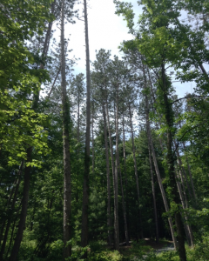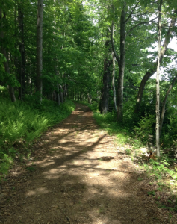

Two Sides of Events
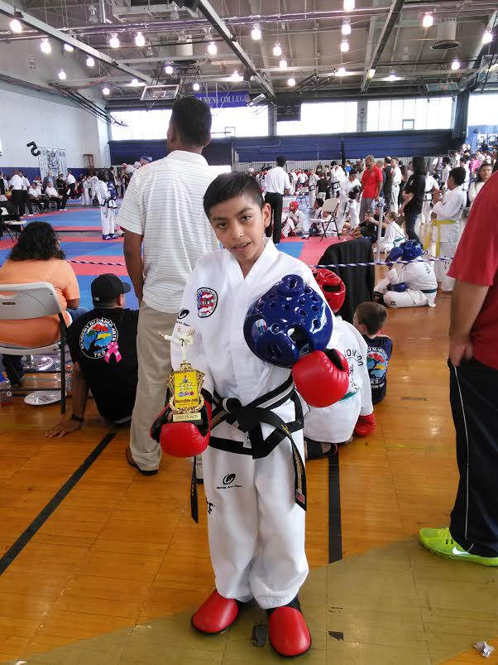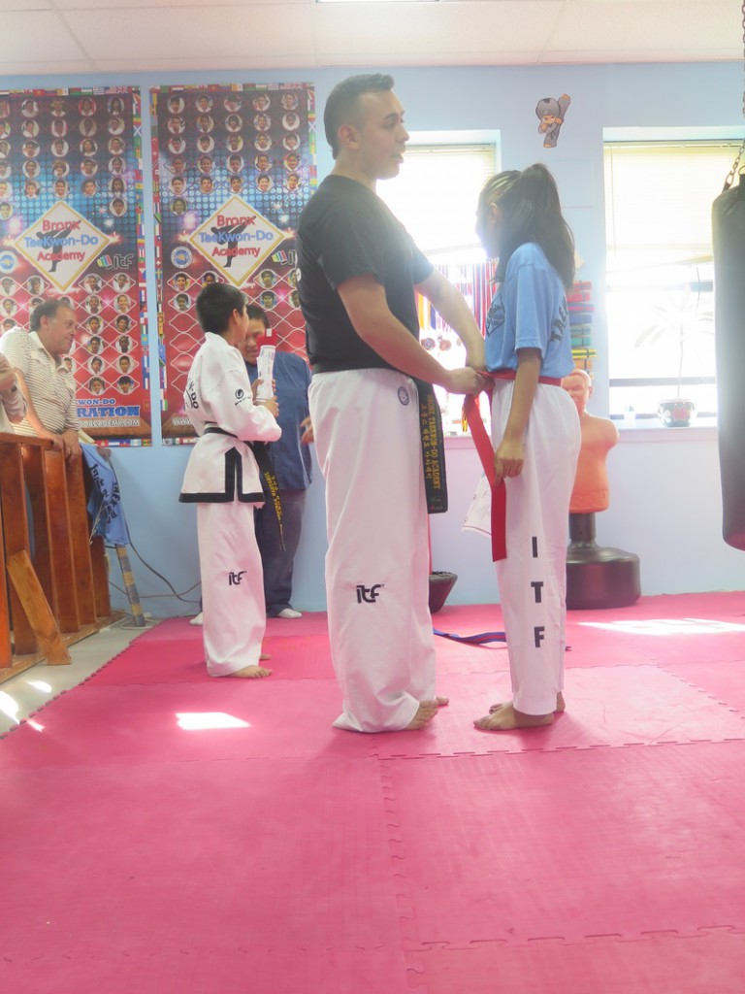
Photos are important, and there are many reasons why photos matter to many people. For example, according to Susan Sontag’s essay On Photography, “Photographs furnish evidence.” This means that something that happened has really existed, taken place. My photos of the taekwondo events really exist and it matters to the little boy named Jonathon Ramirez in the first photo and the girl in the second photo name Lizbeth Ramirez. People take photos to share with their friends, family, or to many people. Yet some people take photos with a surveillance camera to catch a criminal and show proof about a situation. Photos are very interesting depending on what is in the photo and what is happening in the photo and the dominant impression that the people have in the photo, some people may feel happy, calmed, terrified, sad, bored or many other feelings. Another purpose of a photo is just for entertaining which is very addictive. For example, according to Susan Sontag’s essay on photography, she said, “Like guns and cars, cameras are fantasy machines whose use is addictive.” It is true due to the fact that when I take pictures of my hobby, it is really addictive and it affects me based on my dominant impression. Just like guns and cars are addictive like cameras, taking photos on a Taekwondo event is addictive and entertaining to me.
The two photos I chose took place at a tournament and at a taekwondo training school. I chose those photos because those are memories that I will never forget and decided to share it with other people. Those two photos are comparable because, well, even though the photos are both in a different place, they both have a pro-filmic event. Both photos have something to do with the taekwondo sport. Those photos are like comparing green apple with red apple which are both still apples, in other words, both photos have the same type of event.

