Suryia Afsar
Essay 2: The Photo Essay: Describing, Comparing, and Storytelling
English 1101
October 30, 2017

Sunset to a Gloomy Sky
Our eyes catch everything. We see the world in numerous ways. While walking outside we never take the time to stop and observe the beauty around us. We are constantly in a rush and never seize the moment to take it all in. Though our eyes see one thing, capturing the moment through a photo can say another. Like the common saying, “A photo is worth a thousand words.” It is up to you to tell its story and interpret it the way you see it.
My first photo was taken while I was walking home on October 25, 2017 and noticed the sunset. The sky was the perfect mix of light blue to grey to purple to pink and finally to orange all in that order. The colors of sky were so vibrant and beautiful I knew I had to capture it, similar to what John Berger stated in, Understanding a Photograph, “A photo is a result of the photographer’s decisions that is worth recording that this particular event or this particular object has been seen”. I admired the beauty the beauty within the light and thought it was important to capture the moment. Before I took this picture, I crossed the street for a better angle and to be able to capture all the colors at once. Standing almost in the middle of the road, I took the picture at exactly 6:00 pm. In the photo, you can see that the sky was just a burst of stunning colors and were aligned with the street perfectly, houses all parallel to each other and are paired with a car along the road. In that moment the street seemed so peaceful, barely a moving car in sight, along with the wind blowing softly. Three days later on October 28, 2017, I decided to recreate the picture, this time there was no vibrant sunset. The sky was covered with a thick grey cloud casting above the houses. I knew it was not going to look like the first photo and that is why I wanted to take it. There was still some daylight peeking through the dark clouds and the streetlights had just come on. While taking this photo I remember the loud bike rider humming along to his music and traffic had started to pick up. I quickly stood in the middle of the street and took the photo. The difference in light triggered my studium immediately because of the drastic change in colors. My second photo was taken at 6:08 pm on that Saturday evening; it was almost as identical as my first photo, the only difference being the contrast of the light in the sky.
Although these photos were taken on different days, they are still very similar. Both images were taken on the same block of my neighborhood in Queens Village; 104th avenue to be exact. I took the photos using my iPhone 7 plus on the snapchat app. The app was already open when I took the first image, and I decided to take it for the second image as well since I was recreating it. Looking at the images, large clouds are present in both photos and are casted above the homes. Cars that belong to the homeowners are also in similar positions; all in a straight line through the street, along with the word Stop largely painted on road that is in the middle of each photo. Looking closely, there is a car coming through the distance, with its headlights peeking through the middle of the street in both photos. Above the homes, there are power lines that are fading further into the photo with the silhouette of trees behind them.
There are so many things that photos are able to catch. They are still a key statement in our society today and have helped us document every single important and unimportant aspect of our lives. The use of photos can be used as a form of communication; it unwraps untold stories and is generally depicted in so many different ways. Sometimes a photographer's true desire is to capture a message and to display beauty. Photographs have come a tremendously long way and has improved drastically. It is a form of art and has the ability to change one’s emotions. Writer John Berger disagrees with photographs being considered art. Berger states that, “The very principle of photography is that the resulting image is not unique, but on the contrary infinitely reproducible.” I disagree with Berger’s statement simply because I believe that both photographs and painting capture a sense of originality based on different styles and techniques being used.

( 814)
Work Cited:
Berger, John. Understanding a Photograph. pp 292.
Berger, John. Understanding a Photograph. pp 291.

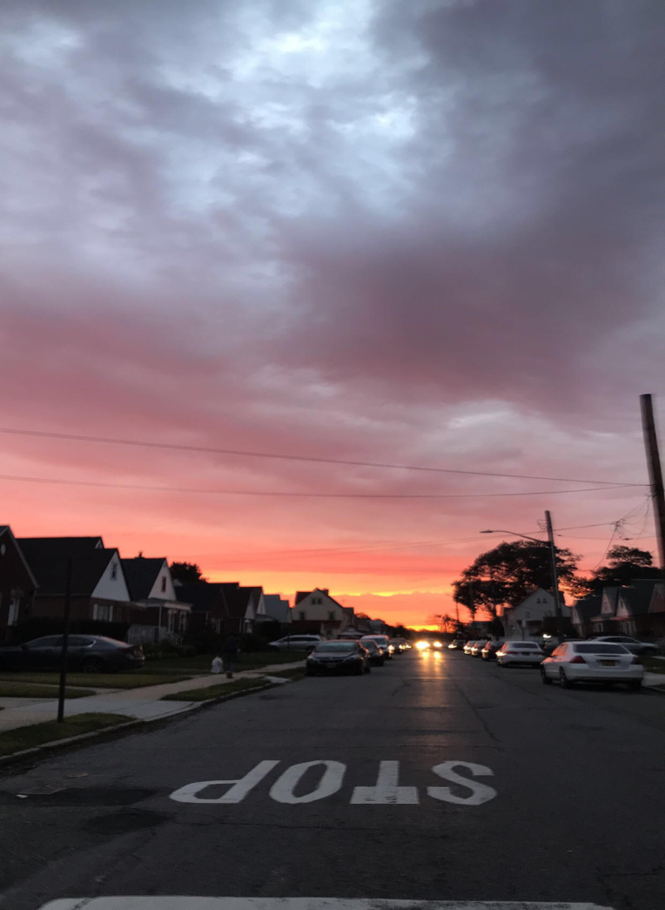
Photo 1: Photo 2:

