Jonathan Villatoro
Photography Essay
English 1101 (Prof. Scanlan)
April 14, 2018

Reality vs Perspective
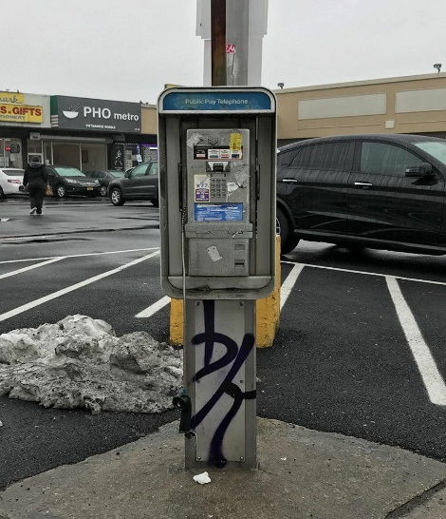
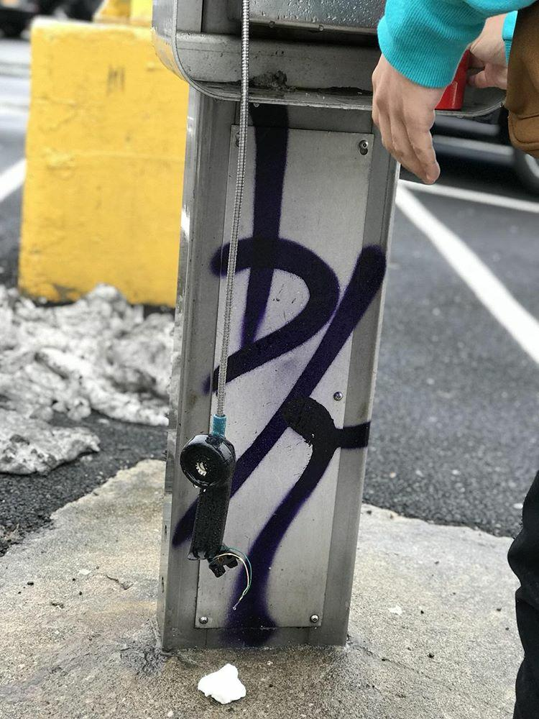
Photography. Largely regarded as a form of artwork and while many oppose that idea it is clear to see that photographs are much more than just simply “infinitely reproducible” images that “have little or no rarity value” as John Berger explains in “Understanding a Photograph.” It is my belief that photography can be seen more than just the “records of things seen.” For several reasons. Although I admit documentary photos clearly do exist and they do capture events and setting that take place, I like to reason that perhaps there is no reality at all to these photos. There is really only our perception of it.
Here I have taken to photographs only moments apart from each other. Before I even decided these photo my friends and I had just met up. We were all discussing what indoor activity we could do for that cold and cloudy day. We discussed our options for a while outside of a supermarket and then decided to play pool like we always do anyway. Soon after we first started walking we encountered they pay phone on the corner of the block. I began to walk towards it drifting away from the rest of our group. I immediately saw the top end of the phone destroyed and understood that these would be my photographs for this assignment. I called my friends over to have a look at the broken phone and we exchanged ideas about how we imagined the phone might have ended up in the state that it is in. We laughed at the idea of a personified phone begging for its life but we ultimately decided on a scenario where an drug dealer destroyed it after some bad news because let’s be honest, who uses one of those things anymore. After we were done joking around I asked my friend to borrow his iPhone 8. Not because of the great focusing but because of the great depth of field effects iPhones have. I really did enjoy taking these pictures and doing this assignment.
It is important we fist speak about the Studium of these photographs. In the photograph entitled Reality we can clearly see that this shot was taken on a rainy day in a parking lot in front of a plaza where there are several different stores and a larger khaki colored building which is a supermarket. You can see some dirty snow behind the payphone and an anonymous person dressed in all black walking in the opposite direction of the camera. This photo was taken with the purposes of being a documentary photo. While in the second photograph entitled Perception we have a depth of field effect and is clearly an art photo. Here although it wasn’t originally my intention we can see the hand, hoodie sleeve, and pants of my friend being cut out of frame after he placed his red reusable water bottle of the side of the payphone. In this photograph it is much easier to see the broken phone and the details in the graffiti behind it. We can still make out the filthy snow although it has a blurred out effect to highlight the focal point of this photograph which is the broken phone. I also enjoy the fact that the water droplets are clearer to see on the phone because it adds a reality effect to a picture. In both photographs we can notice the yellow painted concrete base for a pole and a singular snowball like presence almost directly underneath the phone.
The reason I took these photos was because immediately when I saw that payphone I remembered a payphone that looked just like it down to the dirty blue and white label on the top that says “Public Pay Telephone.” Every time my mother and I would go to do laundry we would pass this payphone by and although I had probably only ever seen it in use about three or four times that pay phone became a landmark to me in my early childhood. Perhaps that was why that image was so satisfying for me to look at and attracted me immediately while my friends were able to walk right passed it without giving it a second look or even noticing it in the first place. In a way maybe this photo will only ever mean anything to me but I’ve accepted that. The photo is no less meaningful to me because of that. The image cannot strike me the same exact way it would strike another person and the fact it can be reproduced an infinite amount of times does not change the way I feel about this photo because my perception of it is exclusive and unique to me. That to me is a quality that is very important in determining whether or not something can be a piece of art. This means that there can never be a set of rules to what art can or can’t be nor is there even a reality to what art is, it is simply based off of our perception and that’s the point I think these two pictures make when I look at them.

(876 words)
Works Cited
Berger, John. “Understanding a Photograph.” Classic Essays on Photography, edited by Alan Trachtenberg, Newhaven: Leete’s Island Books, 1980, pp. 292. Print

