Kyle Brisfere
Class D333
English Essay #2
April 17, 2018
Beauty in Roots

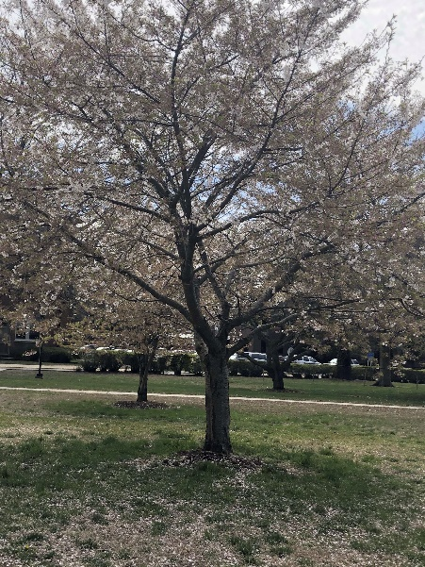 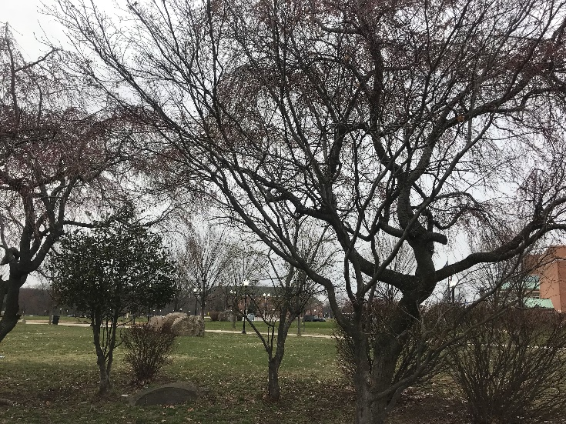
Spring Blossoms Dark Blooms

There is a lot of different kinds of trees. Some trees look beautiful with or without leaves. All trees have roots. The two photos that I took were pictures of trees. One picture had beautiful pink leaves, the other had almost no leaves because they were falling out. Both pictures were taken at two different college campuses at different times of the day. They both have also have color. Both photos were also taken on an iPhone 8 Plus.
The photo “Spring Blossoms” was taken at Hampton University Campus in Hampton, Virginia. It was taken on an iPhone 8+. I took this picture on a Tuesday afternoon at 2:20. I Stopped to take this picture because it made me feel calm. The leaves were pink, and it was windy, so it was blowing off. I had to take several pictures just, so I can find that one picture that I believed looked the best to me. I took this photo with color, so my readers could feel how I felt when I took the picture. The photo made me feel calm because the pink leaves and calm colors represents that it is spring. In the photo you can see pink leaves all over the floor, and that indicates that they were falling off the tree. The audience can also see about seven cars in the background. The environment was empty because kids were in their classes or their dorm rooms and I was a visitor. I witnessed this tree stand out for the whole environment while on a tour of the school. In the photo, readers can also indicate that it was a cloudy day. Out of many trees that were in the area, this tree was the most significant to me because it was the biggest tree and it also had the most leaves out of all the other trees.
The photo “Dark Blooms” was taken at CUNY College of Staten Island in Staten Island, New York. This was also taken on an iPhone 8+. This photo was taken on a Saturday afternoon at 4:07. I took this picture because it reminded me of the first photo I took. I had a complete opposite mood when I took this picture. This photo consists of two colors. Everything in the photo is either green or brown. It made me feel like it was going to rain. Unlike the first photo the colors were dark. It didn’t consist of warm colors. The photo gave me a feeling like winter is here. There are about seven trees and in all those trees you can see their stems. That is because the leaves are falling. In this photo there is also buildings and rocks. This photo doesn’t give me a Dominant Impression because nothing stood out. All the colors involved in this picture were the same. I also wanted to show my audience the difference between a tree on campus in Virginia and a tree on a campus in New York.
In both photos, the audience can spot trees with leaves all over the ground and that indicates that the leaves are falling. In the photo which was taken at Hampton, Virginia, there is pink/white leaves that are on the tree and fall. This picture presents a calm peaceful mood. It shows us that spring is approaching because of the spring colors it shows. There are also several trees in the background, but this one tree had the most leaves on it. In the other photo that was taken in Staten Island, New York, it looks like its about to rain. Unlike the first picture it doesn’t represent a calm mood. This picture can represent a rough stormy mood. I say this because when I look at the sky it dark and very cloudy. In the first picture the sky was nice and blue with little clouds, this one has no sky showing, just one large cloud. Both pictures are beautiful and represent a different mood based on the reader. Being that the photos are in color, it makes it easier for the audience to relate to it in anyway they can. They can react if the photo provides a calm or an angry mood.
Every photo represents something and has a different meaning. According to Susan Sontag, she exclaims that “photographs furnish evidence.” This meaning that every photo has a meaning to it. Photos display information. Trees are also apart of our beautiful nature. Every photo is significant in a different way to everyone. With my photos “Spring Blossoms,” and “Dark Blooms” I hope that my audience see the photos in a significant way or in their own way, and that there is Beauty in Roots.
(802)

