Kelvin Chan
Essay 2
English 3407 (Prof. Scanlan)
October 27, 2015

Two Parks Two Interpretations

What is a photograph? As John Berger said, “A photograph is a result of the
photographer’s decision that it is worth recording that this particular event or this object has
been seen.” I agree to this quote. A photograph is a picture taken by a person that thinks this
view, event or moment in time is worth cherishing. I’m a person that loves parks ever since I was
a little kid. I have always been going to the park. Exploring different parks was always an
amazing and whimsical adventure for me. I have taken two photographs, first one “Prospect Park
during October” is a photo taken at prospect park while the suns still out and second photo
“V Park” is a photo taken at Mellett Playground while it was dark. Both these photographs are of
parks that I love, that are meaningful, and are similar, and comparable in different ways.
First documentary photograph I took is titled “Prospect Park during October” and was
taken on October 11, 2015 at Prospect Park. The dominant impression in this photograph is
very pleasing. The atmosphere or stadium of the photograph is very peaceful and warm. The
suns shinning bright outside made mother nature look amazing. There was so much different
kind of trees and the way the colors would reflect off the pond could catch anyone’s attention.
There are so many vibrant colors and autumn feelings in this view, the trees at the park are just
starting to change colors, and it looks beautiful. John Berger said, “It isolates, preserves, and
presents a moment taken from a continuum.” In addition, Susan Sontag said “A way of
certifying experience.” I wanted to preserve this moment for myself. The photograph had a
reality effect. I was on a date with my girlfriend to Prospect Park and it was such a beautiful
day. But, not only was it a beautiful day but it was also a lively day. A photograph was needed
to save this joyful, emotional, moment in time. It was a day worth remembering.
The next photograph I took is titled “V Park” and I took this photograph on October 27,
2015 at Mellett Playground. This photograph was at night and it has dark mysterious vibe. The
studium of the photograph was while the sun was done and outside in a park. The photograph
is dark and lonely, there is no one playing in the park, and it looks very quiet. The rule of thirds
was used in taking this photograph, showed how the streetlight inside the park was the only
source of light. While the rest of the area surrounding the streetlight was dark. In addition, the
frames cut out the basketball courts and park gates. Parks are usually a happy place that is
bright, safe, and full of kids laughing and having fun. However, in this photograph the park is
dead and this picture gives off that scary mood. As Susan Sontag said “It is a nostalgic time right
now, and photographs actively promote nostalgia. Photography is an elegiac art, a twilight art.”
This park would be pitch black, the only thing keeping this park lighten up is the one street light
standing by itself. This is a photograph has a mournful quality.
Both of the photographs “Prospect Park during October” and “V Park” are similar and
different in way. Both pictures are of parks and I been to both of them many times. These
documentary photos give me a nostalgic feeling of the past. Both these photographs caught my
attention. Prospect Park is so many times bigger than Mellett Playground. Prospect park is a
huge park while Mellett Playground is a small park. For both images, I took them with a similar
set of mind, going home. For “Prospect Park during October” while my girlfriend and I was
trying to find the way out of Prospect Park, we saw this beautiful view of colors and I took the
picture with my phone. For “V Park” I was walking home from college and the lonely streetlight
in the park caught my attention. Even though one photograph was about a park while the sun was
out and the other was about a park at night both pictures were still taken at a park. Susan Sontag
once said, “Although there is a sense in which the camera does indeed capture reality, not just
interpret it, photographs are as much an interpretation of the world as painting and drawing are.”
The two photographs shows and interprets the two different sides of every park. Both these parks
are packed with people and joyful kids having fun while the suns out and while it is nighttime
both parks are also dead and quiet.
Both of the photographs I have taken “Prospect Park during October” and “V Park” have
similarities. They are both pictures of places where people in general go to have fun and enjoy
the look and feel of nature in their free time. Both photographs are also interpreted differently
and in many ways because of the timing, the photograph was taken. One taken while the sun is
shining bright in the sky and one while the sun is missing. Photographs are supposed to be
enjoyable to look at and they always have much to say.

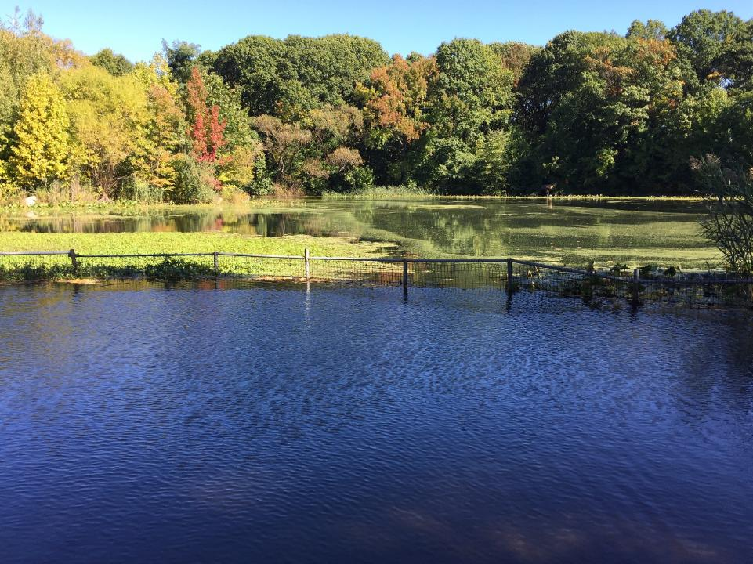

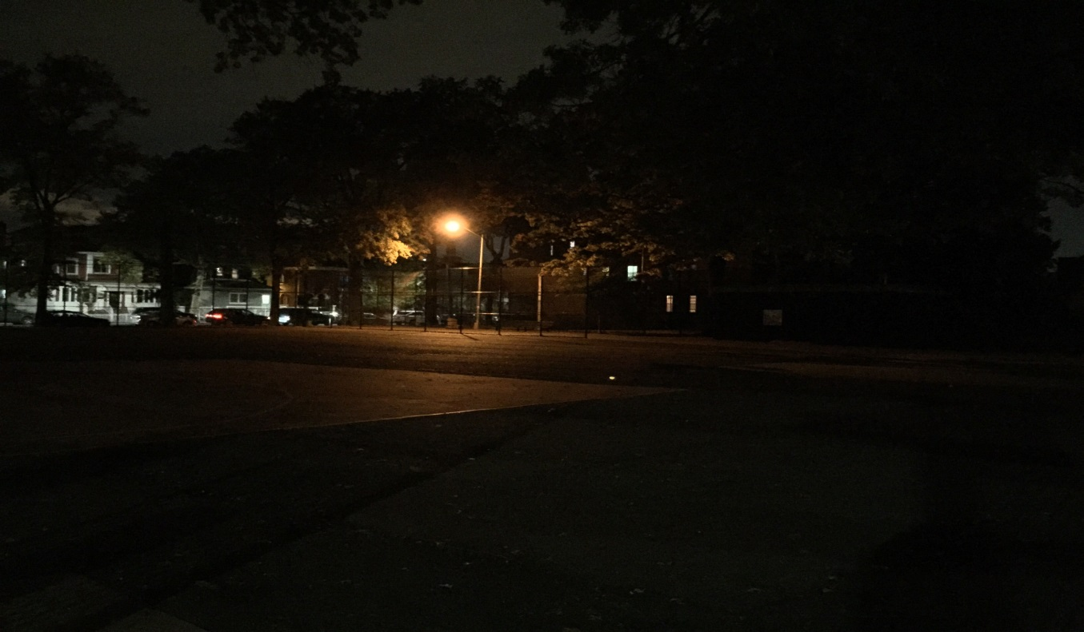

Work Citations
Chan, Kelvin. “Prospect Park during October.” Author’s photo. 11 Oct. 2015. Jpeg.

Chan, Kelvin. “V Park.” Author’s photo. 27 Oct. 2015. Jpeg.

Sontag, Susan. “On Photography”, Essays of The 1960s & 1970s; New York: Farrar, Straus, and
Giroux, 1977. Print. 531 – 539.

Berger, John. “Understanding a Photograph”, Classic Essays on Photography. New Haven;
Leefe’s Island books, 1980. Print. 291 – 294.

