` 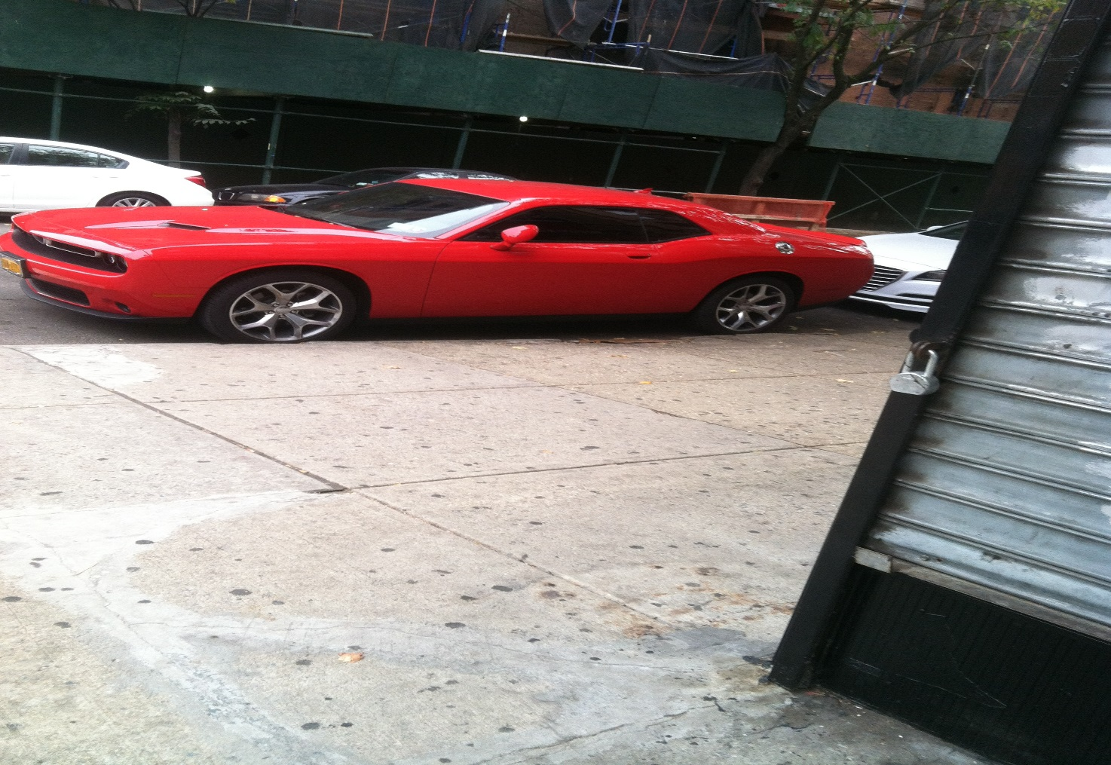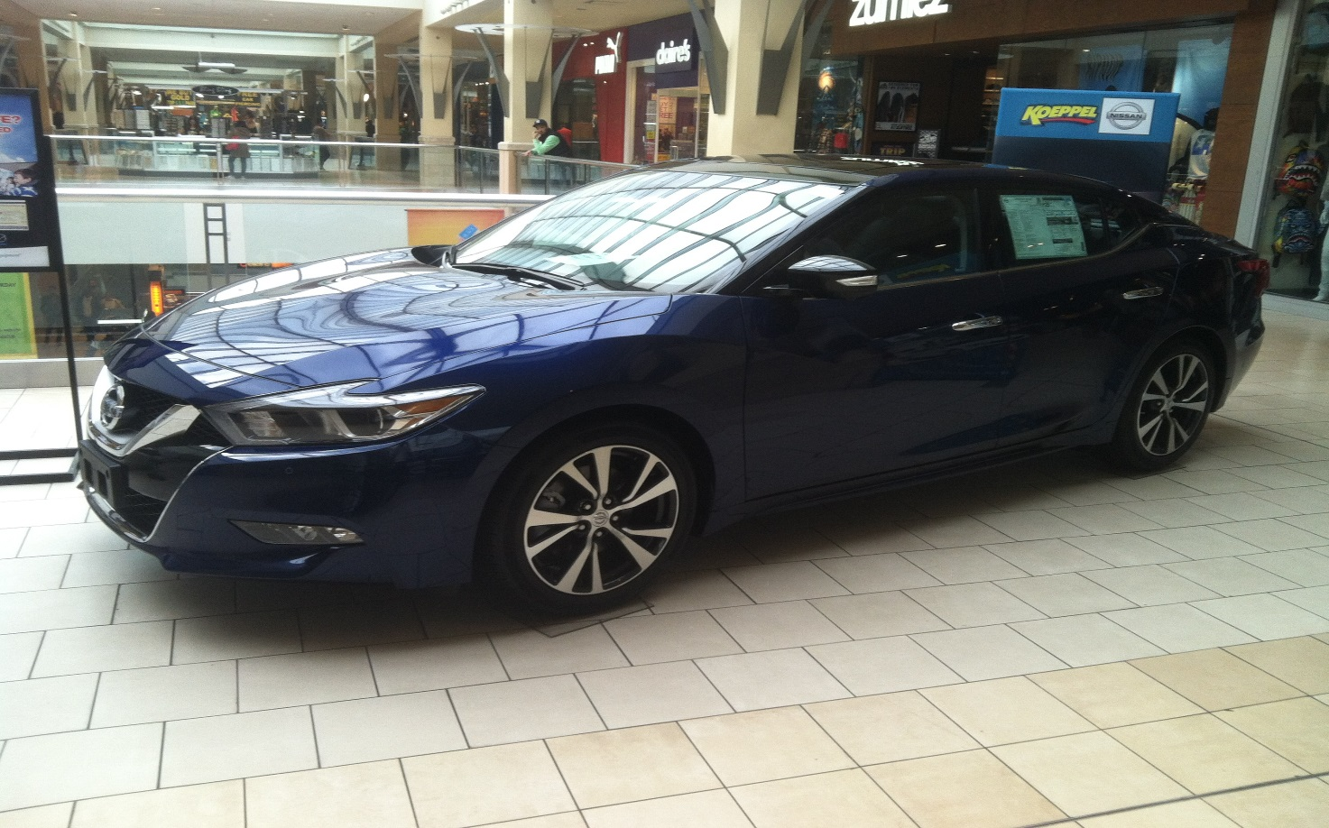
Wesley Donaldson
November 8, 2015
English D394 (Prof. Scanlan)
Essay 2
Two Cars

My assignment was to take two photographs which depicted various physical and
technological elements. The first photo is of a Dodge Challenger, and was taken at the
intersection of Madison Street. and Cypress Avenue. These two streets are located in
Ridgewood, Queens, New York City. The second photo is of a 2016 Nissan Maxima, and this
was taken on the third floor at the Queens Center Mall in Elmhurst, Queens, New York City.
Both cars have some similarities and differences.
In the first photograph, bright red colors are depicted on the Dodge Challenger car. It is
parked in front of a store that is closed and across the street from it there is some scaffolding.
The wheels of the car appear to be flat from the position where I stood. There was nobody in the
car. It was a two-car.
In the second photograph, there is a 2016 Nissan Maxima with a storm blue color to it.
This was taken on the top floor of Queens Center Mall, and one can tell by lookimg at the
windshield of the car. The reflection of the ceiling windows on the Maxima’s windshield was
visible. Also, since the reflection was visible, it was clear that this picture was taken during the
day. It appears that this car is being promoted and advertised by Koeppel, a car dealershp. On
the left side of the rear seat window of the Maxima is a note explaining the quality and features
of this car.
These two motor vehicles appear to have a lot of things in common. One common point
is that they both have four wheels and they are stationary. It is not known if the mechanisms in
both cars worked but after taking the pictures, I asked one of the employees if the car was an
object of a raffle or just for an exhibition. Her response was that it represented a kind of promotion. This exhibition appeared to have a deep aesthetic significance. Another similarity is that both cars has curved lines in certain sections and the shapes of the windows show technological innovation. Both cars were surprisingly lifeless as if they were on display in a museum.

There were also some basic differences between the two cars. One difference was thar
the colors were not the same. Another difference was that one had dour doors and the other had
two. Also, their countries of origin are different because one care was manufactured in Japan
while the other was an American-made car. Nissan is a Japanese brand car company ans Dodge
is an American brand car company. It is more common to see a Nissan Maxima than a Dodge
Challenger, and the Nissan has a more curve looking appearance while the Dodge has a boxy
appearance to it. In addition, the surroundings in which the photos were taken were not similar.
In fact, the car dealership had very few people within its vicinity while the mall had houndreds
of shoppers and sightseers.
The background tells a lot about the pictures. In the background of the second picture,
there is a Puma brand store, Claire’s, and Zumies. On that same floor there are people seen
farther off in the distance and a “We buy gold” section. You can also see a man with a green
long sleeve hoodie and a vest looking this way towards the direction of the camera. There is a
little view of the second floor where you can see three people standing there. There is evidence
of man-made features such as straight, circular, and rectangular lines.
In the end, I was able to develop a sense of understanding art which basically means the
ways people express their feelings through creativity. These two cars are a redlection of
ingenuity and effort. I enjoyed the detailed artwork and the mechanization that helped to put
these two cars together and, even though I have not started to drive yet, I feel a sense of
satisfacttion as I looked at the pictures of the beauty of technology.

Work Cited
Donaldson, Wesley “Dodge Challenger on intersection of Madison St. and Cypress Av,” New York City College of Technology, November 2015 JPEG
Donaldson, Wesley “2016 Nissan Maxima on the third floor at the Queens Center Mall in Elmhurst, Queens, New York City,” New York City College of Technology, November 2015 JPEG

