Raylin Antigua
English 1101 (Prof. Scanlan)
Essay 2
The Evolution of Architecture

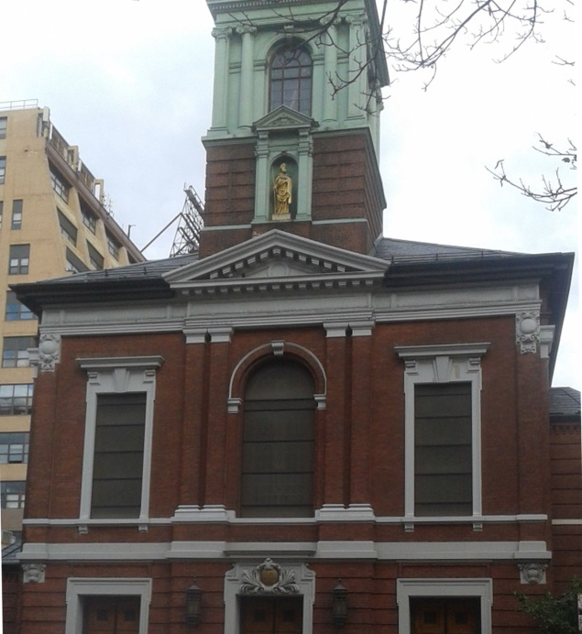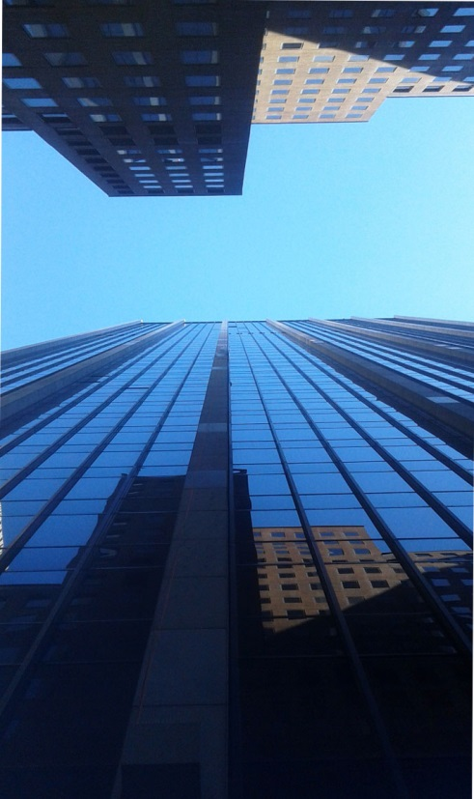

As a student of architecture, I find it hard to visualize buildings as simply buildings. There is more to see than just a tall structure built on the ground. Buildings tell stories; stories of history; of what was, what is, and what later will be. Although buildings are not able to create history, I believe that the evolution of buildings can be envisioned with the term Documentary Photo. Documentary photographs are those types of photos that depict real events without any type of manipulation. The two photographs that I have chosen to compare are a good example of how architecture has evolved throughout the years.
The first photo is of the Cathedral Basilica of St. James, taken on October 14, 2015, in Brooklyn, NY. I chose to use a church as my first example because these types of buildings continue their architectural style throughout centuries. The second photograph is of 1185 Avenue of the Americas, taken on October 15, 2015, in Manhattan, NY. This building is the complete opposite of a church, since its architectural style is modern. Studium is everything that can be described by looking at a photograph. Both photos have one thing in common: they are buildings. However, many things differentiate them. For example, the church has Neo-Georgian architecture style: It is made out of bricks and cement. The walls are not red, but a burgundy color. The décor, window frames, and pillars are painted white, whereas the roof is covered in black slate tiles. Meanwhile, the modern building was built in a postmodern architectural style so that the exterior is glass. The color of the building shown on this photograph is baby blue, but that is because the glass panels reflect the color of the sky.
The angle in which both buildings were taken is the most important factor of both photographs because it shows one aspect of evolution. In the photo of the church, the angle taken was front-faced. The height of this building is around three stories high, the height of what a typical church should be. On the other hand, the second photograph has a different angle. This photo was taken in an upward angle, as if looking towards the sky. This building has 42 floors, and each floor is around 10 feet high. Therefore, an estimated guess of how high this building is varies from 420 to 450 feet. In the 18th and 19th century, these types of buildings were not so common as today. Today, you walk around Manhattan, and you would find dozens of buildings that same size, or even taller. Berenice Abbott’s photograph “Seventh Avenue looking south from 35th street, Manhattan,” 1935 is a good example of what modern buildings look like today.

Understanding the functions of elements in a photograph is very important in order to comprehend the photo. A church is a building used to practice religion. Many people, and in majority, families, gather at church. Susan Sontag mentions “Cameras go with family life.” On that account, cameras are most likely to be seen at church. In the second photograph, the very tall building is an office rental building. Basically, companies rent out a certain amount of space and practice their business. Since this building is located near Rockefeller Center, many tourists, visit the area and photograph themselves and the scenery. Essentially, cameras are everywhere.
“Photographs furnish evidence.” A simple statement written by Sontag that comes with a great meaning. Because of photography, we are able to archive important information in form of photos. Photos of buildings from the past help create the modern buildings that occupy our cities today. From those photographs, we learn and reuse whatever elements seem crucial. In addition, because of photography, we are able to compare ancient and modern buildings, giving the term Documentary Photo more meaning. As John Berger says, “A photograph is already a message about the event it records.” When taking photos of buildings, the architect leaves a message in the form a building; a message engraved in history.
In photography, punctum is the personal connection between the viewer and the actual photograph. The reason I am connected with both photos is simply because architecture is my passion. To be an architect is what I live for. Buildings and their design give me a serene sensation; it makes me feel relaxed. Nevertheless, what would these photographs mean to others? Dominant Impression is another photography term, which can be defined as the main mood a photo gives in general. For those who are religious, the first photo may give a feeling of happiness and hope since those feelings are related to faith. The modern building, however, gives a feeling of progression and success. The angle in which the photo was taken tells the viewer to keep aiming higher.
With evidence of how buildings have evolved throughout the years, the real question here is, how much more will buildings evolve? The answer is unknown. However, if society keeps documenting and photographing buildings, the process of evolution will be clearly visible. After all, stating Sontag, “the camera record justifies.”

Work Cited
Abbott, Berenice. “Photographing the City.” The Place Where We Dwell: Reading and Writing about New York City. Eds Mark Noonan, Juanita But, ad Sean Scanlan. Dubuque, IA: Kendall Hunt 131-2. 143. Print
Sontag, Susan. “On Photography,” Susan Sontag Essays of the 1960’s & 70’s. New York: The Library of America, 2013. 531-533. Print.
Berger, John. “Understanding a Photography,” Classic Essays on Photography. New Haven: Leete’s Island Book, 1980: 292. Print
Antigua, Raylin. Cathedral Basilica of St. James. Brooklyn, NY. Author’s Photo. 14 Oct. 2015. JPEG
Antigua, Raylin. 1185 Avenue of the Americas. Manhattan NY. Author’s Photo15. Oct. 2015. JPEG

(847 words)

